**Title:** Food Web Structural Shifts Under Rapid Global Change

**Authors:** Charlotte Ward, Kevin McCann, Tyler Tunney, Bailey McMeans, John Moore

**Journal:** Frontiers in Ecology and The Environment **(***Reviews***)**

**Introduction**

Traditionally, food web research has primarily focused on identifying fixed structures in different ecosystems. However, recent findings reveal that food webs are more dynamic and responsive to their ever-changing environments. This shift in perspective is significant because this adaptability is crucial for ecosystem resilience, helping them maintain their essential functions in the face of environmental changes and human impacts.

Nonetheless, not all adaptations in food webs are positive, and some alterations can lead to the degradation of ecosystems. Consequently, there is a challenge in science to detect patterns of structural shifts in food webs, enabling us to develop indicators that help monitor undesirable changes and enhance ecosystem management in a rapidly changing world.

At the core of this approach is the idea that specific structural changes in food webs can serve as indicators of undesirable shifts in ecosystem functioning. For instance, food chain length, which represents the flow of energy from primary producers to apex predators, plays a crucial role in vital ecosystem functions like nutrient cycling, productivity, and resilience. Changes in the environment can cause food chains to lengthen or shorten incrementally, making it an attractive potential indicator for ecosystem monitoring.

Similarly, there is a horizontal structural aspect known as food web width that connects vertical food chains in space. This spatial structure is also linked to important ecosystem functions, such as nutrient integration, altering production pathways, and providing resilience to food webs. Additionally, the degree of habitat coupling, a form of spatial coupling, can vary within and across ecosystems and is related to changes in food chain length and other core food web structures. Recent advancements in tools and methods, like stable isotopes, fatty acids, and eDNA, have made it possible to rapidly calculate metrics for these indicators, offering promise for their application in ecosystem change monitoring.

To make these structural properties effective signposts for ecosystem management, we need more knowledge about their consistency in the face of different environmental pressures, whether human-induced or environmental. This information will help us determine whether these structural indicators can reliably signal unwanted changes in ecosystems that don't align with conservation and management goals. We also need to understand when and where these indicators are most effective, a critical consideration for management and monitoring programs.

While there have been numerous studies on changes in food web structures in recent years, there is a gap in the literature regarding the directional consistency of these changes. Therefore, conducting a comprehensive literature review to synthesize this area of research and assess its current applicability would be highly valuable.

Our objective is to advance our understanding of structural indicators for ecosystem conservation and management. This review focuses on two key indicators: food chain length and habitat coupling, outlining the mechanisms that influence changes in these indicators and presenting their role in ecosystem resilience. We conducted a rigorous literature review spanning various ecosystem types and human-induced pressures, documenting our search strategies and study selection process. This allowed us to draw fresh conclusions about the consistency of directional changes in food chain length and habitat coupling across different studies.

Our review shows that while there is variation in these food web structural indicators, there are also contexts where directional change is consistent. This finding holds promise for applying these food web indicators and their associated metrics in conservation and resource management efforts.

**Mechanisms Driving Food Web Structural Shifts**

Several studies have detailed the shifts in food web structure due to biotic and abiotic factors (Post and Takimoto, 2007; Endara and Coley, 2011). In this section, we highlight the primary mechanisms to elucidate how global change drivers influence these structures.

*Maximal Trophic Position (TPmax)*

The presence and behaviour of top predators as well as the proportion and trophic level of the resources they consume mechanistically determine the maximal trophic position of a food web. The omnivory module (Fig. 2A; *omnivory mechanism of TPmax*) depicts a three species food web module in which a top predator feeds on an intermediate predator as well a basal resource that is also consumed by the intermediate predator. Here, the degree of omnivory changes as the top predator passively forages on resources that become more available (i.e., resource preference is fixed, but the amount of each resource consumed changes), or as the predator switches between prey types to exploit resource waves in space and time (i.e., predator preferentially forages on resources that are more available; Gutgesell et al., 2022). Going from left to right of Fig. 2A shows how an increase in the degree of omnivory, driven by changes in the relative density of resources, leads to a decrease in TPmax (i.e., as the predator forages more heavily on the basal resource relative to the intermediate predator, it’s trophic position decreases).

In contrast to changes in TPmax driven by modifications to the strength of trophic interactions, food webs may also experience topological rewiring; where species are added or removed from an ecosystem. Post and Takimoto (2007) refer to the loss or gain of apex predators as the “additive mechanism of food chain length”, where the addition or removal of organisms at the top of food chains results in the respective vertical expansion or contraction of food webs. We refer to this as the *identity mechanism of TPmax*, since the identity of the species that occupies the highest trophic position within a food web is an inherent determinant of TPmax. As a visual description of this mechanism, a tritrophic food web module is shown in Fig. 2B; with the loss of the top predator going from left to right. Here, TPmax decreases due to an intermediate consumer representing the highest trophic level within the food web following the removal of the top predator.

*Coupling*

Generalist consumers play an important role in structuring food webs by linking otherwise discrete food chains when foraging across different habitats in space (Schindler and Scheurell, 2002) or time (Deacy et al., 2017). Coupling is primarily governed by resource availability as well as the behaviour and prey preference of mobile consumers (McMeans et al., 2016), and can therefore be thought of as an analogue to maximal trophic position, but along the horizontal axis of food web structure (Tunney et al., 2012).

The five species module shown in Fig. 2C depicts a generalist top predator that forages across two distinct food web compartments. Going from left to right shows a reduction in coupling from equal dependence (i.e., equal top-down pressure on left and right intermediate predator populations) to a weakly coupled food web in which the apical predator forages more heavily on the right food chain than the left. The arrows in Fig. 2C show the interaction strengths among all food web members (nodes shown as coloured circles) and demonstrates how a predator’s reliance on alternative energy compartments may be altered by its ability to access them (*accessibility mechanism of resource coupling).*

Along with prey accessibility, prey density is an important factor driving the availability of resources to consumer populations (Endara and Coley, 2011). *The density mechanism of resource coupling* describes food web structural shifts driven by changes in the density of resources within discrete compartments (Figure 2D). Figure 2D shows how coupling by an apical predator may decrease (going from left to right) due to reductions in the abundance of resources within an entire energy channel, thus increasing its reliance on the more productive pathway.

In summary, global change may alter the horizontal axis of food web structure such that compartmentalization is compromised. Recent research has shown that the alteration of energetic pathways to mobile consumers may strengthen predator-prey interactions within more available energy channels and thus increase the likelihood of cascading impacts on lower trophic organisms (i.e., trophic cascade; Marklund et al., 2019). Additionally, decades of research on soil webs have emphasized the importance of compartmentalization to the persistence of ecological communities in the face of environmental perturbations (Moore and de Ruiter, 1991), and warns that anthropogenic activities may threaten the underlying structures that stabilize natural ecosystems (Rooney et al., 2006).

**Box 1.** Description of food web structural shifts and stability analysis of various food web structural configurations

Table B1. Descriptions of structural attributes of food webs and their theoretical relevance.





Figure B1. Theoretical stability implications of different food web structural configurations.



Results & Discussion

* + In general, there is reason to believe food webs are shifting analogously across multiple drivers of global change and across ecosystems
  + Food web contraction across both vertical and horizontal axes
  + Despite general patterns, there is still a wide range of outcomes
    - Context is important
  + What does this mean for resiliency ?
    - Global change appears to either excite or dampen food web interactions

Future Directions

* Towards a general theory for food web responses to global change
* Biomonitoring
  + First thing is loss of diversity (Chua et al 2021), then the loss of trophic levels & entire energy channels
  + Mor et al. 2021 shows that predator richness decreased by about 34%, but did not find a change in food chain length
    - Islands example – apex predator identity may switch after a loss/introduction
  + Isotope analysis can reveal more subtle changes in food web structure, and is therefore a way to identify behavioural responses to various drivers of global change that precede the loss of species/guilds
* What is lacking in the current literature?
  + Lacking terrestrial analyses of gross food web structural changes in response to anthropogenic stressors
  + Coupling is a more widely accepted term in aquatic literature than in terrestrial literature

Supplement:

Methods

* Workflow
  + Studies that have a metric describing interaction strengths (SIA, fatty acids, soil energy flux)
* Theoretical analysis methods
* Literature table

Broad analysis results (beyond isotopes and FAs, including fishing down the food web, trophic downgrading for comparison)

**Figures**

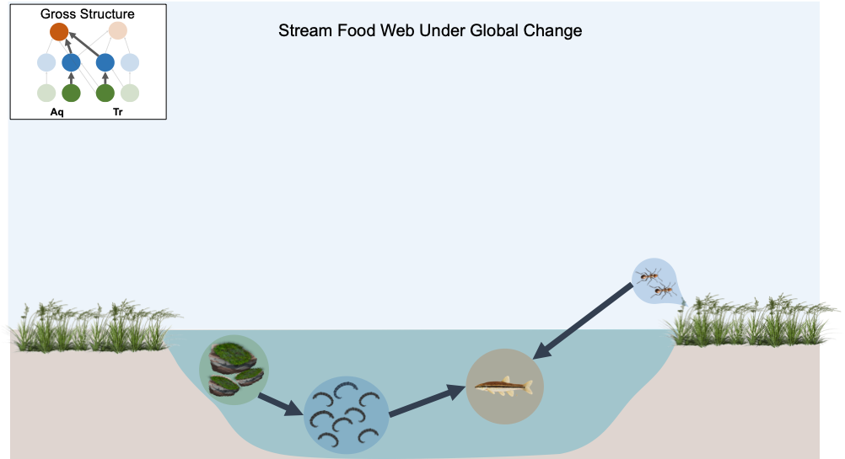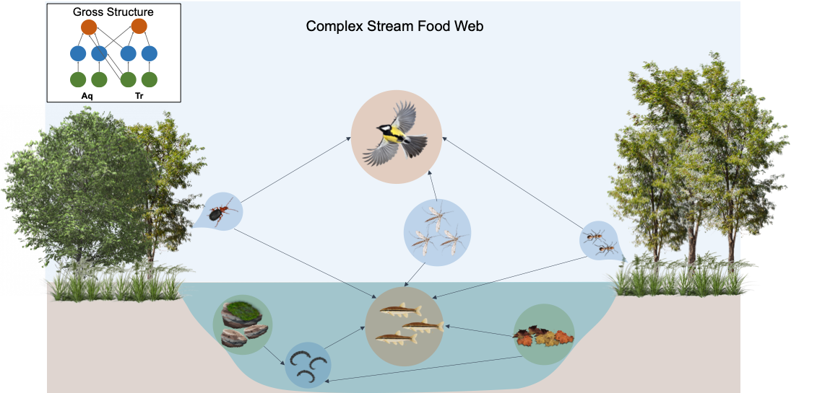

**Figure 1.** Rewiring of energy pathways among interacting species in response to various drivers of global change. Note that TPmax is changing in terrestrial chain (Tr) while coupling is changing in aquatic chain (Aq). Overall increase in average interaction strength from panel (A) to panel (B).

(B)

(A)

**Figure 2.** Mechanisms driving food web structural shifts across vertical axis (A, B; TPmax) and horizontal axis (C, D; coupling)



**Figure 3.**

**Figure 4.**