Title: Habitat coupling by small fish across lake-creek habitats: a missing link in freshwater food webs?
Authors: Charlotte A. Ward^{1,2}*, Reilly F. O’Connor¹, Timothy J. Fernandes^{1,2}, Kevin S. McCann^{1,2}, Mark S. Ridgway³, Bailey C. McMeans⁴, Tyler D. Tunney^{5,1}
Affiliations:
- University of Guelph; Guelph, Canada
- Centre for Ecosystem Management; Guelph, Canada
- Ontario Ministry of Natural Resources; Peterborough, Canada
- University of Toronto Mississauga; Mississauga, Canada
- Fisheries and Oceans Canada; Moncton, Canada
*Corresponding author: Charlotte A. Ward; Address: 50 Stone Road East, Guelph, ON Canada, N1G 2W1; Orchid ID: 0000-0001-7982-1239; Email: cward@uoguelph.ca
Article Type: Research article
Main Text Word Count: 5022
Abstract Word Count: 175
Number of Figures: 6
Number of Tables: 0
Data availability statement:
All data and code necessary to reproduce the analyses presented in this manuscript are currently available for review via a public GitHub Repository linked here. This repository includes data and code for stable isotope analysis, acoustic telemetry-derived movement summaries, and seasonal biomass flux estimates. Repository details and a permanent DOI will be provided in the final published version of the article.
Keywords: habitat coupling; food web, freshwater ecosystem, fish, acoustic telemetry, stable isotope, resilience, seasonal

Abstract
Habitat coupling is central to food web dynamics, yet it is often inferred from the movements and resource use of large predators. This focus overlooks the possibility that small-bodied consumers, often treated primarily as habitat-resident prey, may also integrate resources and move biomass across habitat boundaries. Using stable isotopes, acoustic telemetry, and seasonal biomass flux estimates, we show that small-bodied fishes substantially couple across a lake–creek habitat network. These fishes relied nearly equally on lake- and creek-derived carbon, moved frequently between habitats, and were more likely to use both habitats within a single day during spring and fall than in summer. Biomass flux within the network was also strongly seasonal, with upstream movement peaking in spring, little movement occurring in summer, and downstream movement increasing in fall. Together, these findings show that small-bodied fishes can establish dynamic, seasonally variable links between freshwater habitats. We argue for the need to consider and include small-bodied, lower-trophic level species and their habitat coupling into food web theory and the management of species and habitat connectivity more explicitly.

Introduction
The movement of consumers among distinct habitats and ecosystems establishes critical energy linkages within food webs. Large-scale migrations of birds, fish, and mammals transport carbon and nutrients across vast distances, shaping productivity and nutrient dynamics globally (Bauer and Hoye 2014, Roman et al. 2025). At smaller spatial scales, consumers integrate resources across nearshore and offshore macrohabitats within lakes, as well as across lakes and adjacent terrestrial habitats through the use of resource subsidies (Tunney et al. 2014, Stiling et al. 2023, Wegher et al. 2025, Keva et al. 2025). The process through which consumers integrate resources from spatially explicit energy pathways within food webs is often referred to as habitat coupling (Schindler and Scheuerell 2002).
Habitat coupling may help support consumer populations under environmental variability by enabling opportunistic foraging in habitats or ecosystems with seasonally or stochastically elevated productivity. For example, a predator may shift feeding from a habitat with low resource availability in a particular season to one of higher availability, thereby maintaining consumption rates (Carroll et al. 2021, 2026, Hale et al. 2026). In turn, these behavioural adjustments of mobile consumers are expected to stabilize predator–prey interactions and enhance the resilience of whole food webs by maintaining multiple energetic pathways that respond dynamically to changing conditions (McCann et al. 2005, McMeans et al. 2016). Alarmingly though, human activities are increasingly eroding the spatially explicit energy pathways within food webs that support habitat coupling by consumers (Ward et al. 2025).
Research in freshwater lakes has documented widespread habitat coupling by mobile, large-bodied fishes, including lake trout (Salvelinus namaycush), smallmouth bass (Micropterus dolomieu), and walleye (Sander vitreus) (Dolson et al. 2009, Tunney et al. 2018, Maitland et al. 2024). Yet the potential for small-bodied fishes to couple energy pathways within freshwater food webs has received far less attention. This gap may reflect the tendency to view small-bodied fishes primarily as habitat-resident prey, rather than as mobile consumers capable of integrating resources across habitat boundaries (Minns 1995). However, their small body size and distinct trophic roles may allow them to use freshwater landscapes in ways that differ fundamentally from large predators. For instance, small-bodied fishes may be better able to access the narrow, shallow, and structurally complex habitats that characterize many lake-adjacent creeks and streams. These habitats may provide seasonally important resources for growth, reproduction, or refuge from predators (Brönmark et al. 2008), suggesting that lake–creek coupling by small-bodied fishes may be shaped by changing resource availability, life-history demands, and predation risk over the annual cycle. As a result, understanding their role in habitat coupling requires approaches that capture both population-level patterns and individual-level variation in movement behaviour and resource use.
Traditionally, assessing habitat coupling in small-bodied species has been challenging, but over the past few decades, multiple bio-tracers have been developed that significantly enhance our ability to study the habitat use of fish and the structure of aquatic food webs. For instance, stable isotopes of carbon (¹³C/¹²C) and nitrogen (¹⁵N/¹⁴N) provide insight into the relative contribution of resources from distinct habitats and trophic levels to consumer tissue assimilation, allowing researchers to infer foraging patterns over multiple temporal scales based on the known turnover rates of different tissues (Fry 2008). Acoustic telemetry, on the other hand, enables the fine-scale tracking of movement in real-time, revealing how individuals move between and use distinct habitats across different timescales (Szekeres et al. 2023, Blanchfield et al. 2023, Rodrigues et al. 2025). Approaches such as netting surveys complement these tracers by providing snapshots of species richness, abundance, and biomass distributions across different habitats and, when repeated, how these metrics change over time (Portt et al. 2006). Together, these tools offer a powerful integrated approach for assessing habitat coupling in freshwater ecosystems.
In this study, we assess habitat coupling by two small-bodied consumer fishes, golden shiner (Notemigonus crysoleucas) and common shiner (Luxilus cornutus), in a connected lake–creek ecosystem. Using stable isotope analysis, acoustic telemetry, and seasonal netting surveys, we quantify coupling across trophic, behavioural, and biomass-flux dimensions by evaluating carbon assimilation from lake- versus creek-derived resources, individual movement and habitat residency, and seasonal biomass flux across the lake-creek network. Based on field observations that shiners use adjacent creek habitats seasonally, we hypothesized that lake–creek coupling would vary through time, increasing when creeks provide greater resource availability, reproductive habitat, or refuge from predators. We also examine body size in shiners and a dominant nearshore predator, smallmouth bass (Micropterus dolomieu), to explore how habitat accessibility and predation risk may shape individual variation in lake-creek habitat use. Together, this approach tests whether small-bodied fishes contribute to spatial food web linkages in freshwater ecosystems in ways often overlooked when habitat coupling is assessed primarily through large-bodied predators.

Methods

Study System
Data were collected in the southernmost bay of Lake Opeongo, Sproule Bay, and its adjacent Costello Creek, located within Algonquin Provincial Park, Ontario, Canada (Figure 2; study area: 45.6°N–45.65°N, 78.30°W–78.50°W). Lake Opeongo is a large, oligotrophic, dimictic lake with a surface area of 5,860 ha and a mean depth of 14.8 m (Ridgway et al. 2017, Challice et al. 2019), while Sproule Bay covers approximately 161 ha, does not exceed 10 m in depth, and is typically ice-covered from late November through April (Consiglio, et al. 2024). Costello Creek is a tributary of the Upper Madawaska tertiary watershed and the Opeongo River quaternary watershed and flows into Sproule Bay. The creek is characterized by shallow depths (<2 m) and moderate flow velocities (0.1–0.4 m s⁻¹). Previous research has identified two distinct habitat types in Costello Creek, a downstream portion dominated by a spruce bog with turbid, slow-moving water, and an upstream portion characterized by clear, fast-flowing water (Benoit et al., 2018). In all of our analyses, we delineated lake and creek habitats by the transition from the open bay of the lake into the narrower spruce bog, and we considered fish captured or detected within an approximately 150 m stretch between these delineated habitats as occupying a transition habitat.
Lake Opeongo and Costello Creek support a diverse fish community (Supplementary Materials S1). In this study, we focus on two small-bodied prey fish species, the golden shiner (Notemigonus crysoleucas) and common shiner (Luxilus cornutus), which are both members of the Leuciscidae family that were captured in high abundances across lake and creek habitats throughout the three-year study period. Preliminary analyses indicated that the two species showed consistent responses across habitats and seasons (Figure S5; Table S1). In addition, both species occupy similar functional roles in freshwater food webs (Scott and Crossman 1973, Stone et al. 2016). We therefore pooled the two species for analysis and refer to them collectively as “shiners”, which allowed us to evaluate lake-creek habitat coupling with greater statistical power across sampling locations and seasons.
All sampling and surgical implantation procedures for acoustic telemetry described in the following subsections were authorized by a license to collect fish for scientific purposes from the Ontario Ministry of Natural Resources (#1103418), authorization to conduct research in an Ontario provincial park, and an animal use protocol approved by the DFO Maritimes & Gulf / HMSC Regional Animal Care Committee (#23-11, #24-22) under Canadian Council on Animal Care guidelines.

Foraging Behaviour
We employed stable isotope analysis of δ¹³C or δ¹⁵N to examine the foraging behaviour of shiners across the spring, summer, and fall of 2022–2024. We used liver tissues, as liver has a relatively fast turnover rate (approximately two weeks) and thus more accurately reflects diets during the season of sampling compared to slower-turnover tissues like muscle (Busst and Britton 2018). Spring sampling was conducted approximately two weeks after ice-off each year (late April to early May), summer sampling during the first and second weeks of August and fall sampling during the first and second weeks of October. We aimed to collect a minimum of 10 individual fish of each species from each habitat per season. Across all years and seasons, we obtained liver samples from 134 golden shiners and 117 common shiners. In addition to fish tissue samples, tissue samples were collected from unionid mussels (Elliptio sp.) and mayflies (Ephemeroptera sp.) (Table S1).
Samples were frozen immediately after field capture and stored at –20°C until dissection and preparation for stable isotope analysis. Thawed fish tissue and baseline samples were placed in a drying oven at 60°C for 48–72 hours and then ground into a powder. Most samples were sent to the Jan Veizer Stable Isotope Laboratory at the University of Ottawa for quantification of δ¹³C and δ¹⁵N. Additional baseline (mayfly and mussel) samples collected from the same study area as part of a collaborative project were analyzed separately at the Fisk Lab at the University of Windsor and incorporated into our dataset. Stable isotope values are expressed in δ notation (units ‰), where δ¹³C or δ¹⁵N = ((Rsample/Rstandard) – 1) x 1000, where R represents the ratio of ¹³C/¹²C or ¹⁵N/¹⁴N. We applied lipid corrections to consumer and baseline tissues following Kiljunen et al. (2006) because C:N ratios exceeded the recommended threshold of 3.5 across our dataset (Post et al. 2007). Given ongoing debate over the application of lipid normalization in ecological stable isotope studies (Arostegui et al. 2019), we repeated our analyses (see below) using non–lipid-corrected values and found consistent patterns of foraging behaviour to those presented in the proceeding sections (Figure S3).
To evaluate the foraging behaviour of shiners captured across lake and creek habitats seasonally, we estimated the proportion of lake-derived carbon in liver tissues using a two-source stable isotope mixing model (Post 2002). For each individual, alpha (α; the proportion of assimilated carbon derived from lake resources) was calculated from liver tissue δ¹³C values using the creek and lake mayfly δ¹³C baselines as endpoints:
$Proportion lake derived carbon (α)=\frac{δ^{13}C_{consumer}-δ^{13}C_{creek }}{δ^{13}C_{lake}-δ^{13}C_{creek}}$ (1),
with estimates constrained between zero and one, with zero representing no carbon derived from lake resources and one representing carbon fully derived from lake resources.
Trophic position was then estimated for each individual using the α value derived from Equation 1, in which the baseline δ¹⁵N was calculated as a weighted average of the creek and lake mayfly δ¹⁵N values proportional to each individual’s estimated lake-derived carbon contribution following equation 2:
$Trophic Position =2+\left[α\frac{δ^{15}N_{consumer}-δ^{15}C_{creek}}{3.4}+ \left(1-α\right)\frac{δ^{15}N_{consumer}-δ^{15}C_{lake}}{3.4}\right]$ (2).
A trophic fractionation factor of 3.4‰ per trophic level was assumed throughout (Post 2002). Note that we use only mayflies as baselines in our analyses of shiner foraging, as mussels in the creek were heavily enriched in δ¹⁵N, and thus may have biased our trophic position results. This enrichment may reflect the tendency of filter-feeding mussels to assimilate microbially processed suspended matter with elevated δ¹⁵N (Raikow and Hamilton 2001).

Habitat Use and Movement
Acoustic telemetry was used to track the habitat use and movement of shiners between the lake and creek. Tagging efforts focused exclusively on golden shiners (Notemigonus crysoleucas). A total of 55 individuals were surgically implanted with acoustic transmitters (V6-180 kHz; Innovasea, Halifax, Nova Scotia). Transmitters measured 15 mm in length, 6 mm in diameter, weighed 0.5 g in water, and emitted at ~146 dB. Each transmitter carried a unique identifier and was programmed with one of three nominal ping interval ranges. 10 fish received tags with slower intervals of 130–230 s, 5 fish received faster tags with intervals of 33–57 s, and the majority (40 fish) received tags with intermediate intervals of 80–160 s. Tagged shiners averaged 154 ± 10 mm in total length and 35 ± 8 g in weight, with transmitters representing ≤ 2% of body mass in water. Given a tag battery life of approximately two months for the majority of tags, fish were tagged in successive cohorts across multiple seasons to ensure temporal coverage throughout the study period. Tags were implanted in spring, summer, and fall of 2023 to 2025, and fish were monitored from October 2023 through September 2025 (see Figure S6 for abacus plot of tagged shiner detections through time).
Fish were captured with trap nets and held in aerated lake water for approximately 15 minutes prior to surgery. Anesthesia was induced in buffered MS-222 (100 mg L⁻¹) until loss of equilibrium and no response to caudal pinch. During surgery, fish were placed in a cradle lined with neoprene and irrigated over the gills with maintenance anesthetic (45 mg L⁻¹). A 6–8 mm ventral midline incision anterior to the pelvic girdle was made, and transmitters were inserted into the intracoelomic cavity. Incisions were closed with 1–2 surgical sutures using 5-0 absorbable monofilament. Instruments were disinfected with 10% povidone-iodine prior to each surgery. Surgeries lasted ~3-6 min, and fish typically recovered (normal posture and swimming were observed) in aerated tanks within 10–12 minutes. After recovery, fish were released at their site of capture. The receiver array in which fish were released into consisted of 30 omnidirectional Innovasea receivers (VR2W, 69 kHz) deployed to cover the interface of Sproule Bay and Costello Creek (Figure 2; see Supplementary Materials S1 for details regarding detection range across the study system).
Raw detections were filtered to remove false codes and duplicates (<60 s apart for the same fish) and analyses were restricted to fish detected post-release (n = 46). Two tagged individuals that remained within detection range of a single receiver for the duration of their detection history were excluded from the final dataset, as this pattern is consistent with post-release mortality (Klinard and Matley 2020; transmitter id #34905 and #32999 shown in abacus plot in Figure S6). The number of tagged fish included in our final telemetry dataset was therefore n = 44.
To characterize habitat use, we calculated two telemetry-based metrics for each individual within each season, habitat residency and habitat recurrence. Habitat recurrence was quantified as the number of discrete return events to an individual’s initial detected habitat, defined as cases in which a fish was first detected in one habitat, subsequently exited that habitat, and was later detected there again. Habitat residency was defined as the proportion of minutes within a season during which an individual was inferred to be in the habitat in which they were captured and released, calculated as the number of minutes assigned to the lake divided by the total number of minutes in that season. Seasons were defined as spring (March 21 to June 20), summer (June 21 to September 20), fall (September 21 to December 20), and winter (December 21 to March 20). Note that winter data were excluded from analyses of habitat recurrence and residency to maintain consistency with the stable isotope dataset, which did not include winter sampling.
In addition to these seasonal summaries, we calculated a daily habitat-use metric from the telemetry dataset. For each tagged fish in our final dataset (n = 44) on each day of the year, we determined whether it was detected in both lake and creek habitats, providing a probability-based measure of daily lake–creek habitat coupling. This metric allowed us to evaluate whether the likelihood of same-day use of both habitats varied continuously through the year, rather than only among discrete seasons.

Biomass Flux
Biomass flux was assessed using directionally positioned trap nets that were set across the width of Costello Creek at two locations. One set of trap nets was set at the mouth of the creek and the other approximately two kilometers upstream at the junction of a culvert (see Figure S1 for map showing trap locations and Supplementary Materials for trap dimensions). Fish were inferred to be moving upstream if they were captured in the upstream-facing compartment of the trap nets, while those captured in the downstream-facing compartment were inferred to be moving downstream. Traps were set for five consecutive days (trap net set for 24 hours before sampling) during the spring, summer, and fall of 2023, and for three consecutive days in 2024. Standardized surveys were also conducted using minnow traps (see Supplementary Materials S1 for dimensions). We deployed minnow traps at 10 sites in the creek and 10 sites in the lake, with deployment locations selected to provide broad spatial coverage across Sproule Bay and throughout Costello Creek (Figure S1).
Body Size Distributions
To characterize body size distributions of shiners and smallmouth bass across lake and creek habitats, we compiled total length (TL, mm) data from all individuals captured throughout the study period using all available sampling methods. We then compared the total length of fish captured in the creek and lake using the statistical analyses described below and in the Supplementary Materials S1.

Statistical Analysis
To evaluate seasonal and habitat differences in isotopes, telemetry, biomass, and body size, we used generalized linear models (GLMs) and generalized additive models (GAMMs). Comparisons of candidate models were based on Akaike Information Criterion (AIC) with the model yielding the lowest AIC considered the most parsimonious. See Supplementary Materials S1 for details on specific models and underlying decisions for defining statistical model structure.

Results

Baseline Stable Isotope Ratios
Baseline organisms differed strongly in isotopic composition between habitats (Figure 2) and, in some cases, also showed seasonal variation. Mayflies from the creek had substantially more depleted δ¹³C values than mayflies from the lake but did not differ across seasons (Table S2). Mayfly δ¹⁵N values varied significantly with both season and habitat, with creek mayflies consistently enriched relative to lake mayflies in all seasons (Table S1-S2). Mussel δ¹³C and δ¹⁵N differed significantly among lake and creek habitats and across seasons, with creek mussels consistently more depleted in δ¹³C and enriched in δ¹⁵N than lake mussels across seasons (Table S1-S2).

Foraging Behaviour
The proportion of lake-derived carbon in shiner liver tissues varied significantly across seasons and capture locations (Figure 3A), though it is important to note that summer estimates for lake-captured fish should be interpreted cautiously because that group included only two individuals. The generalized linear model detected significant effects of season, capture location, and their interaction (Table S3). Pairwise comparisons revealed that shiners captured in the creek during summer relied significantly less on lake-derived carbon than in both spring and fall, while spring and fall did not differ. In contrast, lake-captured shiners showed higher reliance on lake-derived carbon in summer and fall than in spring, with no difference between summer and fall. Comparisons between fish captured in the lake and creek within the same season showed that lake-captured shiners had higher lake-derived carbon than creek-captured shiners in spring, summer, and fall.
Trophic position also varied strongly across seasons and capture locations (Figure 3B). The generalized linear model indicated significant effects of season, capture location, and their interaction (Table S3). Creek-captured shiners maintained relatively consistent trophic positions across seasons, as no seasonal pairwise comparisons were significant. However, lake-captured shiners had lower trophic positions in summer and fall than in spring. Pairwise comparisons also showed that trophic position did not differ between creek- and lake-captured shiners in spring, but creek-captured shiners occupied significantly higher trophic positions than lake-captured individuals in summer and fall.

Habitat Use and Movement
Habitat recurrence showed strong seasonal variation and differed by the habitat in which tagged fish were captured and released (Figure 3C). The generalized linear model revealed significant effects of season and release location, and a season × release location interaction (Table S3). For creek-released fish, recurrence to the creek was higher in spring and fall than in summer, whereas spring and fall did not differ from one another statistically (Figure 3C). A similar pattern was observed for lake-released fish, where recurrence to the lake was higher in spring than in summer, while spring–fall and summer–fall comparisons were not significant. Across seasons, fish released in the creek exhibited greater recurrence to their release habitat than fish released in the lake (Figure 3C).
Habitat residency did not vary seasonally, but it differed by release location (Figure 3D). The generalized linear model detected no effect of season and no season × release location interaction but did detect a significant effect of release location (Table S3). Across seasons, lake-released fish showed higher habitat residency than creek-released fish.

The probability of a same-day detection in both lake and creek habitats varied strongly over the annual cycle (Figure 4). The selected GAMM, which included a cyclic smooth for day of year and a term to account for temporal autocorrelation, revealed a significant non-linear effect of day of year on same-day lake–creek detection probability (edf = 6.80, F = 7.06, p < 0.001; Table S4). The model explained 9.0% of the variation in detection probability. Estimated probabilities peaked in spring on Julian day 109 at 0.400 (95% CI: 0.279–0.535), showed a secondary peak in fall on Julian day 301 at 0.261 (95% CI: 0.170–0.379), and reached a pronounced minimum in summer on Julian day 223 at 0.015 (95% CI: 0.005–0.045). Overall, telemetry results indicate that habitat coupling was strongest in spring, lowest in summer, and increased again in fall.

Biomass Flux
The average daily biomass of shiners captured in directionally positioned traps within the creek showed strong seasonal variation in both the magnitude and direction in which fish were inferred to be moving (Figure 5A). The generalized linear model identified a significant effect of season and a significant season × direction interaction, whereas direction alone was not significant (Table S3). Estimated biomass captured in directionally positioned traps was greatest during spring and fall, with seasonal reversals in the predominant direction of movement (spring predominantly upstream; fall predominantly downstream), while summer values were comparatively low in both directions (Figure 5A; Tables S4).
Shiner biomass in minnow traps likewise varied across seasons and capture locations (Figure 5B). The generalized linear model detected significant effects of season, capture location, and their interaction (Table S3). Biomass was generally greater in creek traps than lake traps, particularly in spring, and no shiners were captured in lake traps during summer (Figure 5B shows estimated means and CIs based on GLM output; Tables S4).

Body size distributions
Body size differed between habitats for both shiners and smallmouth bass (Figure 6). For shiners, total length varied significantly with capture location, and this effect depended on season, as indicated by a significant season × location interaction, while the overall main effect of season was not significant (Table S3). For smallmouth bass, total length differed strongly between habitats, with lake-captured individuals substantially larger than creek-captured individuals (Table S3; Figure 6B). Seasonal variation in bass total length was not statistically significant (Table S3).

Discussion
Through multiple lines of evidence, we show that small-bodied fish couple lake and creek habitats through both their resource use and movement behaviour, and that the strength of this coupling varies seasonally. Stable isotope analysis revealed that shiners relied more evenly on lake- and creek-derived resources in spring and fall, but more strongly on resources from the habitat in which they were captured during summer (Figure 3A). Acoustic telemetry showed a similar seasonal pattern in movement behaviour, as the probability of detecting a shiner in both habitats on the same day was highest in spring and fall (Figure 4), and movement between habitats was also greatest during these periods (Figure 3C). Netting surveys further supported this pattern, with shiner biomass flux predominantly in the upstream direction in spring, biomass flux predominantly downstream in fall, and little biomass flux in either direction occurring during summer (Figure 5A). Together, these findings indicate that seasonal habitat coupling in this system emerges through linked changes in habitat-specific resource integration, individual movements between habitats, and biomass flux across the broader freshwater landscape.
Although we did not explicitly examine drivers of cross-habitat movement and foraging in this study, considering our data within the context of previous research suggests that multiple factors are likely at play. First, the use of streams and creeks for spawning is common among many freshwater species (Biette et al. 1981, Childress and McIntyre 2015, White et al. 2023). This may be an important contributor to lake–creek coupling among golden and common shiners in our study system, as we observed very high biomass moving upstream during spring (Figure 5A), which coincides with spawning for both species (Scott and Crossman 1973, Stone et al. 2016). However, this period also showed a greater number of cross-habitat recurrence events in our telemetry data, suggesting fish were not simply moving upstream to spawn and remain in the creek, but were repeatedly moving between habitats during this time of year (Figure 3C).
While spawning migrations likely explain part of the lake-creek movements we observed, freshwater fishes also move between lakes and creeks for other reasons, including to exploit foraging opportunities, to avoid predators, and to seek thermal or oxygen refugia (Magnuson et al. 1985, He and Kitchell 1990, Dolinsek et al. 2014, Hahlbeck et al. 2022). For example, research on lake–stream migrations among prey fish in European freshwater systems shows that movements into streams from adjacent lakes are often driven by trade-offs between growth opportunities and predation risk (Brönmark et al. 2008). In our study system, smallmouth bass (Micropterus dolomieu) are widespread, introduced predators that occupy both Lake Opeongo and Costello Creek. However, their size distributions differ markedly between habitats (Figure 6B), with individuals in the lake observed to be substantially larger (mean total length = 256 ± 123 mm) than those in the creek (mean total length = 112 ± 35 mm; Figure 6B). Given established relationships between body size and piscivory (Mittelbach and Persson 1998), smallmouth bass in the lake are expected to exert strong top-down pressure on prey fish such as shiners (Vander Zanden et al. 1999), whereas the smaller individuals in the creek are less likely to be piscivorous due to gape limitation (Mittelbach and Persson 1998).
This context of predation risk may help explain the observed spatiotemporal differences in shiner body size. Shiners captured in the lake were largest in summer, whereas those captured in the creek tended to be smaller in summer and fall than in spring (Figure 6A). Standardized minnow trap surveys also failed to capture shiners in the lake during summer, when smallmouth bass activity is highest in this system (Bloomfield et al. 2022). However, four shiners from the largest size class observed (139, 143, 150 and 172 mm total length, TL) were caught in the lake using alternative gear, and all exceeded the maximum prey size predicted for the largest bass captured in Sproule Bay during our study (505 mm; Gaeta et al. 2018). Together, these results suggest that smaller shiners may be more restricted to creek habitats during summer to reduce predation risk, whereas larger individuals that exceed predator gape limitations may be better able to persist and exploit resources in the lake.
These size-structured habitat differences may also help explain the observed isotopic patterns (Figure 3A, B). Although lake-captured shiners were generally larger than creek-captured individuals, they occupied lower trophic positions in summer while also relying more heavily on lake-derived carbon, whereas creek-captured fish exhibited higher trophic positions when their reliance on creek-derived resources was greatest in summer (Figure 3A, B). Shiners using the lake in summer may therefore have been feeding lower in the lake food web, while fish remaining in the creek may have relied more on higher-trophic-level prey. Under this interpretation, the lake may function as a productive but risky habitat in which larger shiners feed on more abundant lower-trophic resources, thereby lowering their trophic positions in summer, a pattern consistent with dynamic omnivory (Gutgesell et al. 2022). Although this interpretation remains speculative owing to degradation of labile prey items in stomach contents, it is consistent with theory predicting that consumers in spatially structured food webs adjust both habitat use and diet to balance foraging opportunities against predation risk (Brönmark et al. 2008, Valdovinos et al. 2010, Ahrens et al. 2012, Toscano et al. 2016).
The seasonal nature of lake–creek coupling observed here has important implications for the resilience of freshwater food webs. Movements between lakes and adjacent creeks and streams have often been considered primarily in the context of annual or seasonal migrations (Lucas et al. 2001), but our results show that lake–creek coupling can also occur at finer temporal scales, with small fishes moving between habitats repeatedly within seasons. At the same time, these shorter-term movements were not constant across the year, but followed a clear seasonal pattern, with greater coupling in spring and fall and reduced coupling in summer (Figure 3; Figure 4). This suggests that habitat coupling in lake–creek networks is both dynamic and seasonally structured. By rapidly shifting their habitat use in response to changing conditions, such as predation risk or resource availability, small fishes may access complementary resource pools when one habitat becomes less favourable. This behavioural flexibility can mediate predator–prey encounter rates and distribute foraging pressure across time and space (McCann et al. 2005, Ahrens et al. 2012). In doing so, it may help dampen strong, potentially destabilizing trophic interactions, or increase the strength of weak interactions when resources in one habitat become scarce, thus supporting stable prey fish populations through alternative energy pathways across freshwater landscapes (McMeans et al. 2016, Ward et al. 2023).
Our multi-method field approach revealed that abundant, small-bodied fishes, which are often regarded as forage to fishery species, can serve as key agents linking lakes and adjacent creeks. The seasonal nature of these spatial food web linkages aligns with theory predicting that mobile consumers stabilize food webs by integrating distinct resource pools across space and time, allowing consumer and resource populations to persist under variable conditions (McCann et al. 2005, McCann and Rooney 2009). Thus, protecting and restoring connectivity and refuge habitats for small fish by maintaining passable human-made structures (e.g., culverts), and enhancing riparian cover could sustain linkages among spatially distinct energy pathways and promote the resilience of freshwater ecosystems. The convergent evidence from stable isotopes, telemetry data, and seasonal netting surveys we present here shows that prey-mediated coupling is an important feature of this system. Although larger predators are often emphasized as primary habitat couplers within aquatic food webs (Rooney et al. 2008, Maitland et al. 2024, Wegher et al. 2025), our results indicate that small prey fish species can also serve this role, linking habitats that perhaps remain inaccessible to larger-bodied predators. Incorporating such small-bodied consumers more directly into freshwater food web ecology is therefore a critical task for future research.

Figures

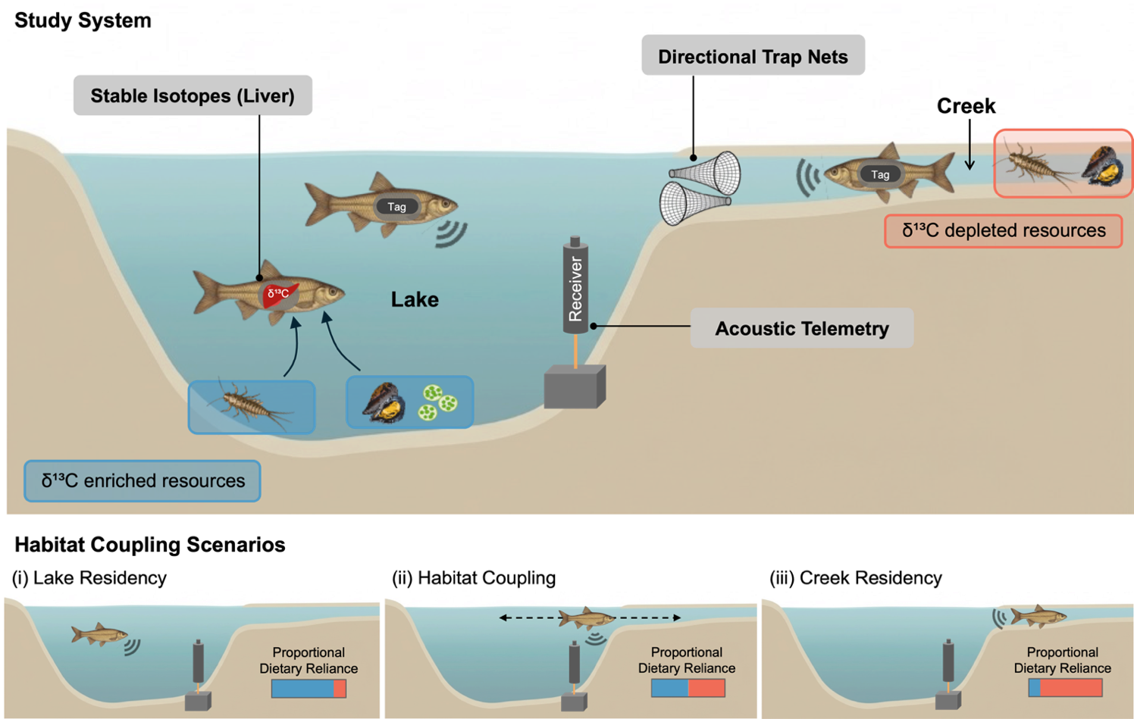
Figure 1. Conceptual diagram illustrating how stable isotope analysis, acoustic telemetry, and netting surveys are used to assess seasonal lake–creek habitat coupling by small-bodied consumer fish species (golden shiner and common shiner). Differences in δ¹³C between lake (enriched; blue) and creek (depleted; pink) resources (e.g., mayflies, mussels) allow stable isotope ratios in fish tissues (liver) to indicate cross-habitat foraging behaviour. Acoustic receivers continuously track the movement and residence of tagged fish across lake and creek habitats. Directional trap nets estimate seasonal biomass of fish moving upstream and downstream in the creek. The lower panels depicts three scenarios of fish foraging and habitat use: (i) lake residency, where fish rely primarily on lake-derived resources and are detected mostly in the lake; (ii) habitat coupling, where fish rely on both lake- and creek-derived resources and show intermediate lake residency, with detections indicating movement between habitats; and (iii) creek residency, where fish rely primarily on creek-derived resources and are detected mostly in the creek. Seasonal variation in habitat coupling is expected as fish adjust movement and foraging in response to changing biotic and abiotic conditions.

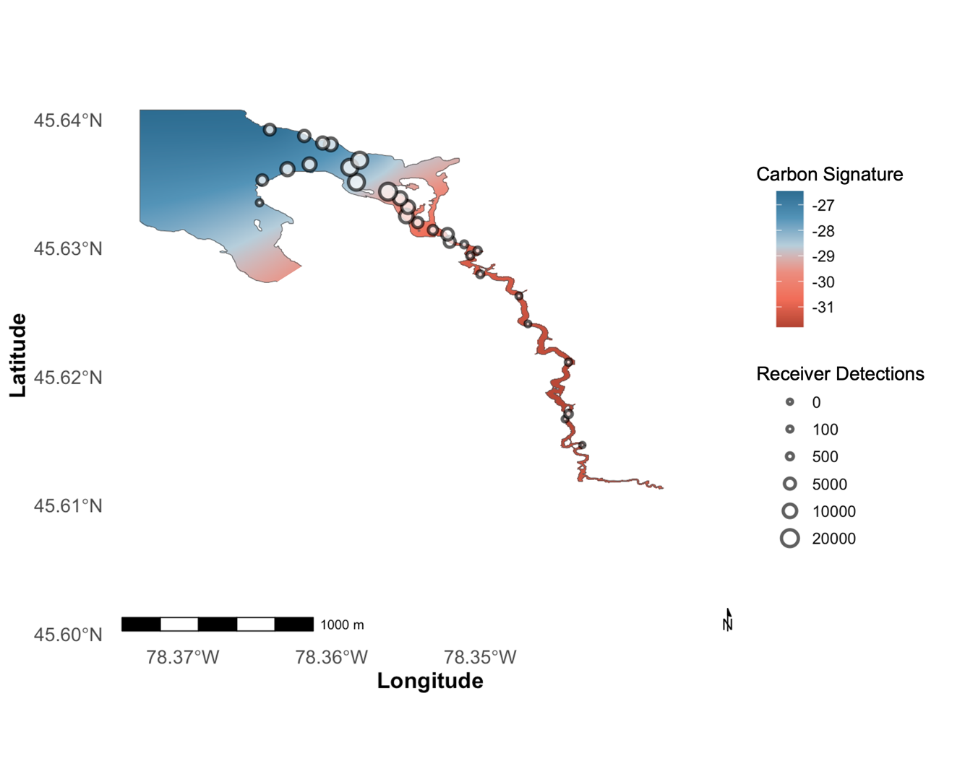
Figure 2. Site map and IsoScape of Sproule Bay (Lake Opeongo) and the adjacent Costello Creek. Baseline organism (Ephemeroptera sp. and Eliptio sp.) average carbon signatures (δ¹³C) across the study system are represented by the coloured gradient, while receiver locations and total detections at each receiver are shown as circles and their relative sizes, respectively. Areas shaded in blue indicate δ¹³C -enriched regions in the lake, while pink-shaded areas represent δ¹³C-depleted regions in the creek.

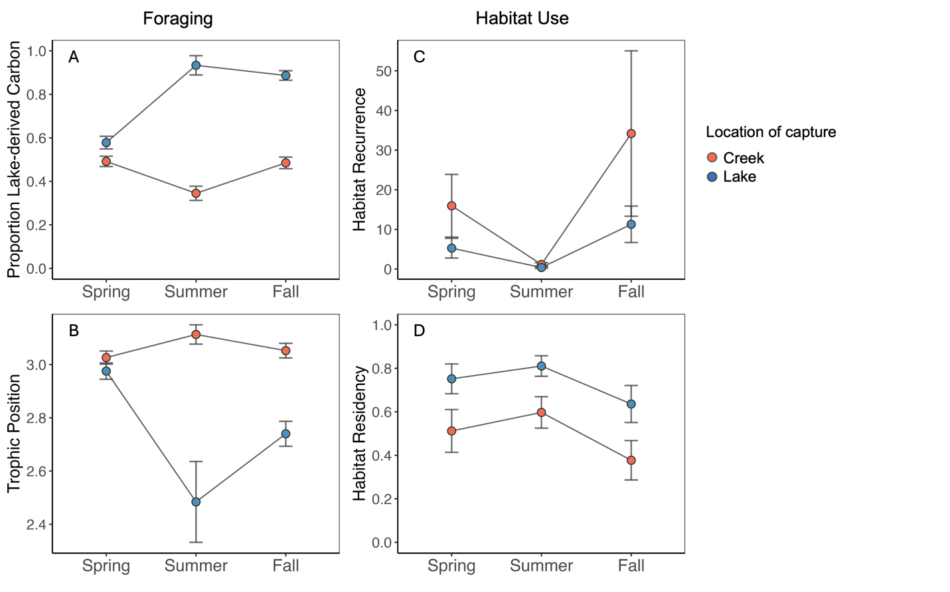
Figure 3. Seasonal patterns in lake-creek coupling observed through the foraging (left panels) and habitat use (right panels) behaviour of shiners captured in Costello Creek and Lake Opeongo (Sproule Bay). (A) Estimated marginal mean (± 95% CI) proportion of lake-derived carbon and (B) estimated marginal mean (± 95% CI) trophic position of shiners captured in creek (pink) and lake (blue) habitats across spring, summer, and fall. (C) Estimated marginal mean (± 95% CI) number of habitat recurrence events per fish per season and (D) estimated marginal mean (± 95% CI) habitat residency of tagged golden shiners captured and released in creek (pink) or lake (blue) habitats. Habitat recurrence was calculated as the number of times an individual exited and later re-entered the habitat in which it was released within that season, and habitat residency was calculated as the proportion of time an individual spent in its release habitat within a season (unitless proportion).

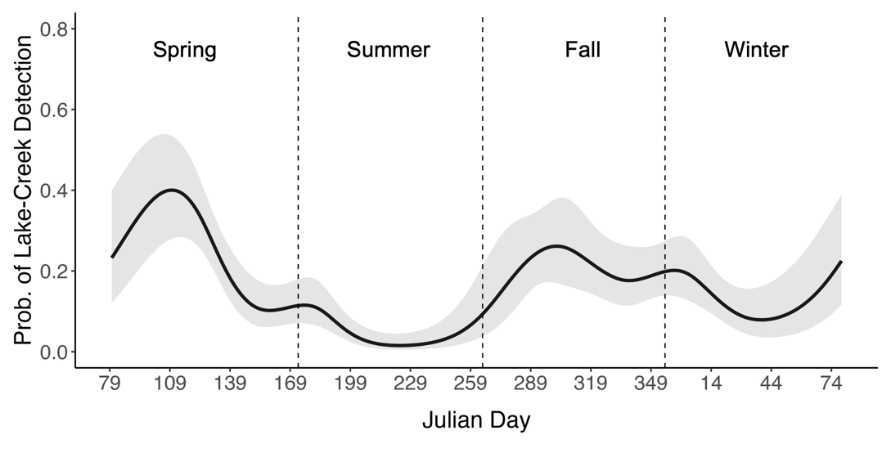
Figure 4. Predicted probability of detecting a tagged shiner in both the lake and the creek on the same day throughout the year (black line) with 95% confidence intervals (shaded area), estimated using a generalized additive mixed model (GAMM) with a logit link function. Vertical dashed lines indicate approximate seasonal boundaries (spring, summer, fall, winter).
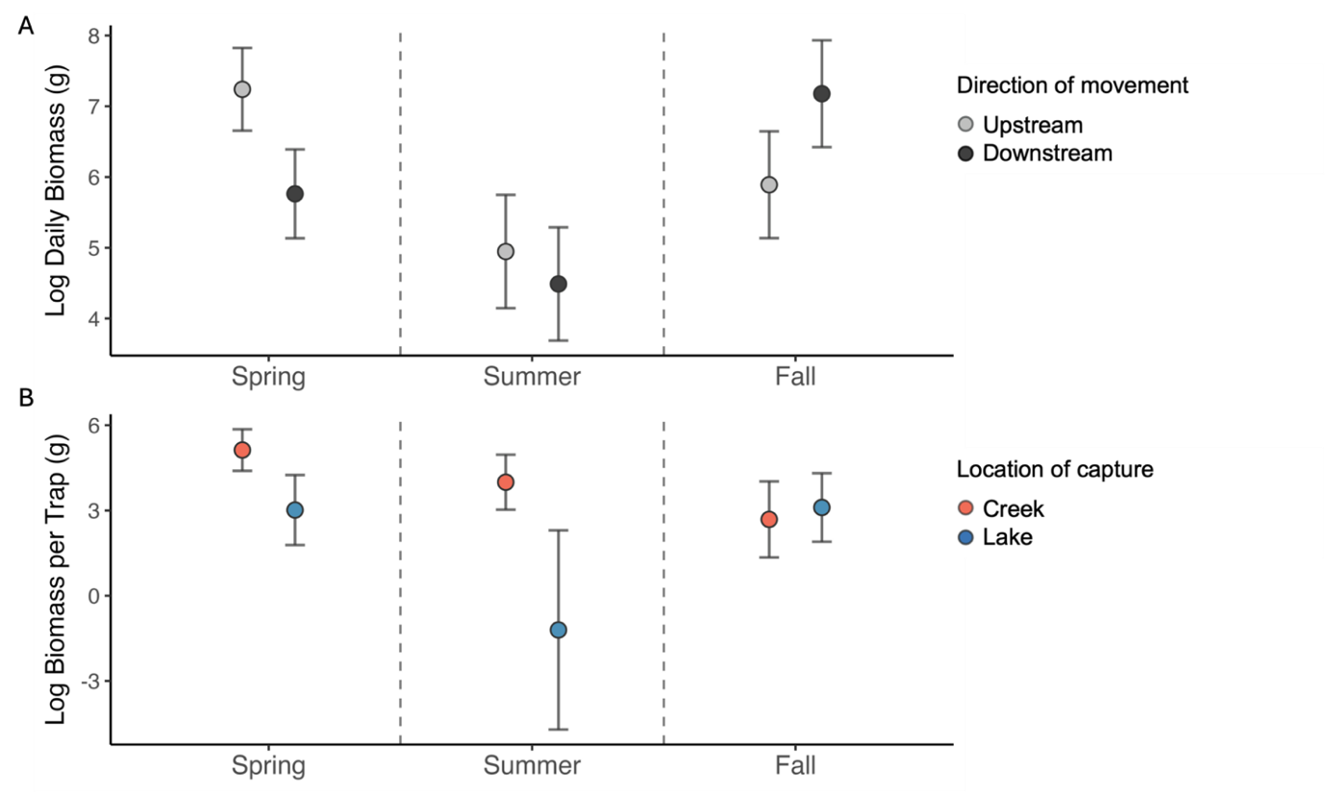
Figure 5. Seasonal patterns in biomass of shiners captured in (A) directionally positioned and (B) minnow traps. (A) Estimated marginal mean (± 95% CI) log daily biomass flux of shiners moving upstream (light grey) and downstream (dark grey) across each sampling season. (B) Estimated marginal mean (± 95% CI) log biomass per trap for shiners captured in minnow traps deployed in the creek (pink) and lake (blue) across each sampling season. Vertical dashed lines indicate approximate seasonal boundaries (spring, summer, fall).

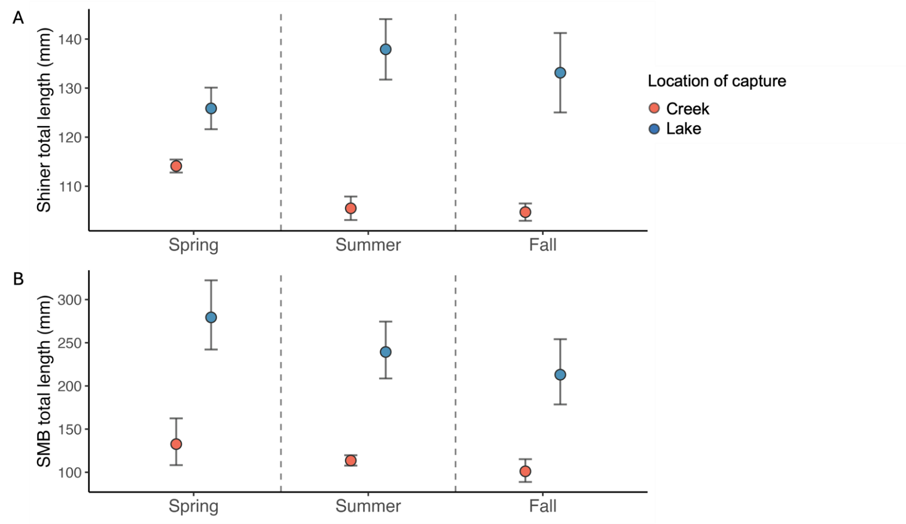
Figure 6. Seasonal summaries of estimated marginal mean (± 95% CI) total length of (A) shiners and (B) smallmouth bass captured in creek (pink) and lake (blue) habitats throughout the study period. Vertical dashed lines indicate approximate seasonal boundaries (spring, summer, fall).
References
Ahrens, R. N. M., Walters, C. J. and Christensen, V. 2012. Foraging arena theory. - Fish and Fisheries 13: 41–59.
Arostegui, M. C., Schindler, D. E. and Holtgrieve, G. W. 2019. Does lipid-correction introduce biases into isotopic mixing models? Implications for diet reconstruction studies. - Oecologia 191: 745–755.
Bauer, S. and Hoye, B. J. 2014. Migratory Animals Couple Biodiversity and Ecosystem Functioning Worldwide. - Science 344: 1242552.
Biette, R. M., Dodge, D. P., Hassinger, R. L. and Stauffer, T. M. 1981. Life History and Timing of Migrations and Spawning Behavior of Rainbow Trout (Salmo gairdneri) Populations of the Great Lakes. - Can. J. Fish. Aquat. Sci. 38: 1759–1771.
Blanchfield, P. J., McKee, G., Guzzo, M. M., Chapelsky, A. J. and Cott, P. A. 2023. Seasonal variation in activity and nearshore habitat use of Lake Trout in a subarctic lake. - Mov Ecol 11: 54.
Bloomfield, E. J., Guzzo, M. M., Middel, T. A., Ridgway, M. S. and McMeans, B. C. 2022. Seasonality can affect ecological interactions between fishes of different thermal guilds. - Front. Ecol. Evol. in press.
Brönmark, C., Skov, C., Brodersen, J., Nilsson, P. A. and Hansson, L.-A. 2008. Seasonal Migration Determined by a Trade-Off between Predator Avoidance and Growth (M Somers, Ed.). - PLoS ONE 3: e1957.
Busst, G. M. A. and Britton, J. R. 2018. Tissue-specific turnover rates of the nitrogen stable isotope as functions of time and growth in a cyprinid fish. - Hydrobiologia 805: 49–60.
Carroll, G., Brodie, S., Whitlock, R., Ganong, J., Bograd, S. J., Hazen, E. and Block, B. A. 2021. Flexible use of a dynamic energy landscape buffers a marine predator against extreme climate variability. - Proc Biol Sci 288: 20210671.
Carroll, D., Zareer, I. H., Pérez, C. C. and Harvey-Carroll, J. 2026. Nutrient availability drives local seasonal movements of an endangered marine megafauna species. - Sci Rep 16: 4997.
Challice, A. R., Milne, S. W. and Ridgway, M. S. 2019. Does habitat occupancy by lake trout and lake whitefish in large lakes match published thermal habitat envelopes? - Ecology of Freshwater Fish 28: 611–623.
Childress, E. S. and McIntyre, P. B. 2015. Multiple nutrient subsidy pathways from a spawning migration of iteroparous fish. - Freshwater Biology 60: 490–499.
Consiglio, J., Knight, T. and McCrum, A. 2024. Recovery Strategy for the LakeWhitefish (Coregonus clupeaformis) – Opeongo Lake large- and small-bodiedpopulations in Ontario. - Ontario Recovery Strategy Series. in press.
Dolinsek, I. J., McLaughlin, R. L., Grant, J. W. A., O’Connor, L. M. and Pratt, T. C. 2014. Do natural history data predict the movement ecology of fishes in Lake Ontario streams? (P Magnan, Ed.). - Can. J. Fish. Aquat. Sci. 71: 1171–1185.
Dolson, R., McCann, K., Rooney, N. and Ridgway, M. 2009. Lake morphometry predicts the degree of habitat coupling by a mobile predator. - Oikos 118: 1230–1238.
Fry, B. G. 2008. Stable isotope ecology. - Springer.
Gaeta, J. W., Ahrenstorff, T. D., Diana, J. S., Fetzer, W. W., Jones, T. S., Lawson, Z. J., McInerny, M. C., Jr, V. J. S. and Zanden, M. J. V. 2018. Go big or … don’t? A field-based diet evaluation of freshwater piscivore and prey fish size relationships. - PLOS ONE 13: e0194092.
Gutgesell, M. K., McCann, K. S., Gellner, G., Cazelles, K., Greyson-Gaito, C. J., Bieg, C., Guzzo, M. M., Warne, C. P. K., Ward, C. A., O’Connor, R. F., Scott, A. M., Graham, B. C., Champagne, E. J. and McMeans, B. C. 2022. On the Dynamic Nature of Omnivory in a Changing World. - BioScience 72: 416–430.
Hahlbeck, N., Tinniswood, W. R., Sloat, M. R., Ortega, J. D., Wyatt, M. A., Hereford, M. E., Ramirez, B. S., Crook, D. A., Anlauf‐Dunn, K. J. and Armstrong, J. B. 2022. Contribution of warm habitat to cold‐water fisheries. - Conservation Biology 36: e13857.
Hale, K. R. S., Fernandes, T. J., O’Connor, R. F., Ward, C. A., Cazelles, K., Bernhardt, J., Chu, C., Giacomini, H., Koeberle, A., Koops, M., Ludsin, S. A., Muir, A., Stewart, T., Tucker, C., Tunney, T. and McCann, K. 2026. Managing for Resilience with Ecological Structure: Portfolio Effects in the Laurentian Great Lakes. in press.
He, X. and Kitchell, J. F. 1990. Direct and Indirect Effects of Predation on a Fish Community: A Whole-Lake Experiment. - Transactions of the American Fisheries Society 119: 825–835.
Keva, O., Cobain, M. R. D., Eloranta, A. P., Hämäläinen, H., Kiljunen, M., Schilder, J. and Jones, R. I. 2025. The role of land use in terrestrial support of boreal lake food webs. - Nat Commun 16: 3572.
Kiljunen, M., Grey, J., Sinisalo, T., Harrod, C., Immonen, H. and Jones, R. I. 2006. A revised model for lipid-normalizing δ13C values from aquatic organisms, with implications for isotope mixing models. - Journal of Applied Ecology 43: 1213–1222.
Klinard, N. V. and Matley, J. K. 2020. Living until proven dead: addressing mortality in acoustic telemetry research. - Rev Fish Biol Fisheries 30: 485–499.
Lucas, M. C., Baras, E., Thom, T. J., Duncan, A. and Slavík, O. 2001. Migration of freshwater fishes. in press.
Magnuson, J. J., Beckel, A. L., Mills, K. and Brandt, S. B. 1985. Surviving winter hypoxia: behavioral adaptations of fishes in a northern Wisconsin winterkill lake. - Environ Biol Fish 14: 241–250.
Maitland, B. M., Bootsma, H. A., Bronte, C. R., Bunnell, D. B., Feiner, Z. S., Fenske, K. H., Fetzer, W. W., Foley, C. J., Gerig, B. S., Happel, A., Höök, T. O., Keppeler, F. W., Kornis, M. S., Lepak, R. F., McNaught, A. S., Roth, B. M., Turschak, B. A., Hoffman, J. C. and Jensen, O. P. 2024. Testing food web theory in a large lake: The role of body size in habitat coupling in Lake Michigan. - Ecology 105: e4413.
McCann, K. S. and Rooney, N. 2009. The more food webs change, the more they stay the same. - Phil. Trans. R. Soc. B 364: 1789–1801.
McCann, K. S., Rasmussen, J. B. and Umbanhowar, J. 2005. The dynamics of spatially coupled food webs. - Ecology Letters 8: 513–523.
McMeans, B. C., McCann, K. S., Tunney, T. D., Fisk, A. T., Muir, A. M., Lester, N., Shuter, B. and Rooney, N. 2016. The adaptive capacity of lake food webs: from individuals to ecosystems. - Ecological Monographs 86: 4–19.
Minns, C. K. 1995. Allometry of home range size in lake and river fishes. - Can. J. Fish. Aquat. Sci. 52: 1499–1508.
Mittelbach, G. G. and Persson, L. 1998. The ontogeny of piscivory and its ecological consequences. - Can. J. Fish. Aquat. Sci. 55: 1454–1465.
Portt, C. B., Coker, G. A., Ming, D. L. and Randall, R. G. 2006. A review of fish sampling methods commonly used in Canadian freshwater habitats. in press.
Post, D. M. 2002. Using Stable Isotopes to Estimate Trophic Position: Models, Methods, and Assumptions. - Ecology 83: 703–718.
Post, D. M., Layman, C. A., Arrington, D. A., Takimoto, G., Quattrochi, J. and Montaña, C. G. 2007. Getting to the fat of the matter: models, methods and assumptions for dealing with lipids in stable isotope analyses. - Oecologia 152: 179–189.
Raikow, D. F. and Hamilton, S. K. 2001. Bivalve diets in a midwestern U.S. stream: A stable isotope enrichment study. - Limnology and Oceanography 46: 514–522.
Ridgway, M., Middel, T. and Bell, A. 2017. Aquatic ecology, history, and diversity of Algonquin Provincial Park. - Information Report IR–10. 203 p. in press.
Rodrigues, T. H., Hrenchuk, L. E. and Blanchfield, P. J. 2025. Spatially-explicit foraging by an apex predator linked to nearshore prey and their accessibility in lakes. - Oikos 2025: e11066.
Roman, J., Abraham, A. J., Kiszka, J. J., Costa, D. P., Doughty, C. E., Friedlaender, A., Hückstädt, L. A., Marcondes, M., Wetsel, E. and Pershing, A. J. 2025. Migrating baleen whales transport high-latitude nutrients to tropical and subtropical ecosystems. - Nat Commun 16: 2125.
Rooney, N., McCann, K. S. and Moore, J. C. 2008. A landscape theory for food web architecture. - Ecology Letters 11: 867–881.
Schindler, D. E. and Scheuerell, M. D. 2002. Habitat coupling in lake ecosystems. - Oikos 98: 177–189.
Scott, W. B. and Crossman, E. J. 1973. Freshwater fishes of Canada. - Fisheries Research Board of Canada.
Stiling, R. R., Olden, J. D., Boulêtreau, S., Cucherousset, J. and Holtgrieve, G. W. 2023. Global investigation of lake habitat coupling by fishes. - Oecologia 202: 617–628.
Stone, N. M., Kelly, A. M. and Roy, L. A. 2016. A Fish of Weedy Waters: Golden Shiner Biology and Culture. - Journal of the World Aquaculture Society 47: 152–200.
Szekeres, P., Agberien, A. V., Dick, M., Danylchuk, A. J. and Cooke, S. J. 2023. Short-term space use of small-bodied fish in coastal flats ecosystems in The Bahamas: an acoustic telemetry study using the smallest commercially available transmitters. - Environ Biol Fish 106: 321–336.
Toscano, B. J., Gownaris, N. J., Heerhartz, S. M. and Monaco, C. J. 2016. Personality, foraging behavior and specialization: integrating behavioral and food web ecology at the individual level. - Oecologia 182: 55–69.
Tunney, T. D., McCann, K. S., Lester, N. P. and Shuter, B. J. 2014. Effects of differential habitat warming on complex communities. - Proceedings of the National Academy of Sciences 111: 8077–8082.
Tunney, T. D., McCann, K. S., Jarvis, L., Lester, N. P. and Shuter, B. J. 2018. Blinded by the light? Nearshore energy pathway coupling and relative predator biomass increase with reduced water transparency across lakes. - Oecologia 186: 1031–1041.
Valdovinos, F. S., Ramos-Jiliberto, R., Garay-Narváez, L., Urbani, P. and Dunne, J. A. 2010. Consequences of adaptive behaviour for the structure and dynamics of food webs. - Ecology Letters 13: 1546–1559.
Vander Zanden, M. J., Casselman, J. M. and Rasmussen, J. B. 1999. Stable isotope evidence for the food web consequences of species invasions in lakes. - Nature 401: 464–467.
Ward, C. A., Tunney, T. D. and McCann, K. S. 2023. Managing aquatic habitat structure for resilient trophic interactions. - Ecological Applications 33: e2814.
Ward, C. A., Tunney, T. D., Donohue, I., Bieg, C., Hale, K. R. S., McMeans, B. C., Moore, J. C. and McCann, K. S. 2025. Global Change Asymmetrically Rewires Ecosystems. - Ecology Letters 28: e70174.
Wegher, M. E., Fisk, A. T., Johnson, T. B. and Rennie, M. D. 2025. Regional variability of resource use, trophic position and habitat coupling within Lake Superior. - Journal of Great Lakes Research 51: 102457.
White, M., Wheeler, K., Hudson, R. R. and Murdock, J. N. 2023. Salmon of the Southeastern U.S.: Sucker migrations deliver resource subsidies to oligotrophic stream. - Ecology of Freshwater Fish 32: 181–194.

