**PECAP Data Collection Procedure for Advanced Bionics**

The below guidelines set out the procedure which is to be used for Advanced Bionics Cochlear Implant Devices only. It is the responsibility of the tester to ensure that all stimulation parameters are safe and comfortable for the patient.

***Pre-Testing Notes*:** if the testing computer goes to sleep during PECAP data collection for a significant portion of time, the MATLAB script that runs the PECAP acquisition will pause. The recording sequence will then re-commence when the computer is woken up. It is best practice to continuously monitor the computer screen throughout data collection and maintain mouse movement to keep the system awake, however.

You are strongly advised to go through these steps with the testing implant coil connected to a load board before testing a patient, in order to ensure that the software is installed correctly on your computer and that you have the necessary settings selected for communicating between the processor and the computer.

*Required Software and Hardware:*

1. AB PECAP Software

***Note****: provided by Charlotte Garcia from the MRC Cognition & Brain Sciences Unit at the University of Cambridge in a zip folder:* ***AB_PECAP.zip***

1. SoundWave

***Note****: tested using version 3.1*

1. Bionic Ear Data Collection System (BEDCS) version 1.8

***Note****: tested using version 1.18.321 and 1.18.337*

1. MATLAB

***Note****: tested using version 2018a*

1. Advanced Bionics (AB) Research Hardware required for measuring ECAPs (i.e. a Clarion Programming Cable, Programming Interface, associated Power Supply, AB sound processor & magnet

***Note****: Data collection will be much faster (approximately ½ the time) if the serial port from the PSP can be connected directly to the testing laptop. The USB to Serial converters generally cause communication between the PSP and the computer to be twice as slow*

1. Optional: Advanced Bionics Load Board

***Note:*** *this is strongly recommended for testing the program prior to assessment with a patient*

Example of the hardware setup:

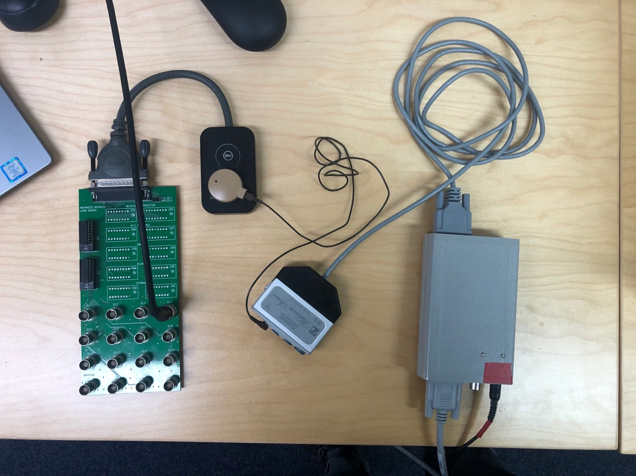

Notes:

* The BNC cable connected to the green load board on the left of the image is connected to an oscilloscope for testing purposes
* The black cable with red tape on the bottom right of the image is connected to power
* The grey serial cable on the bottom right of the image is connected to the testing computer

*Outline of Operations:*

1. In SoundWave
   1. Connect the processor to the test computer and connect the coil to the research participant’s implant
   2. Measure Impedances for all electrodes
   3. Using the impedance measurements, calculate upper compliance limits for stimulation in BEDCS

***Note****: Compliance controls are not embedded in the PECAP software, so the tester is responsible for making sure not to stimulate out of compliance with the participant’s implant*

1. Open BEDCS
   1. Confirm that the serial port configuration is appropriate and that BEDCS can communicate with the research hardware
   2. Close this instance of BEDCS
2. Open MATLAB
   1. Open the MP_Loudness_DAQ.m script
   2. Enter desired recording parameters within the first part of the script. There are descriptions in the comments in the code for what suggested values to set these to.
      1. Ln 132 >> param.extraplot = 1; % switch to 1 to see ABCD frames plotted
      2. Ln 133 >> param.BEDCSVisible = 1; % switch to 1 to make BEDCS visible
      3. Ln 150 >> param.loudness_electrodes = [1 4 7 10 13 16];
      4. Ln 162 >> param.loudness_options = [5 6 7];
      5. Recording Parameters

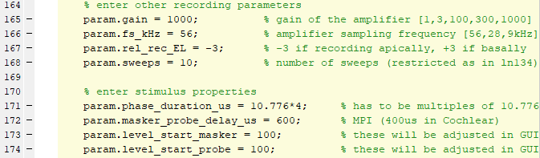

* + 1. Stimulation Parameters



* 1. Run the MP_Loudness_DAQ.m script
     1. Follow the prompts in the Command Window
     2. This will start by asking you to enter a string defining the ID of the research participant, and will call a Graphical User Interface (GUI) that allows you to do loudness scaling. It will call this GUI for each of the electrodes indicated in line 150 (param.loudness_electrodes). It is recommended that this contain every 2nd or 3rd electrode active in the patient’s MAP. Start at a low current level and increase using the buttons in the GUI. The GUI will call instances of BEDCS with the recording parameters in the GUI for ECAP recording.
     3. The GUI will not allow you to move on from one electrode to the next unless loudness scaling has been done for all levels indicated in line 162 (param.loudness_options).
     4. Once loudness scaling has been completed for each electrode, the script will ask you which loudness level you would like to collect ECAPs at, and will interpolate the current level for the electrodes for which the loudness was not scaled
  2. Open the MP_PECAP_DAQ.m script
     1. This script will require that you run the MP_Loudness_DAQ.m prior to commencing. If this was not done directly prior to collecting ECAP recordings and a previous loudness scaling was done for the current research participant, you can load this information from the data/ folder
  3. Change any recording parameters at the top of the script as in MP_Loudness_DAQ.m
  4. Run the MP_PECAP_DAQ.m script
     1. Follow the prompts in the Command Window
     2. It will ask you to select a loudness level to record the diagonal of the PECAP matrix at, and to confirm the number of sweeps to record. It is recommended that you start with a loudness level of 6 (MCL), and 50 sweeps
     3. If the participant indicates that the loudness level was uncomfortable, or if no ECAPs are visible, then adjust the loudness level and re-record the diagonal
     4. Once there are visible ECAPs and the participant has indicated it is a comfortable loudness level, collect the entire PECAP matrix

***Note****: If your setup connects the serial port directly to your test computer, you are recording PECAP for all 16 electrodes, and you are recording 50 sweeps, then the PECAP data collection time should be approximately 30 minutes.*

1. For analysis
   1. Convert the /data folder into a .zip file, and send to the MRC Cognition & Brain Sciences unit for analysis.

***Note****: as of September 2021, the point of contact is Charlotte Garcia who can be reached by email at Charlotte.Garcia@mrc-cbu.cam.ac.uk*