Working with isoHelpR

Aim of this package:

IsoHelpR is a package aiming to help the user of the continuous flow isotope mass spectrometry to filter their row data (TCD and CNEA) and to produce final outputs (quant file and signature file). Its interactive user interface allows to parametrize as much as possible the filtation, while allowing the user to check the validity of his/her data.

- How to start?

Requirement of the software: the R cran software (at least ≥ 3.2.3, to update your version click here). For more practicity, it is better to also install Rstudio (to download, see here)

To install the isoHelpR package, open your usual R environment (R, Rstudio...) and run the following instructions:

The installation of the package is to conduct only the first time the computer runs the isoHelpR for the first time (or if you reinstall R). If you already installed isoHelpR before, you don’t need to install it everytime you runs the software. However, everytime you want to use isoHelpR, you need to source the package (see below).

To source isoHelpR, you will have to run the following command:

library(elementR)

Once isoHelpR is installed and sourced, its utilization will consist into two steps. First, converting the TCD file into a “Quant_results” file to get all the quantitative values of the analyses (e.g. µg N/cup, C/N). Secondly, converting the CNEA file into an “Isotope Data” file with all the signatures of the samples

- Creation of the “Quant results” file

In this part, the software will convert the TCD file into a “Quant_results” file based on the function TCD.cleanR

  - Launch the TCD.cleanR function

In your usual R environment, execute the following command:

TCD.cleanR()

At this point, the web browser opens a new page with the operational application based on the isoHelpR code (see Figure 1).

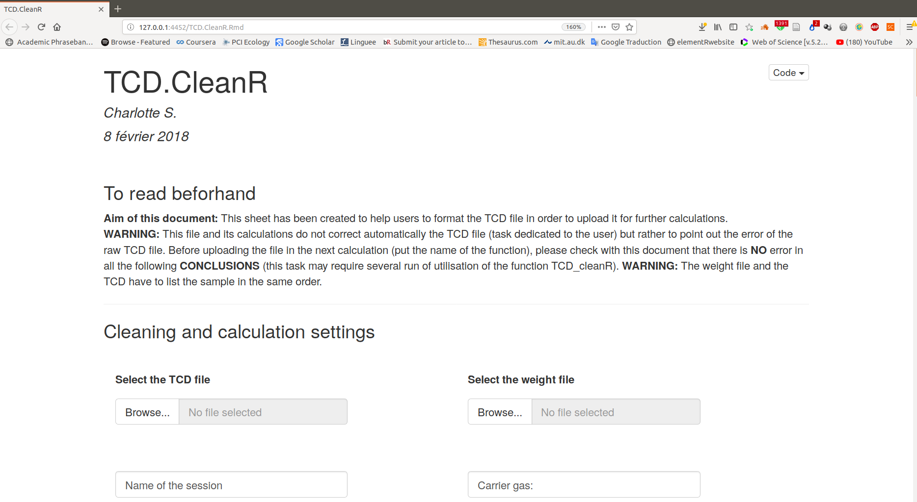

Figure 1: TCD.cleanR into Firefox (Ubuntu version 18.04)
If no new windows appears, check on the Rstudio icone on the icone bar of your desktop.
If you do not get into your regular browser, click on the icone saying ‘Open in Browser’:

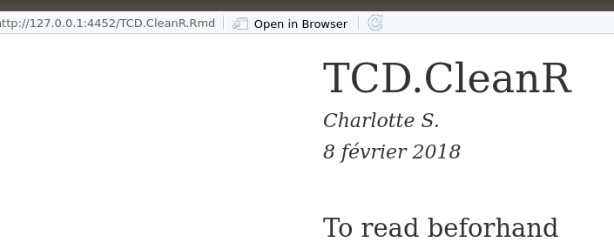

  - Import the data (TCD + weight of the samples)

The format of the TCD file you have to import is the format you got from the machine (see Figure 2). The most important is the fact that the names of the column stay the same.
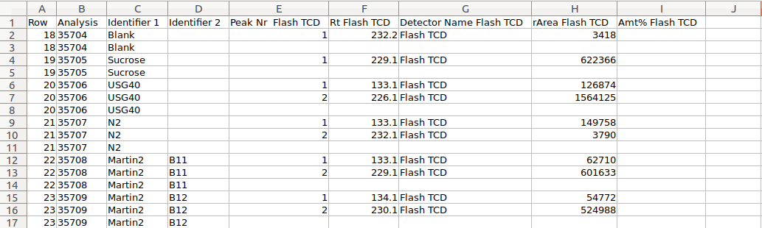
Figure 2: Format of the TCD file to import into TCD.cleanR

The weight data you have to import will have the format of the Figure 3. The most important thing is that the TCD and the weight file have the same sample order. It is also important to keep the same name of column.

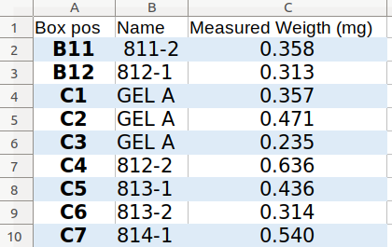
Figure 3: Format of the weight to import. Note that B11 comes first in figure 2 and 3 → same rank in TDC and weight files

Template are provided with the IsoHelpR package, take a look ! (in the folder where R packages are installed², reach the elementR folder and look at the “ExampleAndtemplate”)

You will first import the TCD file as shown in the figure 3 to the left, and then import the weight data as shown on the same figure but to the right.

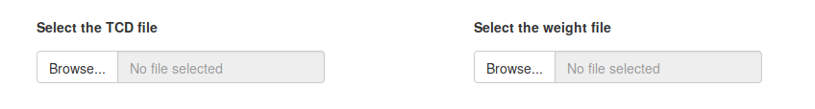
Figure 3 : How to import TCD and weight data by clicking on the “Browse” buttons respectively on the left and right.

  - Fill the session information
The informations on the session are not mandatory but can be helpful to keep in mind the parameters of the session. This information will be displayed on the final Quant_file

  - Select the name of the samples
Here you need to indicate which analysis correspond to samples. In the example, it is SIROT_BOX1 (containing both GelA and Samples) that have to be ticked. The rest of the non ticked names will be considered as standards and blanks.

  - Cleaning the session for optimal calculations
The three next parts will be dedicated to detect potential mistakes in the TCD file. The software will first look at the format of the file, then will show you the values in a boxplot for a visual detection of outliers.
In the “Condition tested for cleaning” part, the software will show the potential mistakes the TCD and weight files show.
For that, we defined a single sample analysis as a sample that have the same analysis name. So, ensuring a single and unique name of each analysis is the priority in this software and the first thing to check in your TCD file when you check it visually before using isoHelpR.

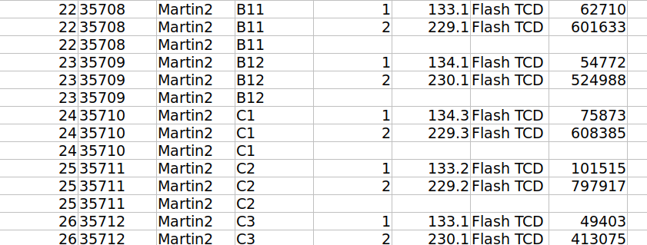
Figure 3 : Three different samples analysis (name 35709, 35710 and 35711)

- Condition 1: Check that all analysis has an analysis number
- Condition 2: Check that all analysis has only one single row name and that none of these cells are empty
- Condition 3: Check that all analysis has only one single Identifier 1 and that none of these cells are empty
- Condition 4: Check that all analysis has only one single Identifier 2 and that none of these cells are empty
- Condition 5: Check that rArea Flash TCD has exactly three lines (except for the sucrose that has only two lines) cand contains exactly two values (respectively one) and an empty cell
- Condition 6: Check that the order of the samples are the same between the TCD and weight files
- Condition 7: Check that weight of the samples and rArea values do not contain any character

The Data Samples and Data Standard are then the table with the rArea.flash. TCD N and C that are put in the same line for the samples and standards.

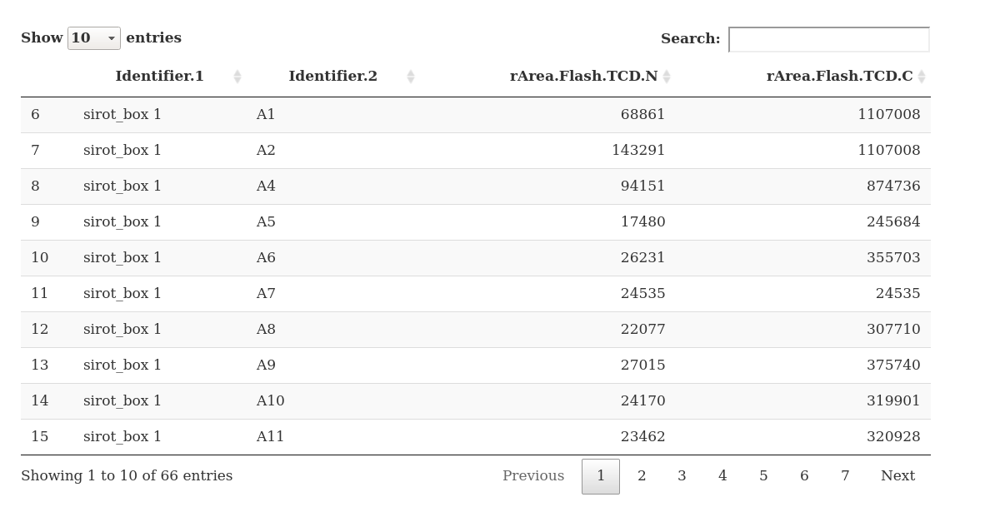
Figure 3 : the Data Sample and it customization (in red, parameters that you can customize)

Here, it is recommanded to select three places randomly in the box (e.g. D11) and check the data from the TCD correspond to those in these tables.

Finally, two boxplots of the rArea.flash. TCD N and C will allow you to have a last setp to verify outliers and therefore find mistakes in the files.
Here again you can customize what data you want to display with the tick boxes at the top of the boxplots.

A last conclusion conclusion will summarize the potential error that is observed by the software. It is your responsibility to correct them before continuing as THESE MISTAKES MIGHT ALTER THE QUALITY OF YOUR RESULTS.

  - Setting the Quant_results creation
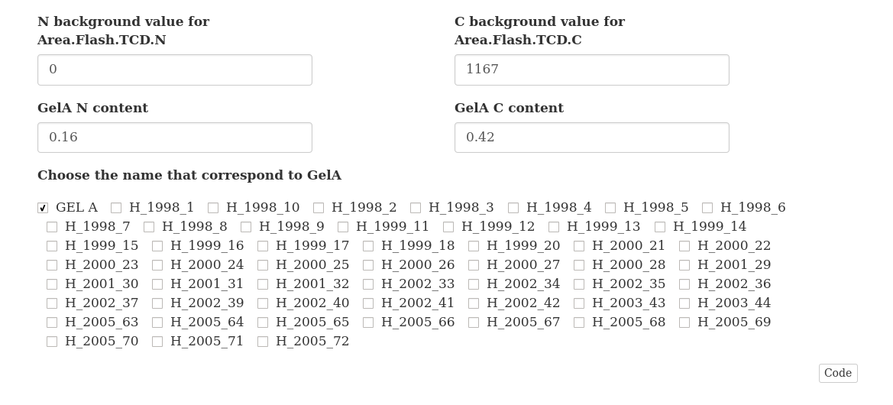
To obtain accurate values of Quant_results, isoHelpR will require you fill in the N background value for Area.Flash.TCD.N & C background value for Area.Flash.TCD.C (see figure X, 1). You will have to enter here the value of the blank that you obtained with the blank). Moreover, you will have to write the value of the GelA N and C content (see figure X, 2). Finally, you have to indicate which of your samples are Gel A (as you can have different way to write it, GelA, GEL A…) (see figure X, 3).

Figure 3 : Setting of the Quant_results creation
1
2
3

  - Linear regression based on Gel A

In the gelA linear regression graphic, you can choose the gel A that you wish to keep in the results and those that you seems not good and that you want to exclude for your results. The slope of the linear will be automoatically recalculated based on your gel A choice (see Figure X).

  - Creating the Quant_results

According to the linear regression and the gel A that you chose, the Quant_results will be displayed in the “Final Sample table” (that you can customize like the table observed in the figure X).
The last step is to export your data by pressing the button “Save the data” located below the final table. Before closing the software make sure that your results have been actually saved by checking in the folder where you saved it.

  - Data exploration

Here you have the possibility to use this reactive table like a pivot table and graph. This data exploration will not change in any case you reduced data and is just to facilitate the observation of the final data. So enjoy :)

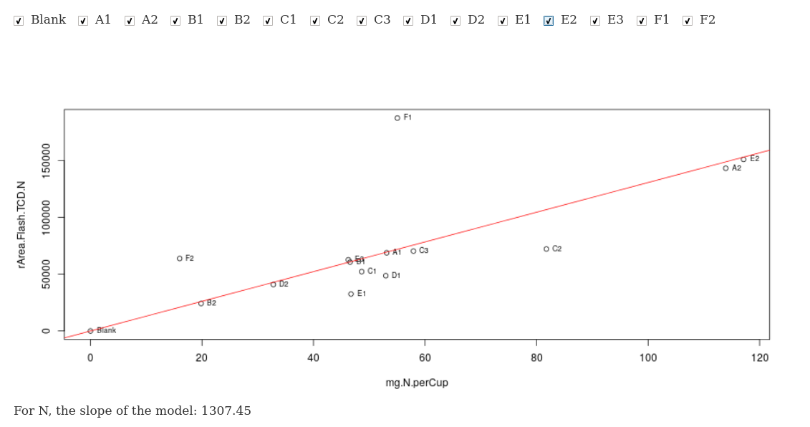
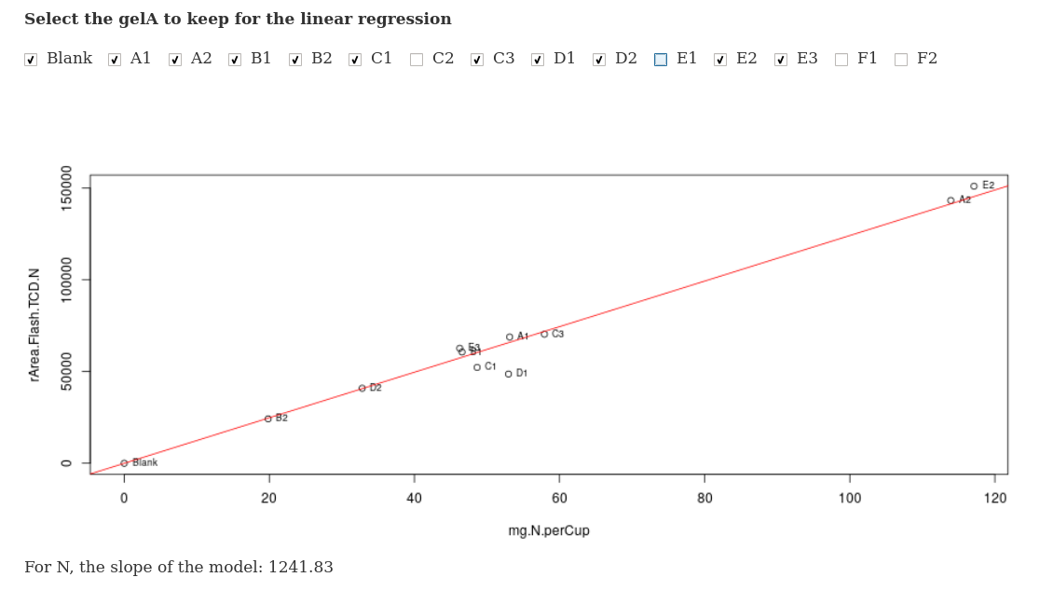
Figure X : linear regression with all the gel A (on the top) and with excluding C2, E1, F1 and F2 on the bottom. Note that the slope of the model changed between these two regressions.

- Creation of the “Isotope Data” file

In this part, the software will convert the CNEA file into a “Isotope_data” file based on the function CNEA.cleanR.

  - Launch the CNEA.cleanR function

In your usual R environment, execute the following command:

CNEA.cleanR()

At this point, the web browser opens a new page with the operational application based on the isoHelpR code. As for the function TCD.cleanR, if no new windows appears, check on the Rstudio icone on the icone bar of your desktop. In addition, if you do not get into your regular browser, click on the icone saying ‘Open in Browser’ (see figure XX).

  - Import the data (CNEA + weight of the samples)

The format of the CNEA file you have to import is the format you got from the machine (see Figure X). The most important is the fact that the names of the column stay the same.

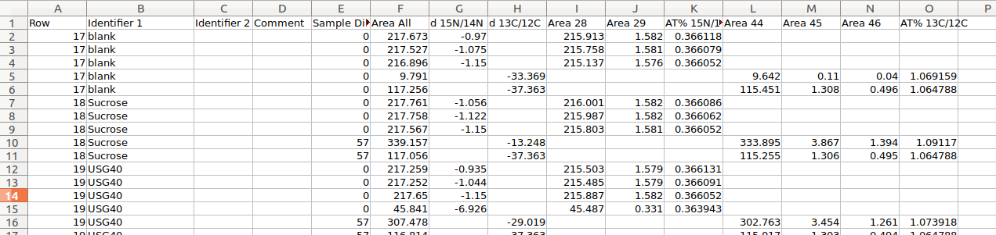
Figure X: Format of the CNEA file to import into CNEA.cleanR

Template are provided with the IsoHelpR package, take a look ! (in the folder where R packages are installed², reach the elementR folder and look at the “ExampleAndtemplate”).

For the weight data, the file to upload is the same that one uploaded in the TDC.cleanR function.

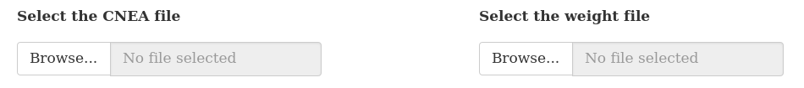
You will first import the CNEA file as shown in the figure X to the left, and then import the weight data as shown to the same figure to the right.

Figure X : How to import CNEA and weight data by clicking on the “Browse” buttons respectively on the left and right.

