**Problem**

Can the CAPM, Fama-French Models describe and explain the stock return in the long term?

**Introduction**

The CAPM, Fama-French 5 factor model and Carhart four-factor model will be illustrated to evaluate whether the models are statistically significant. These are financial models that employs factors in its calculation to explain market phenomena and equilibrium asset prices . By combining the factors that are statistically significant, a new model will be generated and compared with all the models to generate some insights regarding the stock returns.

**Data**

We have gathered stock prices of Walt Disney Co (DIS) from Jan 1970 to Oct 2019. We found the monthly return in excel by dividing last month’s return from this month’s return, the excess monthly return is calculated by subtracting the risk free rate from monthly return. The data for the factors, including five factor model and the momentum, we are going to use it in the following report, are from Kenneth French’s website (<https://mba.tuck.dartmouth.edu/pages/faculty/ken.french/data_library.html>). In the end, we will conduct our own model and do comparison across these models.

rDIS refers to the return of the stock price of Walt Disney Co. rDIS_ex is the excess return of Walt Disney Co. rM_ex is the return spread between the capitalization weighted stock market and cash. rSmB is the return spread of small minus large stocks in terms of capitalization. rHmL is the return spread of cheap minus expensive stocks. rMoM is the return of the momentum effect which is the top winner minus bottom losers portfolios. rRmL is the return spread of the most profitable firms minus the least profitable. rCmA is the return spread of firms that invest conservatively minus aggressively.

For the details of the data, it can be found in the “stock_regression.xlsv”, while we use “stock_regression.csv” for our R codes.

**Stock Overview**

The Walt Disney Company is a worldwide entertainment company and its stocks is listed in the New York stock exchange market. The company operates in four business segments: Media networks, Parks Experiences and Products, Studio Entertainment, and Direct-To-Consumer and International.

**DIS vs SP500**

The price of DIS and SP 500 is positively correlated even though DIS is excluded from SP500.

**Figure 1.** LS Regression of BH vs SP500.

The return of DIS and SP 500 is positively correlated and clustered around from -0.1 to 0.1.

**Figure 2.** LS Regression of Returns on BH vs Returns on SP500.

**One factor model: CAPM - LS regression**

|  |
| --- |
| Coefficients:              Estimate Std. Error t value Pr(>|t|)  (Intercept) 0.003339   0.002789 1.197 0.232  rM_ex       1.206888 0.061507  19.622 <2e-16 ***  ---  Signif. codes:  0 ‘***’ 0.001 ‘**’ 0.01 ‘*’ 0.05 ‘.’ 0.1 ‘ ’ 1  Residual standard error: 0.06761 on 595 degrees of freedom    (1 observation deleted due to missingness)  Multiple R-squared:  0.3929, Adjusted R-squared:  0.3919  F-statistic: 385 on 1 and 595 DF,  p-value: < 2.2e-16 |

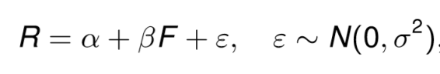CPAM model:

The market (excess) is significant in explaining the variation in the return of DIS.

The p-value of rM_ex is <2e-16 which is less than 5% , so rM_ex is useful in explaining the variation in the return of DIS.

α is not significantly different from 0 at 5% significant level since the p-value for α is 0.232 which is larger than 5%. This means that α is as good as 0, the stock has earned a return adequately for the risk taken, in this case, comparing to the market return.

β is significantly away from 1. It is significantly smaller than 1 and it is negative.

Set t -statistics: 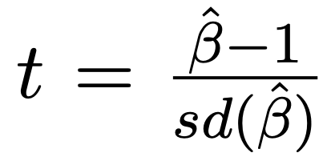=  (1.206888 -1)/ 0.061507  = 3.3636. For t = 3.3636, the absolute value of t is bigger than 2. So the value of beta is significantly larger than 1, this means that the stock is more sensitive to market fluctuations.

The R2 for this model is 0.3929 under LS regression which indicates that the one factor model can explain the variation in the DIS returns by 39.29%.

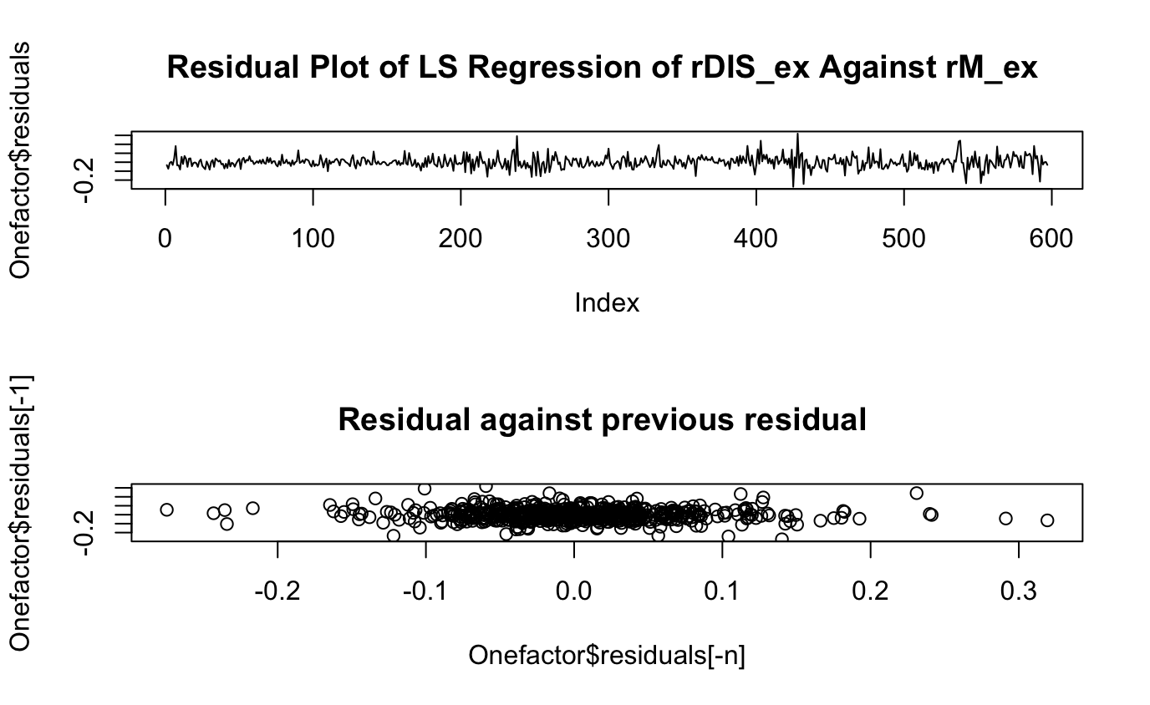

**Figure 3.** The residual plot of LS regression of one factor model.

**Figure 4.** The scatter plot of residuals against the previous one of one factor model.

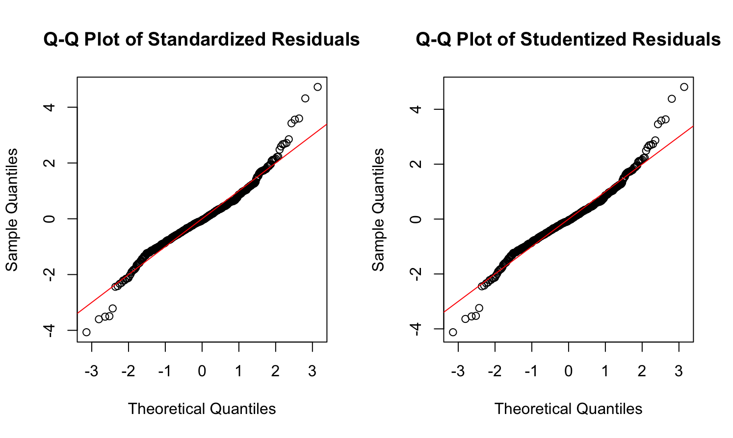

**Figure 5.** Normal Q-Q plots of the standardized and studentized residuals from the one factor LS Regression.

From the above graphs, we can observe that the standardized/studentized residuals from one factor model is roughly i.i.d distributed. The linearity relation with the model explains the data well. However, from the normal Q-Q plots, the residuals both have heavier left and right tails than normal distribution. It might be better to model the residuals with a heavier tailed distribution, such as t distribution.

**One factor model: CAPM – LAD regression**

|  |
| --- |
| Coefficients:              coefficients lower bd upper bd  (Intercept) -0.00062     -0.00371 0.00443  rM_ex        1.16757 1.04451  1.29701  > plot(Onefactorlad$residuals,type="l",main="Residual Plot of LAD Regression of rDIS_ex Against rM_ex ")  > plot(Onefactorlad$residuals[-n],Onefactorlad$residuals[-1],main="Residual against previous residual ")  > cor(Onefactorlad$residuals[-n],Onefactorlad$residuals[-1])  [1] -0.05351765 |

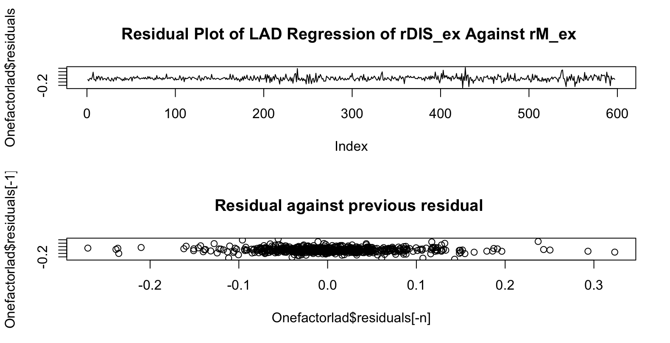

**Figure 6.** The residual plot of LAD regression of one factor model.

**Figure 7.** The scatter plot of residuals against the previous one of one factor model.

The residual and scatter plot of LAD regression illustrates that the outliers still exist and there is no significant difference when comparing the residuals between LS and LAD regression.

We would not use LAD regression in the following as LAD regression is sensitive to one type of outliers, however the sample size is quite large, thus LAD regression would not make much differences in the results. From the model diagnostic in the LS regression, the residuals are roughly i.i.d distributed, thus we do not need to conduct the LS regression, the conduction of LS regression is simply for illustration purposes. If we found outliers, the preferred method would be using a non-linear formulation or apply a transformation, for example, taking log to the monthly return or remove suspected observations. Since the data would be the same across this report, we conclude that LAS regression would not be illustrated furthermore since the conclusion will be the same.

After conducting the LAD regression for the one factor model, the result for the coefficients of alpha and beta is similar while LAD regression has many drawbacks, it has no explicit formula for coefficient estimator and the lack of distribution theory makes us prefer LS regression.

**Fama-French Five-factor model – LS regression**

We decided to skip the three-factor model and directly conduct the five-factor model because the conclusion on the first three factors are more or less the same, we would like to analyze more factors and combine the statistically significant factors into one model.

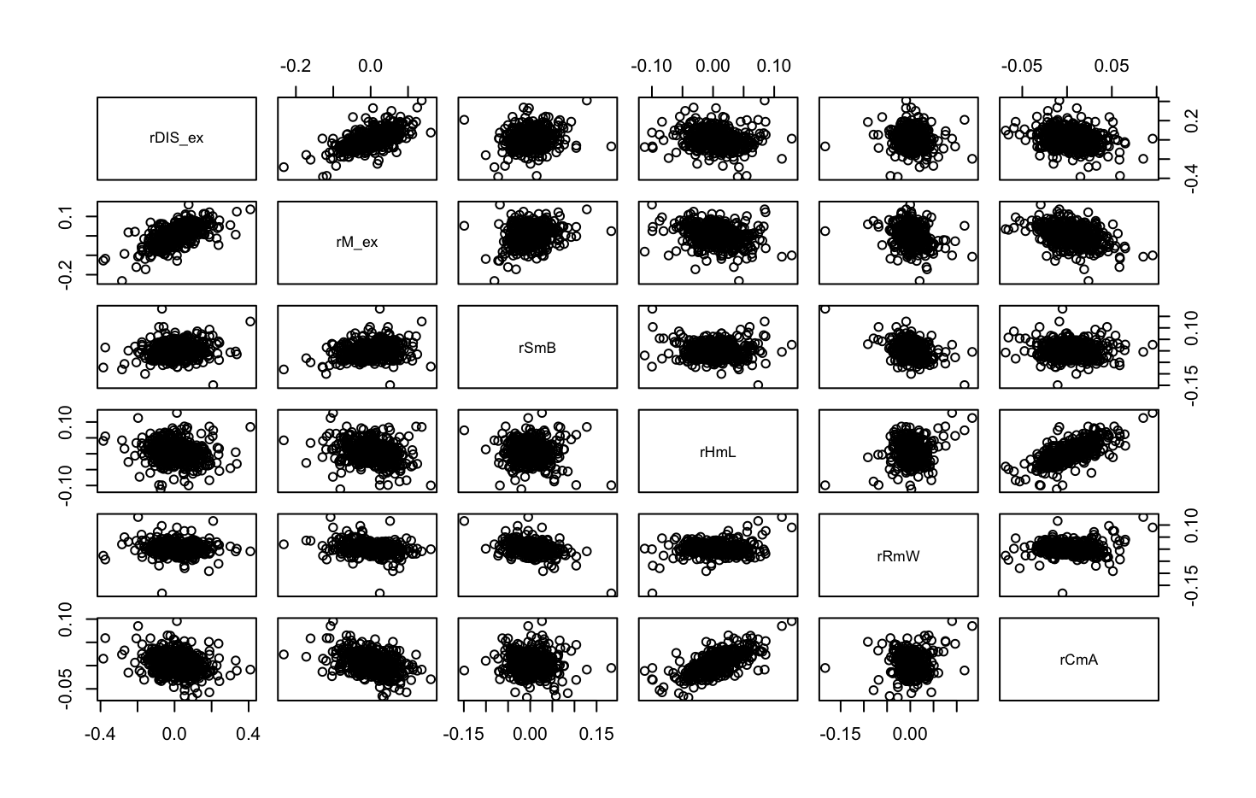

**Figure 8.** Asset Returns VS the Five-factor Returns.

There is a positive linear relationship between rHmL and rCmA, thus we should remove one of these factors if they are statistically significant.

|  |
| --- |
| Coefficients:              Estimate Std. Error t value Pr(>|t|)  (Intercept) 0.001007   0.002890 0.348 0.727676  rM_ex       1.275013 0.069701  18.293 < 2e-16 ***  rSmB        0.088953 0.099841   0.891 0.373318  rHmL        0.044226 0.133342   0.332 0.740256  rRmW        0.452494 0.136627   3.312 0.000983 ***  rCmA        0.122656 0.205197   0.598 0.550238  ---  Signif. codes:  0 ‘***’ 0.001 ‘**’ 0.01 ‘*’ 0.05 ‘.’ 0.1 ‘ ’ 1  Residual standard error: 0.06714 on 591 degrees of freedom    (1 observation deleted due to missingness)  Multiple R-squared:  0.4053, Adjusted R-squared:  0.4003  F-statistic: 80.56 on 5 and 591 DF,  p-value: < 2.2e-16 |

The five-factor model as a whole is statistically significant as the p-value is < 2.2e-16 which is smaller than 5%.

Checking p-values for each factors in FF-5:

p-value for rM_ex is <2e-16, indicating rM_ex is statistically significant at 5% level.

p-value for rSmB is 0.373318 , indicating rSmB is not statistically significant at 5% level.

p-value for rHmL is 0.740256 , indicating rHmL is not statistically significant at 5% level.

p-value for rRmW is 0.000983, indicating rRmW is statistically significant at 5% level.

p-value for rCmA is 0.550238, indicating rCmA is not statistically significant at 5% level.

Thus, we would include rM_ex and rRmW into our model.

**Carhart Four-factor model – LS regression**

We decided to do the four-factor model analysis that includes three factor and the momentum factor to determine whether the momentum factor is statistically significant to explain the returns of DIS.

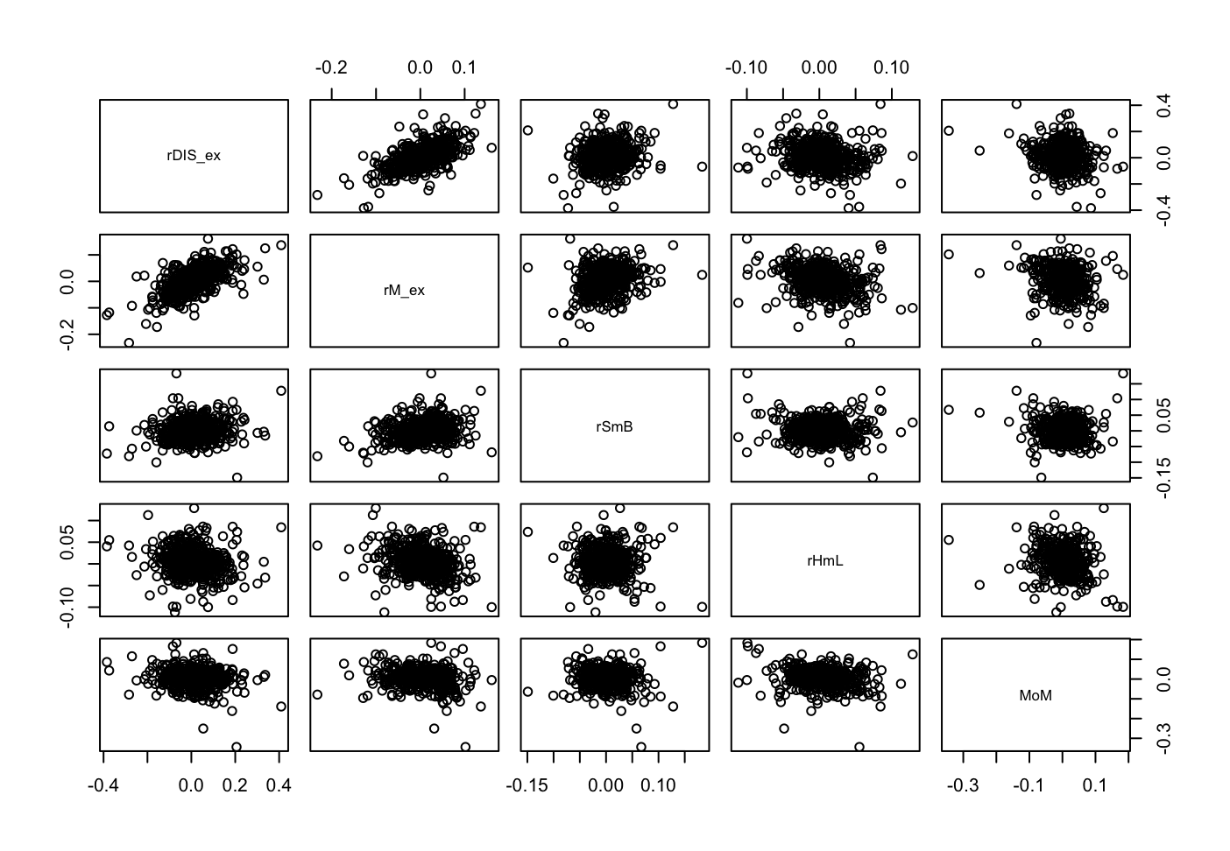

**Figure 9.** Asset Returns VS the Four-factor Returns.

There is no linear correlation between these factors, thus we can continue with our analysis.

|  |
| --- |
| Residuals:  Min 1Q Median 3Q Max  -0.27435 -0.03805 -0.00439 0.03536 0.31960  Coefficients:  Estimate Std. Error t value Pr(>|t|)  (Intercept) 0.003911 0.002874 1.361 0.1741  rM_ex 1.204067 0.067268 17.900 <2e-16 ***  rSmB -0.022397 0.094974 -0.236 0.8137  rHmL 0.068633 0.101657 0.675 0.4998  MoM -0.118556 0.066523 -1.782 0.0752 .  ---  Signif. codes:  0 ‘***’ 0.001 ‘**’ 0.01 ‘*’ 0.05 ‘.’ 0.1 ‘ ’ 1  Residual standard error: 0.06752 on 592 degrees of freedom  (1 observation deleted due to missingness)  Multiple R-squared: 0.3975, Adjusted R-squared: 0.3934  F-statistic: 97.64 on 4 and 592 DF, p-value: < 2.2e-16 |

The Carhart Four-factor model as a whole is statistically significant, the p-value is < 2.2e-16 which is smaller than 5%.

From the Carhart Four-factor model, it includes the first 3 factors, i.e. rM_ex, rSmB and MoM. We have analysed whether it is statistically significant or not, the conclusion towards these 3 factors are the same so we will only focus on the momentum factor.

p-value for MoM is 0.0752, indicating MoM is not statistically significant at 5% level. Thus, we will not include this factor while conducting the new model.

The momentum factor is not significant in this case because we have used a long-term data in analysing the factors, while in momentum strategies, financial analysts incorporate the 52-week price high/low in their buy/sell recommendations. In the medium-run, 6-12 months, stocks with high return tend to continue outperform over the next 6-12 months. While stocks with high long-term returns tend to underperform those with low long-term returns.

We skipped the model diagnostic in the Fama-French five factor and Carhart four factor because after generating the graphs, we found that the graphs and the results are the same as the model diagnostic in the one factor model.

**New model – LS regression**

We made a new model by including the factors that are statistically significant, which are the excess return of the market index portfolio (rM_ex) and Robust Minus Weak (rRmW).

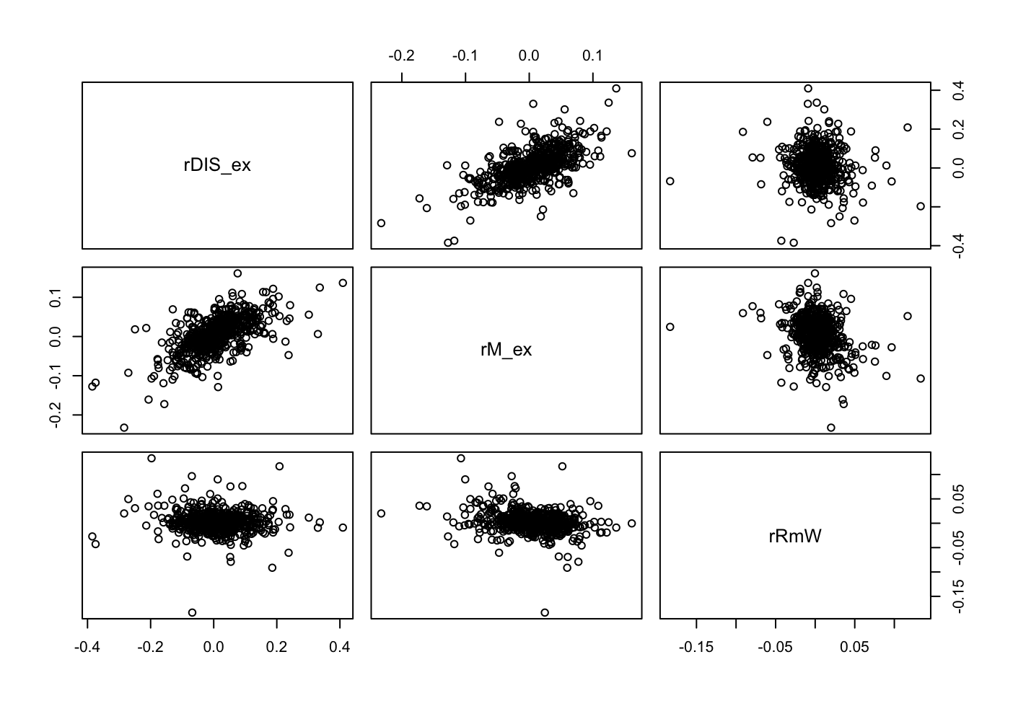

There is roughly no correlation between rM_ex and rRmW so we can continue with our analysis.

**Figure 10.** Asset Returns VS the Two-factor Returns.

|  |
| --- |
| Coefficients:  Estimate Std. Error t value Pr(>|t|)  (Intercept) 0.001892 0.002804 0.675 0.50023  rM_ex 1.256516 0.062980 19.951 < 2e-16 ***  rRmW 0.407951 0.127640 3.196 0.00147 **  ---  Signif. codes:  0 ‘***’ 0.001 ‘**’ 0.01 ‘*’ 0.05 ‘.’ 0.1 ‘ ’ 1  Residual standard error: 0.06709 on 594 degrees of freedom  (1 observation deleted due to missingness)  Multiple R-squared: 0.4031, Adjusted R-squared: 0.4011  F-statistic: 200.6 on 2 and 594 DF, p-value: < 2.2e-16 |

The new model as a whole is statistically significant ,the p-value is < 2.2e-16 which is smaller than 5%.

p-value for rM_ex is <2e-16, indicating rM_ex is statistically significant at 5% level.

p-value for rRmW is 0.00147, indicating rRmW is statistically significant at 5% level.

These 2 factors are still statistically significant. Even though rRmW is added to the one factor model however the contribution is not as significant as rM_ex, the coefficient is only 0.4 compared to 1.26.

|  |
| --- |
| > par(mfrow=c(2,1))  > plot(ownmodel$residuals,type="l",main="Residual Plot of LS Regression")  > n <- length(rDIS_ex) - 1  > plot(ownmodel$residuals[-n],ownmodel$residuals[-1],main="Residual against previous residual ")  > cor(ownmodel$residuals[-n],ownmodel$residuals[-1])  [1] -0.05095367 |

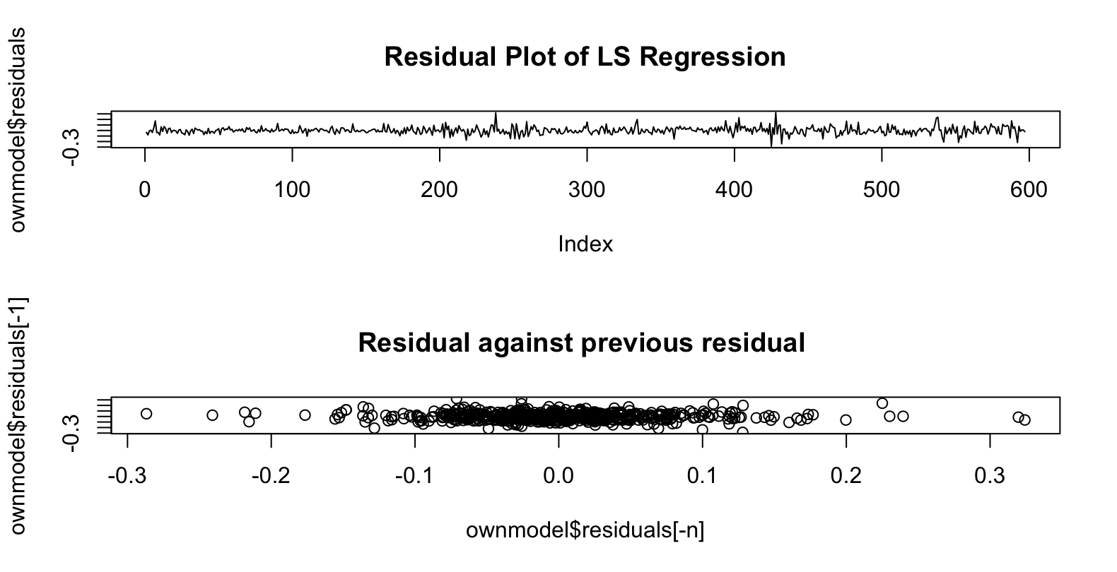

**Figure 11.** The residual plot of LS regression of our own model.

**Figure 12.** The scatter plot of residuals against the previous one of our own model.

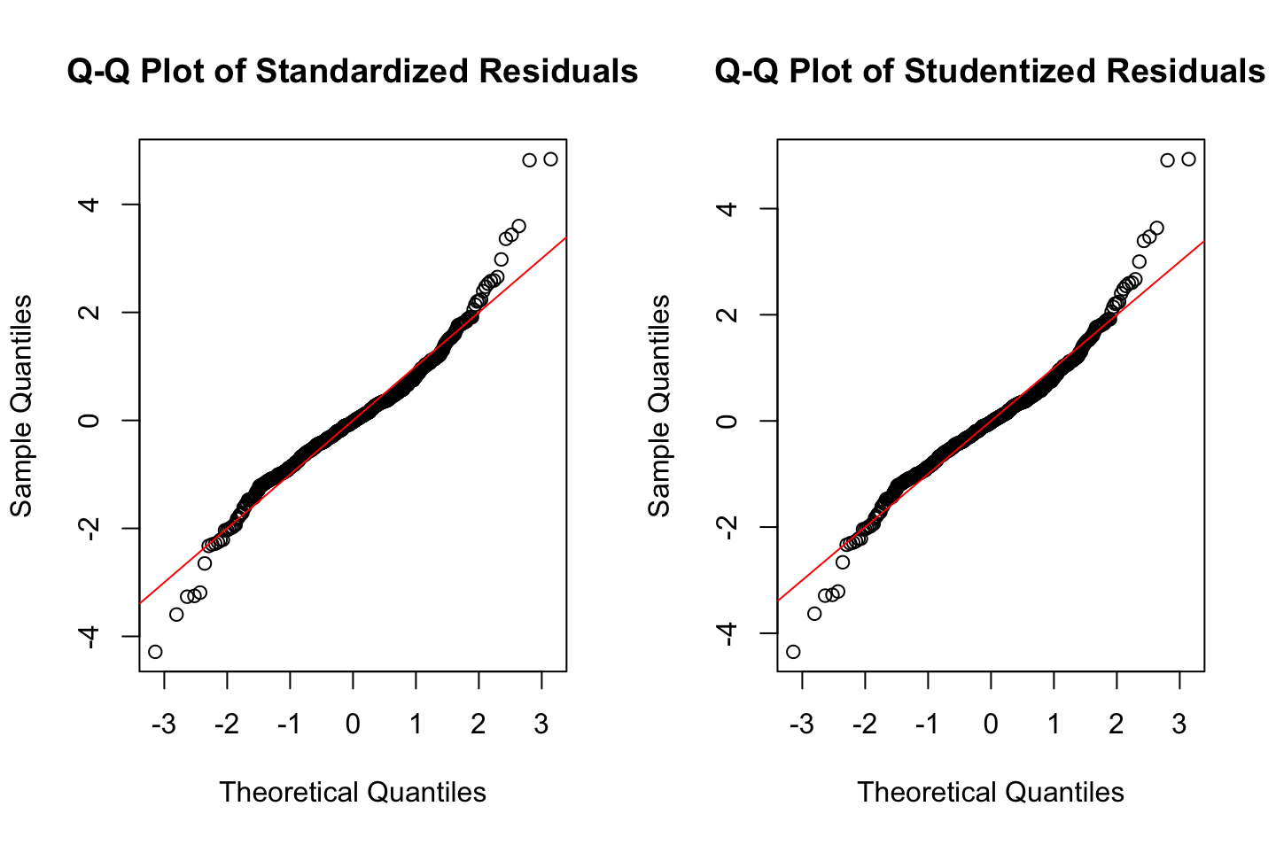

**Figure 13.** Normal Q-Q plots of the standardized and studentized residuals from the LS Regression of our own model.

The model diagnostic for all the models we conducted are similar. The standardized/ studentized residuals from one factor model is roughly i.i.d. distributed. The linearity relation with the model explains the data well. However, from normal Q-Q plots, the residuals both have heavier left and right tails than normal distribution.

We would do the comparison of models below.

**Comparison and Conclusion**

**Table 1.** R squared value of different models

|  |  |
| --- | --- |
| **Model** | **R squared** |
| One factor model: CAPM | 0.39287 |
| Fama-French Three-factor model | 0.39425 |
| Carhart Four-factor model | 0.39748 |
| Fama-French Five-factor model | 0.40530 |
| New model | 0.40314 |

The model diagnostic for all of the above models are more or less the same. They can all be used for the estimation of DIS stock and it is all as a whole statistically significant, thus we will choose the best model by considering the R squared and order of the model.

The Fama-French five factor model has the largest R squared, this mean that it explains the return the best, however the differences between it and the one factor model is less than 0.01. More surprisingly is that the R squared of our own model is not the highest since we combined the statistically significance factors.

Although higher models can explain more of the return, however it has a trade-off. When the order gets higher, the model gets even more complicated. Therefore, lower order models are preferred.

We would choose the one factor model for the prediction or estimation of stock returns, because the R squared difference between the one factor model and five factor model doesn’t justify choosing a much higher order model. Even though an extra factor, i.e. profitability factor, is important in determining expected return but the differences between having it and not does not affect the expected return much.

Furthermore, the problems with multi-factor model is that it is A-theoretical, meaning that the result aren’t being backed up by any theory, while one factor model can be explained by CAPM. The second problem is data-snooping. We look at the past data and add them back into our model, such factors might by chance work but there is no theory to proof it will continue to work in the future.

In conclusion, the one factor model CAPM will be chosen.