**Determination of the Correlation Function of Na22 Annihilation**

Lab 4

PHY 353L (56185)

Yeji Yun

EID: yy6829

April 6th, 2018

Partner: Laney Wicker

Instructor: Chris Reilly

Using a pair of scintillation detectors and a coincidence circuit, we measured the angular correlation functions for γ-rays emitted from a sodium nuclei [5]. According to conservation of momentum and energy, byproduct photons of antiparticle annihilation in Na22 must exhibit a δ-function distribution; indeed, both of our measured coincidence rates strongly peaked around θ = 180° with the width consistent with the angular resolution of the detectors. Using trigonometry, we derived a mathematical relationship between the angular resolution and separation distance of our detectors. We then found the effective radius, the radius contained by the angular resolution, of our detectors to be **r = .3428 ± .0015 inches.**

1. **Introduction**

Annihilation radiation is a term used in Gamma spectroscopy for the gamma radiation produced when a particle and its antiparticle collide and annihilate [1]. In the case of Na22 decay, the sodium nucleus emits a high energy positron which begins to give up its excess energy; as it emits energy, the probability of its annihilation with its antiparticle, electron, increases. As a result, the two 511-keV gamma rays are created simultaneously as an electron and a positron collide at rest [2]. The total energy and momentum before the collision is,

Ei = 2mec2 (1)

pi = 0. (2)

The energy equals twice the electron rest mass energy (since electron and positron have identical rest mass energy), and the momentum is zero since the anti-particles are colliding at rest [2]. Therefore, the only way to conserve momentum in this process is for the two gamma rays to travel in exactly opposite directions [2]. Therefore, the correlation function for the radioactive decay is generalized by a delta function,

C(θ) = δ(π – θ) [2]. (3)

A Dirac delta function is equal to zero everywhere except for zero and its integral over the entire real line is equal to one [3]. By measuring the number of coincidental gamma rays at multiple angles, one can measure the correlation function for the annihilation radiation of Na22. If the correlation function of the Na22 decay returns a delta distribution, one can conclude that the annihilation of an electron and a positron is a momentum and energy conserving process.

1. **Experiment**
   1. **Apparatus**

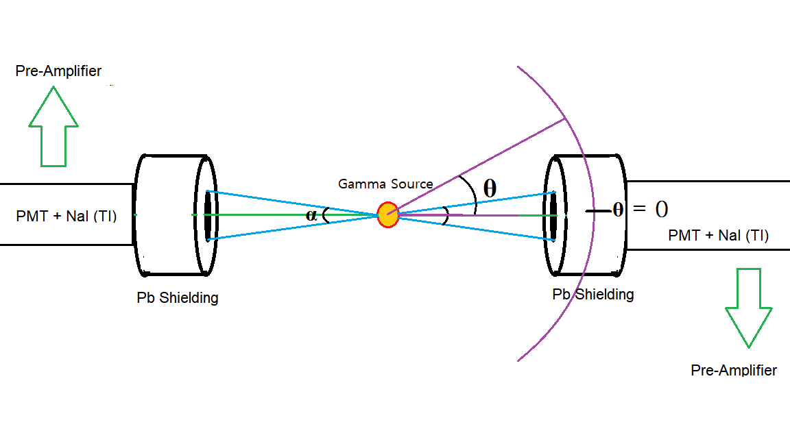

Figure (1): Bird eye view of a pair of PMT – NaI detectors: the left detector is angularly fixed by the green parallel axis, while the right detector is rotatable along the purple arc. Both detectors can slide along the parallel axis so that source – to – detector separation is adjustable.

Radiation from a source of coincident gamma rays was detected by two photomultiplier tubes (PMT), each optically coupled to Sodium Iodide Scintillation Crystals. NaI Scintillation Crystals break the original high-energy gamma-ray into a large number of low-energy photons which can be detected by the PMTs [4]. The source was placed in between the scintillators with PMT on the other side. One detector was lined up with the source along a fixed axis, and the other was allowed to swivel relative to the source [2]. The scintillators were surrounded by lead shielding which serves to collimate radiation from the source [4].

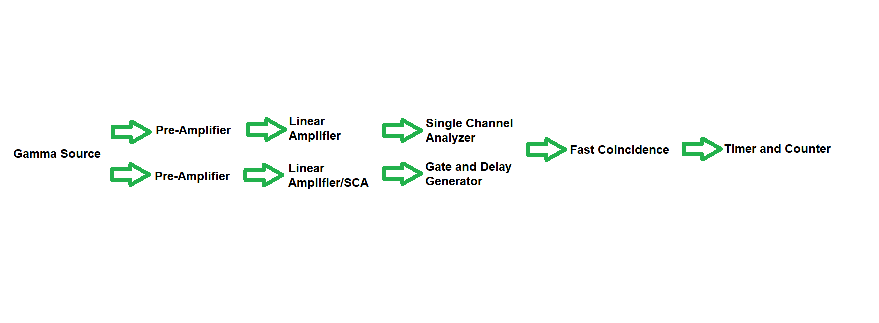

Figure (2): Coincidence circuit: the input of each pre-amplifier is connected by the output of each PMT – NaI detector.

The Gamma rays detected by each PMT – NaI detectors were then fed into each Pre-Amplifier, which amplifies the initially weak electrical signal. The amplified signals were then input to the Linear Amplifiers, which make an accurate copy of the inputs at an increased power level. One of the linear amplifiers were coupled with a Single Channel Analyzer, while the other signal was fed into the Single Channel Analyzer from the output of its Linear Amplifier; the Single Channel Analyzer produces an output if the peak of the input signal falls within the specified window. One of the signals were sent to the Gate and Delay Generator, which delays an input signal up to 110 μs, to compensate for systematic delays introduced by the instrumentation. Both signals were input to the Fast Coincidence, which outputs one signal as long as the start of a signal and the end of another fall into the specified time window. The output of the signal from the Fast Coincidence was then fed into the Timer and Counter, which counts the number of coincidences detected within a given time interval.

1. **Data Analysis and Results**

**3.1 Data Analysis and Hypothesis Testing**

We first began by setting each of the PMT – NaI detectors equidistant and directly opposite of Na22 (at an angular separation of 180 degrees). Then one of the detectors was circularly rotated about the gamma source, so that the number of coincidences could be measured at desired angular separations. We calibrated the counter so that it counts the amount of coincidences occurring in 10 seconds. We measured the coincidences in five 10-second intervals for each angular separation, and carried out the analysis using the average of the five measurements. This process was repeated at two distance (between one PMT – NaI detector and the gamma source) separations: at 5 inch separation, and at 8.5 inch separation.

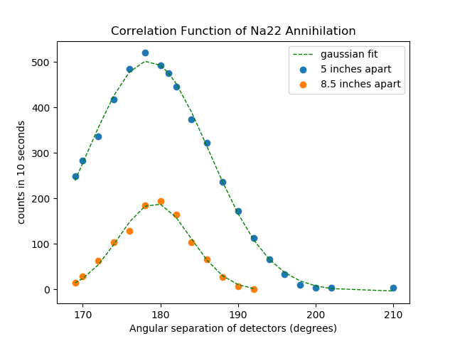

Figure (3): Two sets of angular separation vs. coincident events data + best fit Gaussian functions, each recorded at 5 inch and 8.5 inch source – to – distance separations.

|  |  |  |
| --- | --- | --- |
|  | 5 inches | 8.5 inches |
| Amplitude | 9906.63796 ± 228.7588 | 2235.46479 ± 190.7498 |
| Center | 178.461058 ± 0.086447 | 179.247667 ± 0.144290 |
| Width ( $σ)$ | 7.81238054 ± 0.134808 | 4.63951337 ± 0.276140 |
| Offset | -3.54911375 ± 5.332442 | -2.49127715 ± 7.580754 |

Figure (4): Best fit Gaussian parameters of each data set in Fig (3);

As a result, the two sets of measurements shown in Fig (3) were generated, and were each fitted to unique Gaussian functions. The analysis of the Gaussian fit returned the best-fit estimates and uncertainties of the amplitude, central angular separation, width, and offset of each coincidence peaks. The fit parameters can be used to derive a unique correlation function for each data set.

Theoretically, the most probable angular separation for maximum coincidences is at 180 degrees, since the gamma rays resulting from the antiparticle collision are to have equal and opposite momenta. As theoretically expected, the best fit centers of our measured correlation functions lie approximately at 180 degrees within less than 2 degrees of deviation. Such deviation could have been caused by incorrect angular calibration of our detectors.

The non-zero widths of our correlation function disagree with a perfect delta function, which seemingly falsify the theory of conservation of momentum and energy; if such theory were true, we’d instead expect to see sharp angular peaks of infinitely small widths centered at 180 degrees. However, such broadening phenomenon is expected due to the non-zero angular resolution of our detectors. Since our detectors have non-zero surface areas, the detection probability of coincident events is non-zero within the given angular resolution. Thus, the widths of our measured correlation functions represent the angular resolutions of our detectors at a given separation. Using trigonometry, a mathematical relationship between the angular resolution and source – to – detector distance can be derived, which is discussed further in 3.2: Calculations and Results.

**3.2 Calculations and Results**

A Gaussian function is represented by

$\frac{a}{σ\sqrt{2π}} e^{-{(θ-c)}^{2}/2σ^{2}}+ b$ (4)

where a is the amplitude, c is center, σ is width, b is offset, and θ is the independent variable, or the angular separation. Plugging in the best fit parameters given in Fig (4), the correlation functions of Na22 Annihilation at 5 and 8.5 inch source – to – detector separations can be derived.

The trigonometric relationship between source – to – detector separation, Gaussian width profile σ (proportional to angular resolution), and effective detector radius r is:

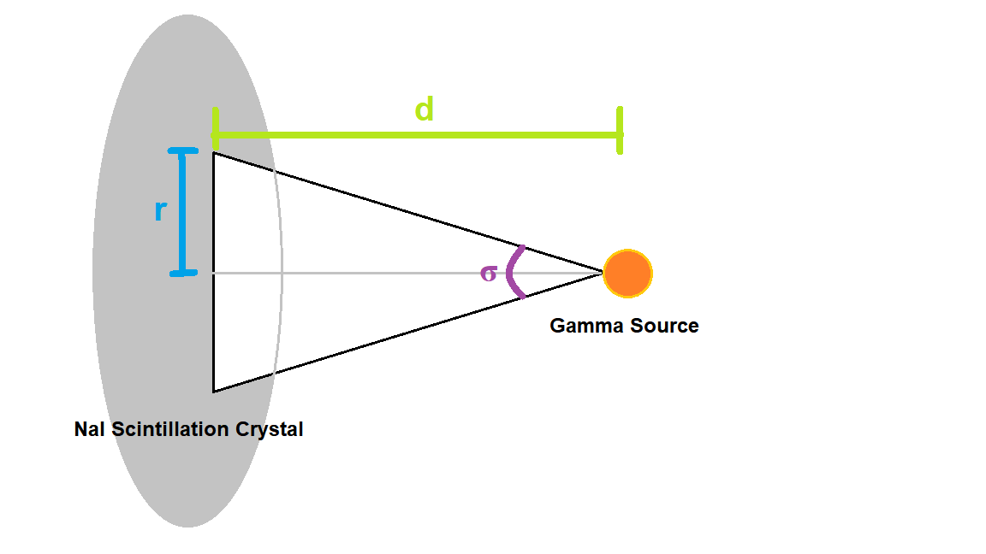

$tan\frac{σ}{2}= \frac{r}{d}$ (5)

The effective radius can be estimated using a two system of equations and the known σ and d.

$r= .3428$ ± .0015 inches (6)

where .3428 is the average of the two effective radius values solved from each set of known σ and d, and the uncertainty .0015is the half of their difference.

1. **Conclusion**

We found the experimental correlation functions for Na22 decay to be represented by a Gaussian function, Eq. (4), with its numerical parameters given in Fig (4). Both of our measured correlation functions resembled delta distributions peaking near θ = 180° with less than 2 degrees of deviation. This proves that an angular separation of θ = 180° returns the maximum probability to detect coincidental gamma rays; such result reinforces that the annihilation of an electron and a positron is a momentum and energy conserving process. Though our measured correlation functions had non-zero widths, unlike a perfect delta function, such broadening phenomenon is a result of the non-zero angular resolution of our detector.

1. **Acknowledgements**

Thank you Chris or your patience, coaching, and being open minded to hearing about my brain. I will come back to studying Co 60 when I’m a couple semesters smarter.

**References**

[1] “Annihilation Radiation.” Wikipedia, Wikimedia Foundation, 8 Sept. 2017, en.wikipedia.org/wiki/Annihilation_radiation.

[2] “Gamma Gamma Coincidence.” PHY 353L Modern Lab, University of Texas at Austin, web2.ph.utexas.edu/~phy353l/GammaGamma/gammagamma.html.

[3] “Dirac Delta Function.” Wikipedia, Wikimedia Foundation, 3 Apr. 2018, en.wikipedia.org/wiki/Dirac_delta_function.

[4] “Nuclear and Relativity Experiments: Scintillator Detector Operation” PHY 353L Modern Lab, University of Texas at Austin, https://web2.ph.utexas.edu/~phy353l/RelativisticDynamics/Scintillator%20Explanation.pdf