Grad CAM: Review of Visual Explanations for Gradient Based Localization

Charlson So
California State Polytechnical University
3801 W Temple Ave,
Pomona, CA 91768
charlsonso@cpp.edu

Abstract

Grad Cam is a visual explantion for the decisions made in convolutional neural network based models in order to increase transparency of the inner workings of a neural network. Convolutional neural networks have enabled unprecedented breakthrough in regards to computer vision tasks ranging from object detection, semantic segmentation, image captioning, and visual question answering. But their architectures are considered as a black box where a given input is defined and an output is then analyzed. Only the stimuli/response is accounted for during development of a convolutional neural network. Grad CAM seeks to dispel the inner workings of a convolutional neural network by creating visualization for a neural network.

Definitions:

Logits - Function that maps probabilities from
R(0,1) -> R(-inf, inf)

Introduction
In order to create intelligent systems and move towards integration of neural networks into more of our critical system, it must be clear why models predict what they predict. Current neural network models are not implemented in mission critical components such as flight software due to its lack of interpretability. Therefore, an explanation of why intelligent systems fail is a necessary requirement in order for the technology to be implemented into a variety of use cases.
CAM (or Class Activation Mapping) is a technique proposed by Zhou [3] for identifying discriminative regions used by a restricted class of image classification convolutional neural networks which do not use fully connected layers. This work trades off model complexity and performance for transparency. Grad CAM is a generalization of CAM and is used with a wide variety of CNN models such as fully connected layers, structure outputs, and mutli modal inputs.
In order to understand what makes a good visualization, requirements should be generated that explains what feature the neural network is using to achieve its task

- Feature Requirements For Clear Visualization

A good visual explanation should detail the predicted class by having a clear class discriminative visualization. The visualization should be able to clear localize the target category. If there is an image containing a cat and dog and the classifier has classified the image as a dog, the dog should be clearly visualized using the tool.
Another feature of a strong visualization tool should also have high resolution and capture the fine grained details of the image.

- Grad CAM Architecture

Grad CAM was designed so it can generate visualization for any CNN based network without requiring architectural changes or re
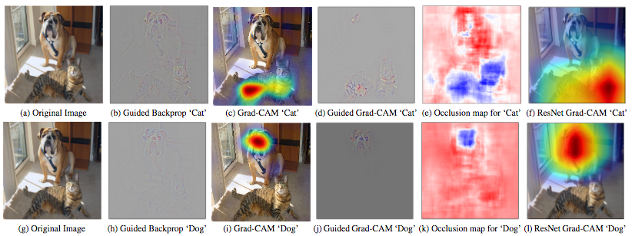

Figure 1: (a) Original Image (b-f) Support for the cat category according to visualizations for VGG (b) Guided Backpropagation highlights all contributing features. (c, f) Grad-CAM: localizes class discriminative regions (d) Combining (b) and (c) gives Guided Grad CAM

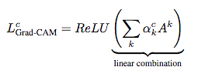
training. Human studies were also conducted to show that Guided Grad-CAM explanations are class-discriminative and can explain a stronger network from a weaker one.
Grad-CAM uses gradient information flowing into the last convolutional layer of the CNN to understand the importance of each neuron fro a decision of interest. [1] In order to generate a class discriminative localization map, Grad-CAM computes the gradient of the score for class c with respect to feature maps A^{k} of a convolution. These gradients flowing back are global average pooled to obtain the neuron importance weights.
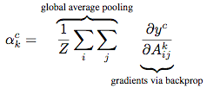
Figure 2: Calculating the partial linearization of the deep network downstream from A in order to capture the impact of feature map k for a class c.

Then a weight combination of forward activation maps is calculated and followed by a ReLU to generate a coarse heat map the same size of the convolutional feature maps. ReLU is applied because we are only interested in the features that have a positive influence on the class of interest. Negative pixels are more likely to belong to other categories.

Figure 3: Using ReLU to a linear combination of maps in order to generate a heat map.

Global average pooled convolutional feature maps are fed into a softmax to produce K feature maps. These maps are then pooled to produce a score for each class.
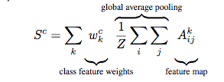
Figure 4: Generate scores for each feature map.

Finally, in order to produce a localization map the following formula is then implemented.

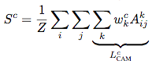
Figure 5: Calculations in order to generate localization map.

- Evaluating Visualization
The Grad CAM team then analyzed the quality of the visualization by obtaining class predictions from a network by using pretrained VGG-16 model from the Caffe Model Zoo and it was shown that Grad CAM did not effect performance and did not require retraining.
Zhang [2] introduced the Pointing Game experiment to evaluate the discriminativeness of different attention maps. Grad-CAM showed that Grad-CAM outperforms c-MWP by a significant margin (70.58% vs. 60.30%).
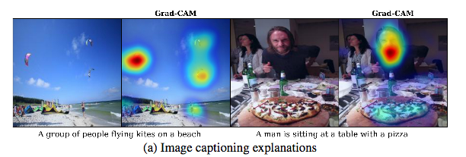
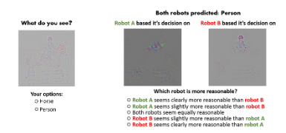
Figure 6: AMT interfaces for evaluating visualizations and trust worthiness.

Images were selected and then category specific visualizations were selected between four techniques: Deconvolution, Guided Backpropagation and Grad-CAM. Then users were asked, “Which of the two object categories is depicted in this image” [1]. 9 ratings were collected for each image and human subjects correctly identified the category in 61.23% of the cases using Guide Grad-CAM. It was also discovered that Grad-CAM helps make Deconvolution more class-discriminative.

Another aspect that can be analyzed is evaluating which visualizations seem more trust worthy. VGG is known to be more reliable than AlexNet so users were given a test to see if they were able to select VGG over AlexNet with the Grad-CAM visualization. Given a visualization from Alex Net and one from VGG 16, users were instructed to rate the reliability of each visualization tool. Human subjects were able to identify VGG over AlexNet despite viewing identical predictions from the two with different explanations.

- Image Captioning and VQA
Grad-CAM was applied to image captioning and Visual Question Answering tasks and found that Grad-CAM leads to intrepetable visual explanations compared to baseline visualizations.
Grad-CAM was built ontop of neuraltalk2 that uses a VGG-16 CNN for images and an LSTM-based language model. Given a caption,a visualization was generated. As seen in figure 7, Grad-CAM maps the generated caption to every occurance of kites and people despite their relative small size. In the image with a person and pizza, Grad-CAM correctly higlights the pizza and man and ignores the woman nearby since the class labeled is not mentioned in the caption.

Figure 7: Interpreting image captioning models

VQA architectures typically consist of a CNN to model iamges and an RNN language model for questions. Therefore, these tasks are a type of classification problem and used the score to compute a Grad-CAM visualization. In figure 8, the question “What color is the firehydrant?” was asked. Visualization for the answer red, yellow, and yellow and red were generated. The visualization changes when asked about different class labels and will concentrate on the yellow top or the entire hydrant.

Figure 8: Results of the VQA model using Grad-CAM

6. Conclusion
Grad-CAM is a technique that will generate visualizations for any CNN-based model and will help generate transparency by producing visual explanations. By combining Grad-CAM localization with existing high resolution visualizations, Guided Grad-CAM can provide high resolution class discriminative visualizations that can help clarify the underlying model.
Human studies proved that visualization can discrimante between classes more accurately and better reveal the trustworthiness of a classifier. [1] This work is desperately needed in order to advance the use of neural networks in industrial settings.
Grad-CAM can be used on various off the shelf architectures and can help further explanations of the decision made by deep networks in domains ranging from reinforcement learning, natural language processing, video applications, and perceptions tasks.

References
- R. Selvaraju. M. Cogswell. A. Das. R. Vedantam. D. Parikh. D. Batra. Grad-CAM: Visaul Explanations from Deep Networks via Gradient-Based Localization
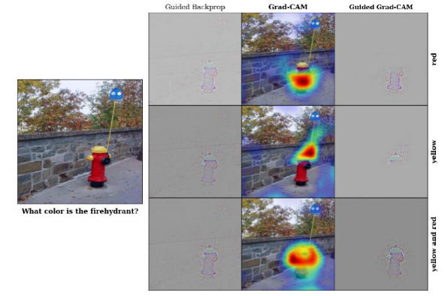
- J. Zhang, Z. Lin, J. Brandt, X. Shen, and S. Sclaroff. Top-down Neural Attention by Excitation Backprop. In ECCV, 2016. 3, 5, 2
- B. Zhou, A. Khosla, L. A., A. Oliva, and A. Torralba. Learning Deep Features for Discriminative Localization. In CVPR, 2016. 2, 3, 4, 5, 20

