Day 7 Exercises

Exercise 1
Time: 10 mins.
- Open Spring tool suite (Eclipse) and open our player application
- Go to test source code (src/test/java) and expand the package with the test file.
- Open the test
- Run the test.

Exercise 2
Time: 30 mins.
Creating tests
- Make the test fail.
Note: Look that we included an import static line on the code, import static is not common but is very usefull when you don’t want to write (in this case) Assertion.fail (“reason to fail”) too many times you can try to use this solution for any static method you want to use.

Answer
package com.beisbolicos.playerStats;

import static org.junit.jupiter.api.Assertions.fail;

import org.junit.jupiter.api.Test;
import org.springframework.boot.test.context.SpringBootTest;

@SpringBootTest
class PlayersStatsApplicationTests {

@Test
void contextLoads() {
fail("Not yet implemented");
}

}
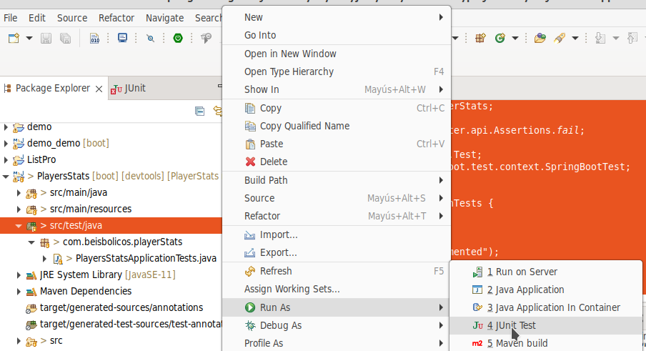
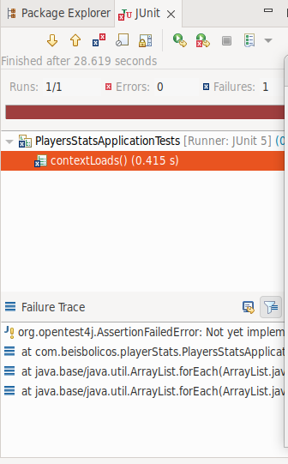

Exercise 3
Time 15 minutes.
Given the class:
package main.java;

public class MySimpleMath {
/**
* A simple method that takes and input and returns
* "positive" or "negative" depending on the input number
*/
public String checkSign(int number) {
if(number >= 0 ) {
return "positive";
} else {
return "negative";
}
}

}
create a testing class with two methods, one to check numbers as positives and other to check numbers as negative.
Execute testing.

Answer
Create a new “Maven project” on Eclipse IDE, set the MySimpleMath class on it.
Create the following test class:
package test.main;

import org.junit.*;
import main.java.MySimpleMath;

public class MySimpleMathTest {

@Test
public void testCheckSignShouldReturnPositive() {
MySimpleMath sm = new MySimpleMath();
Assert.assertEquals("positive", sm.checkSign(5));
Assert.assertEquals("positive", sm.checkSign(0));
}

@Test
public void testCheckSignShouldReturnNegative() {
MySimpleMath sm = new MySimpleMath();
Assert.assertEquals("negative", sm.checkSign(-5));
}

}
Execute tests

Exercise 4
Time 15 mins
Add a division method to the MySimpleMath class:
/**
* Returns the division of numerator by the denominator.
* If the denominator is zero, it throws an Exception
*/
public double divide(int num, int denom) {
if(denom == 0) {
throw new ArithmeticException("Cannot divide by zero");
} else {
return num/(double)denom;
}

}
Now add testing components for division. Include a part to validate an ArithmeticException.
Answer:
package com.beisbolicos.testing;
import static org.junit.jupiter.api.Assertions.assertEquals;
import static org.junit.jupiter.api.Assertions.assertThrows;

import org.junit.jupiter.api.Test;

public class AppTest {
@Test
public void testCheckSignShouldReturnPositive() {
MySimpleMath sm = new MySimpleMath();
assertEquals("positive", sm.checkSign(5));
assertEquals("positive", sm.checkSign(0));
}

@Test
public void testCheckSignShouldReturnNegative() {
MySimpleMath sm = new MySimpleMath();
assertEquals("negative", sm.checkSign(-5));
}

@Test
public void testDivisionShouldReturnPositiveQuotient() {
MySimpleMath sm = new MySimpleMath();
assertEquals(2.0, sm.divide(10, 5), 0);
assertEquals(0.0, sm.divide(0, 5), 0);
}

@Test
public void testDivisionShouldReturnNegativeQuotient() {
MySimpleMath sm = new MySimpleMath();
assertEquals(-2.0, sm.divide(10, -5), 0);
}

@Test
public void testDivisionShouldThrowArithmeticException() {
MySimpleMath sm = new MySimpleMath();
assertThrows(ArithmeticException.class, () -> sm.divide(5, 0));
}
}

Exercise 5
Create a class for multiplying arrays and found the minium
package com.beisbolicos.testing;

public class MySimpleArrayOperations {

public int findMin(int[] array) {
if(!(array.length > 0)) {
throw new IllegalArgumentException("Input array is empty");
}

int min = Integer.MAX_VALUE;
for(int i=0; i<array.length; i++) {
if(array[i] <= min)
min = array[i];
}

return min;
}

public void multiply(int[] array, int factor) {
if(!(array.length > 0)) {
throw new IllegalArgumentException("Input array is empty");
}

for( int i=0; i<array.length; i++ ) {
array[i] = array[i] * factor;
}
}

}
Now test the class with data prepared before the test executions

Answer
package com.beisbolicos.testing;

import static org.junit.jupiter.api.Assertions.assertArrayEquals;
import static org.junit.jupiter.api.Assertions.assertEquals;
import static org.junit.jupiter.api.Assertions.assertNotEquals;
import static org.junit.jupiter.api.Assertions.assertThrows;

import org.junit.jupiter.api.BeforeAll;
import org.junit.jupiter.api.Test;

public class MySimpleArrayOperationsTest {
private static MySimpleArrayOperations msao = new MySimpleArrayOperations();
private static int[] array;

@BeforeAll
public static void initInstanceVariables() {
//System.out.println(this.getClass().getName() + " --> initializing fields");
msao = new MySimpleArrayOperations();
array = new int[] {10, 2, 3, 10, 1, 0, 2, 3, 16, 0, 2};
}

@Test
public void testFindMin() {
assertEquals(0, msao.findMin(array));
assertNotEquals(10, msao.findMin(array));
}

@Test
public void testFindMinShouldThrowException() {
assertThrows(IllegalArgumentException.class,()->msao.findMin(new int[]{}));
}

@Test
public void testMultiply() {
msao.multiply(array, 10);
assertArrayEquals(new int[]{100, 20, 30, 100, 10, 0, 20, 30, 160, 0, 20}, array);
}

@Test
public void testMultiplyShouldThrowException() {
assertThrows(IllegalArgumentException.class, ()->msao.multiply(new int[]{}, 0)); //method call with dummy arguments
}

}

Exercise 6
In a new project generate a calculator service like:
public interface CalculatorService {
public double add(double input1, double input2);
public double subtract(double input1, double input2);
public double multiply(double input1, double input2);
public double divide(double input1, double input2);
}
Then implement it:

public class MathApplication {
private CalculatorService calcService;

public void setCalculatorService(CalculatorService calcService){
this.calcService = calcService;
}

public double add(double input1, double input2){
//return calcService.add(input1, input2);
return input1 + input2;
}

public double subtract(double input1, double input2){
return calcService.subtract(input1, input2);
}

public double multiply(double input1, double input2){
return calcService.multiply(input1, input2);
}

public double divide(double input1, double input2){
return calcService.divide(input1, input2);
}
}

Create mocks to add and verify and test the service

Answer
import static org.mockito.Mockito.verify;
import static org.mockito.Mockito.when;

import org.junit.Assert;
import org.junit.Test;
import org.junit.runner.RunWith;
import org.mockito.InjectMocks;
import org.mockito.Mock;
import org.mockito.runners.MockitoJUnitRunner;

// @RunWith attaches a runner with the test class to initialize the test data
@RunWith(MockitoJUnitRunner.class)
public class MathApplicationTester {

//@InjectMocks annotation is used to create and inject the mock object
@InjectMocks
MathApplication mathApplication = new MathApplication();

//@Mock annotation is used to create the mock object to be injected
@Mock
CalculatorService calcService;

@Test
public void testAdd(){
//add the behavior of calc service to add two numbers
when(calcService.add(10.0,20.0)).thenReturn(30.00);

//test the add functionality
Assert.assertEquals(calcService.add(10.0, 20.0),30.0,0);

//verify the behavior
verify(calcService).add(10.0, 20.0);
}
}

