

CSIS 4495-001
Applied Research Project
Instructor: Padmapriya Arasanipalai Kandhadai

Project Proposal
“FurBot”
This is a web-based chatbot designed to help dog owners with everyday needs. Whether you're looking for dog-friendly parks, restaurants, cafes, grooming salons, vet clinics, or supplies, this project provides quick and accurate responses to enhance your pet-friendly lifestyle.

Member:
Charlie Medialdea 300374504

Introduction

Background and Context
The idea for FurBot stems from a deeply personal experience. As a dog owner migrating to Canada with my pet, I encountered numerous challenges in navigating a new environment. Without established connections, it was difficult to find dog-friendly restaurants, reliable grooming services, and other essential resources for pet care. This experience highlighted a significant gap in the availability of accessible, localized, and reliable information for pet owners in unfamiliar settings. It became clear that many other dog owners likely face similar challenges, especially in urban areas where navigating pet-friendly facilities can be overwhelming.

Domain Overview
The focus of this research lies between pet care, technology, and conversational AI. Horizon Grand View Research (n.d.) forecasts that the pet care e-commerce market in Canada will reach USD 6,899.3 million by 2030, with an anticipated compound annual growth rate (CAGR) of 9.2% from 2025 to 2030. While numerous pet care platforms and resources are available, many are operated by small businesses with limited budgets for advertising and marketing, often lacking personalization. This makes it particularly challenging for newcomers to access relevant, localized, and reliable information efficiently.
Meanwhile, advancements in technology, particularly in artificial intelligence (AI), have transformed how users interact with technology, enabling the development of chatbots that deliver real-time assistance across various domains. Despite these advancements, the application of conversational AI in pet care remains underutilized, highlighting a significant opportunity to meet the unique needs of dog owners. FurBot addresses this gap by providing a user-friendly platform that integrates real-time assistance, personalized recommendations, and localized information, empowering dog owners to manage their pets' well-being conveniently—all from the comfort of their homes using a single, comprehensive platform.

Context of the Research
In an era where convenience and personalization are highly valued. FurBot addresses a unique role by catering specifically to the needs of dog owners. By combining real-time assistance, localized data, and user-focused personalization, FurBot transforms how pet owners access and utilize essential information. This project is not only inspired by personal experiences but also aims to empower pet owners with the resources they need to provide the best possible care for their dogs. Additionally, FurBot serves as a valuable platform for local businesses, enabling them to gain visibility in the competitive market while connecting with pet owners more effectively

Summarizing Relevant Literature and Research
During the pandemic, much of the focus shifted toward providing essential services closer to users, such as online consultations for human healthcare. However, this focus on human health often overlooked the importance of accessible care for pets. FurBot addresses this gap by consolidating localized information on essential pet services, such as nearby veterinary clinics, pet supply stores, and grooming salons, into a single platform. Designed to assist pet owners in navigating their local environment, FurBot focuses on simplifying access to reliable resources tailored to the user's location. By offering a streamlined experience, FurBot helps pet owners save time and make informed decisions about their pets' needs.

The use of chatbots for pet care has steadily increased as a means of improving accessibility and convenience for pet owners. Current research highlights several advancements:
- Virtual Assistance for Pet Owners
Woof.AI introduced a virtual canine consultant to provide personalized product recommendations and guidance tailored to individual pets' needs, enhancing convenience for pet owners (Woof.AI, 2024).
- Veterinary Chatbots
AI-powered veterinary chatbots are used for scheduling appointments, answering common questions, and sending reminders for vaccinations and follow-ups, ensuring around-the-clock support (FastBots, 2024).

Existing Knowledge Gaps or Limitations:
Despite these advancements, significant gaps remain in existing solutions:
- Limited Personalization:
Current platforms often fail to provide personalized customization to cater to the unique needs of users. For example, as a newcomer to a community, finding nearby services such as veterinarians, pet salons, or pet supply stores can be a challenge.

- Fragmented Accessibility:
Many solutions are spread across different platforms, requiring users to spend considerable time gathering information from multiple sources. This fragmented experience is both inefficient and inconvenient.

How FurBot Addresses these gaps:
- Personalization:
FurBot offers tailored recommendations based on the unique circumstances of pet owners. For instance, newcomers to an area can use FurBot to identify the nearest veterinary clinics, pet salons, and pet supply stores. By understanding the user's situation, FurBot ensures highly relevant and location-specific suggestions.
- Accessibility:
FurBot serves as a one-stop platform for pet-related information. Users can interact with the bot, which is trained to provide recommendations for veterinary clinics, pet salons, pet supplies, pet-friendly restaurants or cafes, and accommodations. This integration eliminates the need to use multiple platforms, saving users time and effort.

Hypotheses
- Users who are new to a community will find FurBot more effective in locating pet-related services compared to traditional search methods.

- Consolidating pet-related services into a single platform will significantly reduce the time users spend searching for information.

Assumptions
- Pet owners prefer personalized recommendations tailored to their unique situations, such as being new to a community.

- Users value a centralized platform for accessing multiple pet-related services, such as veterinarians, pet salons, and pet-friendly accommodations.

Potential Benefits
For Users
- FurBot saves users time by providing a one-stop platform for all pet-related services.
- Tailored recommendations enhance the user experience by addressing specific needs.

For the Community
- Local pet service providers gain visibility through FurBot's platform.
- Pet welfare improves due to easier access to timely care and resources.

Proposed Research Project

Research Design
This research adopts an exploratory and user-centred design to develop FurBot, a chatbot tailored to the unique needs of dog owners. The study focuses on leveraging conversational AI to address challenges in accessing localized, reliable, and personalized pet care information.

Objectives
- To identify the challenges faced by dog owners in finding relevant pet care information.
- To develop FurBot, a user-friendly platform offering real-time assistance, personalized recommendations, and localized data.
- To evaluate FurBot’s impact on improving the accessibility and convenience of pet care management.

Methodology
- Personal Experience: Drawing from my own challenges as a dog owner, particularly in accessing trustworthy and localized resources, FurBot aims to fill these gaps.
- Prototyping and Testing: Develop a chatbot prototype using Natural Language Processing (NLP) and test it with a small group of users for refinement.
- Technology Tools: The chatbot will be implemented using Python and integrated with AI-driven frameworks to enable smooth and personalized interactions. A supporting database will be utilized to store localized information, ensuring that responses are contextually relevant and location-specific.

Justification
The motivation for FurBot extends beyond personal experience, as it aligns with challenges I have observed in my workplace. With an extensive collection of learning materials, the primary hurdle lies in efficiently retrieving information without extensive digging. Developing FurBot not only addresses the needs of dog owners but also serves as a foundation for implementing similar chatbot technology in professional environments, where quick and accurate information retrieval can significantly improve productivity of hospital clerks.

Data Collection Methods
- Research:
- Collect data about local pet-related businesses, such as veterinary clinics, dog parks, grooming services, and pet supply stores. This information can be sourced from:
  - Online directories (e.g., Google Maps, Yelp).
  - Social media platforms where businesses advertise.

- Business Integration:
- Reach out to local pet-related businesses to gather detailed and up-to-date information (e.g., services offered, operating hours, special promotions). This can help your chatbot provide reliable and specific recommendations.

- Existing Knowledge and Resources:
- Use my own experience and knowledge of dog ownership to predefine common user queries and the corresponding responses FurBot will handle (e.g., "Where can I find a dog park nearby?").

Technologies for FurBot
- Operating System or Platform:
  - Development Environment – Windows 11
  - Deployment Environment – Cloud services such as Microsoft Azure or Google Cloud.

- Programming Language(s):
  - Python - Primary programming language for chatbot logic and integration of Natural Language Processing (NLP) features.
  - Flask – To handle the API
  - HTML/CSS/JavaScript – Front-end interface for web-based.

- Database:
  - SQLite

- Front-end:
  - Vue.js

- Backend:
  - Flask
  - OpenAI API (if possible)

Project Planning and Timeline
- https://charliemedialdea.atlassian.net/jira/software/projects/SCRUM/summary
Sprint 1


Project Contract

Work Logs
- https://charliemedialdea.atlassian.net/jira/software/projects/SCRUM/summary
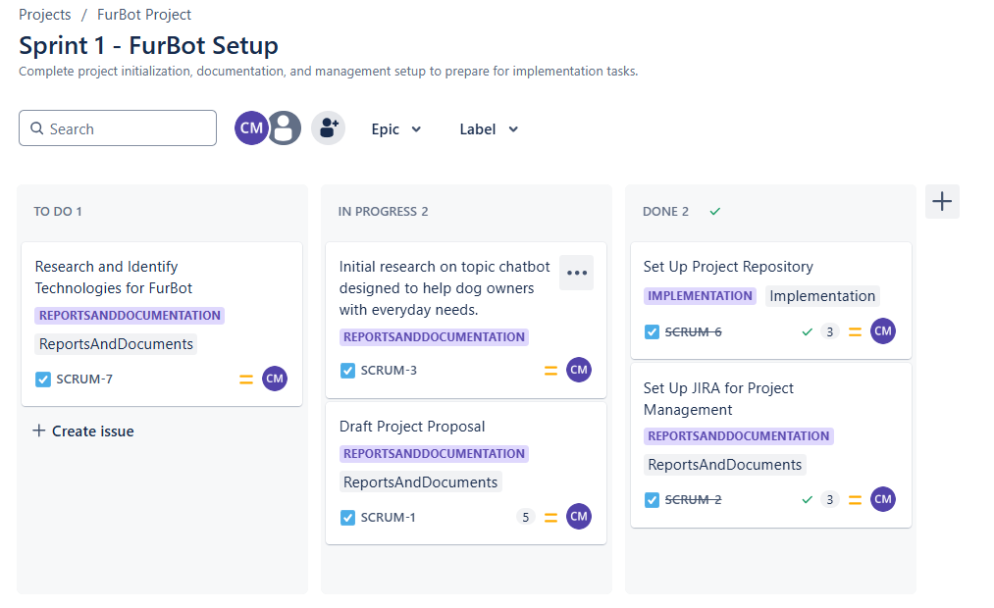

Appendix
- GitHub Repo
https://github.com/charlz1202/W25_4495_S1_CharlieM

- JIRA Project
https://charliemedialdea.atlassian.net/jira/software/projects/SCRUM/summary

References
Horizon Grand View Research. (n.d.). Pet care e-commerce market outlook: Canada. Retrieved from https://www.grandviewresearch.com/horizon/outlook/pet-care-e-commerce-market/canada
Virtual Assistance for Pet Owners
Woof.AI. (2024). Virtual canine consultant: Enhancing personalized pet care through AI. Retrieved from https://www.woof.ai
Veterinary Chatbots
FastBots. (2024). Enhancing pet care with AI: The role of veterinary chatbots. Retrieved from https://www.fastbots.ai/blog

