Final Report

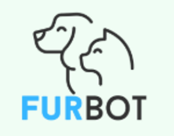
“FurBot”

  - FurBot is a web-based assistant that combines smart chatbot support with personalized pet profile management, helping dog owners easily handle everyday needs—from finding parks and grooming services to managing vet visits and reminders

Winter 2025
CSIS 4495 - 001

Presented By:
Charlie Medialdea – 300374504

Table of Contents
Introduction 4
I. Introducing the domain, and overview of the background, and context of the research 4
II. Problem Statement 4
III. Relevant Literature and Research 5
IV. Hypothesis, Assumptions, and Potential Benefit of Research 5
Summary of the Research Project 6
Changes to the proposal 7
Features Added: 7
Technology Stack 8
Project Completion Timeline 12
System Architecture (MVC Pattern) 12
Gantt Chart 13
Sprint 1 (January 18 – 25, 2025) 13
Sprint 2 (February 3 – 8, 2025) 14
Sprint 3 (February 9 – 13, 2025) 15
Sprint 4 (February 14 – 18, 2025) 15
Sprint 5 (February 19 – March 10, 2025) 16
Sprint 6 (March 11 – 18, 2025) 18
Sprint 7 (March 24 – 30, 2025) 18
Sprint 8 (March 29, - April 13, 2025) 19
Implemented Features 21
Implemented Feature 1: Login 21
Implemented Feature 2: Registration 23
Implemented Feature 3: Dashboard 25
Implemented Feature 4: Pet Profile Management 27
Implemented Feature 5: Pet Care Reminder and Scheduling 33
Implemented Feature 6: Chatbot 42
Implemented Feature 7: Saving to Favorites 48
Implemented Feature 8: Automated Email Reminder 52
Evaluation and Techniques 54
Reflections/Discussions 57
Work Date/Hours logs 58
Concluding Remarks 59
References 60
Appendix A: Installation Guide 62
Appendix B: User Guide 63
Getting Started 64
Access FurBot 64
Sign Up / Login 64
Managing Your Pet Profile 66
Add a Pet 66
Delete a Pet 67
Viewing Pet Profile and Setting a Reminders for a Pet 68
Adding a Reminder 68
Delete a Reminder 70
Email Notification 70
Using the Chatbot 71
Example commands: 71
Adding result to favorites and viewing 72
Need Help or Want to Suggest a Feature? 73
Appendix C: Survey Questionnaire 74

Introduction

Introducing the domain, and overview of the background, and context of the research
FurBot was inspired by a personal journey as a dog owner migrating to Canada and facing challenges in navigating an unfamiliar environment. Without local connections, finding dog-friendly facilities, reliable grooming services, and essential pet care resources was overwhelming. This experience revealed a significant gap in accessible, localized, and reliable information for pet owners, particularly in urban settings. It became evident that many dog owners, especially newcomers, share similar struggles in identifying pet-friendly options and resources.

Combining pet care and technology, FurBot is a web-based chatbot designed to provide pet owners with quick and reliable access to essential services and information. FurBot uses a straightforward approach by leveraging predefined intents and responses to handle user queries. Through natural language processing (NLP), the chatbot is trained to recognize user input and match it to the most relevant predefined answers, such as locating nearby veterinary clinics, grooming salons, or dog parks. Additionally, FurBot can assist users with process-related questions, such as guidelines for traveling with pets to the US. This approach ensures an efficient and user-friendly experience while consolidating resources into a single platform, helping pet owners save time and navigate pet care services with ease.

Problem Statement
Here are some questions that help frame the problem:

- How can a chatbot provide reliable and real-time assistance to dog owners in finding localized pet care resources?
- What solutions can effectively bridge the gap between dog owners and small pet-related businesses?

Dog owners often struggle to access reliable and localized information about pet-friendly facilities and services, such as veterinary clinics, grooming salons, and dog parks. This challenge is further compounded when navigating process-related tasks, like traveling with pets or understanding local pet care regulations. A centralized, chatbot-driven platform like FurBot can address these issues by leveraging predefined intents and responses, supported by natural language processing (NLP).

Relevant Literature and Research
During the pandemic, much of the focus shifted toward essential human healthcare services, such as online consultations, often overlooking the need for accessible and reliable pet care solutions. This gap in localized pet care services highlighted the challenges pet owners face in finding nearby veterinary clinics, grooming salons, and pet supply stores. FurBot addresses this gap by consolidating vital pet care information into a single, chatbot-driven platform. By leveraging predefined intents and natural language processing (NLP), FurBot provides a streamlined experience tailored to users’ locations, simplifying access to reliable resources and helping pet
owners save time while making informed decisions about their pets’ needs.

Advancements in chatbot technology have demonstrated the potential to improve accessibility and convenience for pet owners. Platforms like Woof.AI offer personalized product recommendations to enhance user experiences (Woof.AI, 2024). Similarly, AI-powered veterinary chatbots support scheduling, answer frequently asked questions, and manage reminders for vaccinations, providing round-the-clock assistance (FastBots, 2024). Building on these innovations, FurBot offers a userfriendly and efficient platform that provides real-time assistance through predefined questions and answers, supported by NLP. It ensures users receive accurate, personalized, and location-specific recommendations, meeting a wide range of needs, including finding pet-friendly spaces, accessing essential services, and addressing process-related queries like traveling with pets.

Hypothesis, Assumptions, and Potential Benefit of Research

Hypotheses and Assumptions

FurBot aims to address key challenges pet owners face in accessing reliable, localized pet care services. Localized recommendations will reduce search time for services like veterinary clinics, grooming salons, and dog parks, while personalized suggestions tailored to user profiles will enhance satisfaction. The interactive Q&A chatbot will improve engagement by providing real-time answers to common pet care questions, ensuring a seamless user experience. The development of FurBot assumes that pet owners prefer a centralized platform offering quick access to multiple pet-related services, as well as personalized and location-specific recommendations. It also assumes that real-time assistance via a chatbot is more practical and engaging than traditional search methods.

Expected Benefits

For users, FurBot simplifies pet care by acting as a one-stop platform, saving time and offering tailored recommendations. Real-time assistance enhances usability, making FurBot a dependable tool for pet owners. For the community, FurBot increases visibility for local pet service providers and improves access to timely resources, fostering better pet welfare and stronger connections within local communities.

Summary of the Research Project
FurBot is a web-based intelligent assistant designed to support dog owners in managing their pets' everyday needs through a seamless combination of chatbot functionality and pet profile management. The platform was developed to address the gap in centralized, personalized care tools for pet parents, offering a user-friendly interface backed by practical features like appointment reminders, grooming suggestions, and travel guidance.
In its final form, FurBot allows users to register, log in, and create detailed pet profiles. The system can schedule and send automated email reminders for important events such as vaccinations and grooming sessions. A key feature of the project is the AI-powered chatbot, which provides real-time assistance with common queries related to parks, dog-friendly establishments, travel requirements, grooming services, and supplies.
The backend was built with a focus on scalability and modular development, using MongoDB for data management and Flask for the API. The system supports dynamic chatbot intent expansion and integrates CRON-based scheduling for timely reminders. By centralizing key pet care functions and enhancing them with AI support, FurBot contributes to improving pet wellness, streamlining daily care routines, and supporting responsible pet ownership.

Changes to the proposal
Initially, the goal of the project was to develop a chatbot application for answering pet-related queries. However, based on the professor’s guidance and iterative feedback from users, the scope of the project was expanded significantly. The following key changes were made:

Features Added:
- User Authentication (JWT)
Originally, the chatbot did not require login functionality. However, to support personalization (e.g., saving pet profiles and reminders), authentication was added using JSON Web Tokens (JWT).

- Pet Profile Management
Users can now create and manage detailed pet profiles, capturing pet-specific information such as name, breed, and birthdate. This core feature enhances the user experience by offering a more personalized and thoughtful approach to pet care.

- Reminders System
A dedicated reminder system has been introduced, allowing users to schedule important pet care activities such as vaccinations, grooming, and vet visits. This feature helps ensure that critical health and wellness tasks are not overlooked, supporting responsible pet ownership and contributing to the overall well-being of pets.

- Email Notification Integration
With the integration of Flask-Mail, users no longer need to log in to check their pet care reminders — personalized email notifications are automatically sent for upcoming appointments such as vaccinations, grooming, or vet visits. The system checks for scheduled reminders daily, ensuring that users receive timely updates straight to their inbox. This feature adds a convenient, hands-off layer to pet care, offering a more personal and proactive experience for pet owners.

- Smart/Pro-active Notifications
Leveraging the existing reminder system and further investing in making FurBot smarter, a proactive notification feature has been implemented. The system intelligently checks the last recorded reminders for services like grooming or vaccinations, and if they exceed a defined threshold (e.g., 30 days for grooming and 365 days for vaccination), it automatically sends a personalized email to the user suggesting it's time to schedule a new appointment. This smart feature ensures pets receive timely care without requiring manual input from the user, reflecting a more intuitive and thoughtful approach to pet wellness management.

- Integration with Yelp Fusion API (External API Free Subscription)
The chatbot now fetches real-time data on pet-friendly businesses like groomers, vets, and parks request, enhancing response relevance.

- Location-Aware NLP Queries
In response to user feedback requesting more specific, location-based results, a location-aware natural language processing feature has been implemented using spaCy. Due to time constraints and the need for a solution that was easy to implement, spaCy was chosen for its out-of-the-box support for entity recognition. The chatbot can now detect and extract city names from user queries (e.g., "Looking for dog parks in Richmond"), enabling it to deliver more accurate and relevant location-specific information. This enhancement makes FurBot more context-aware and improves the overall user experience.

- Deployment to Production
Initially planned as a local-only application, the backend was successfully deployed to production using Railway, making it accessible online for testing and demo purposes.

Technology Stack
- Frontend:
  - Vue.js
No change. Used to create a responsive and user-friendly interface.

- Backend and Framework:
  - Flask (Python)
No change. Continued to provide a lightweight yet powerful backend framework.

  - Email Service: Flask-Mail
Newly added to enable the system to send automated, personalized email reminders to users. Since the project is built using the Flask framework, Flask-Mail was a natural choice due to its seamless integration and ease of use. It allowed for quick setup of an email notification system without the need for complex configurations. This feature enhances user engagement by delivering timely updates directly to their inbox, supporting a more proactive and user-friendly experience.

  - Task Scheduler: APScheduler
Newly added to automate the dispatch of reminder emails. APScheduler was integrated with Flask to schedule daily tasks that trigger email reminders through Flask-Mail. This combination ensures that reminders are sent consistently and on time without manual intervention, helping maintain a smooth and reliable user experience. By automating this process, the system becomes more efficient and scalable, especially as the number of users and reminders grows.

- Authentication and Security:
  - JWT (JSON Web Tokens)
Newly added. Enable secure user login and access control. JWT was recommended by many developer forums and is widely adopted in modern web development. It offers a good balance between ease of implementation and scalability, making it suitable for both small projects and larger systems that involve APIs or multiple services.

- Database:
  - MongoDB Atlas
No changes were made to the database choice. MongoDB Atlas continues to be used for storing user data, pet profiles, and reminders. While I have industry experience working with SQL (Structured Query Language), I chose MongoDB for this project to gain hands-on experience with NoSQL databases and explore document-oriented data modeling. This decision also aligned with the flexible and scalable nature of the application.

- Natural Language Processing:
  - String Matching: FuzzyWuzzy
No changes were made in this area. FuzzyWuzzy continues to be used for fuzzy keyword matching to handle user typos and near-matches. This approach was inspired by my previous role, where I served as the subject matter expert (SME) for our application. During the early stages of chatbot development in that role, I worked closely with the development team, and we initially used string matching to define and recognize basic user intents. That experience influenced my decision to adopt a similar method for this project, especially given my foundational knowledge in natural language processing at the time. Through research, I found FuzzyWuzzy to be a simple, Python-based solution well-suited for entry-level implementations.

  - spaCy
Newly added to enable the chatbot to extract location information from user queries, allowing it to deliver more accurate and context-aware responses. This approach was chosen because spaCy offers out-of-the-box support for named entity recognition (NER) and is easy to use, making it an ideal choice for entry-level natural language processing tasks within the Python ecosystem.

- External API and Integrations:
  - Railway
Newly added to deploy the Flask backend along with MongoDB integration into a live environment. Railway was chosen for its simplicity and ease of use, offering free tier and allowing smooth deployment of the full stack. This setup provided valuable hands-on experience with continuous integration and continuous deployment (CI/CD), helping to bridge development and production in a more automated and efficient way.

  - Yelp Fusion API
Newly added to provide real-time data on nearby pet-related services, such as groomers, veterinarians, and pet stores, based on city names detected in user input. This integration enhances the chatbot’s usefulness by offering location-specific and practical responses. Yelp Fusion was selected due to its extensive business database, ease of integration, and the availability of a free subscription tier for development and testing purposes—making it a cost-effective choice during for this project.

- Development Tools:

  - ChatGPT (OpenAI) – Paid subscription
Used extensively as a conversational assistant throughout the project. ChatGPT supported backend and frontend development by offering help with coding, debugging, and logic design. It also contributed to shaping the chatbot's behavior and flow by providing guidance on conversational structure and natural language handling. Beyond development, ChatGPT was instrumental in enhancing the quality and clarity of project reports, offering suggestions for wording, structure, and presentation. Additionally, it played a key role in helping me understand and explore new technologies that I used for the first time in this project, such as Flask-Mail, APScheduler, JWT, Flask and MongoDB.

  - GitHub Copilot – AI Coding Assistant (Integrated with Visual Studio Code)
Used as a built-in assistant within Visual Studio Code to support both backend and frontend development. GitHub Copilot provided real-time code suggestions, helping accelerate the coding process and improve efficiency. When used alongside ChatGPT, it offered a powerful combination — with Copilot suggesting code directly within the IDE, and ChatGPT providing deeper explanations, logic validation, and troubleshooting support. This collaboration significantly enhanced my development workflow and confidence in working with unfamiliar technologies.

  - JIRA – Free subscription
Used for project tracking, task management, and logging hours worked throughout the development of the project. JIRA helped maintain clear visibility over progress, deadlines, and milestones, supporting a more organized and accountable workflow even as a solo developer.

  - GitHub
Version control and project repository management.

- Document Creation
  - Canva (Free subscription)
Canva was used to enhance the visual presentation of key project documents, including the proposal, progress report, and midterm report. It allowed for a more creative and professional layout, helping to effectively communicate ideas and milestones in a visually engaging way. However, for the Final Report, I switched to Microsoft Word, as it involved compiling all project components into a single, extensive document where structured formatting and easier content management were more suitable.

  - Microsoft Word
Used for compiling and formatting the Final Report.

Project Completion Timeline

System Architecture (MVC Pattern)
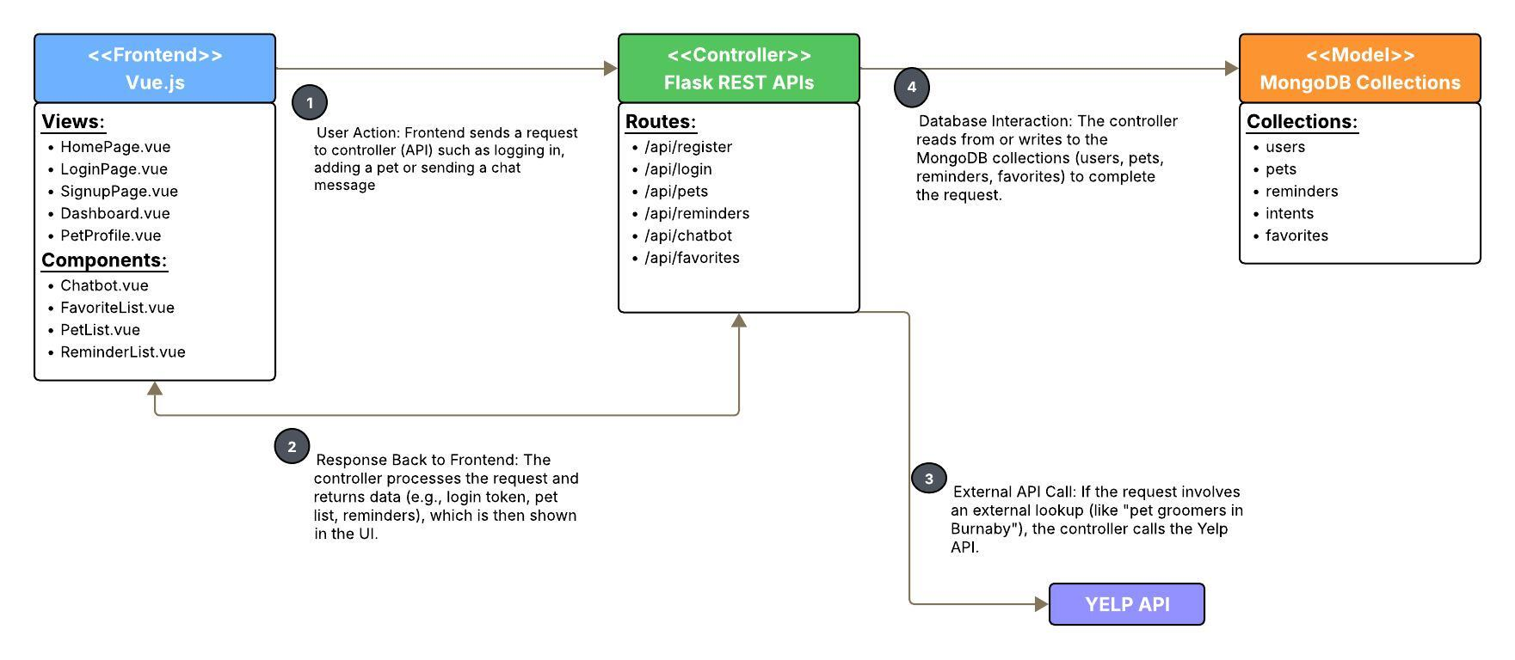

Gantt Chart
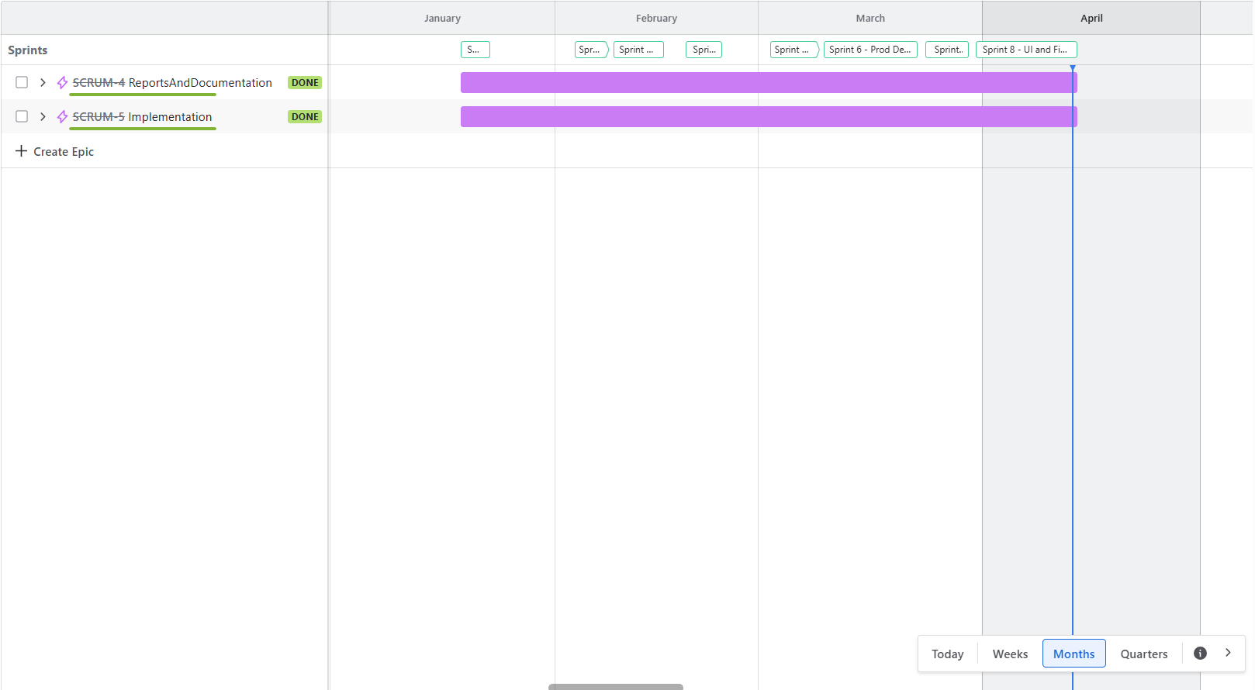

Sprint 1 (January 18 – 25, 2025)
Summary of Work Done

- Drafted the Project Proposal (SCRUM-1)
Researched and documented the scope, objectives, and deliverables for FurBot. Incorporated feedback from the professor to refine the direction of the project.

- Set Up GitHub Repository (SCRUM-6)
Initialized the GitHub repo to manage version control throughout the development cycle.

- Created JIRA Board (SCRUM-2)
Configured a JIRA board to manage tasks, track progress, assign story points (Work log), and maintain an agile workflow.

- Conducted Initial Topic Research (SCRUM-13)
Explored various approaches to pet-related chatbot solutions and framed the problem area to address a clear user need based on my own experience.

- Identified and Finalized Technology Stack (SCRUM-7)
Selected appropriate technologies including Flask, Vue.js, MongoDB Atlas.

Sprint 2 (February 3 – 8, 2025)
Summary of Work Done

- Created Backend Folder Structure (SCRUM-8)
Organized the implementation folder with subdirectories for routes, services, and configurations, following a scalable Flask project structure.

- Set Up Python Environment (SCRUM-9)
Installed Python and configured a virtual environment to manage project dependencies in isolation.

- Installed Required Dependencies (SCRUM-10)
Installed essential libraries including Flask, Flask-JWT, Flask-Mail, pymongo, and FuzzyWuzzy.

- Set Up MongoDB Integration (SCRUM-11)
Connected the backend to MongoDB Atlas and verified connectivity for storing user and pet profile data.

- Built the Authentication API (SCRUM-12)
Developed the user authentication system using JWT, allowing secure login and registration functionality.

- Tested API Endpoints (SCRUM-14)
Verified core endpoints for authentication and data handling using tools like Postman to ensure stability and correct responses.

Sprint 3 (February 9 – 13, 2025)
Summary of Work Done

- Set Up MongoDB for Pet Profiles (SCRUM-15)
Created MongoDB collections and schemas to store pet-related data.

- Create Endpoints for Pet Profiles (SCRUM-16)
Developed API endpoints to support CRUD operations for pet profiles. Integrated routes with MongoDB to allow pet data creation, retrieval, updating, and deletion.

- Set Up Reminders (SCRUM-17)
Implemented the logic to schedule reminders for pet-related tasks (e.g., vaccinations, grooming). Designed backend logic to store and manage reminder data.

- Set Up Job Scheduler to Automate Email Reminders (SCRUM-20)
Integrated a job scheduler using APScheduler to send automated email notifications based on user-defined reminder dates. Emails are delivered to the user's registered email address using Flask-Mail.

Sprint 4 (February 14 – 18, 2025)
Summary of Work Done

- Progress Report #1 (SCRUM-18)
Compiled and submitted the first formal progress report covering Sprint 3 deliverables and initial plans for Sprint 4.

- Initial Functional UI for Login & Sign-Up (SCRUM-21)
Built the front-end components for user login and sign-up using Vue.js. Integrated form validation and navigation for smooth user flow.

- Basic UI for Adding & Viewing Pets (SCRUM-22)
Created the UI elements for users to input pet profiles and view existing entries for pet profile management.

- User Session Handling (SCRUM-24)
Implemented logic to store JWT tokens and maintain authentication state across pages using local storage.

- API Integration for Authentication & Pet Management (SCRUM-23)
Connected the frontend with backend API endpoints for user login, registration, and CRUD operations for pet profiles (e.g., POST to add user to the database and GET to display the saved pets.

- UI Testing & Debugging (SCRUM-25)
Performed testing on all UI components to fix layout issues, logic bugs, and ensure a responsive and smooth user experience.

Sprint 5 (February 19 – March 10, 2025)
Summary of Work Done

- Create API Endpoint for Chatbot (/chatbot) and Simple UI Integration (SCRUM-26)
Built the initial Flask API endpoint for chatbot interaction. Set up a simple UI to test chatbot responses and ensure request-response flow using static intents.

- Midterm Report and Video (SCRUM-33)
Prepared and submitted a detailed midterm project report along with a walkthrough demo video highlighting progress and key features implemented.

- Implement Basic Chatbot Logic (SCRUM-27)
Developed the foundational logic for parsing user input and generating appropriate responses using FuzzyWuzzy string matching for intent detection and similarity scoring.

- Yelp Registration and Initial Setup (SCRUM-28)
Registered the app with Yelp Fusion API and configured API keys and request handling logic.

- Integrate Yelp with Backend API (SCRUM-31, 35, 38, 40)
Connected Yelp API to the backend by creating functions that dynamically fetch data for pet-related services based on user queries and location.

- Create Initial Chatbot UI (SCRUM-30)
Designed and implemented a basic chatbot interface allowing users to type messages and view responses in real-time.

- Integrate Yelp with Chatbot UI (SCRUM-34, 36, 37, 39)
Enhanced the chatbot frontend to handle and display Yelp results using cards to display the business name, address and ratings.

- Implement Basic Conversation Flow (SCRUM-32)
Created basic interaction logic including greetings, help prompts (e.g., what are the different questions user can ask, and fallback responses to improve user experience.

- User Session Handling (SCRUM-24)
Handled token storage and user session persistence to maintain login state across since I’ve implemented the dashboard.

- API Integration for Authentication & Pet Management (SCRUM-23)
Integrated both the chatbot and pet profile management into a unified dashboard. This required reworking the layout and logic to ensure seamless interaction between authentication, pet data handling, and chatbot functionality within a single interface.

- Creating Progress Report #2 (SCRUM-44)
Prepared report #2 for project tracking and submission.

Sprint 6 (March 11 – 18, 2025)
Summary of Work Done

- Sign Up with Railway (SCRUM-45)
Created a Railway account and set up the project environment to enable cloud-based deployment for FurBot.

- Deploy FurBot to Railway 1 (SCRUM-46)
Performed the initial deployment of the FurBot backend to Railway.

- Test and Debug – March 12 (SCRUM-47)
Tested the deployed application, fixed issues related to API prefixing, CORS policies, and ensured that frontend-backend communication worked as expected.

- Deploy FurBot to Railway 2 (SCRUM-48)
Attempted a second round of deployment but continued facing CORS configuration issues that prevented the frontend from accessing the backend API. Investigated headers and Flask-CORS settings but was unable to fully resolve the issue during this sprint. Environment variable setup was completed.

- Deploy FurBot to Railway 3 (SCRUM-49)
Proceeded with the deployment despite ongoing CORS challenges. Updated wsgi.py and configured the production start command. Frontend assets loaded successfully, but API interaction remains limited due to unresolved CORS restrictions.

Sprint 7 (March 24 – 30, 2025)
Summary of Work Done

- Automate Email Reminders (SCRUM-52)
Refined the job scheduler to ensure reminder emails are sent using PST (Vancouver Time). Verified backend logic for triggering emails and improved reliability of the APScheduler task.

- UI Enhancement 1 (SCRUM-55)
Changes the theme into green as light and family and pet-oriented app.

- UI Enhancement 2 (SCRUM-58)
Continuation of UI enhancement.

- Store Frequently Asked Questions in MongoDB (SCRUM-29)
Added a new MongoDB collection to store FAQs for chatbot use. This enables static responses to common user queries and lays the groundwork for richer conversational flows e.g., adding spaCy.

- Retry Production Environment Deployment (SCRUM-53)
Made another attempt to deploy FurBot to Railway. Continued efforts to resolve CORS issues and verify backend availability in production, with partial success.

- Progress Report #4 (SCRUM-54)
Documented the sprint’s progress, challenges (particularly deployment-related), and updates to features like email reminders and UI enhancements.

Sprint 8 (March 29, - April 13, 2025)

Summary of Work Done:
- Final Report Documentation 1–5 (SCRUM-62 to SCRUM-66)
Prepared the comprehensive final report in five stages, covering all technical components of FurBot. Sections included: system overview, implemented features, backend logic, API integrations (spaCy, Yelp), changes to the proposal and project completion timeline.
- spaCy Implementation for Location Extraction (SCRUM-60)
Integrated spaCy to extract city/location names from chatbot queries. This enhanced the chatbot’s ability to deliver accurate, location-specific responses for pet services (e.g., “dog groomers in Burnaby”).

- User Evaluation (SCRUM-61)
Conducted user testing to assess ease of use, chatbot interaction quality, and overall satisfaction. Collected feedback on reminder creation, pet profile setup, and chatbot suggestions for future improvements.

- Personalize Feature for Additional Novelty – Day 1 to 4 (SCRUM-56 to SCRUM-59)
Implemented FurBot’s intelligent reminder suggestion system.
- Tracked last sent reminder date per pet
- Suggested reminders like grooming or vaccination based on time elapsed
- Integrated logic into chatbot to offer actionable prompts
This feature adds novelty and proactive care suggestions for users.

- Progress Report #5 (SCRUM-67)
Compiled and submitted the fifth progress report. Summarized feature implementations, ongoing challenges (e.g., spaCy accuracy, UI polish), and deployment readiness.

- Presentation Preparation (SCRUM-68)
Developed slides and demo plan for the final presentation. Ensured feature walkthroughs (chatbot, reminders, favorites) were well-organized and aligned with project goals. Practiced delivery to meet time constraints.

Implemented Features

Implemented Feature 1: Login
Description:
This feature allows registered users to securely log in to the FurBot platform. The frontend login form captures the user’s email and password, then sends a request to the backend API. Upon successful authentication, a JWT token and user ID are returned and stored in localStorage, granting access to the dashboard and other authenticated features.

Frontend (Vue.js): LoginPage.vue
Handle user login through a form that collects email and password. On submission.
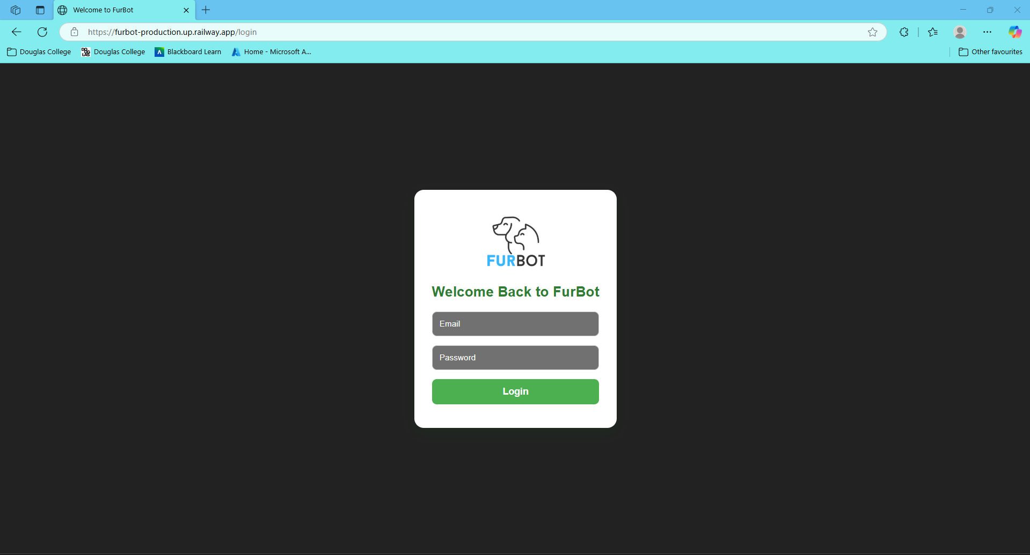
Figure 0: Log in UI with form.

Code Highlight: LoginPage.vue - handleLogin() method calls the authService.js to validate the credentials and store the token
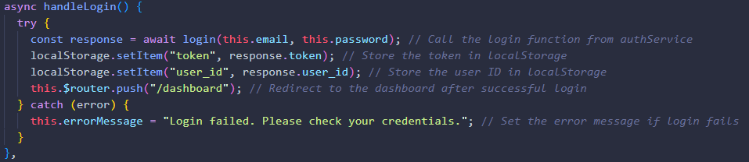
Figure 1: Method from LoginPage.vue triggering API Call and redirecting on success

Service Layer: Contains the login() function, which sends a POST request to the Flask API with the user’s credentials. It expects a response containing a token and user ID.
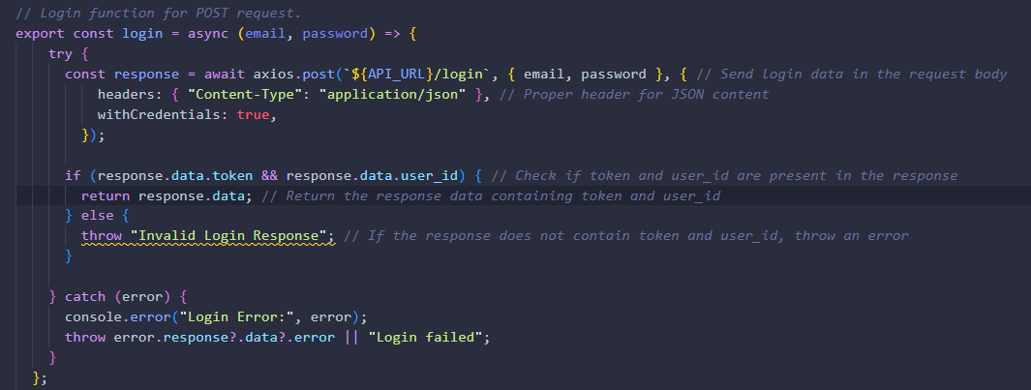
Figure 2: Login function in authService.js that handles API call and returns token upon success

Backend: (/api/login) This Flask route handles authentication. It validates the email and password against the MongoDB user’s collection. If valid, it generates a signed JWT token valid for one hour and returns it with the user ID.
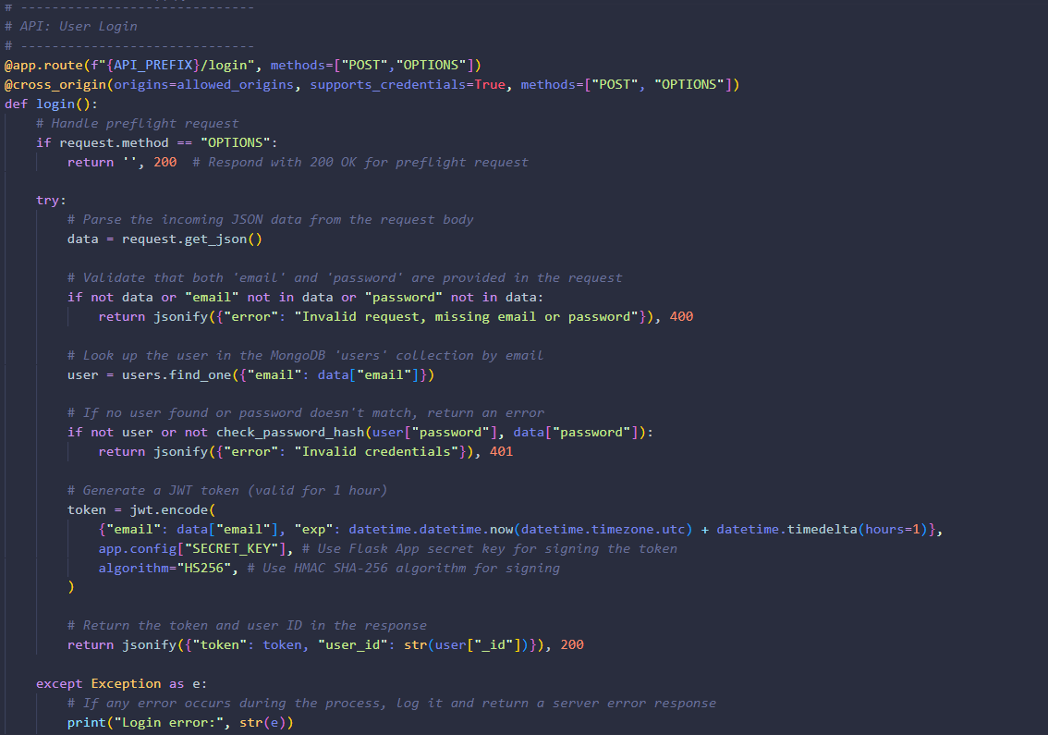
Figure 3: Flask API endpoint for login, handling credential validation and token generation

Summary of Logic Flow:
- User enters email and password in the login form
- LoginPage.vue triggers handleLogin() calls authService.js - login().
- authService.js sends POST to /api/login.
- Flask verifies credentials and return JWT + user ID.
- Token and user ID are stored in localStorage (e.g., cookies).
- Users redirected to the dashboard.

Implemented Feature 2: Registration
Description:
This feature enables new users to create an account in FurBot by entering their email, and password. Once successfully registered, the user is redirected to the login page to access personalized features.

Frontend (Vue.js): SignupPage.vue
Displays a registration form that collects the user's email, and password. On submission, the handleRegister() method calls the register() function in authService.js, handles validation, and redirects the user upon success.
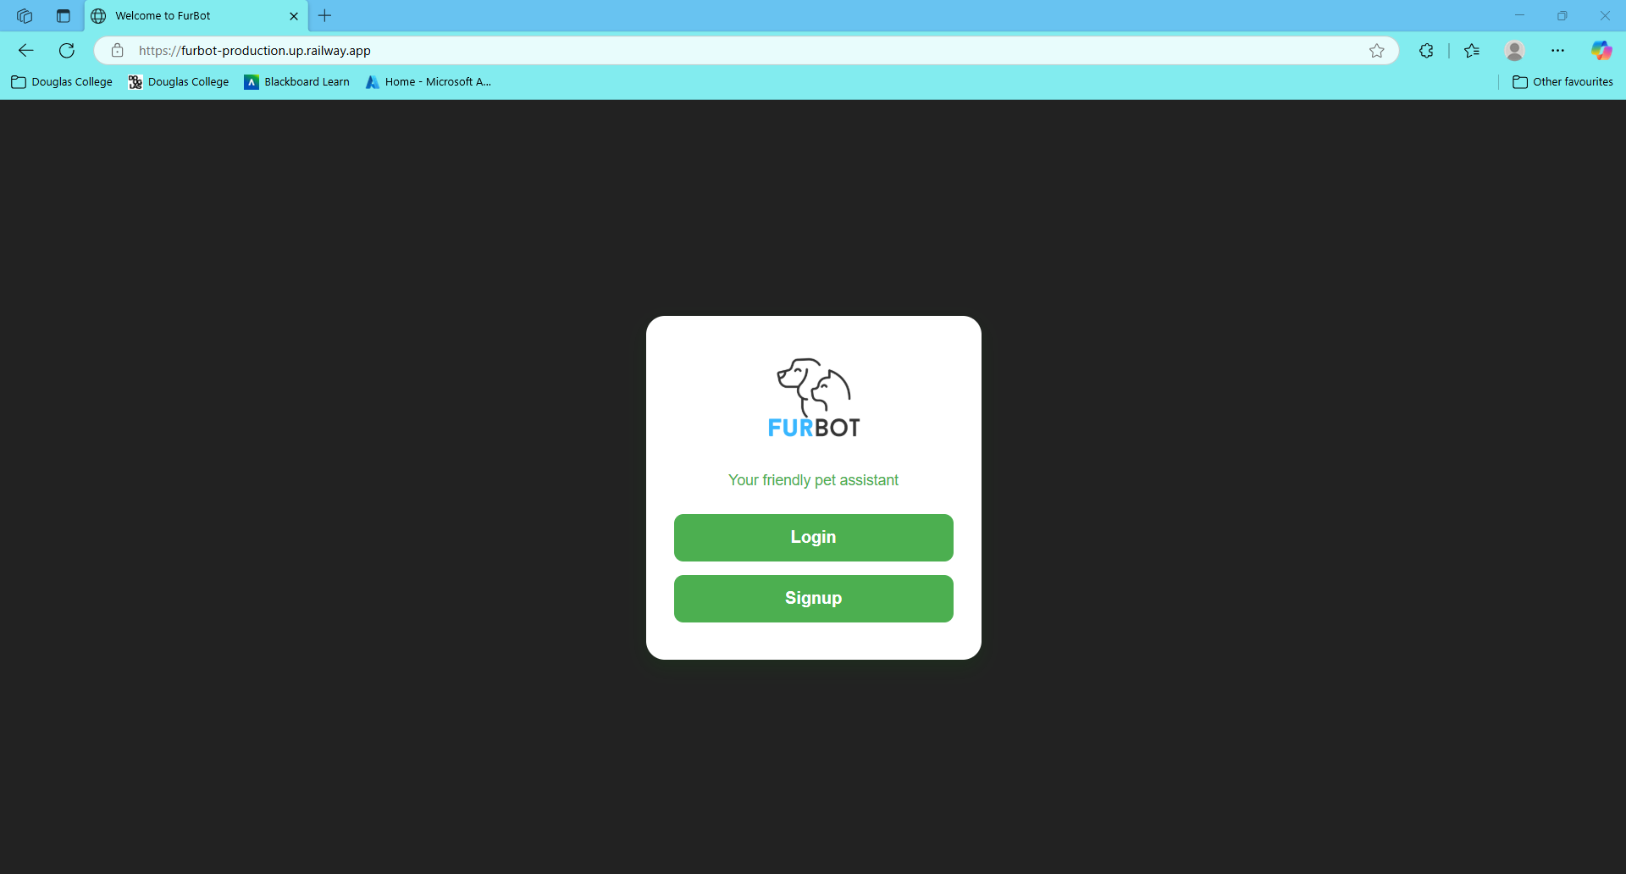
Figure 4: Sign up UI with form

Code Highlight: SignupPage.vue - handleSignup() method calls the register() function in authService.js, handles validation and redirects upon successful.
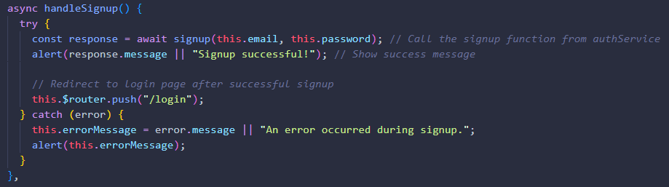
Figure 5: handleSignup() method from SignupPage.vue handling user registration and form submission

Service Layer: Defines the signup() method which sends a POST request to the /api/register endpoint. It returns the response message or throws an error if validation fails.
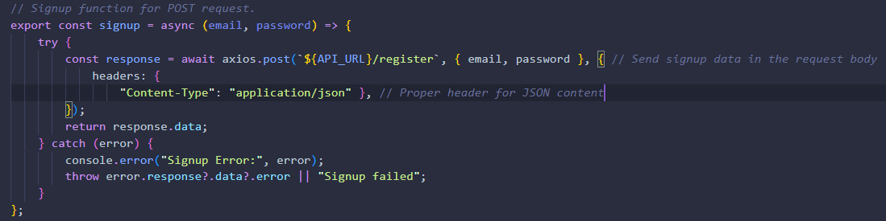
Figure 6: Registration method in authService.js that sends POST request to app.py (backend)

Backend: (/api/register) This API endpoint validates input data, hashes the password securely using werkzeug.security, and inserts the new user into the MongoDB users collection. If the user already exists, it returns an error.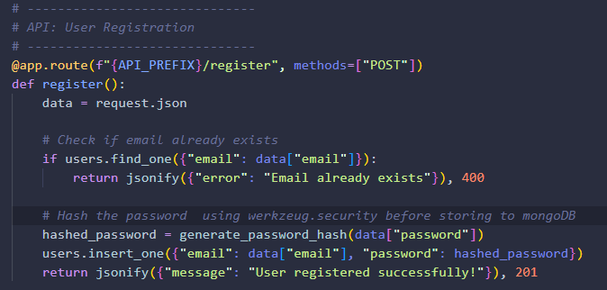
Figure 7: Flask API route for /api/register handling input validation and user creation

Database: users collection

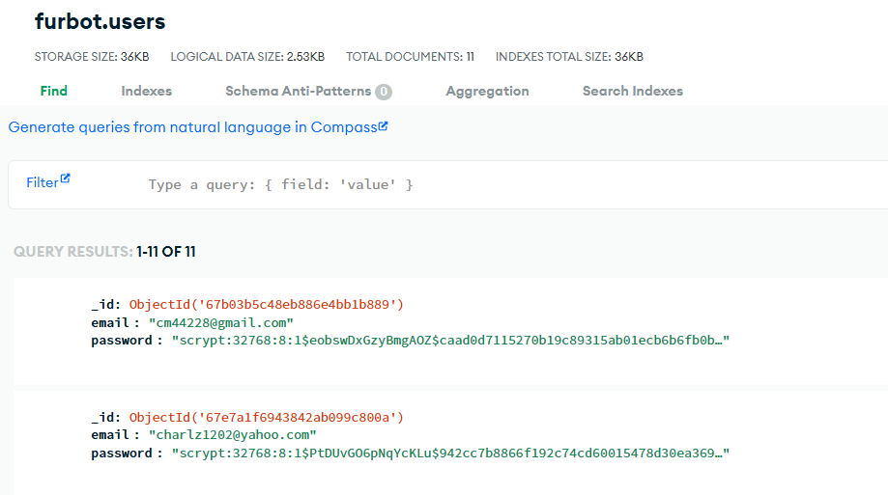

Summary of Logic Flow:
- User enters name, email, and password in the registration form.
- SignupPage.vue triggers handleRegister() calls authService.js - register().
- authService.js sends POST to /api/register.
- Flask validates input, hashes the password, saves to MongoDB.
- Success response is returned and user is redirected to /login.

Implemented Feature 3: Dashboard
Description:
After successful login, users are redirected to the Dashboard, where they can manage their pet-related information. This includes viewing and managing favorites, adding or deleting pets, checking upcoming reminders, and interacting with the FurBot Chatbot for assistance. The interface is personalized for the logged-in user using their JWT token and user ID stored in localStorage.

Frontend (Vue.js): Dashboard.vue
  - <FavoriteList /> – Displays saved result from Yelp.
  - <PetList /> – Shows all pets registered by the user
  - <ReminderList /> – Lists upcoming pet care reminders
  - <Chatbot/> – AI chatbot that supports pet-related queries and integrates with Yelp.
  - Logout button (calls handleLogout())

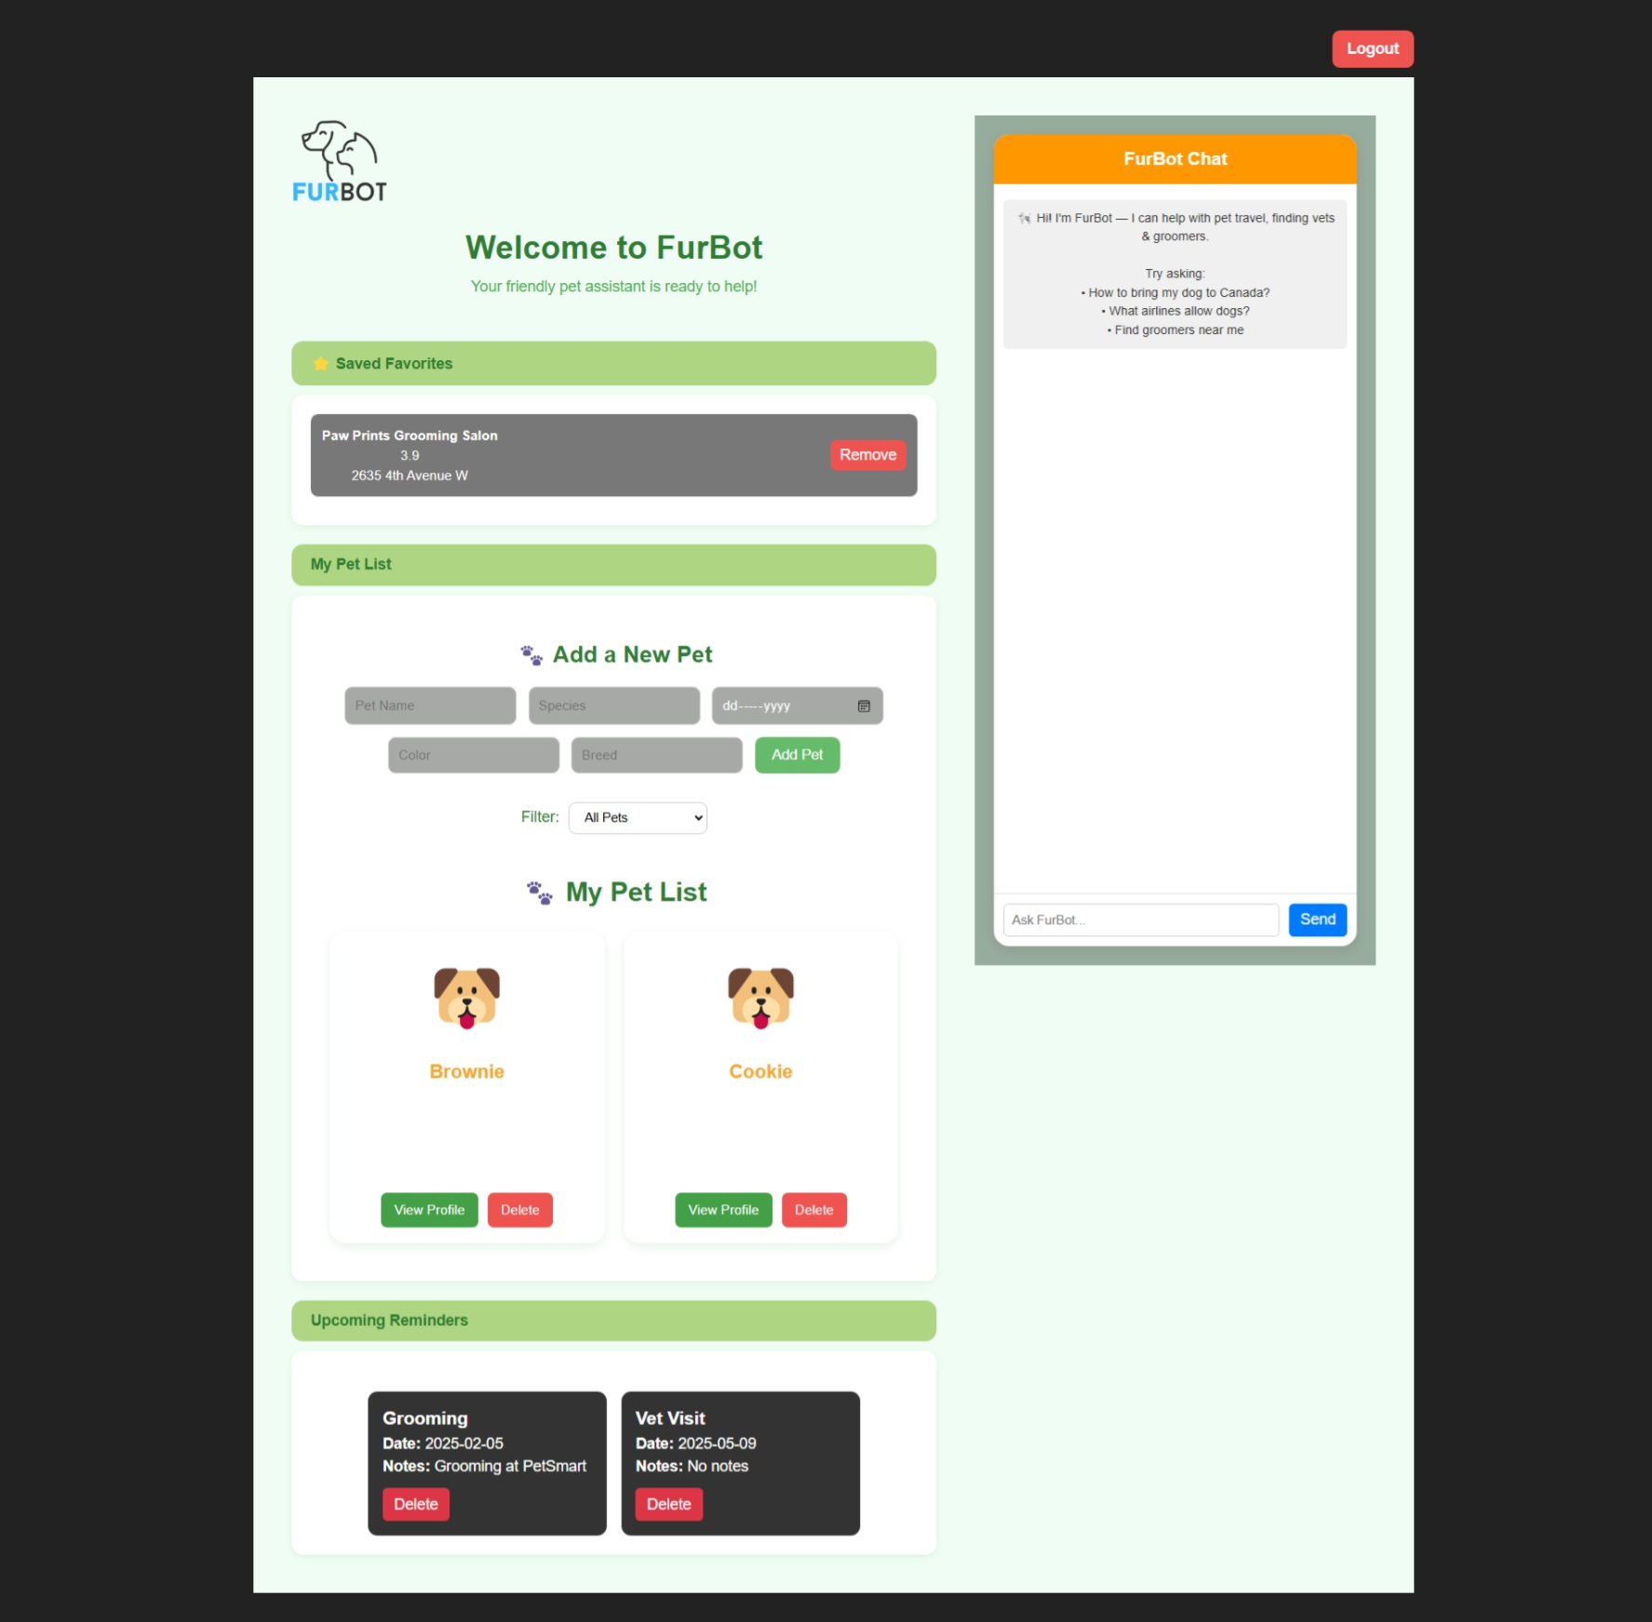
Figure 8: Dashboard UI and chatbot where user can input a question.

Code Highlight: Dashboard.vue - handleLogout() Logs the user out and redirects to the login page.
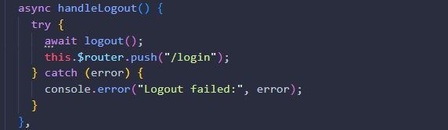
Figure 9: handleLogout() method from Dashboard.vue logs the user out of FurBot and redirected to Login page.

JWT Token Check (on mount):
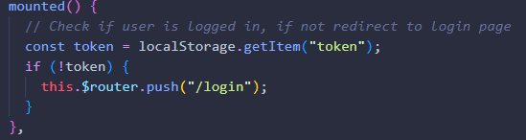
Figure 10: Dashboard logic in Dashboard.vue checking for authentication

Summary of Logic Flow:
- After login, user is redirected to /dashboard
- Vue checks for JWT token in localStorage
- Displays:
- User’s favorite businesses
- Pet profiles from MongoDB (/api/pets)
- Reminders fetched via /api/reminders
- Chatbot available for pet related queries

Implemented Feature 4: Pet Profile Management
Description:
This feature allows users to manage their pets from the Dashboard after login. Users can add a new pet, view all registered pets, and remove any pet from the list. Each pet includes attributes like name, species, birthdate, breed, and color. The data is saved in the MongoDB collection and retrieved using the logged-in user’s ID (via JWT token).
Frontend (Vue.js): PetList.vue
Add a Pet Form
User can input a new pet’s details and submit the form. The data is sent to the backend using Axios and displayed immediately in the pet list.

Pet List Display
Displays all pets saved by the current user in card format. Each card includes the pet’s name, species, and action buttons (View Profile, Delete).

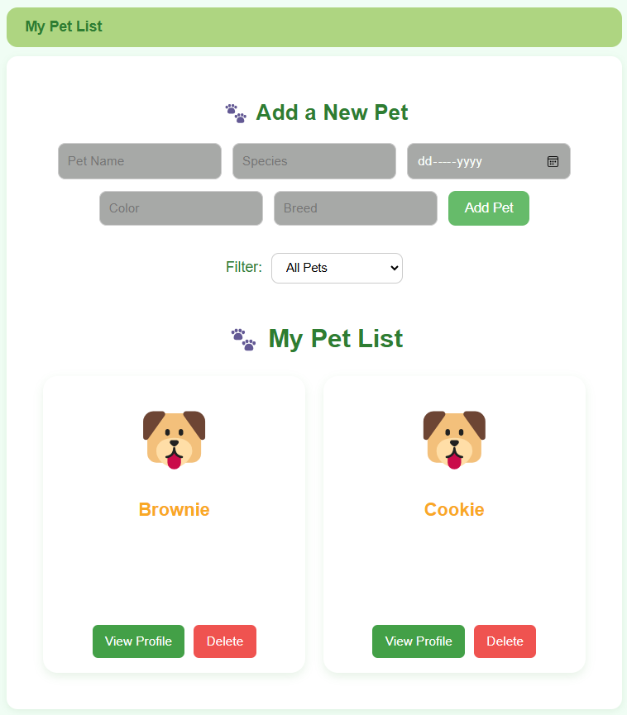
Figure 11: Add a Pet Form UI from PetList.vue

Code Highlight: Displays a form for adding a new pet and a list of pets saved by the logged-in user. The addNewPet() method is triggered when the form is submitted. It calls the addPet() method in the service layer, cleans the form, and refreshes the pet list display fetchPets() method and it triggers getPets() from service layer. Also, if user delete a pet, it calls the deletePet() method which then calls deletePet() from service layer.
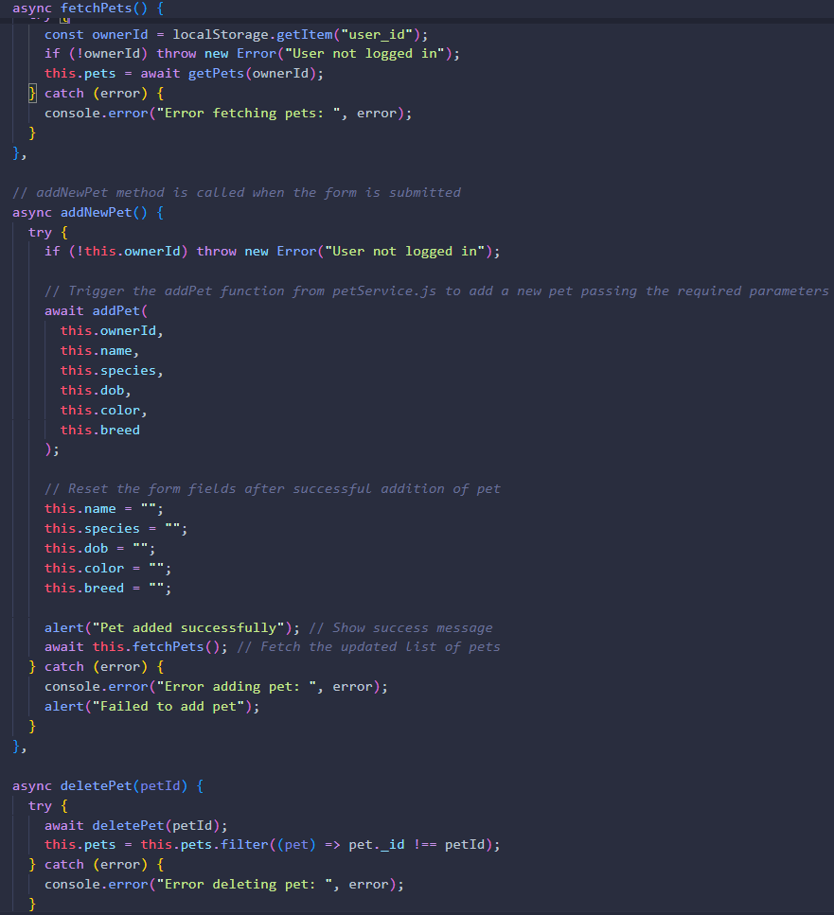
Figure 12: Method in PetService.js handling form submission for adding a new pet and displaying pets and it also allow user to delete a pet.

Service Layer: addPet() in petServices.js – This function sends a POST request to the /api/pets endpoint with the pet data and the user’s ID. It uses the authentication token stored in localStorage to associate the pet with the correct user.
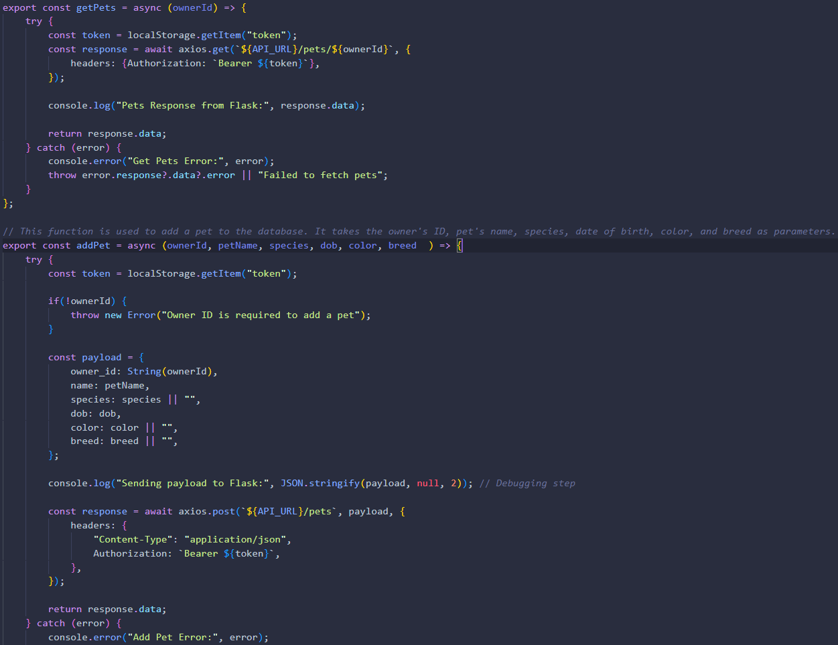
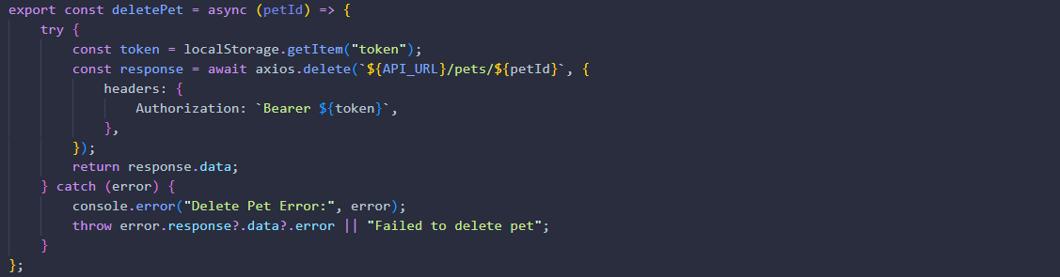
Figure 13: Method in petService.js that sends a POST | GET | DELETE request with pet data to the backend

Backend: (/api/pets) This endpoint receives the POST request to create a pet. It verifies the user’s token, saves the pet to the pets collection in MongoDB, and associates it with the provided owner_id.
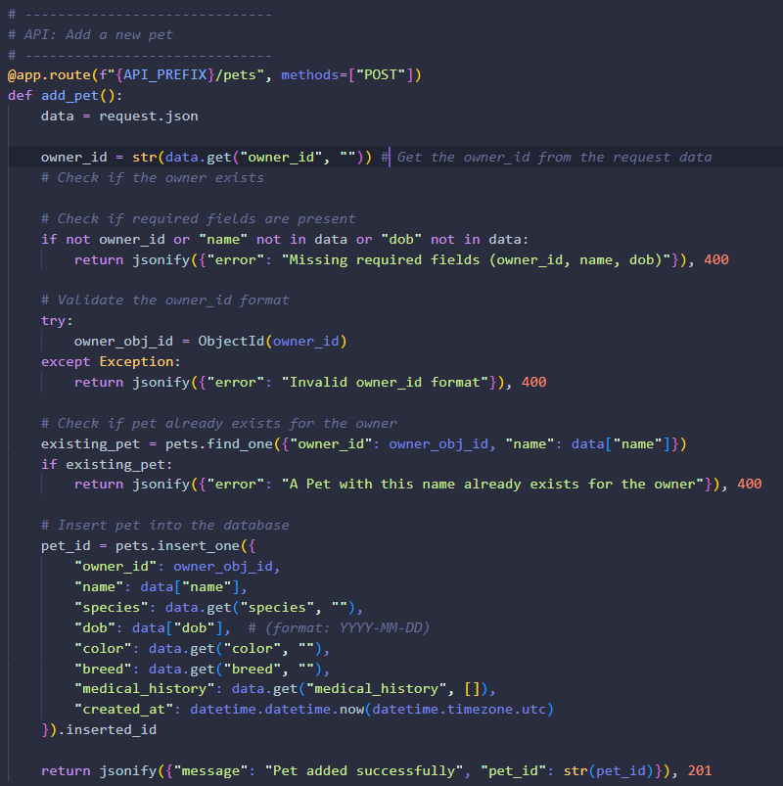
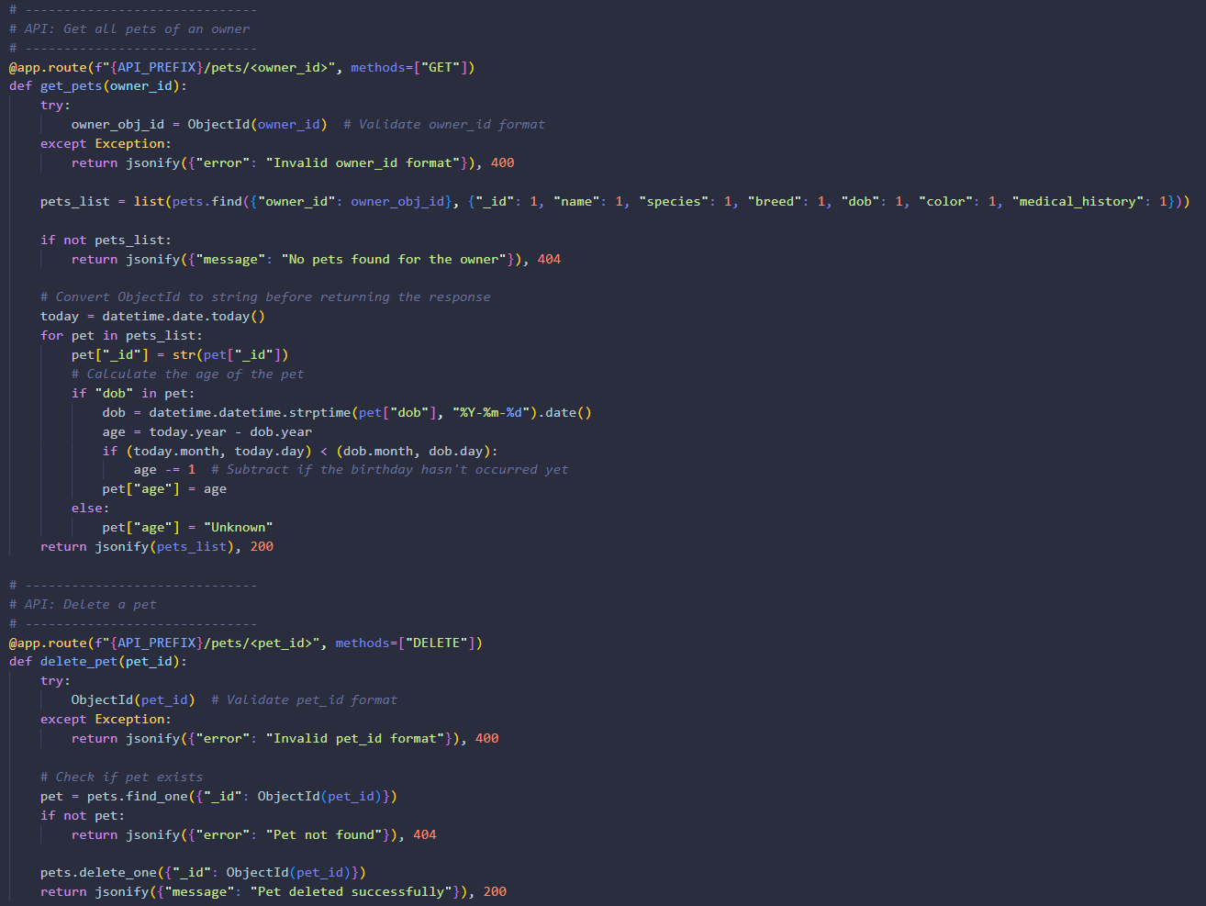
Figure 14: Flask API route for /api/pets (POST) , /api/pets/<owner_id>, /api/pets/<pet_id> handling input validation and user creation

Database: Pets collection from MongoDB
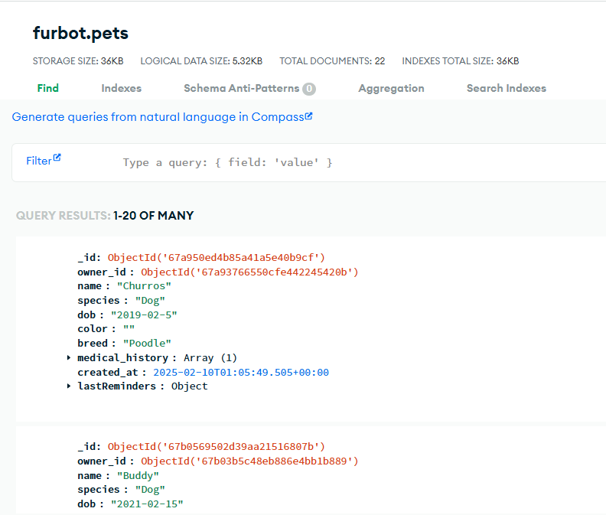

Figure 15: MongoDB Pets collection

Summary of Logic Flow:

Add new pet:
- User enters pet details into the form on PetList.vue
- addNewPet() triggers → calls addPet() from the service layer
- addPet() sends a POST request to /api/pets with JWT token and form data
- Flask validates the token and saves the pet in MongoDB under the user's owner_id
- The updated pet list is fetched using getPets() and reloaded in the dashboard
To retrieve pets:
- In PetList.vue, fetchPets() is triggered calls getPets() using the logged-in user's ID
- getPets() sends a GET request to /api/pets, including the token
- Flask decodes the token and returns only the pets associated with the authenticated owner_id
- The frontend displays the fetched pet list in real-time
To delete a pet:
- User clicks the “Delete” button on a pet card
- deletePet() is called → sends a DELETE request to /api/pets/<pet_id>
- Flask verifies the token and removes the pet from MongoDB
- The pet list is refreshed by calling getPets() again and updating the view

Implemented Feature 5: Pet Care Reminder and Scheduling
Description:
This feature allows users to manage care reminders for their pets, such as grooming, vaccinations, and vet visits. From the pet profile screen, users can view, add, and delete reminders associated with a specific pet. All reminder data is stored in the MongoDB reminders collection and is only accessible to authenticated users.

Frontend (Vue.js): PetProfile.vue
Add a Reminder Form
User can input a new pet’s reminder (e.g., Vaccine, Grooming or Vet Visit) and submit the form. The data is sent to the backend using Axios and displayed immediately in the PetProfile.vue.

Reminder Display
Displays all reminders saved by the current pet in card format. Each card includes the specific pets reminder.

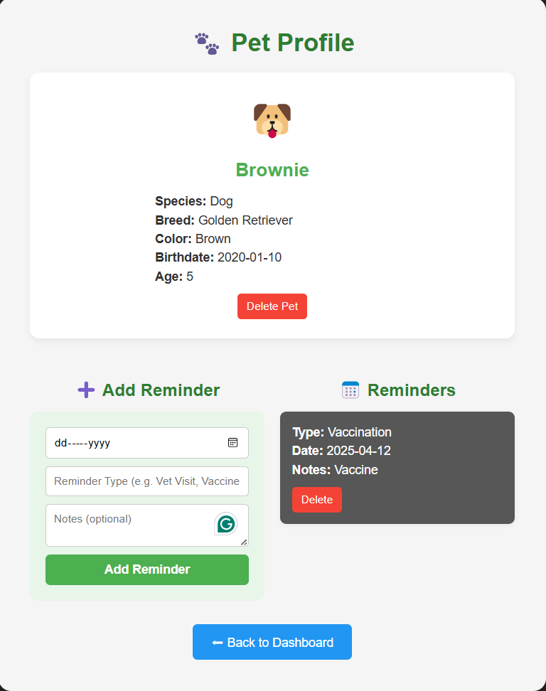
Figure 16: Add reminder and fetchReminders() to get the list of reminders for a pet from PetProfile.vue

Reminder Display
The mounted() lifecycle hook in ReminderList.vue is triggered when Dashboard.vue is loaded, and it calls getRemindersForOwner() to fetch reminders
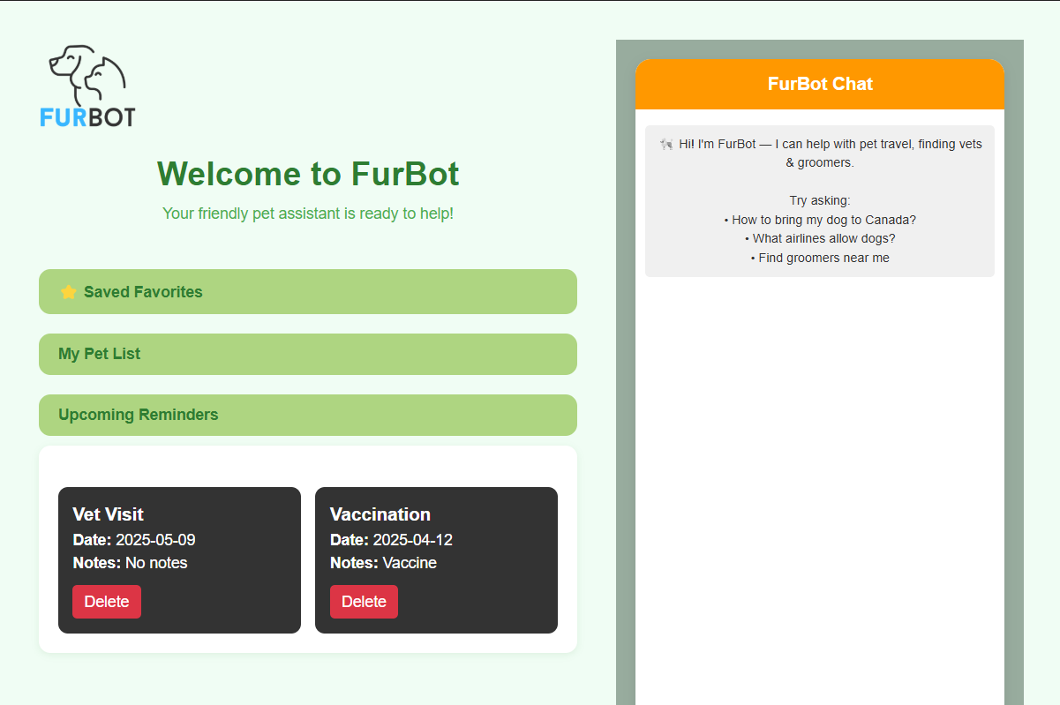

Figure 17: Reminder list from Dashboard which gets the reminder for an owner.

Code Highlight: The component fetches reminders for a specific pet when the page loads. It also includes a form where users can input a reminder type (e.g., grooming), choose a date, and optionally add a note.

- When the form is submitted, the addNewReminder() method calls the addReminder() function from the service layer, then refreshes the reminder list.
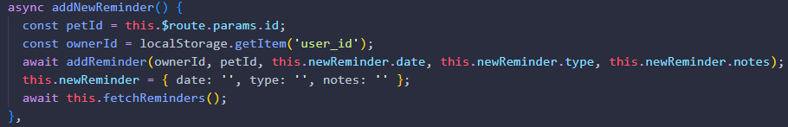
Figure 18: addNewReminder() method from PetProfile.vue.

- In PetProfile.vue, the fetchReminders() method invokes getRemindersForPet() from the service layer, which sends a GET request to /api/reminders/<pet_id> to retrieve pet-specific reminders.

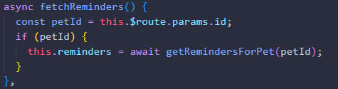
Figure 19: fetchReminders()method from PetProfile.vue

- In Dashboard.vue, the mounted() lifecycle hook of the embedded ReminderList.vue component is triggered automatically. Inside ReminderList.vue, it calls getRemindersForOwner(), which sends a GET request to /api/reminders/owner/<owner_id> to retrieve owner-wide reminders.

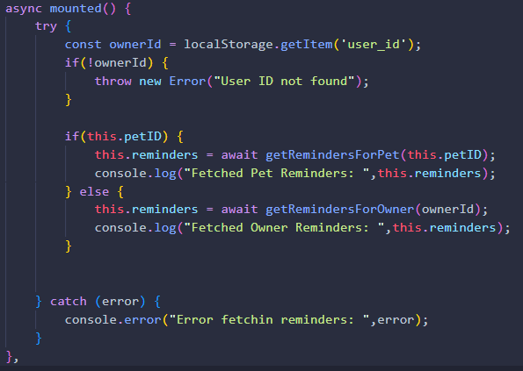
Figure 20: mounted() lifecycle embedded in ReminderList.vue.

- The deleteReminder() calls deleteReminder() from the service layer that sends a DELETE request from the backend /api/reminders/<reminderId> to remove the reminder.
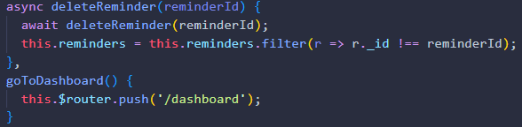
Figure 21: deleteReminder from PetProfile.vue.

Service Layer: addPet() in petServices.js – This function sends a POST request to the /api/pets endpoint with the pet data and the user’s ID. It uses the authentication token stored in localStorage to associate the pet with the correct user.

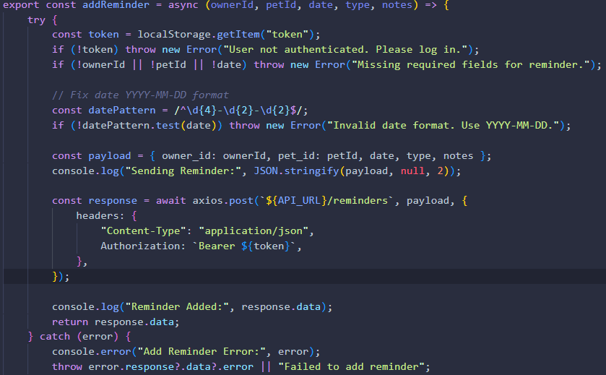
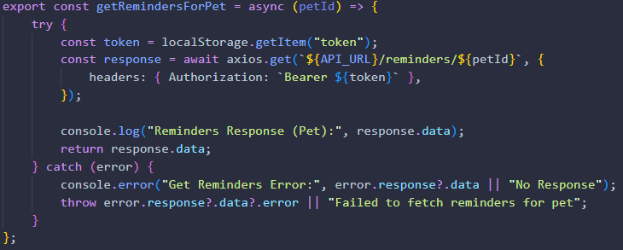
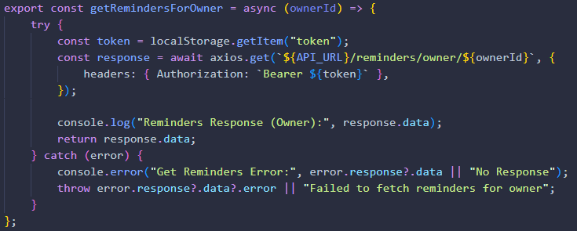
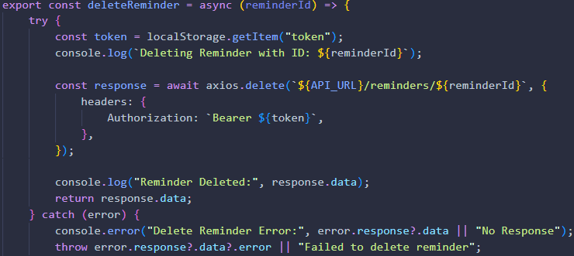

Figure 22: Method in petService.js that sends a POST | GET | DELETE request with pet reminders to the backend

Backend (Reminders): The /api/reminders/<pet_id> endpoint receives a GET request to retrieve all reminders associated with a specific pet by querying the reminders collection in MongoDB using the provided pet_id. The /api/reminders/owner/<owner_id> endpoint handles a GET request to fetch all reminders linked to a particular owner by searching the collection with the owner_id. To create a new reminder, the /api/reminders endpoint accepts a POST request, validates the incoming data, and saves the reminder to the database, associating it with the specified pet_id and owner_id. Lastly, the /api/reminders/<reminder_id> endpoint handles a DELETE request to remove a reminder, locating and deleting the corresponding document from the collection using the provided reminder_id.
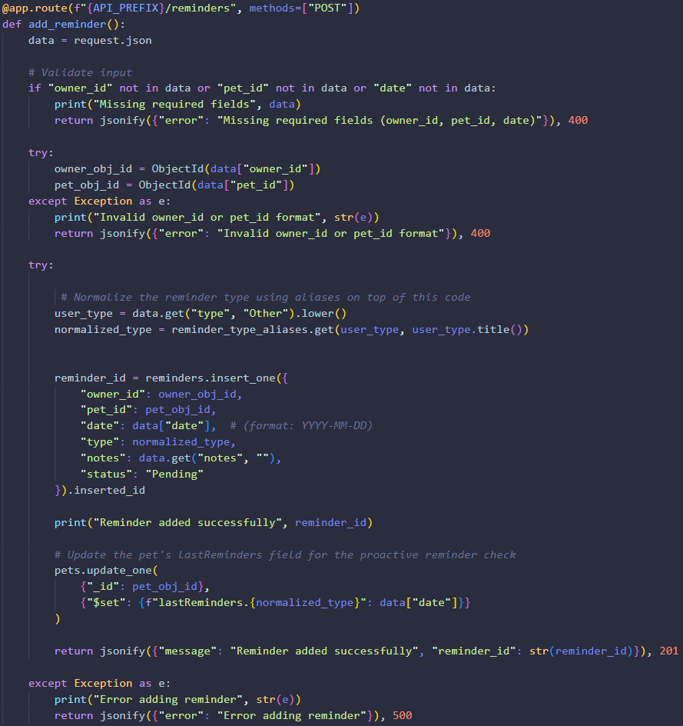
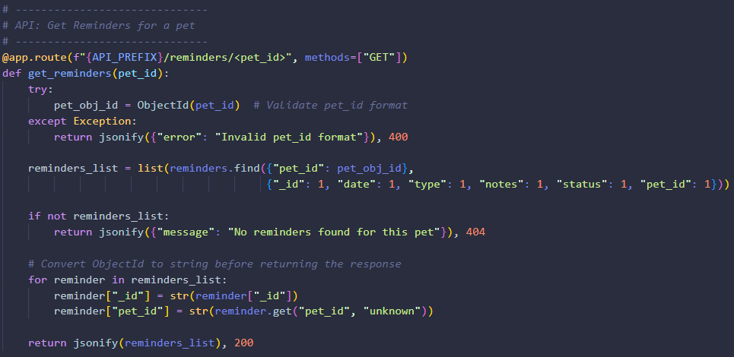
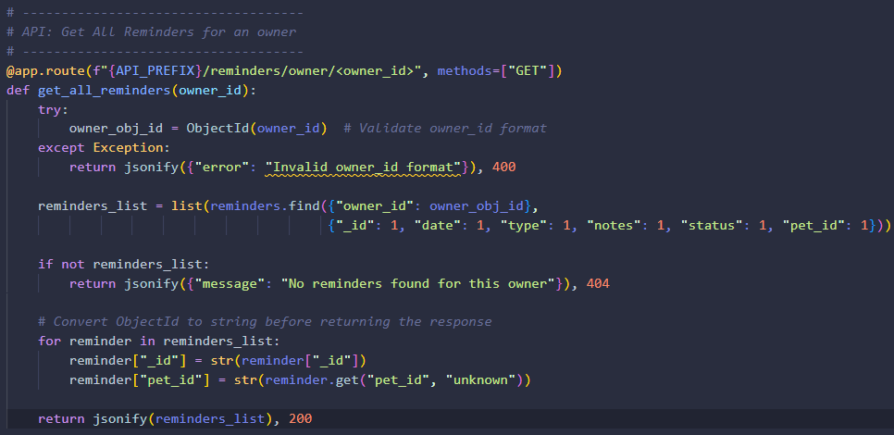
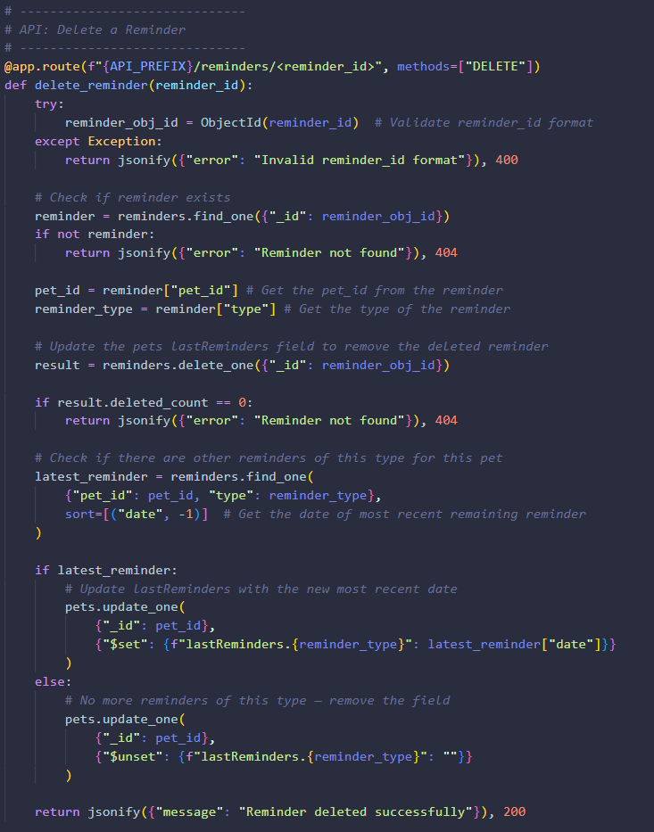
Figure 23: Flask API route for reminders that handles requests like POST/GET/DELETE
Database: reminders collection from MongoDB
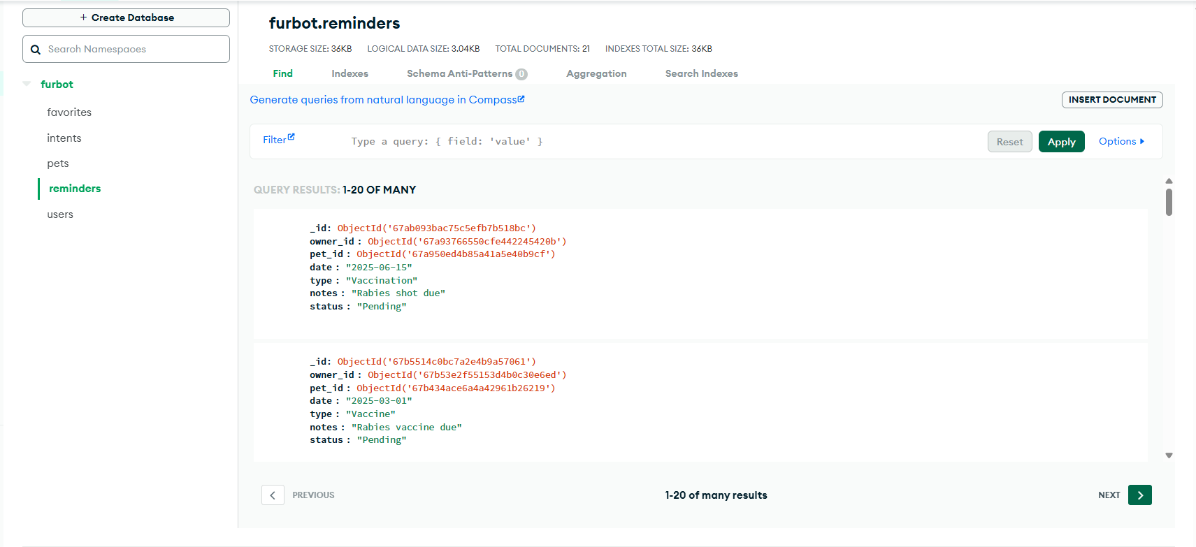

Figure 24: MongoDB reminders collection

Summary of Logic Flow:

Add new reminder:
  - User fills out the reminder form in ReminderList.vue (type, date, and optional note).
  - addNewReminder() is triggered calls addReminder() from the service layer.
  - addReminder() sends a POST request to /api/reminders with the form data and associated pet_id and owner_id.
  - Flask validates the data and inserts the reminder into the reminders collection in MongoDB.
  - The reminder list is refreshed by calling fetchReminders() and updated on the frontend.
To retrieve reminders for a pet:
  - In PetProfile.vue, fetchReminders() is triggered calls getRemindersForPet() from the service layer.
  - getRemindersForPet() sends a GET request to /api/reminders/<pet_id>.
  - Flask fetches all reminders associated with the given pet_id and returns them.
  - The frontend displays the fetched pet-specific reminders.
To retrieve reminders for an owner:
  - When Dashboard.vue is loaded, the mounted() lifecycle hook in ReminderList.vue is triggered.
  - getRemindersForOwner() is called sends a GET request to /api/reminders/owner/<owner_id>.
  - Flask retrieves all reminders associated with the authenticated owner_id and sends them back.
  - The reminders are displayed dynamically in the ReminderList.vue component.
To delete a reminder:
  - User clicks the "Delete" button next to a reminder card in ReminderList.vue.
  - deleteReminder() is called sends a DELETE request to /api/reminders/<reminder_id>.
  - Flask locates and deletes the reminder from the database.
  - The reminder list is refreshed by calling fetchReminders() again and updating the view.

Implemented Feature 6: Chatbot
Description:
The FurBot Chatbot acts as a virtual pet assistant embedded within the dashboard. It allows users to ask questions, get location-based recommendations (e.g., nearby groomers, vets, pet-friendly cafes), and even save favorite businesses. The chatbot enhances user experience by providing real-time, conversational support powered by Flask and Yelp API.

Frontend (Vue.js): Chatbot.vue

The chatbot UI includes:
  - A message input field
  - A scrolling message list
  - A typing animation while waiting for a response
  - Yelp search results (e.g., business cards).

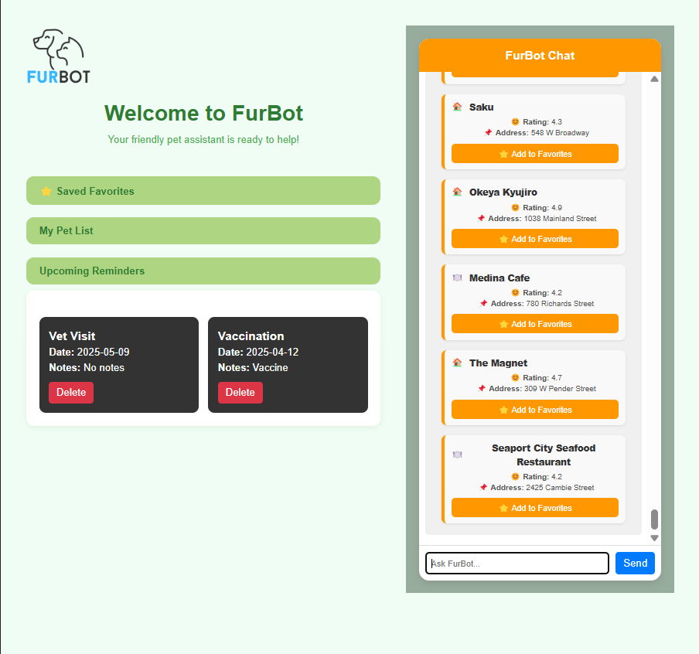
Figure 25: Chatbot UI embedded in Dashboard.vue

Code Highlight: The component Chatbot.vue is embedded in the Dashboard and loads automatically when the user logs in. It provides a real-time chat interface for user interaction.
When the user sends a message, the sendMessageToChatbot() method from chatService.js is called. This method determines whether to:
  - Route the message to the /api/chatbot endpoint (to query from the intent in MongoDB), or
  - Trigger the Yelp API

Service Layer: Keyword detection logic used to identify if it is a Yelp-related request from service layer.

- Receives the user message

- Scans the message for service-related keywords
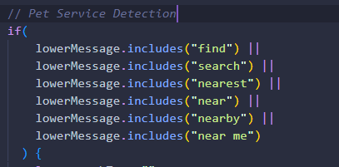

- If matched, it triggers the Yelp-related logic.
  - Searches for keywords like groomer, vet, restaurant, hotel, etc.
  - Determines what kind of pet service to search for (i.e., sets searchTerm, category, and attributes)
  - Defaulted the location to Vancouver, BC if no location found.

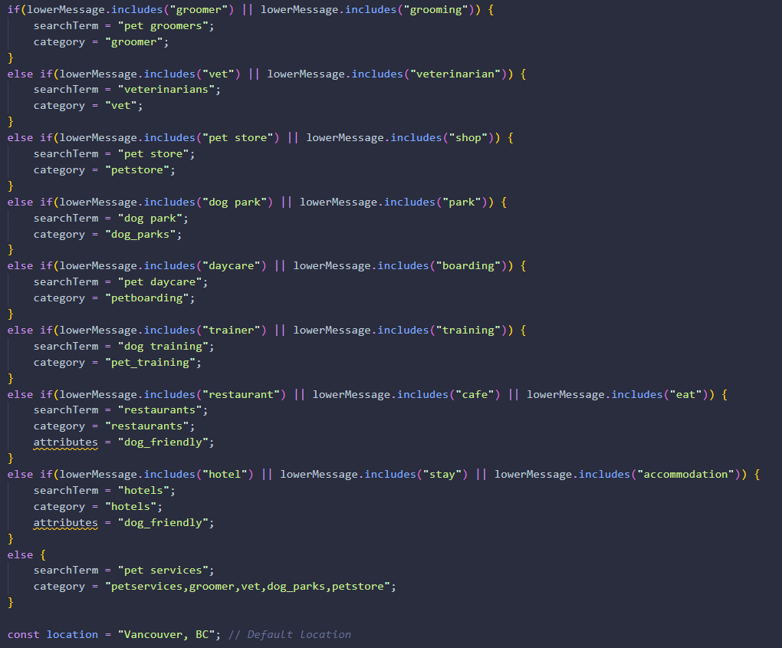

- Sends GET request to /api/yelp/search and format the Yelp pet service result.
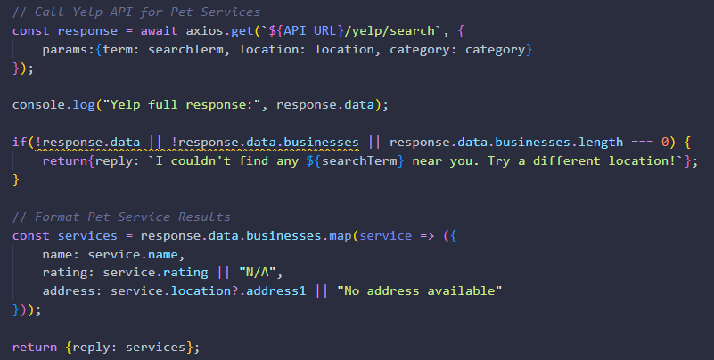

- If the message does not contain a service/location keywords, it then send POST request to /api/chatbot endpoint and check the MongoDB intent collection and return the response saved from the collection.
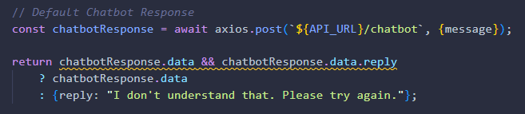
Figure 26: Different parts of chatService.js

Backend: The /api/chatbot endpoint handles a POST request containing the user’s message. Upon receiving the message, the server performs intent detection by analyzing the content and matching it against predefined intents stored in a MongoDB collection. If a matching intent is found, the server responds with a corresponding reply. If no match exists, a fallback response is returned (e.g., "I don't understand that").

1. If the message includes “hello”, “hi” or” help”, a static answer returned.
2. Using the spaCy NLP model in Python it attempts to extract GPE (Geopolitical Entity) entities such as city names from the user's message. If no GPE is detected by spaCy, it falls back to a regular expression to extract the location from the message. If both methods fail, it defaults to "Vancouver, BC".
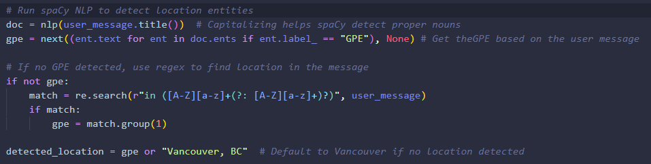

3. Load intent documents from intents collection. Using the the fuzzyWuzzy (fuzz.token_set_ratio) the system compares the message against all intents from the MongoDB, the highest matching intent is selected if it scores 60 or above.
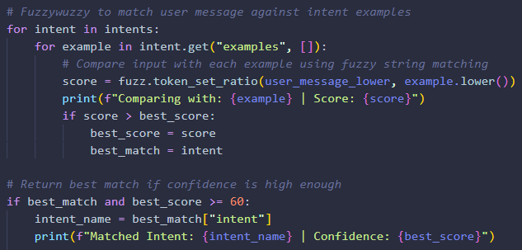
- The best match checks if it is in intent_to_yelp_config it then calls search_yelp() from yelp_service.py
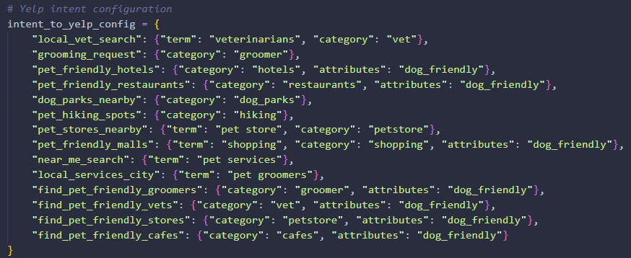
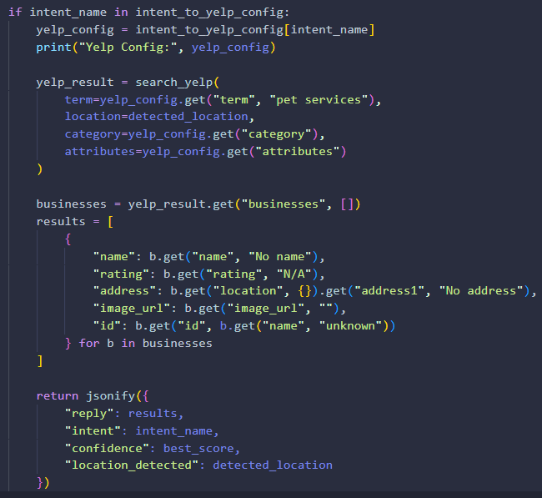
- Search_yelp function from the yelp_service.py
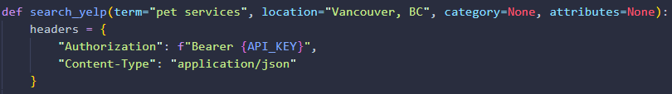
Figure 27: Different parts of api/chatbot and /yelp/search

Database: intents collection from MongoDB

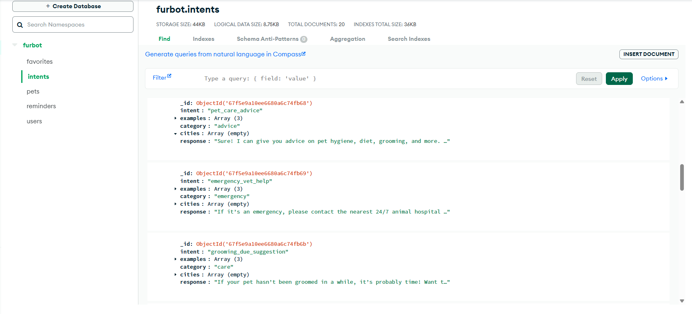
Figure 28: intents collection from MongoDB

Summary of Logic Flow:
Send user message to chatbot:
  - User types a message in the chatbot input field in Chatbot.vue.
  - Then sendMessage() method is triggered calls sendMessageToChatbot() from chatService.js.
  - sendMessageToChatbot() checks if the message contains keywords like “find” or “near” to determine if the request is location-based.
  - If location-based, it uses spaCy NLP and fallback regex to detect city or region in the message.
  - Once the location and service type (e.g., “groomer”, “vet”) are determined, a Yelp API request is sent to retrieve matching pet services.
  - The API response is returned to the frontend and displayed in the chat window as service cards (e.g., name, address, contact info).
For general chatbot questions (non-location-based):
  - If no location-based keywords are detected, the message is sent via a POST request to the /api/chatbot endpoint.
  - Flask receives the message and matches it against stored intents in the MongoDB intents collection using fuzzy matching.
  - A response is generated (either static or calls the search_yelp function from yelp_service.py) and returned to the frontend.
  - The chatbot displays the reply in the chat window.

Implemented Feature 7: Saving to Favorites
Description:
This feature allows users to save pet-related businesses (e.g., vets, groomers, pet stores) to their Favorites list directly from the chatbot. When the chatbot shows a list of businesses (via Yelp), users can click "Add to Favorites". The selected business is saved in MongoDB and displayed on the dashboard under the Saved Favorites section.

Frontend (Vue.js):
Chatbot.vue
  - Renders business cards with an "Add to Favorites" button.
  - When clicked, it calls the saveToFavorites() method from Chatbot.vue.
  - Emits the @favorite-added event, which notifies Dashboard.vue to refresh the favorite list.
Dashboard.vue
  - Displays the <FavoriteList /> component inside a collapsible card.
  - Listens for the event @favorite-added from Chatbot.vue and refreshes the favorites.
FavoriteList.vue
- Fetches the current user’s favorites on mount.
- Displays each saved business with name, address, rating, and delete button.

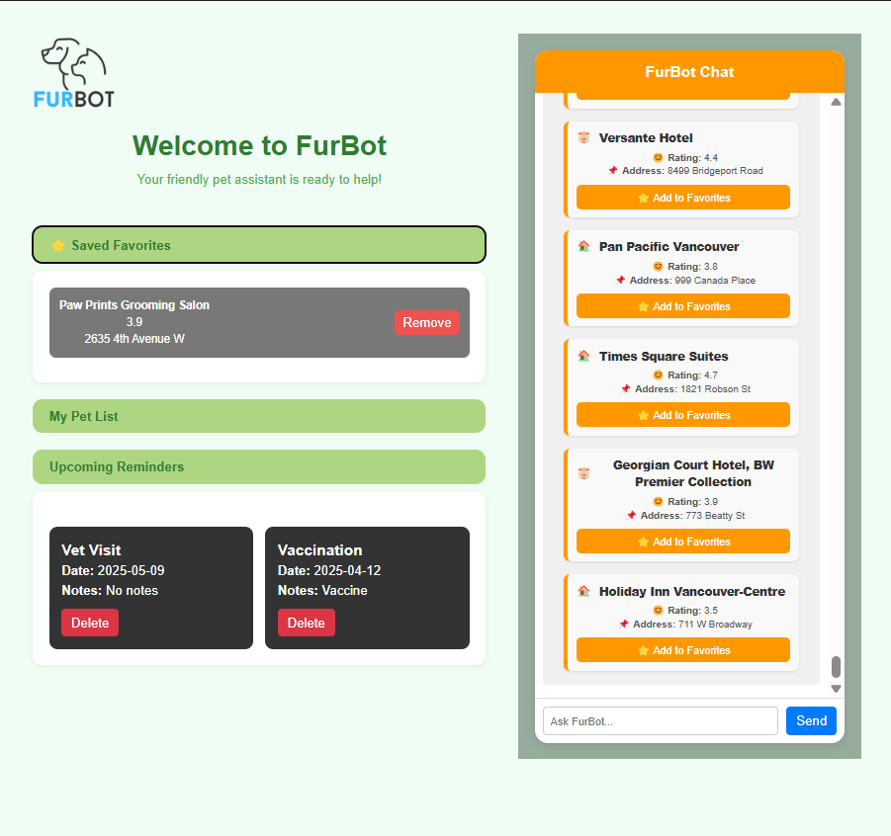
Figure 29: Chatbot UI with Add to Favorites

Code Highlight: Inside Chatbot.vue, when a user clicks "Add to Favorites" on a business card, the component calls the saveToFavorites() function from the Chatbot.vue that sends the POST request to /api/favorites. It then emits a @favorite-added event, which is captured by the handleFavoriteAdded() method in Dashboard.vue, triggering the FavoriteList.vue component to refresh and display the updated list of saved businesses.
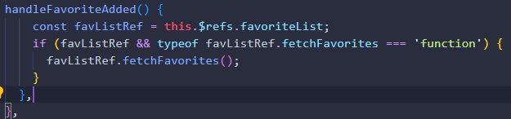
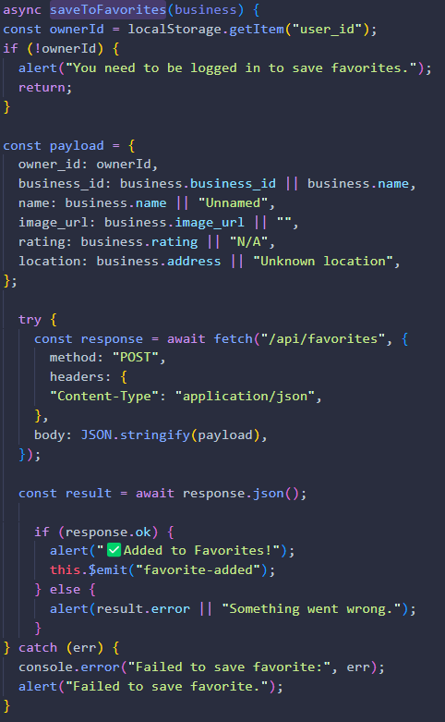
Figure 30: Service Layer for Favorites

Backend: The service layer provides functions to manage user favorites: saveToFavorites
(business) sends a POST request to /api/favorites with the owner's ID and selected business data to save it as a favorite, including an authorization token in the header. getFavorites(ownerId) sends a GET request to retrieve all saved businesses associated with the given owner. deleteFavorite(favoriteId) sends a DELETE request to /api/favorites/<favoriteId> to remove a specific favorite from the database.
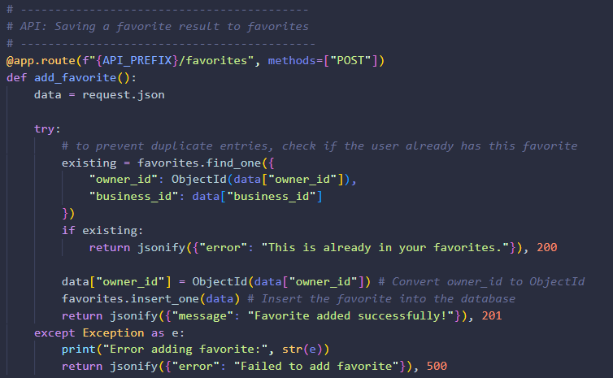
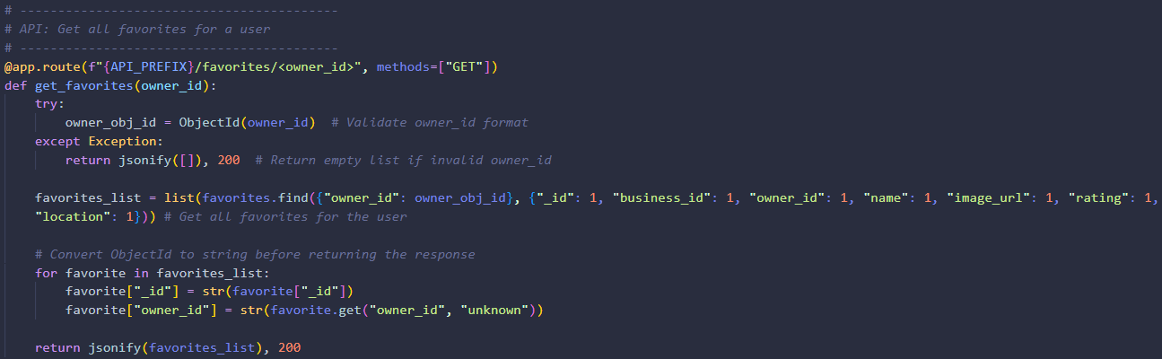
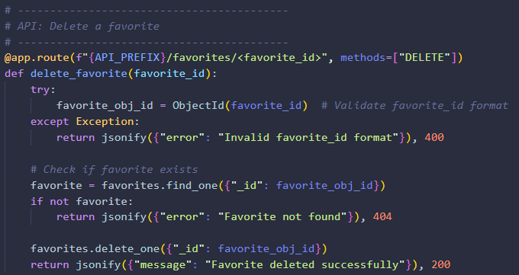
Figure 31: Backend AIP endpoints for Favorites

Database: favorites collection from MongoDB
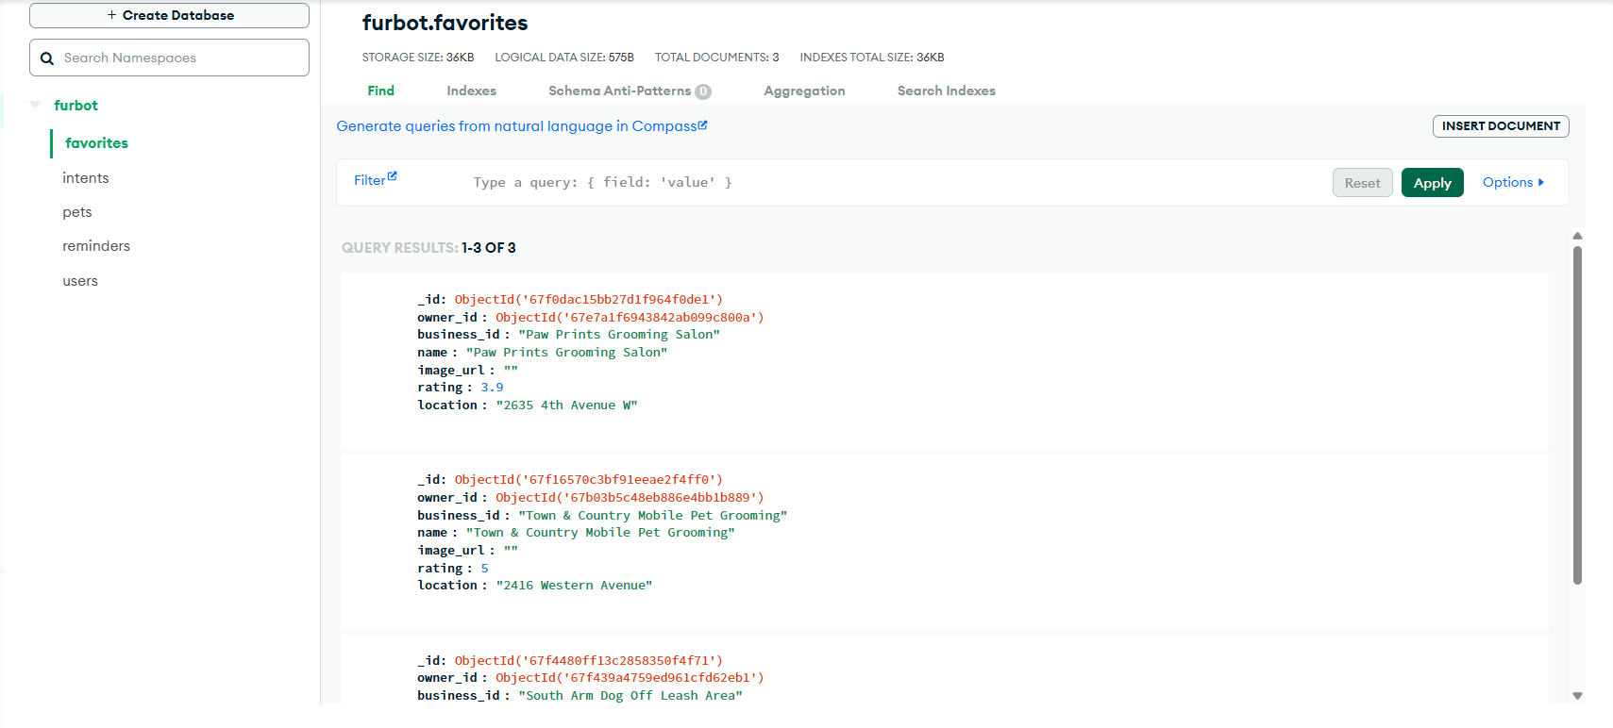

Summary of Logic Flow:

Add a favorite service:
- User clicks the "Add to Favorites" button on a service card displayed by the chatbot.
- This triggers the saveToFavorites() method in Chatbot.vue, passing the business_id and the logged-in owner_id.
- A POST request is sent to the /api/favorites endpoint.
- Flask validates the request and inserts the favorite into the favorites collection in MongoDB, associating it with the user's owner_id.
- A success message is returned, and the frontend updates accordingly.
Retrieve user favorites:
- In Dashboard.vue, when the Favorites section is expanded, the FavoriteList.vue component is rendered.
- The fetchFavorites() method is triggered calls getFavorites() from the service layer.
- getFavorites() sends a GET request to /api/favorites/<owner_id>.
- Flask queries the favorites collection for all entries matching the given owner_id.
- The retrieved list of saved services is returned and displayed as cards in the FavoriteList.vue component.
Delete a favorite service:
- User clicks the "Delete" icon next to a saved service in the FavoriteList.vue component.
- This triggers the deleteFavorite() method from the service layer, passing the favorite_id of the selected item.
- A DELETE request is sent to /api/favorites/<favorite_id>.
- Flask locates the corresponding entry in the favorites collection and deletes it.
- After successful deletion, the frontend calls fetchFavorites() again to refresh and update the list of saved favorites in real time.

Implemented Feature 8: Automated Email Reminder
Description:
This feature automatically scans upcoming pet care reminders (e.g., grooming, vaccinations, vet visits) and sends an email notification to the pet owner. It uses a scheduled background task powered by APScheduler to check reminders on a daily basis. When a relevant reminder is found an email is composed and sent using Flask-Mail. Additionally, it proactively/smart checks the if the last reminder for grooming is above 30 days and vaccination 365 days, it will remind the user to schedule a reminder.

Backend: A scheduled task (check_reminders) runs daily and scans the reminders collection for any appointments scheduled for the current day (e.g., grooming, vaccinations). If a match is found, the system sends a personalized reminder email to the pet owner and updates the status to "Completed" to prevent duplicate notifications.
In addition to daily alerts, FurBot also features a proactive reminder system (check_proactive_reminders) that checks for overdue care routines based on each pet’s history. Specifically, if a pet hasn't received a grooming reminder in the last 30 days or a vaccination in the last 365 days, the system automatically generates a gentle suggestion and sends it via email to the owner. These proactive reminders are stored under each pet’s record to ensure suggestions are not repeatedly sent unless necessary.

- Scheduler Setup

- Reminder Matching Logic
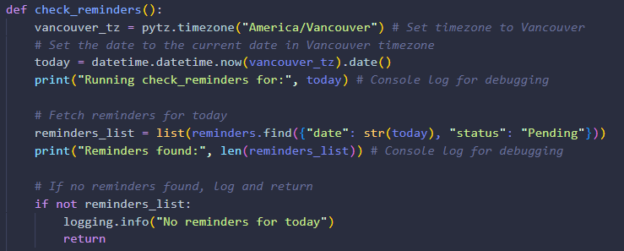

- Proactive check threshold
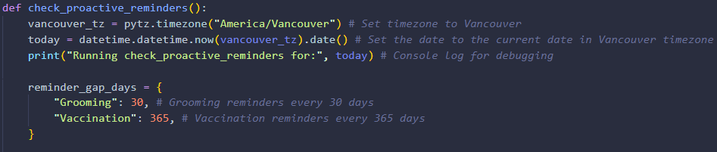

- Suggestion Email Formatting
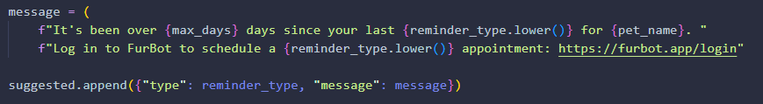

Evaluation and Techniques
To gather user insights on my MVP product, I utilized a survey-based evaluation technique. Users were invited to log in to the deployed production version of the application via https://furbot-production.up.railway.app and subsequently complete a feedback form available at https://forms.office.com/r/EanTkxbsZ2. The following section presents an analysis of the responses to each survey question, along with the corresponding action items identified for improvement.
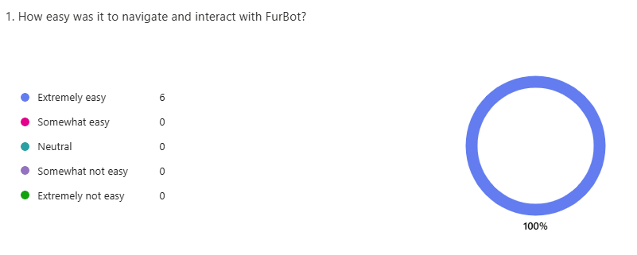
Analysis: This clearly states that based on user feedback that FurBot is easy to use.
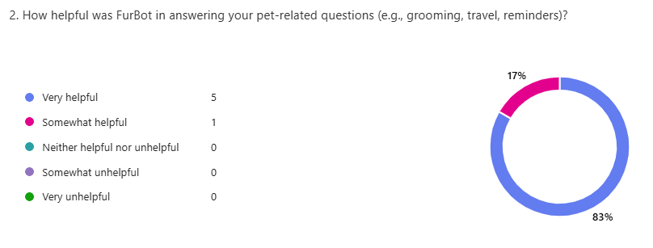
Analysis: Generally, FurBot is very helpful specially for pet parents.
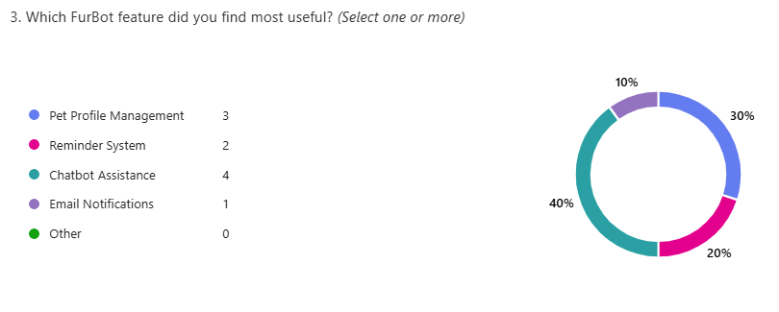
Analysis: The majority of users found the Chatbot Assistance feature most useful, followed by Pet Profile Management and the Reminder System.
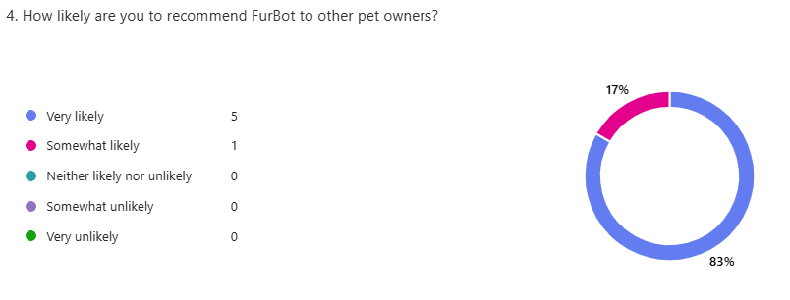
Analysis: 83% of users indicated they are very likely to recommend FurBot. This reflects strong user satisfaction and suggests a positive overall reception of the MVP.

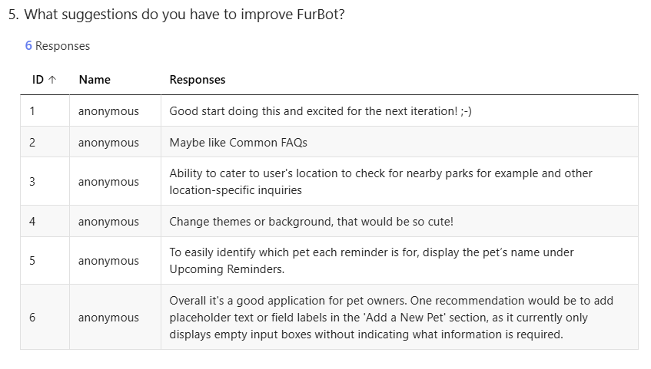
Analysis: Several users suggested improvements such as adding location-based searches, FAQs, themed UI options, and clearer labels for form fields. In response, spaCy NLP was implemented to support location detection for nearby parks and services, enhancing the chatbot’s contextual awareness. The other items/suggestion were added to the backlog.

Reflections/Discussions
After 18 years in the IT industry, FurBot marks a significant personal milestone—as it is the first time, I have independently developed a full-stack product from the ground up. The project has been an insightful and transformative journey that tested both my technical and soft skills. One of the most rewarding aspects was seeing how the integration of external APIs like Yelp and the use of NLP via spaCy made the chatbot responses more intelligent and relevant in real-world scenarios. It was especially satisfying to see users engage with the chatbot, pet profile management, and automated reminders, while also providing positive feedback.
One key challenge I faced was in deploying FurBot to Railway especially managing CORS errors and routing configurations between the frontend (Vue) and backend (Flask). Troubleshooting these issues taught me the importance of environment-based configuration and proper API structuring. Additionally, putting myself in a user’s shoes and a pet owner itself made me realize how important small details in UI/UX as well as the detailed information that the chatbot can answer also, how can it be personalized getting automated reminders for pet cares.
Throughout this project, I developed a deeper appreciation for essential soft skills such as time management, resilience, critical thinking, problem-solving, and staying composed under pressure. While technical skills can be learned quickly, it’s these soft skills that form the foundation for long-term success in any career.

Work Date/Hours logs

Concluding Remarks

First of all, I would like to sincerely thank Professor Padmapriya Arasanipalai Kandhadai for her continuous support and encouragement throughout this journey. Her guidance consistently pushed me to go further and think more critically.
FurBot began as a simple concept a chatbot to assist pet owners, but it evolved into a fully functional and intelligent web application through iterative development and applied research. This project not only allowed me to apply technical knowledge in real-world contexts such as API integration, natural language processing, and deepened my understanding in full-stack deployment/development and practical problem-solving.
Through continuous feedback from Professor and user evaluation, technical challenges, and continuous testing, FurBot became more than just a school project, it became a demonstration of how thoughtfully implemented technology can enhance everyday life. Moving forward, the experience and lessons gained from this project will serve as a strong foundation for future innovation and my continued growth in the tech industry.

References
YouTube Videos:
- Corey Schafer. (n.d.). Flask Tutorials - Profile Management [YouTube playlist]. YouTube. https://www.youtube.com/playlist?list=PL-osiE80TeTs4UjLw5MM6OjgkjFeUxCYH
Used for research in implementing Flask for user authentication and profile management in my project.

- Sheryians Coding School. (2022, June 11). Flask and Chatbot [Video]. YouTube. https://www.youtube.com/watch?v=70H_7C0kMbI&t=170s
Used for research in implementing backend (Flask) for chatbot.

- Tech With Tim. (2019, April 30). Fuzzywuzzy for chatbot [Video]. YouTube. https://www.youtube.com/watch?v=1jNNde4k9Ng
Used for research inimplementing backend (Flask) for string matching for chatbot.

AI Tools:
- OpenAI. (2025). ChatGPT [AI language model, paid subscription]. https://chat.openai.com
Used extensively as a conversational assistant throughout the project. ChatGPT supported backend and frontend development by offering help with coding, debugging, and logic design. It also contributed to shaping the chatbot's behavior and flow by providing guidance on conversational structure and natural language handling. Beyond development, ChatGPT was instrumental in enhancing the quality and clarity of project reports, offering suggestions for wording, structure, and presentation. Additionally, it played a key role in helping me understand and explore new technologies that I used for the first time in this project, such as Flask-Mail, APScheduler, JWT, Flask and MongoDB.

- GitHub. (n.d.). GitHub Copilot [AI coding assistant]. Integrated to Visual Studio Code.
Used as a built-in assistant within Visual Studio Code to support both backend and frontend development. GitHub Copilot provided real-time code suggestions, helping accelerate the coding process and improve efficiency. When used alongside ChatGPT, it offered a powerful combination — with Copilot suggesting code directly within the IDE, and ChatGPT providing deeper explanations, logic validation, and troubleshooting support. This collaboration significantly enhanced my development workflow and confidence in working with unfamiliar technologies.

Other Tools:
- Yelp Inc. (n.d.). Yelp Fusion API. Yelp. https://www.yelp.com/developers/documentation/v3
Used for real-time data on nearby pet-related services, such as groomers, veterinarians, and pet stores, based on city names detected in user input.

- Railway. (n.d.). Modern software deployment made simple. https://railway.app/.
Used for hosting FurBot, allowing the Flask backend and MongoDB integration to be deployed and accessed in a live environment.

- Atlassian. (n.d.). JIRA Software.
https://www.atlassian.com/software/jira
Used for project tracking, task management, and logging development hours throughout the FurBot project.

- GitHub. (n.d.). GitHub.
https://github.com
Used for version control and repository management to track code changes, and maintain the overall project codebase and reports.

- MongoDB, Inc. (n.d.). MongoDB Atlas [Cloud database service]. https://www.mongodb.com/atlas
Used to store and manage user data, pet profiles, and reminder records for the FurBot system.

Appendix A: Installation Guide
- Open any modern web browser (e.g., Google Chrome, Microsoft Edge, or Safari).
- In the address bar, type the following URL and press Enter:
https://furbot-production.up.railway.app/

Appendix B: User Guide



FurBot User Guide
Your smart assistant for managing pet care.

Getting Started

Access FurBot
Visit the deployed application here:
https://furbot-production.up.railway.app

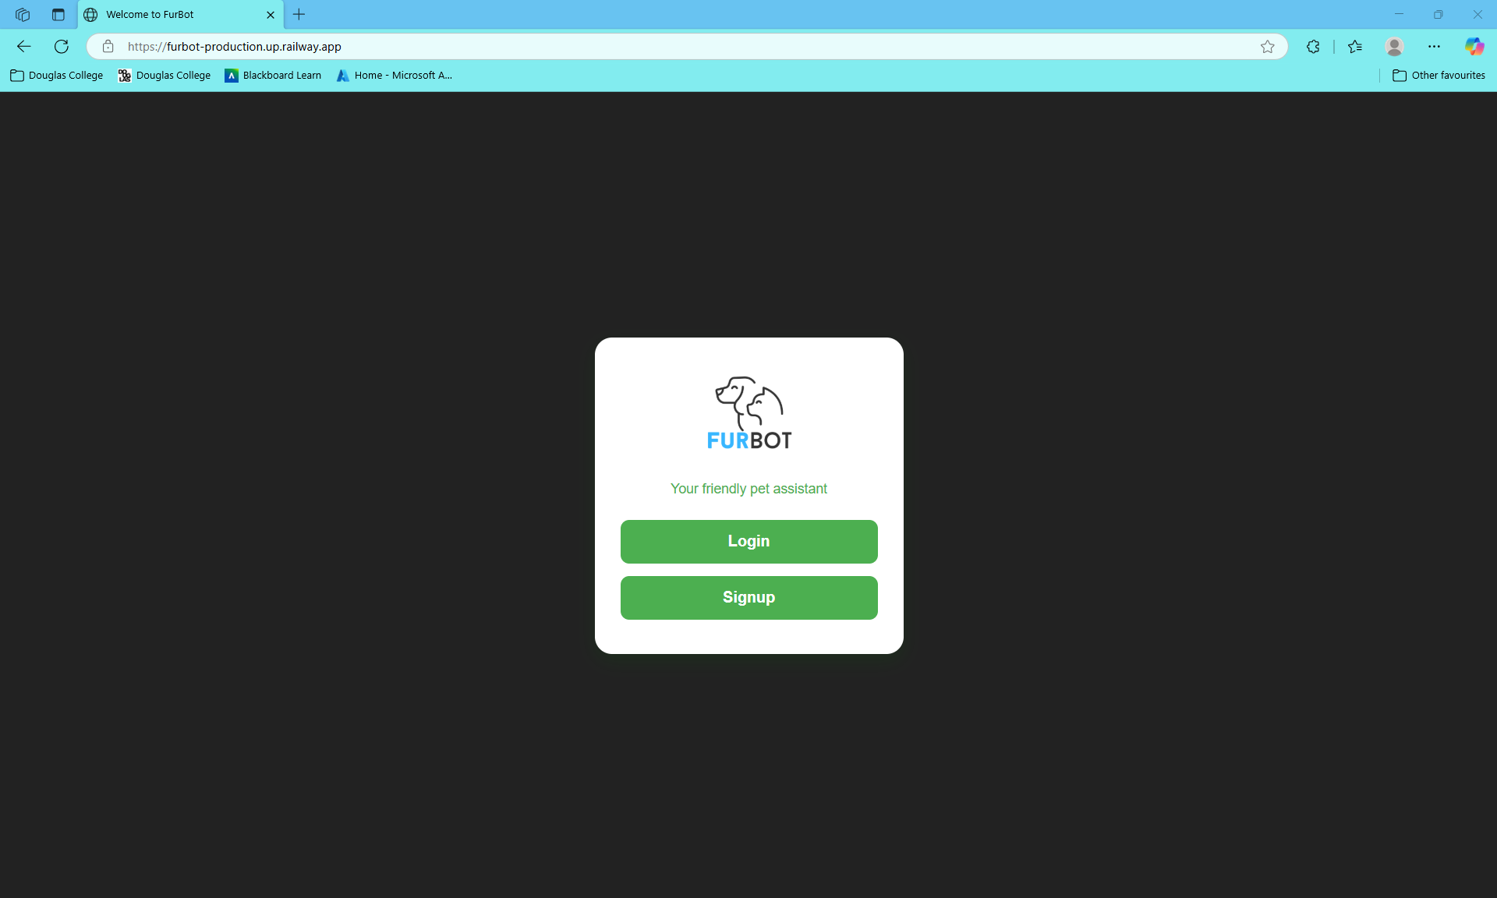

Sign Up / Login

New User Registration:
- Click "Signup" to create an account.
- Enter a valid email address — this is required to receive pet care reminders.
- Enter a secure password.
- Click "Signup" to complete the registration.
- You will be automatically redirected to the Login page.
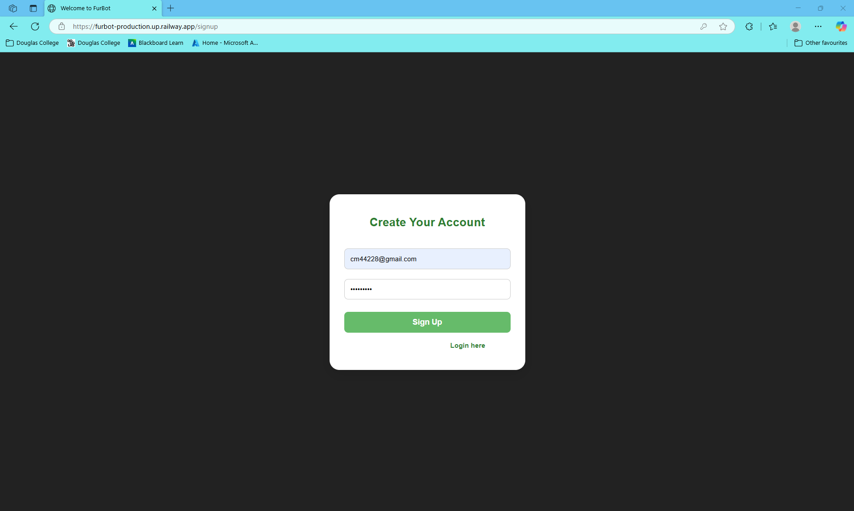

Returning users: Log in with your credentials:
- Enter an email address.
- Enter a secure password.
- Click "Login" to complete the registration.
- You will be automatically redirected to the Dashboard page.

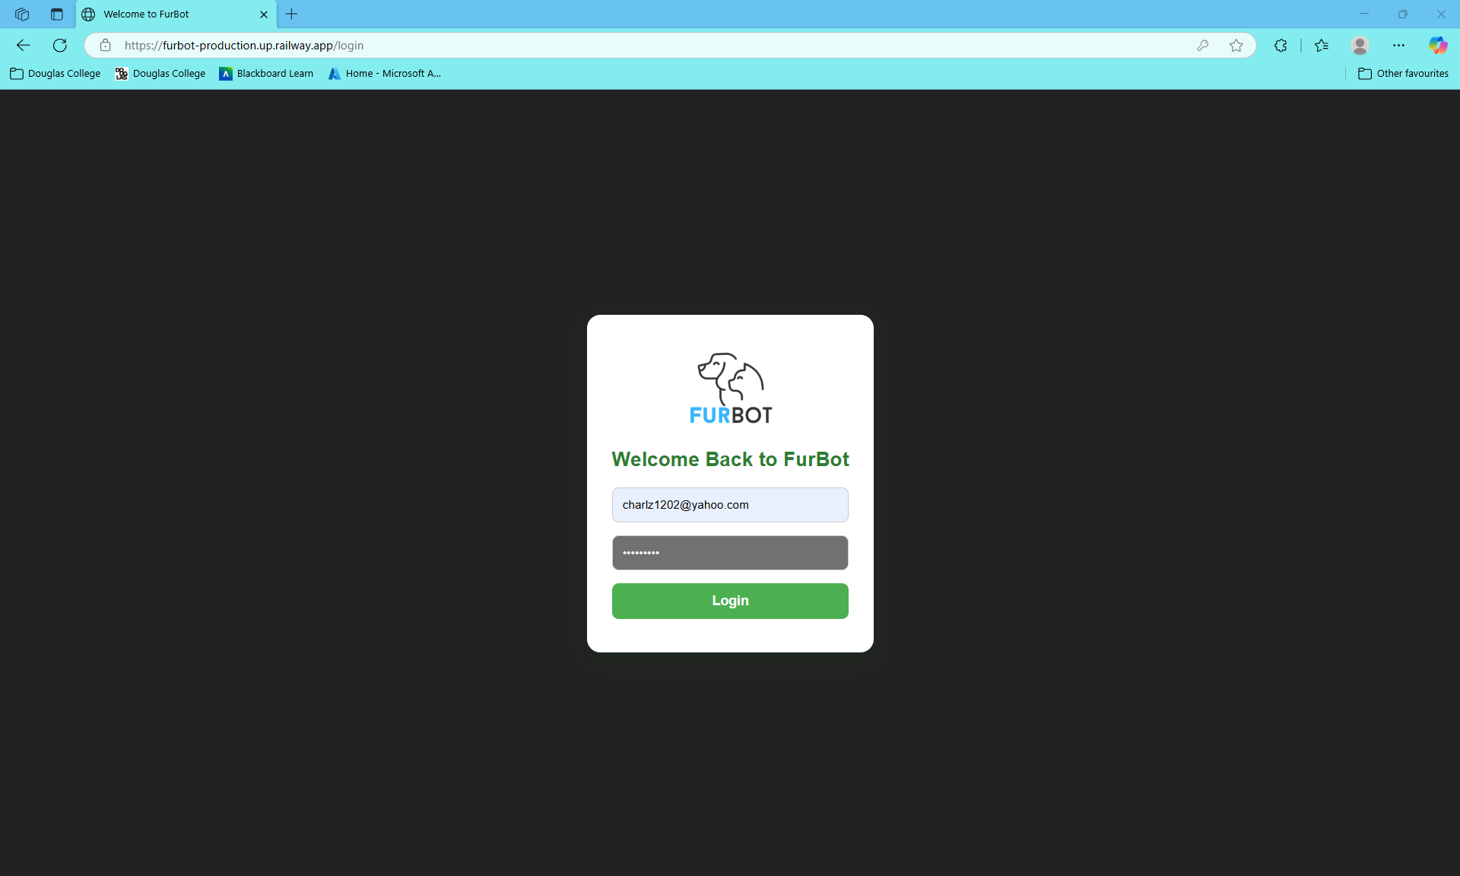

Managing Your Pet Profile

Add a Pet
- Navigate to the Dashboard.
- Under "My Pet List", fill in your pet’s details:
  - Pet Name
  - Species (e.g., Dog, Cat)
  - Birthdate
  - Color
  - Breed
- Click "Add Pet".
- Your pet will be automatically added to the list.
- An appropriate icon (🐶 or 🐱) will be assigned based on the selected species.

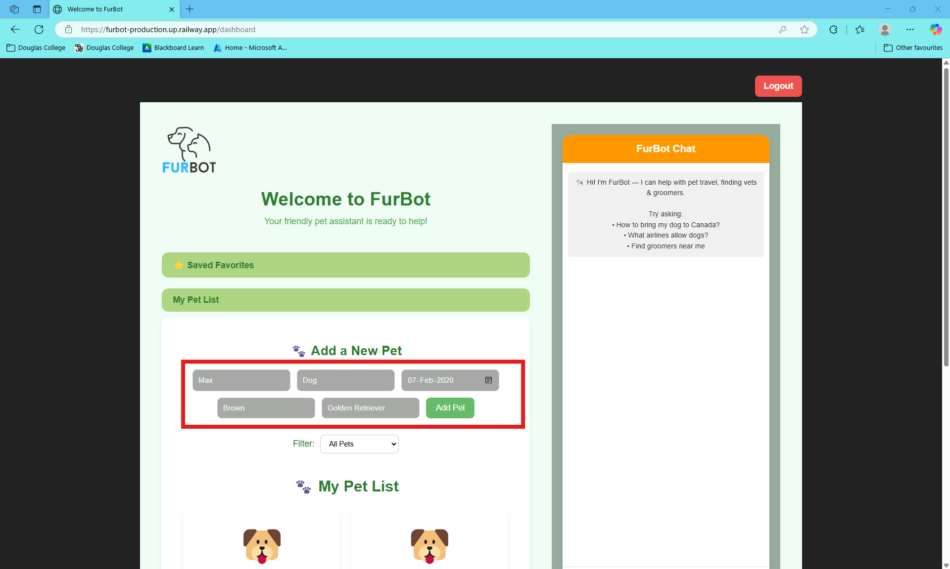

Delete a Pet
- Click the “Delete” button from the pet’s card to remove the pet from the profile.
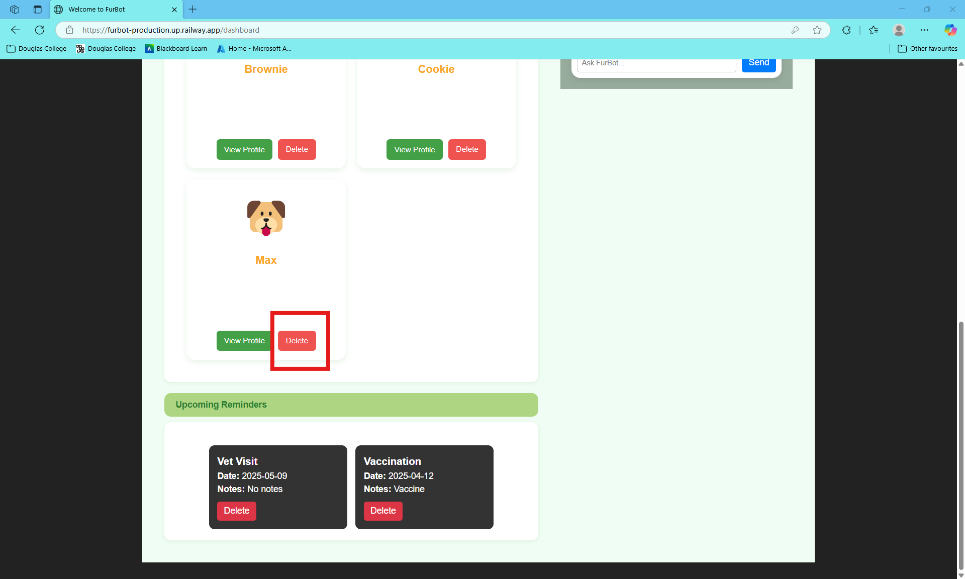

Viewing Pet Profile and Setting a Reminders for a Pet

Adding a Reminder
To view your pet’s full profile and manage reminders:
- On the Dashboard, under your pet’s card, click “View Profile”.
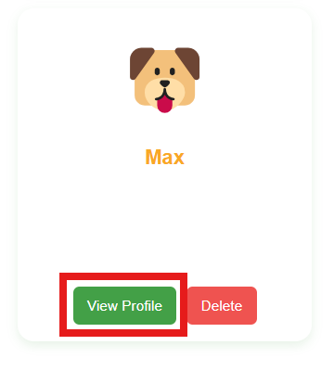
- You will be taken to the Pet Profile page, where you can view:
  - Pet Name
  - Species
  - Breed
  - Color
  - Birthdate
  - Age

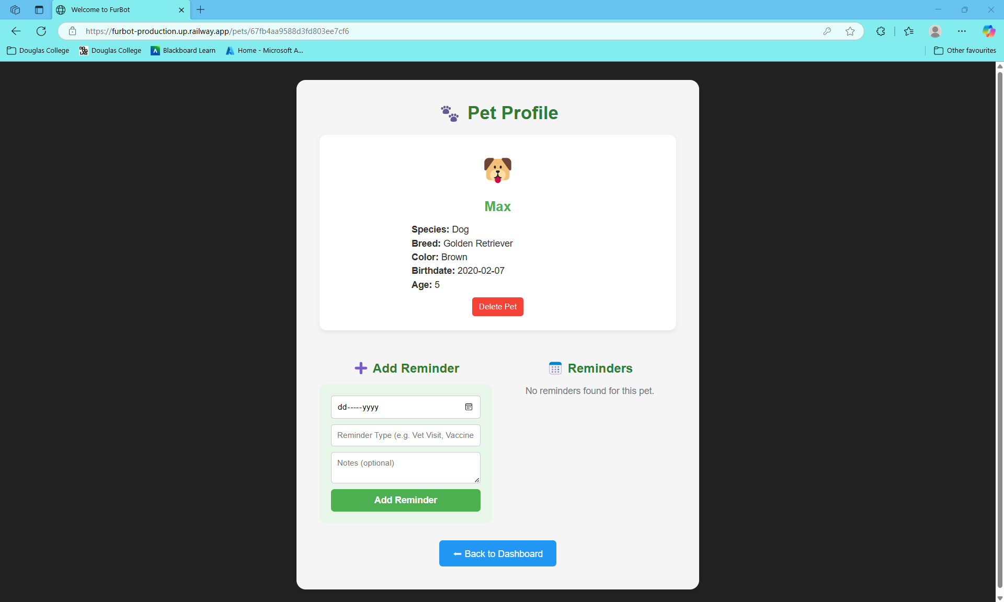

- To add a reminder for this pet:
  - Select the date of the reminder.
  - Enter the reminder type (e.g., Vet Visit, Vaccine).
  - Optionally, enter any notes.
  - Click “Add Reminder” to save.

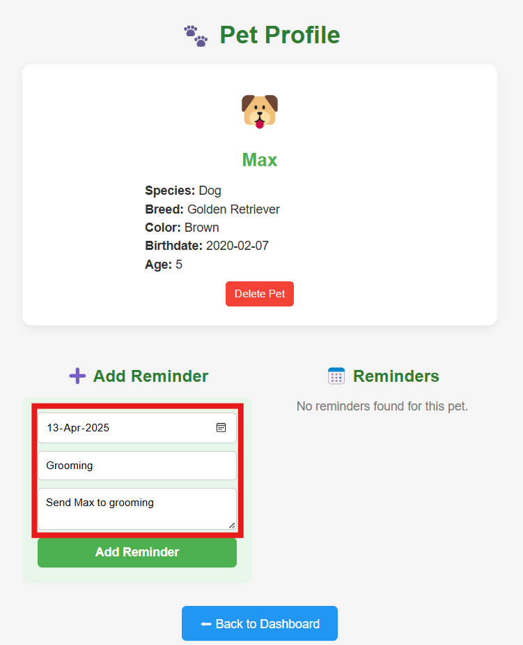

- The reminder will appear in the Reminders section on the right.

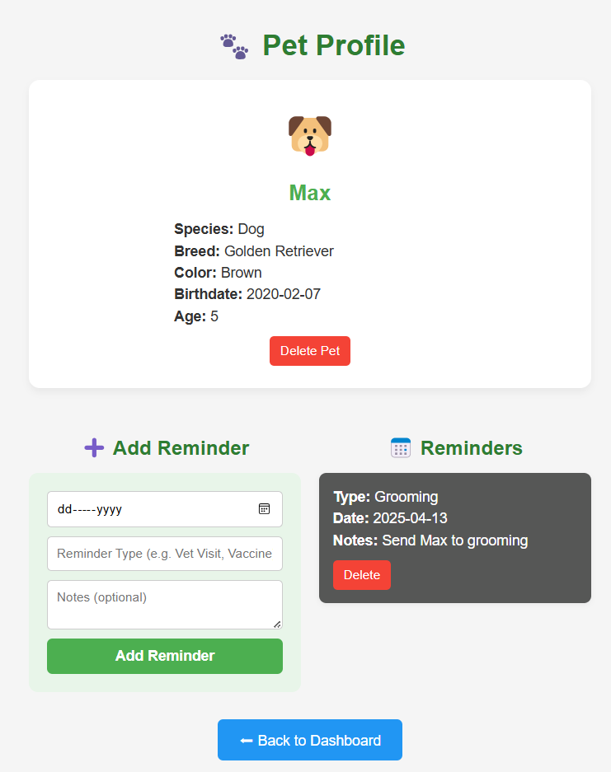

Delete a Reminder
- Click “Delete” next to a reminder to remove it.
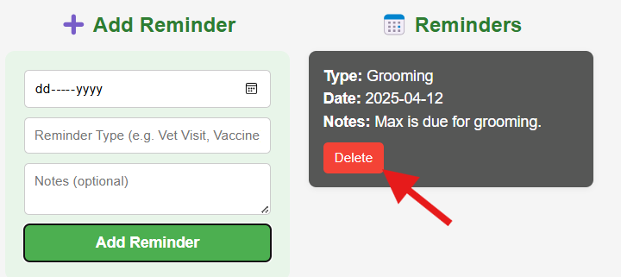

Email Notification
- Email notification are sent automatically for upcoming reminders.
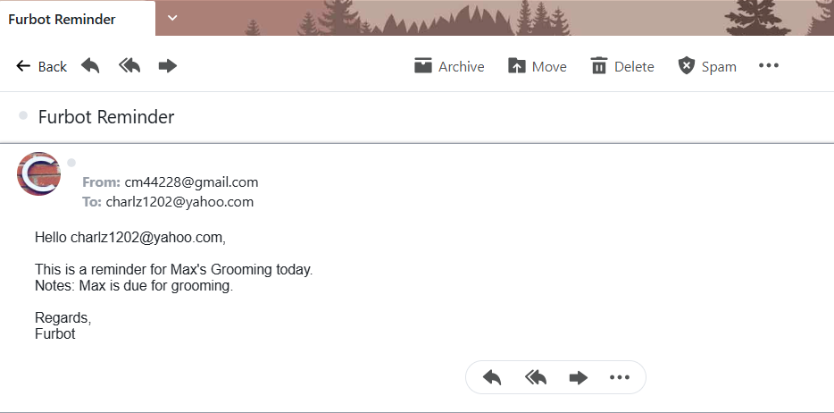

Using the Chatbot
FurBot’s chatbot can help you find services and answer pet-related questions.

Example commands:
- “find groomers near Burnaby”
- “pet friendly hotel in Vancouver”
- “travelling to Canada with pet”
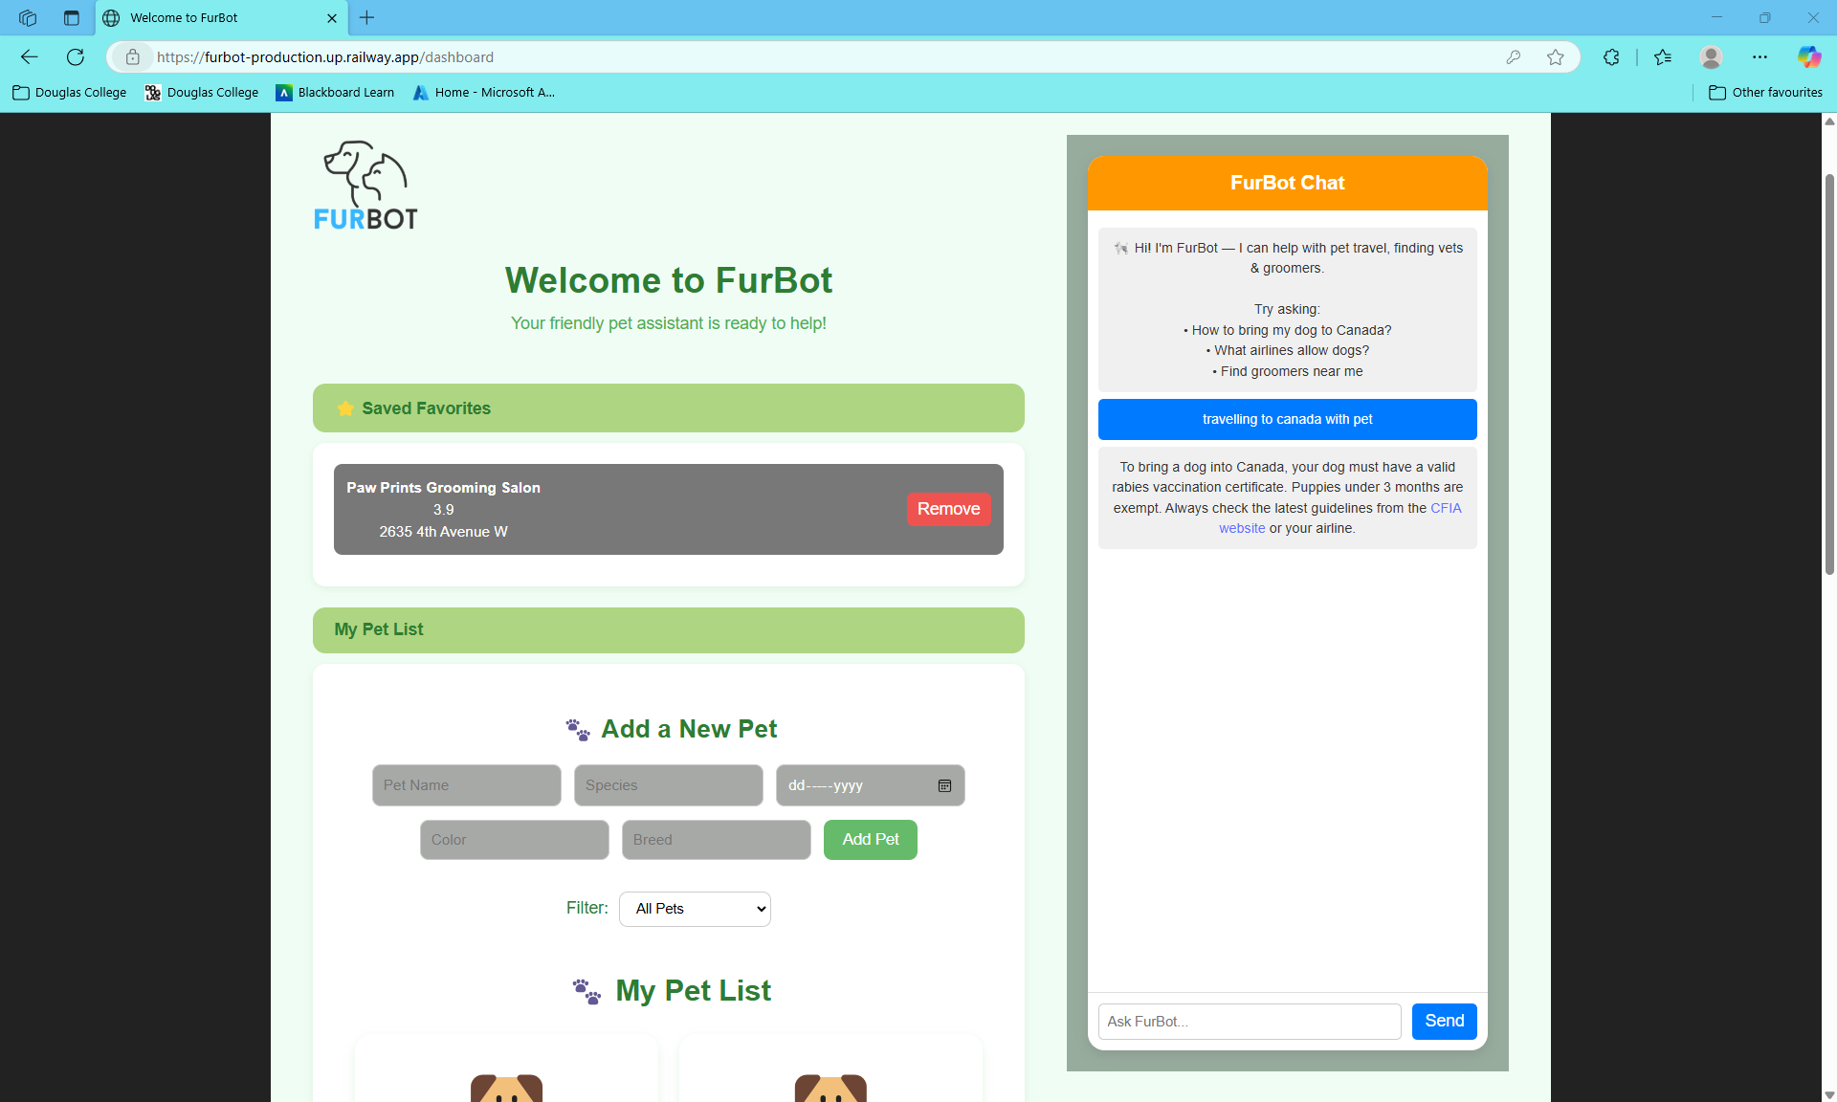
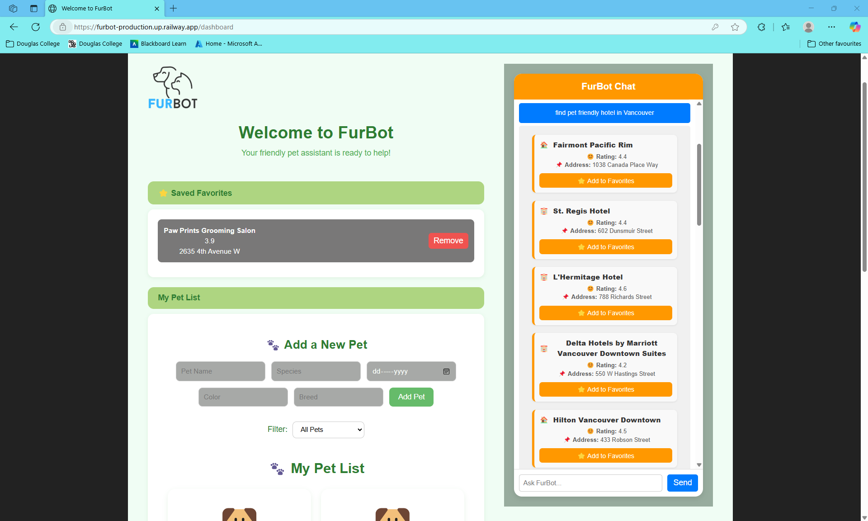

Adding result to favorites and viewing
- From the chatbot results, locate the business or service you’d like to save.
- Click “Add to Favorite” next to the desired result.
- The item will be automatically added to your personal favorites list.
- To view saved favorites, go to the Dashboard and scroll to the Favorites section.

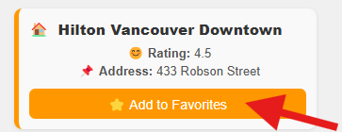
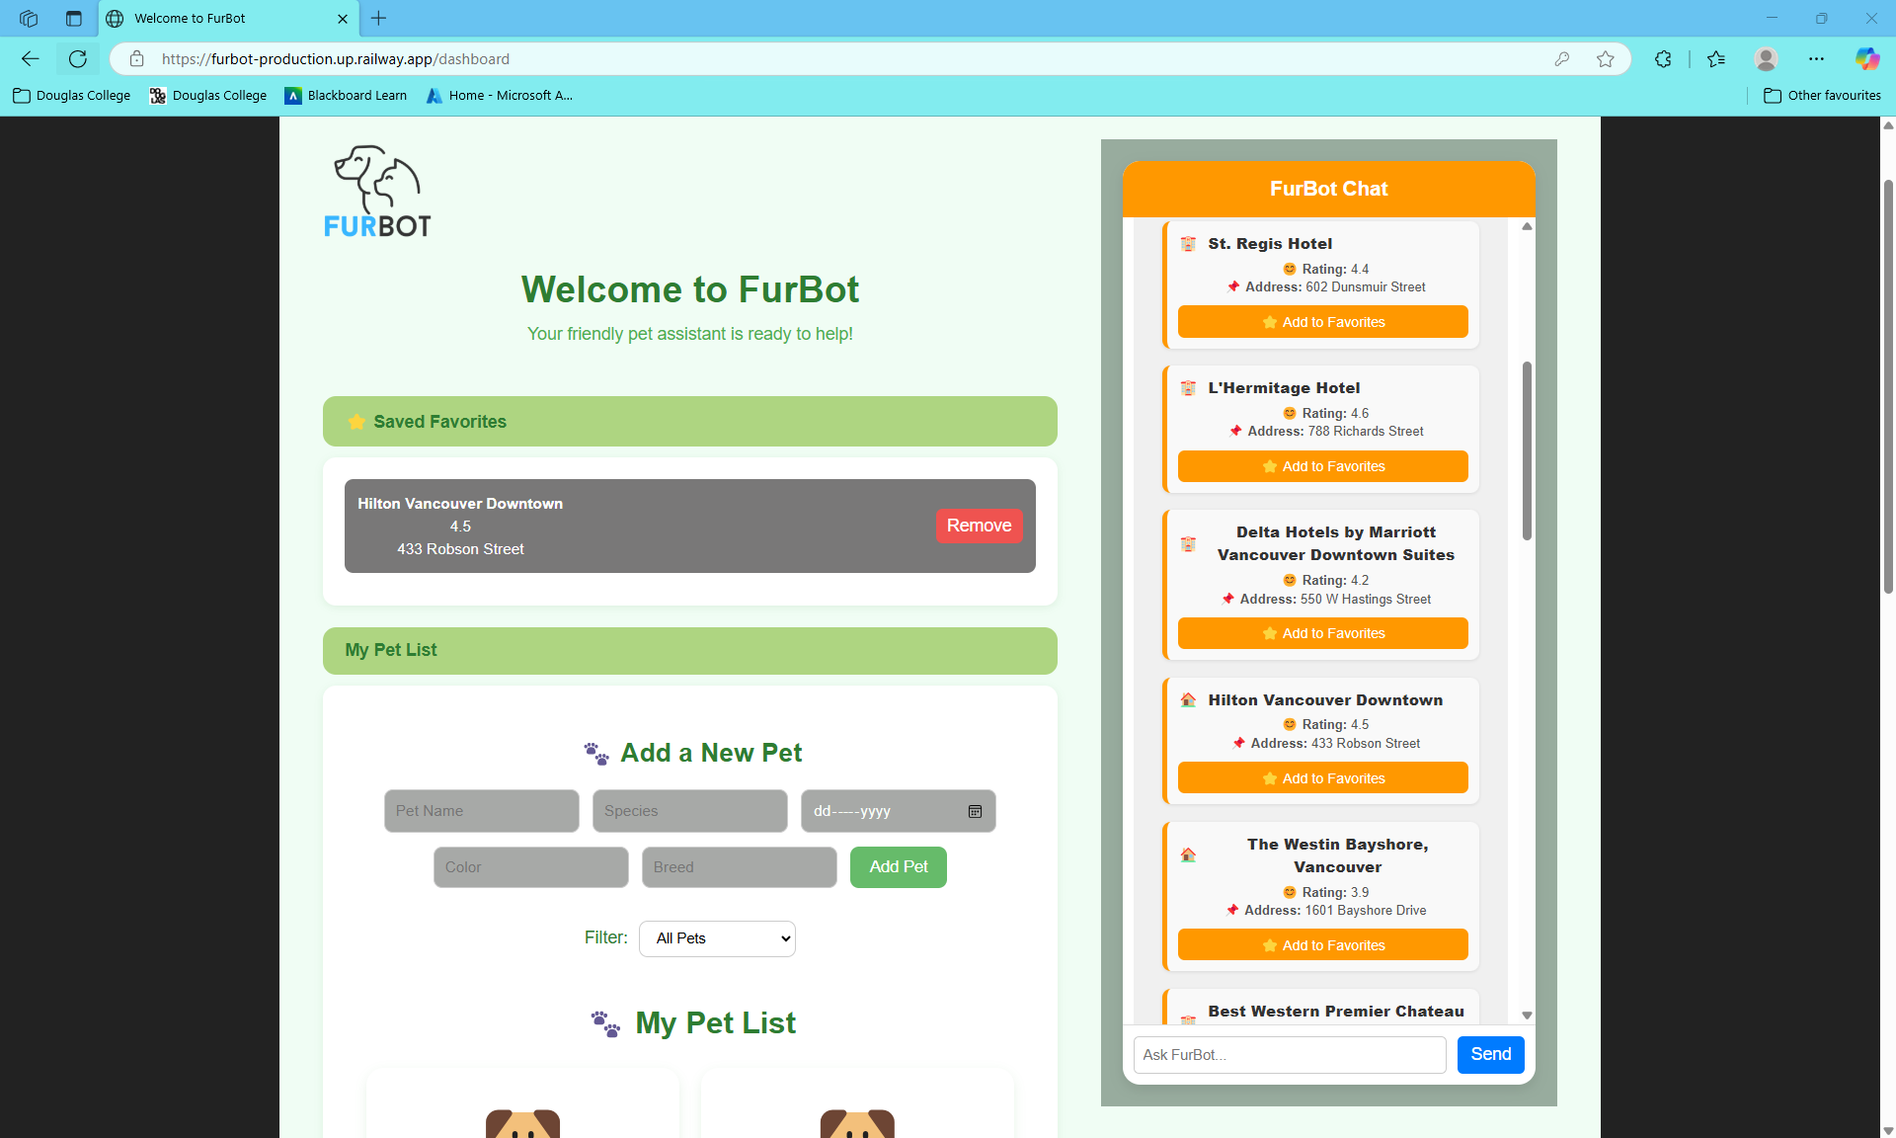

Need Help or Want to Suggest a Feature?
Reach out via contact:
📧 medialdeac@student.douglascollege.ca

Appendix C: Survey Questionnaire
🐾 FurBot User Evaluation Survey Questions
Help us make FurBot better! Tell us about your experience using our pet care assistant.
1.How easy was it to navigate and interact with FurBot?Required to answer. Single choice.
Extremely easy
Somewhat easy
Neutral
Somewhat not easy
Extremely not easy

2.How helpful was FurBot in answering your pet-related questions (e.g., grooming, travel, reminders)?Required to answer. Single choice.
Very helpful
Somewhat helpful
Neither helpful nor unhelpful
Somewhat unhelpful
Very unhelpful

3.Which FurBot feature did you find most useful? (Select one or more)Required to answer. Multiple choice.
Pet Profile Management
Reminder System
Chatbot Assistance
Email Notifications
Other

4.How likely are you to recommend FurBot to other pet owners?Required to answer. Single choice.
Very likely
Somewhat likely
Neither likely nor unlikely
Somewhat unlikely
Very unlikely
5.What suggestions do you have to improve FurBot?Required to answer. Multi Line Text.
Enter your answer

