LAB EXERCISE 6
DIABETES HEALTHCARE ANALYTICS & VISUALIZATION DASHBOARD
Class: 2MCA-B Date: 09 November 2026
Course: MCA411-2 Python Programming Register Number: 2647213

Dataset Description
The dataset selected for this application is the Diabetes Prediction Dataset containing clinical health observations. It encompasses patient demographic information, medical history (hypertension, heart disease, smoking history), and clinical indicators (BMI, HbA1c level, blood glucose level, and diagnostic diabetes status).

Question 1: Sidebar Controls and Dynamic Data Filtering
Design an interactive sidebar with dynamic filter controls (multiselect, selectbox, slider) to allow users to filter dataset records interactively.

Python Code
import streamlit as st
import pandas as pd
import numpy as np
# Load dataset with synthetic fallback
try:
df = pd.read_csv("diabetes_prediction_dataset.csv")
except:
np.random.seed(42)
n = 300
df = pd.DataFrame({
'gender': np.random.choice(['Female', 'Male'], n),
'age': np.random.randint(18, 80, n),
'smoking_history': np.random.choice(['never', 'former', 'current', 'No Info'], n),
'bmi': np.round(np.random.uniform(18.5, 40.0, n), 2),
'blood_glucose_level': np.random.randint(80, 250, n),
'diabetes': np.random.choice([0, 1], n, p=[0.8, 0.2])
})
# Sidebar filters
st.sidebar.header("Filter Options")
gender = st.sidebar.multiselect(
"Select Gender",
options=df["gender"].unique(),
default=list(df["gender"].unique())
)
smoking = st.sidebar.selectbox(
"Select Smoking History",
["All"] + list(df["smoking_history"].unique())
)
age = st.sidebar.slider("Select Age", 0, 80, (0, 80))
# Filter dataset
data = df[
(df["gender"].isin(gender)) &
(df["age"].between(age[0], age[1]))
]
if smoking != "All":
data = data[data["smoking_history"] == smoking]

Output
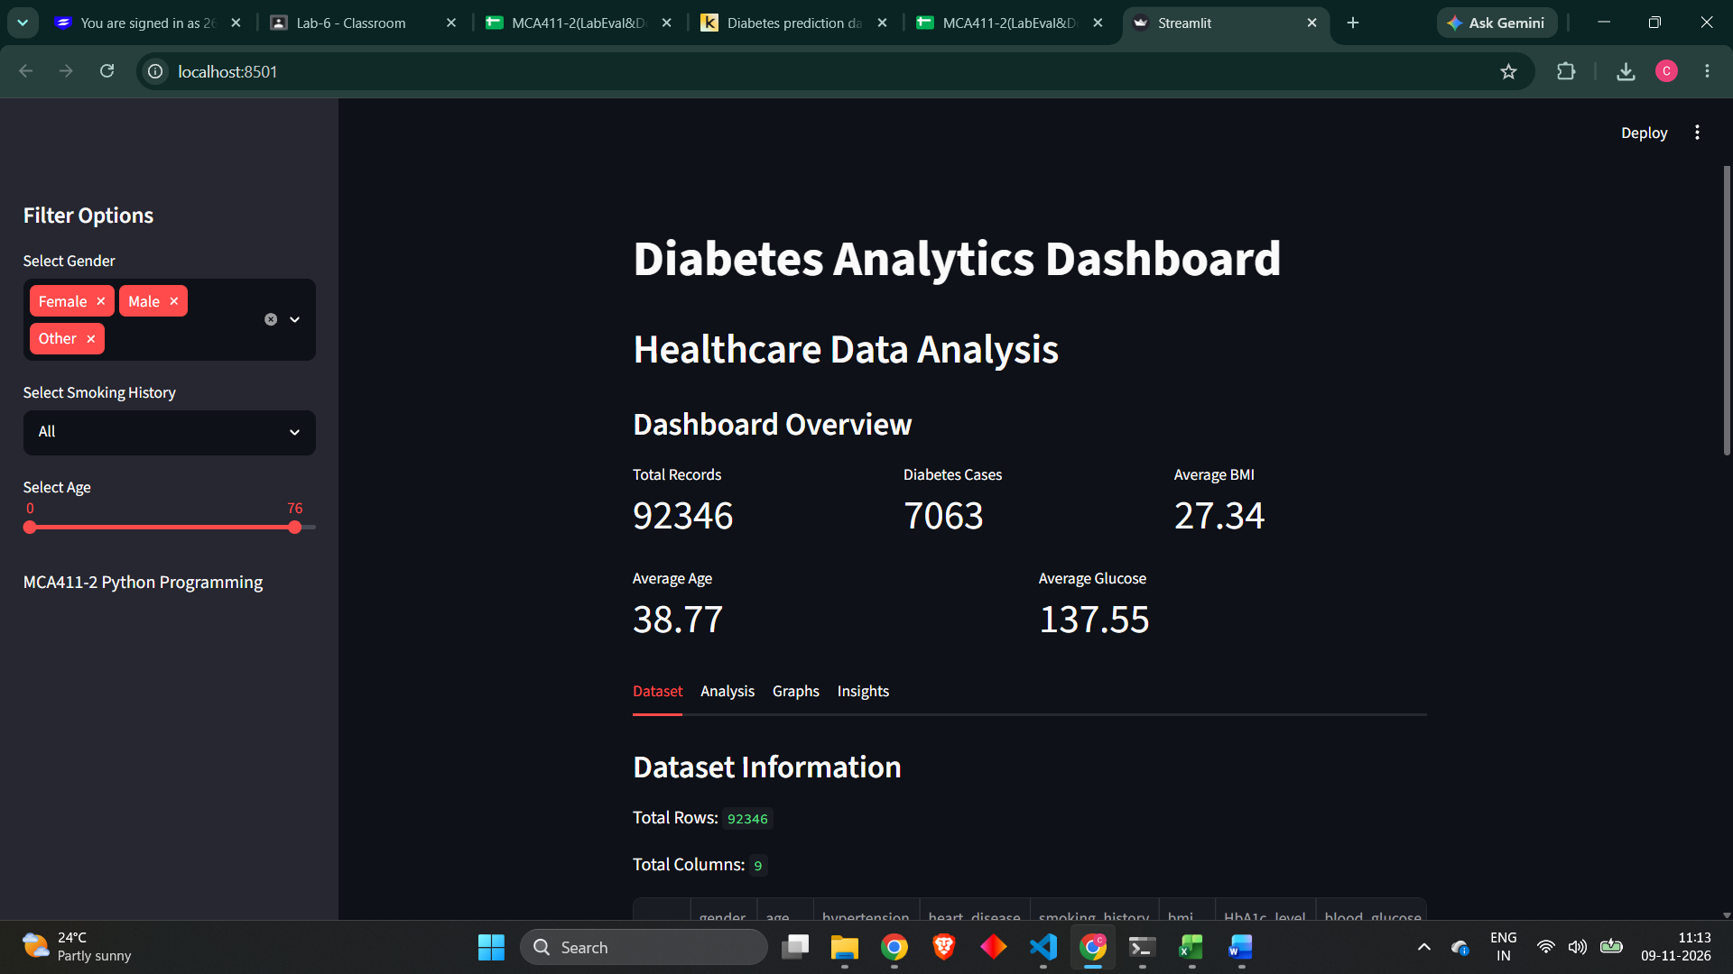

Question 2: Key Performance Indicators (KPIs) & Metrics Layout
Display Key Performance Indicators (KPIs) including total observation count, diabetes cases sum, average BMI, average age, and average blood glucose level responding to sidebar filters.
Python Code
st.subheader("Dashboard Overview")
col1, col2, col3 = st.columns(3)
col1.metric("Total Records", len(data))
col2.metric("Diabetes Cases", int(data["diabetes"].sum()) if len(data) > 0 else 0)
col3.metric("Average BMI", round(data["bmi"].mean(), 2) if len(data) > 0 else 0)
col4, col5 = st.columns(2)
col4.metric("Average Age", round(data["age"].mean(), 2) if len(data) > 0 else 0)
col5.metric("Average Glucose", round(data["blood_glucose_level"].mean(), 2) if len(data) > 0 else 0)

Output

Question 3: Application Navigation via Tabs and Expanders
Organize the web application using Streamlit Tabs component for Dataset Overview, Data Analysis, Visualizations, and Key Insights.
Python Code
tab1, tab2, tab3, tab4 = st.tabs(["Dataset", "Analysis", "Graphs", "Insights"])
with tab1:
st.subheader("Dataset Information")
st.write("Total Rows:", data.shape[0])
st.write("Total Columns:", data.shape[1])
st.dataframe(data.head(20))
with st.expander("Statistical Summary"):
st.write(data.describe())

Output
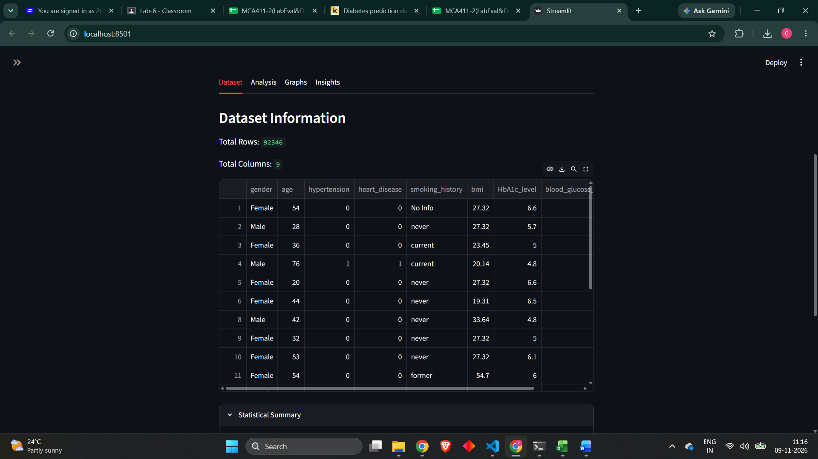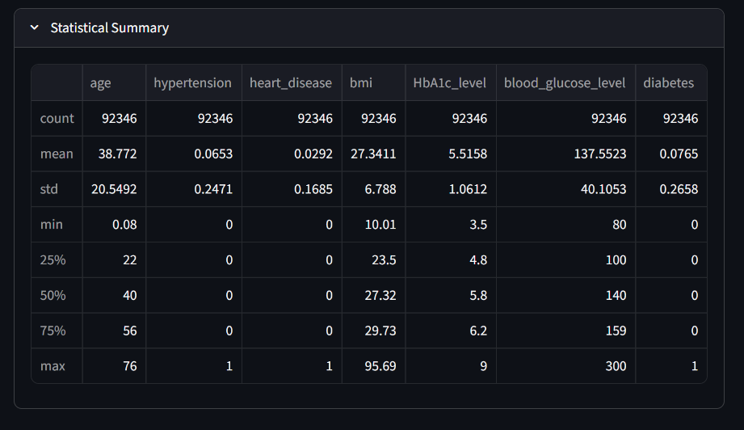
Question 4: Categorical Group-By and Numerical Analysis
Perform group-by operations for category-wise record counts and calculate summary statistics (sum and average) for selected numerical columns.
Python Code
with tab2:
st.subheader("Category-wise Analysis")
category = st.selectbox(
"Select Category",
["gender", "smoking_history", "diabetes"]
)
result = data.groupby(category).size()
st.write(result)
st.subheader("Numerical Analysis")
column = st.selectbox(
"Select Numerical Column",
["age", "bmi", "blood_glucose_level"]
)
st.write("Sum:", data[column].sum())
st.write("Average:", data[column].mean())

Output
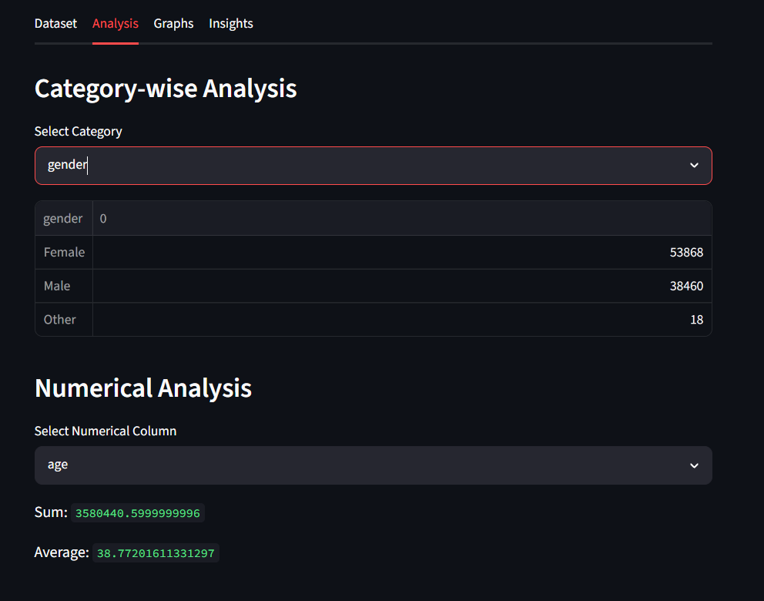

Question 5: Data Visualization (Bar Chart, Line Chart, Scatter Plot)
Develop exploratory data visualizations including a Bar Chart (Diabetes by Smoking History), Line Chart (Age vs Blood Glucose trend), and Scatter Plot (BMI vs Blood Glucose).
Python Code
with tab3:

# 1. Bar Chart
st.subheader("Diabetes Cases by Smoking History")

bar_data = data.groupby("smoking_history")["diabetes"].sum()

fig, ax = plt.subplots()
ax.bar(bar_data.index, bar_data.values,
color=["skyblue", "orange", "lightgreen", "coral", "violet", "gold"])

ax.set_title("Diabetes Cases by Smoking History")
ax.set_xlabel("Smoking History")
ax.set_ylabel("Number of Diabetes Cases")
ax.tick_params(axis="x", rotation=30)

st.pyplot(fig)
plt.close(fig)

# 2. Line Chart
st.subheader("Average Blood Glucose at Different Ages")

line_data = data.groupby("age")["blood_glucose_level"].mean()

fig, ax = plt.subplots()
ax.plot(line_data.index, line_data.values,
color="green", marker="o", linewidth=2)

ax.set_title("Age vs Average Blood Glucose")
ax.set_xlabel("Age")
ax.set_ylabel("Average Blood Glucose Level")
ax.grid(True, linestyle="--", alpha=0.5)

st.pyplot(fig)
plt.close(fig)

# 3. Scatter Plot
st.subheader("Relationship Between BMI and Blood Glucose")

fig, ax = plt.subplots()
ax.scatter(data["bmi"], data["blood_glucose_level"],
color="purple", alpha=0.4)

ax.set_title("BMI vs Blood Glucose Level")
ax.set_xlabel("BMI")
ax.set_ylabel("Blood Glucose Level")
ax.grid(True, linestyle="--", alpha=0.4)

st.pyplot(fig)
plt.close(fig)

Output

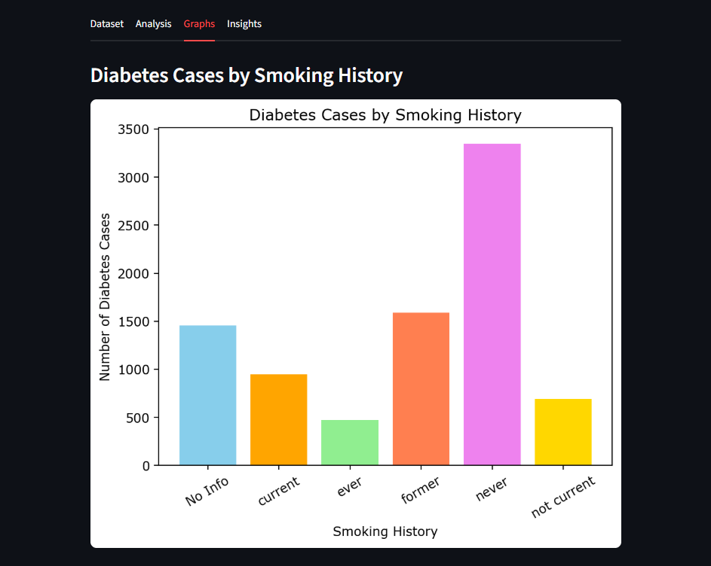
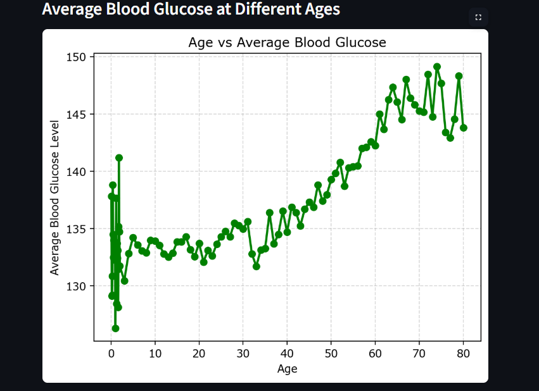
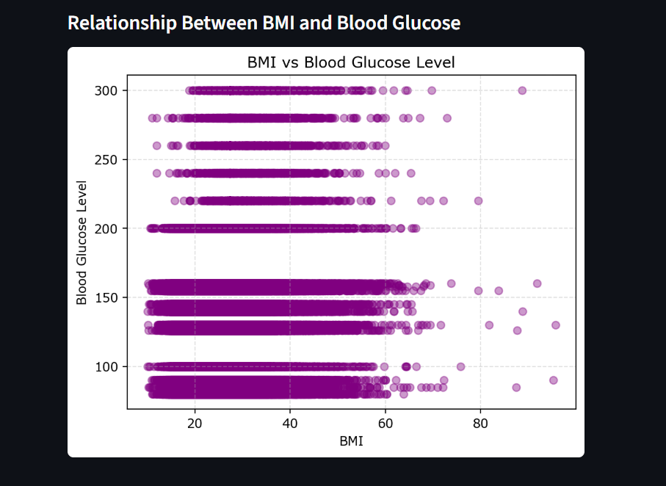

Question 6: Analytical Insights and Integrated Dashboard Summary
Display actionable analytical insights, summary statistics, and deployment information within the Insights section.

Python Code
with tab4:
st.subheader("Key Insights")

if len(data) > 0:

st.write("Total Diabetes Cases:", data["diabetes"].sum())

st.write("Average BMI:", round(data["bmi"].mean(), 2))

st.write("Average Age:", round(data["age"].mean(), 2))

st.write("Average Blood Glucose:",
round(data["blood_glucose_level"].mean(), 2))

st.write("Diabetes Cases by Smoking History:")
st.write(data.groupby("smoking_history")["diabetes"].sum())

else:
st.warning("No data available. Change the filters.")

st.info("Dashboard created for MCA411-2 Python Lab Exercise 6.")

Output
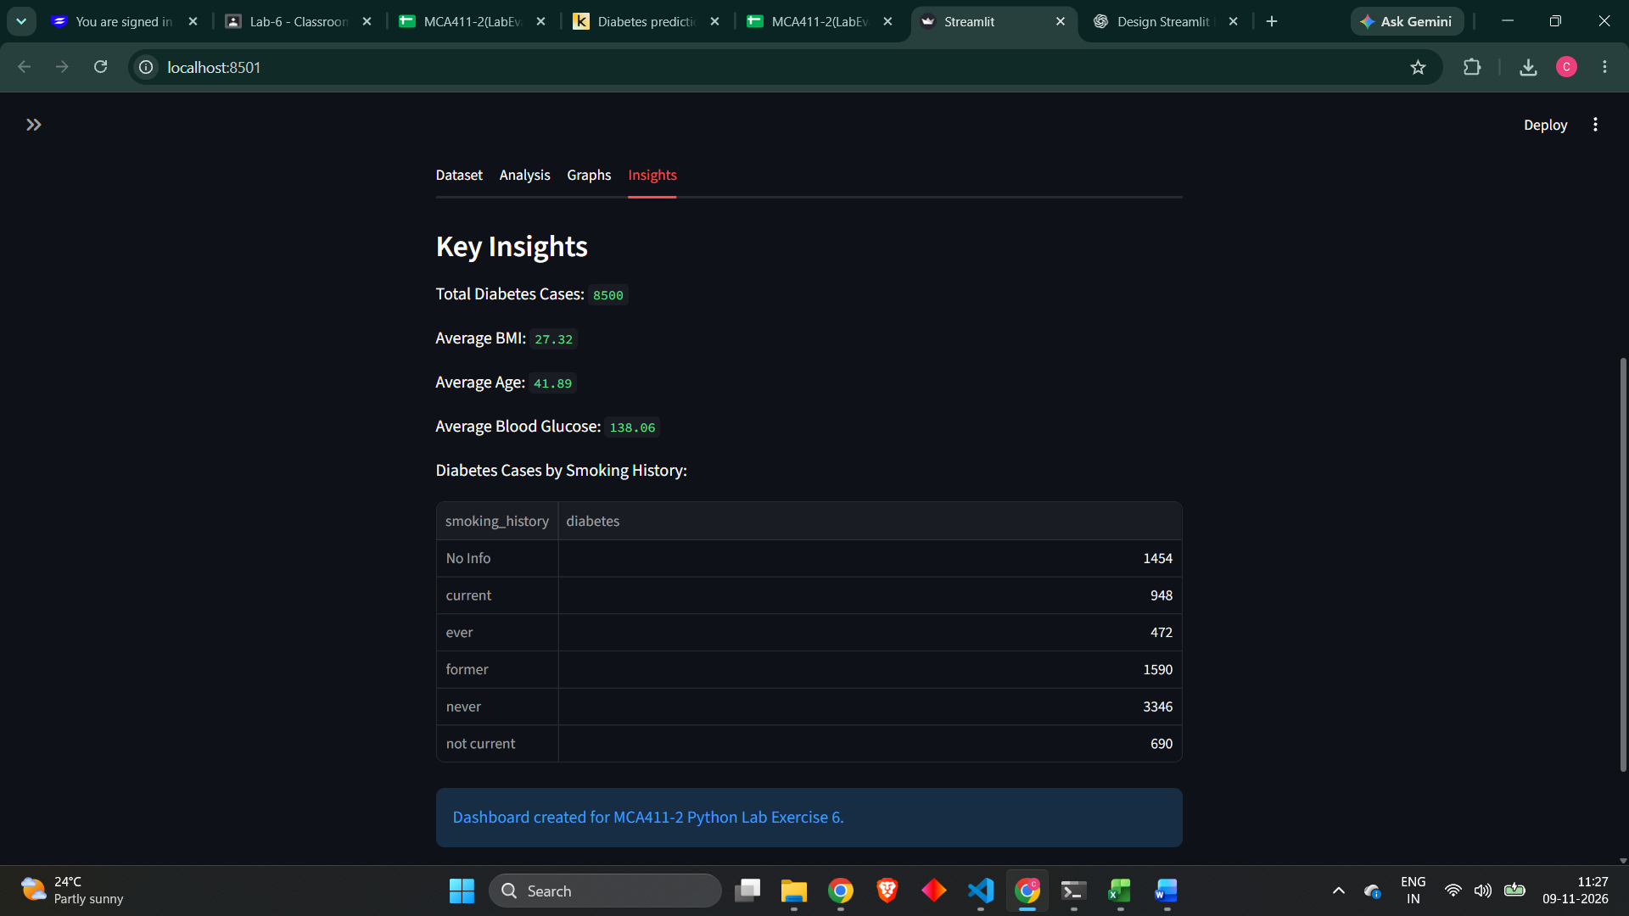

Public Deployment Information
Public Deployment URL: https://charles2647213-diabetesdashboard.streamlit.app/

