Swagger-UI

POST-**https://localhost:7293/api/BloodBank**

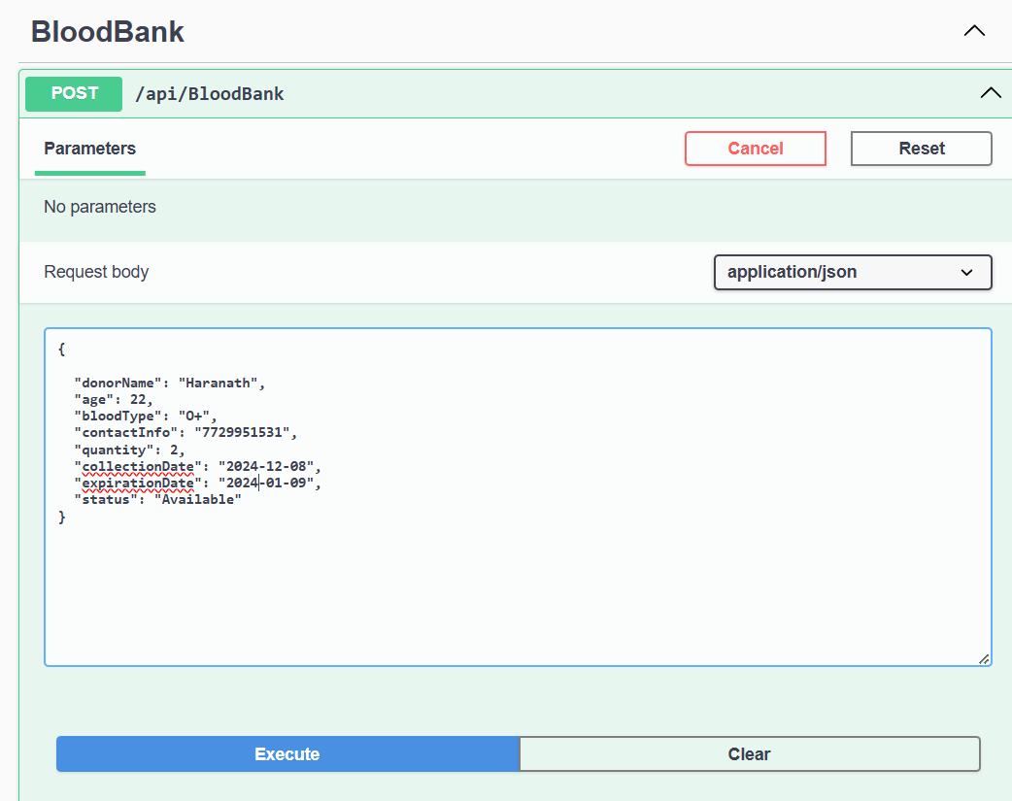

**Correct response**

**GET-https://localhost:7293/api/BloodBank/all**

**GET-ById-https://localhost:7293/api/BloodBank/2**

**PUT-Update by id-https://localhost:7293/api/BloodBank/updateby4**

**DELETE-https://localhost:7293/api/BloodBank/deleteby8**

**Get-Page-https://localhost:7293/api/BloodBank/paged?page=1&size=2**

**GET-BySearch-https://localhost:7293/api/BloodBank/search?bloodType=B%2B&status=Available**

POSTMAN-tool(Screenshots)



