How to register charmee.test domain using smart contracts
namehash('test')---> 0x04f740db81dc36c853ab4205bddd785f46e79ccedca351fc6dfcbd8cc9a33dd6
sha3('charmee') --->
0x6d7dc26fd16e485dac7db86d80bbec7f7bc8203acc90be8cfd6f6ae63b6b7efa
namehash("charmee.test") --->
0x60aa9d96f258a0e75d0dec7b373a4ebafc7dbd2e1667996c7792235a6331e06b
1.compile using 0.4.25 version only and deploy ens registry contract
2.compile using 0.4.25 version only and deploy TestRegistrar contract by passing ens registry address and namehash("test") of tld domain in constructor.
3.compile using 0.5.16 version only and deploy PublicResolver contract by passing ens registry address in constructor
4.call setOwner() function of ens registry and pass (namehash('test'),contract address of test registrar).
5.call setResolver() function of ens registry and pass (namehash('test'),contract address of public resolver ).
6.In order to check owner call owner() function of ens registry and after calling you will see the address of test registrar as a owner in the output.
7.In order to check resolver call resolver() function of ens registry and after calling you will see the address of public resolver as a resolver in the output.
8. call register() of testRegistrar contract and pass sha3("charmee") and metamask account address.
9.call setName() function of public resolver contract and pass namehash("charmee.test") and charmee.test as a string without inverted commas.
10.In order to check charme.test is set call name() function of publicresolver contract and pass namehash("charmee.test") and in the output you will see charmee.test as a string.
11.If you want to check that is charmee.test domain owner then call owner() function of ens registry and pass namehash("charmee.test") and in the ouput you will see metamask account address as a owner.

I had already deploy above contracts on ropsten network , below are the address
ens registry --> 0x5DA9f4a82ACd3751Aa1D86c5215d3CdE2fb39010
public resolver --->0xb876535208B8669221029989B11e2576AfD54fFa
test registrar ---> 0xb97D67d7F309A6420426A64Cff391244fa983e72

Step 2
Above steps are for the understanding purpose if you want to deploy charmee.test domain on https://app.ens.domains/ website then follow below steps.
1. clone the code of ens-contracts in the localhost and copy paste your address in your .env file below
PRIVATE_KEY=metamask account private key.
ETHERSCAN_API_KEY= https://etherscan.io/ website api key
INFURA_API_KEY=https://ropsten.infura.io/v3/projectID
METADATA_HOST=ropsten
INFURA_ID=projectID of https://infura.io/dashboard website
DEPLOYER_KEY=private key of metamask account
OWNER_KEY=infura private of ropsten address
2. run the command npx hardhat run --network ropsten scripts/wrapper/deploy.js
3. you will get below same output
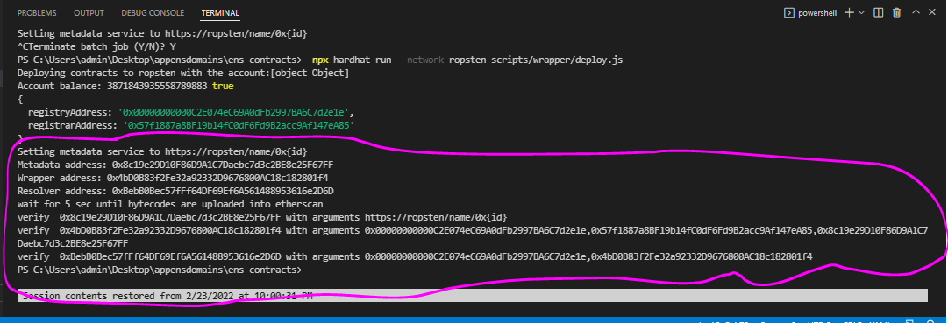
4. After getting above ouput grab ens registry with fallback contract address from the highlighted section and search on ropsten network.
5. To find out the test registrar address ,interact with ens registry contract owner() function and pass namehash(“test”) in the input ,you will get test registrar addresss.
6. When you get test registrar address , call register() function by passing sha3(“charmee”) and metamask account owner address.
7. 0x42D63ae25990889E35F215bC95884039Ba354115 is the public resolver contract address on ropsten network where you have to call setName() function by passing namehash(“charmee.test”) and “charmee.test” parameters.
8. After above steps got to your ens contracts code .env and add extra parameters by copy paste your address of metadata wrapper ,ens registry ,resolver ,wrapper , registar and resolver address which you got first time by running the command npx hardhat run --network ropsten scripts/wrapper/deploy.js in your .env file below are
SEED=charmee.test (mentioned the address which you have registered already via contracts above)
METADATA_ADDRESS=(address which you got from above ouput in the console)
WRAPPER_ADDRESS=(address which you got from above ouput in the console)
RESOLVER_ADDRESS=(address which you got from above ouput in the console)
REGISTRY_ADDRESS=(address which you got from above ouput in the console)
REGISTRAR_ADDRESS=(address which you got from above ouput in the console)
9. After done setting above run below command npx hardhat run --network ropsten scripts/wrapper/seed.js and check
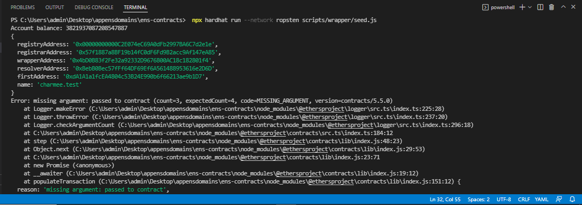

10. check the website https://app.ens.domains/ before setting above things you will see below output
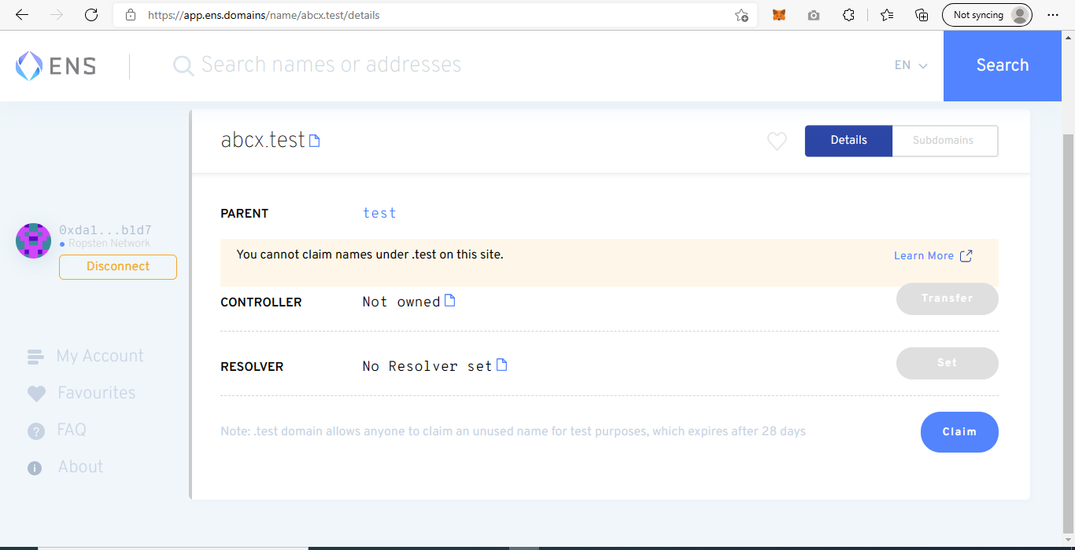
11. After following above steps you will see below ouput
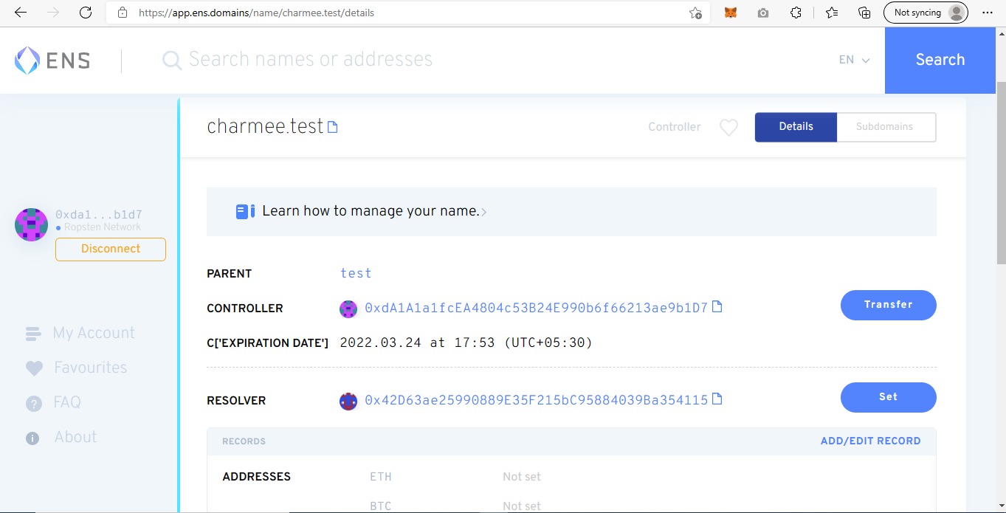
12. use that resolver address where you have call setName() function and set your domain for ex “charmee.test” and set it on above website and you wll see above output successfully on https://app.ens.domains/ website.
13. And below screenshot on ropsten network
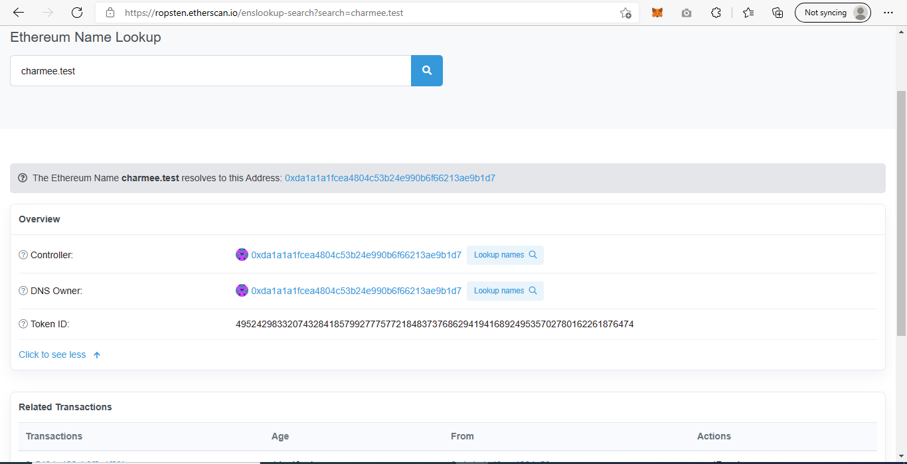

Below are the references where you can refer
1. https://medium.com/the-ethereum-name-service/claim-test-ens-domain-for-easy-testing-1127e415c76d
2. https://blog.decenter.com/2018/08/30/registering-an-ens-domain-and-setting-up-reverse-lookup/
3. https://gist.github.com/sterlu/9e47011baedf60921b12d7c3183e25ba
4. https://michalzalecki.com/register-test-domain-with-ens/
5. https://github.com/ensdomains/ens-contracts/tree/master/contracts/wrapper (steps).
6. https://github.com/ensdomains/ens-contracts.

For references
Changes done in below files for using .test domain in the ens- contracts code.
1. NameWrapper.sol
2. deploy.js
3. Seed.js
https://ropsten.etherscan.io/address/0xc19fd9004b5c9789391679de6d766b981db94610#writeContract

Steps for deploying contracts with namewrapper and staticmetadataservice contracts.
1 deploy ens registry contract with 0.4.25 version
2.deploy baseregistrar contract with parameters (ens registry address, basenode address(namehash(test))) with version --->0.8.1
3.deploy static wrapper contract with uri https://ropsten/name/0x{id} and with version 08.1 and then deploy namewrapper contract with version (0.8.1)(ensregistry address ,baseregistrar address, staticmetadawrapper address)
3. deploy reverse registrar contact(ens address) with 0.8.1 version.
4. deploy ethregistrarcontroller contract with 0.8.1 version and by passing parameters (ens registry address ,stableprice address, days into seconds,days into seconds,reverse registrar contract address,namewrapper contract address)
5.deploy public resolver address with 0.8.4 version and by passing paramters (ens registry address,name wrapper address,ethcontroller,reverse registrar address).

