# NYC FoodInspection Assignment

## Alteryx

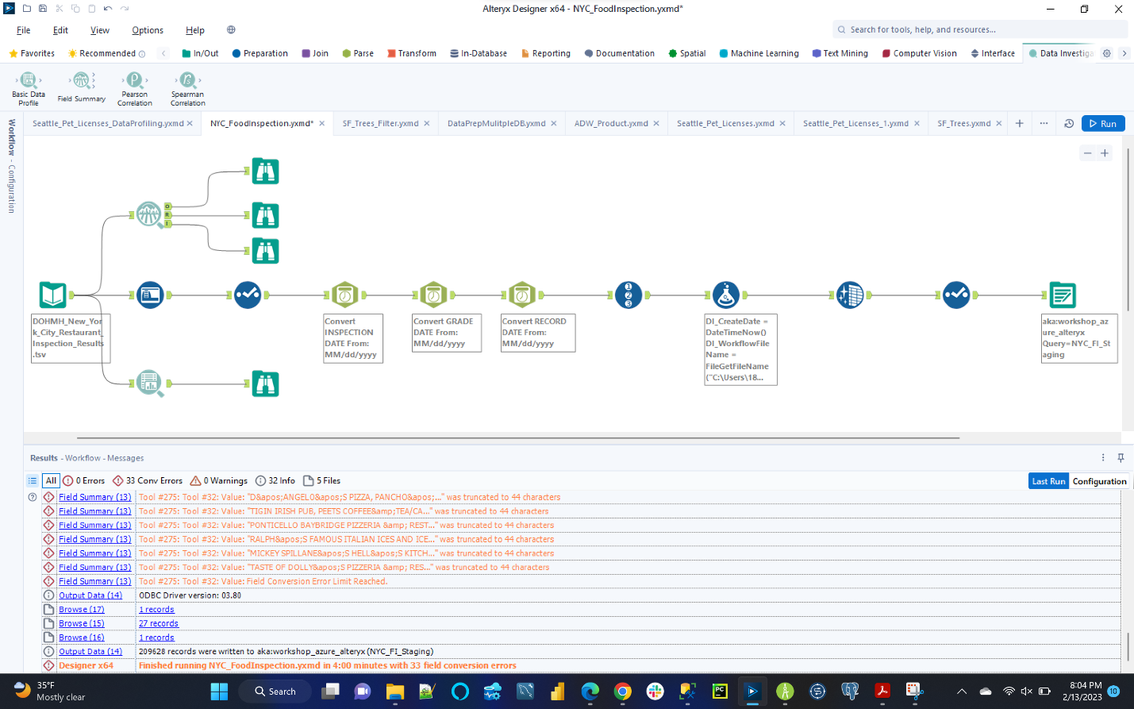

## Runtime:

## ER Studio Dimensional Model (Logical):

## ER Studio Dimensional Model (Physical):

## DDL Script Execution:

