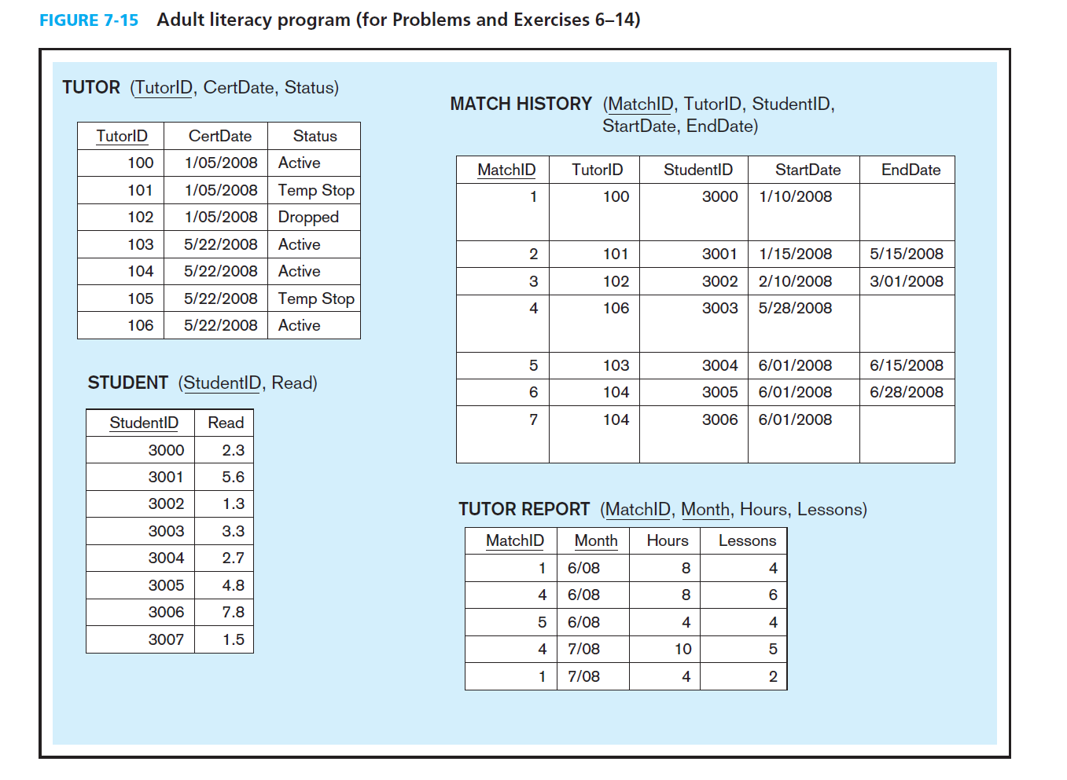

1. Create a database named ““AdultLiteracy” on your RDBMS environment. Using Figure 7-5 above, write DDL commands to create table structures for each entity above. Name your tables the following names: Tutor, Student, MatchHistory, TutorReport
2. Write SQL scripts to insert sample data from Fig 7-5 into the database.
3. 7. Write the SQL command to add MATH SCORE to the STUDENT table.
4. 8. Write the SQL command to add SUBJECT to TUTOR. The only values allowed for SUBJECT will be Reading, Math, and ESL.
5. 10. Write the SQL command to find any tutors who have not submitted a report for July.