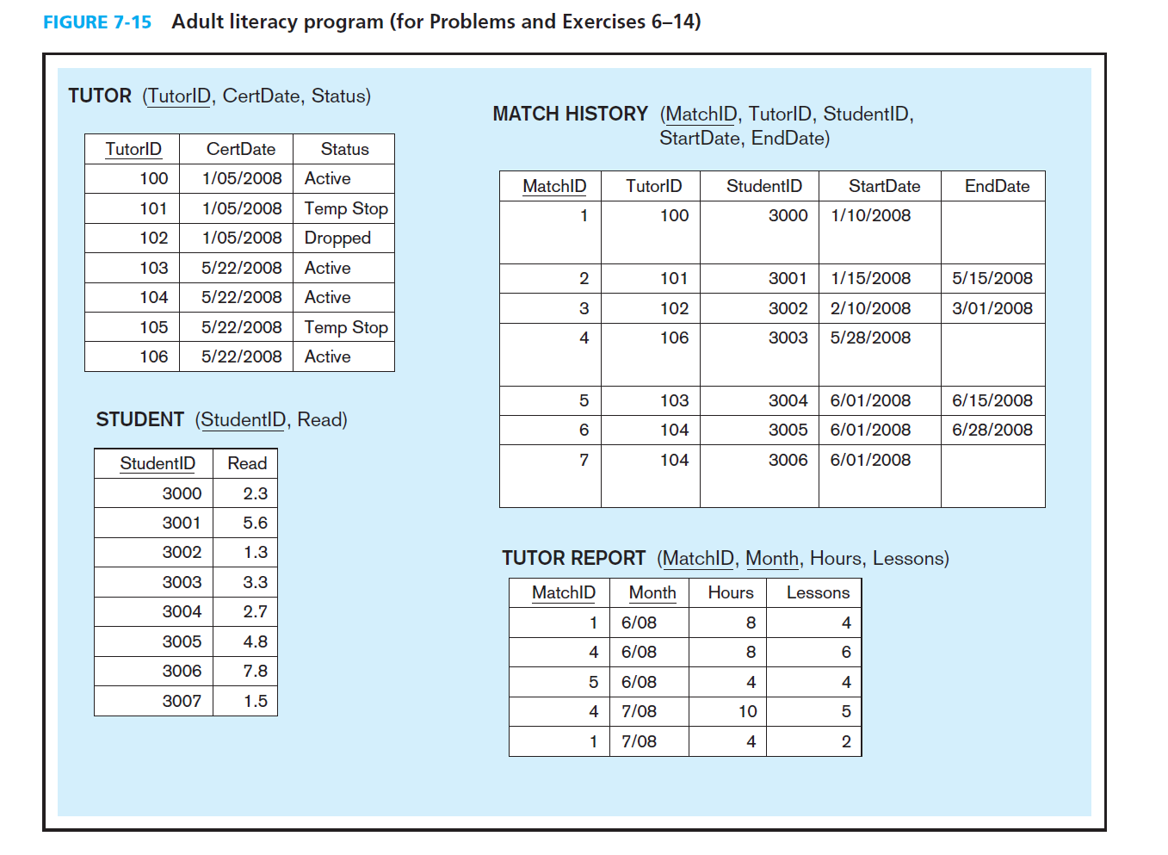

Using ““AdultLiteracy” database created last week, answer the following questions:

1. Which tutor needs to be reminded to turn in reports? Write Stored Procedure that returns a result set. No Parameters required
2. Create a stored procedure that returns a result set of all tutors that are available to tutor (by name). No input parameters required
3. Create a UDF named GetTutorStatus that takes TutorID as input parameter and return status (Active or Deactive)