DML Assignment

Q1.
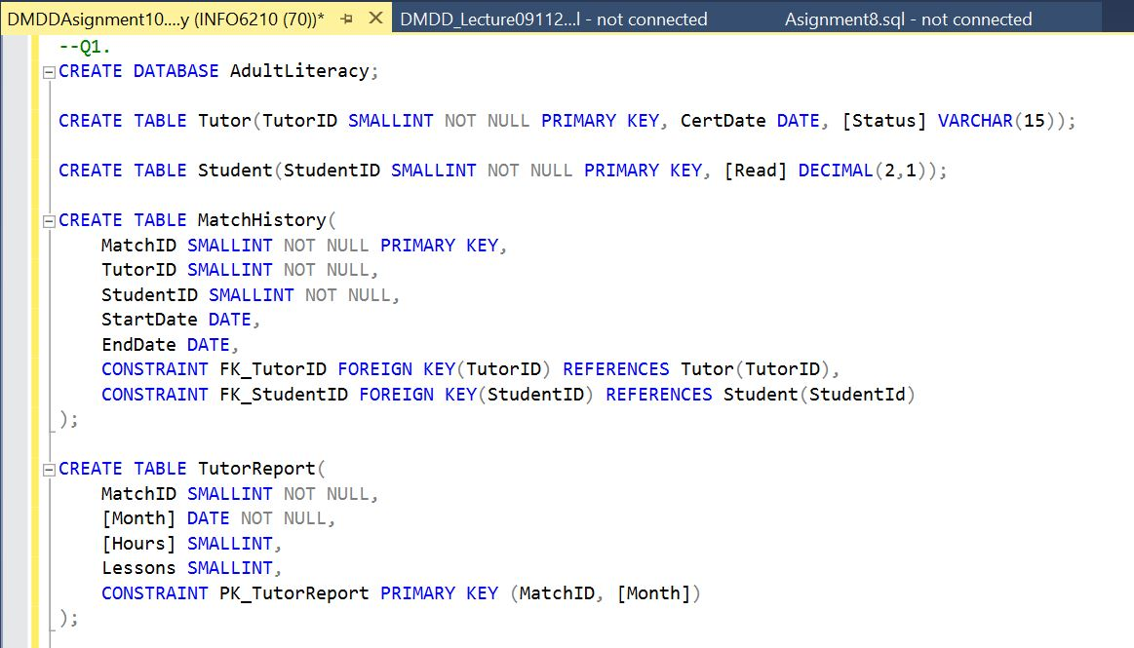

Q2.
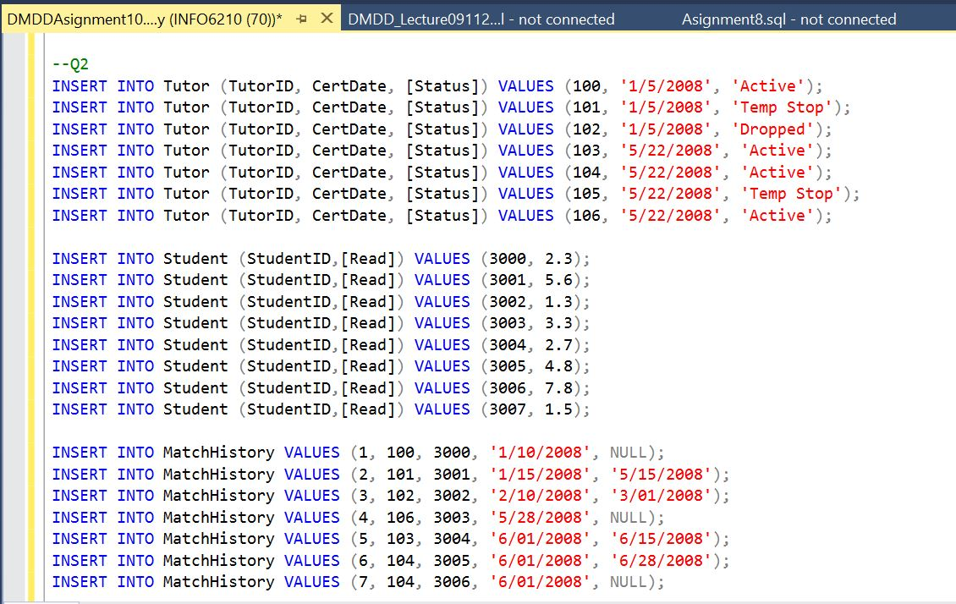
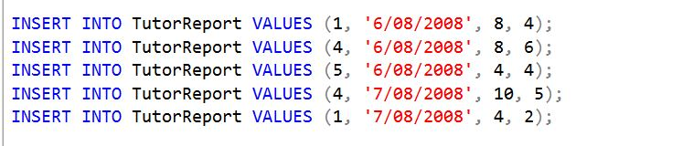

Q3., Q4, Q6.
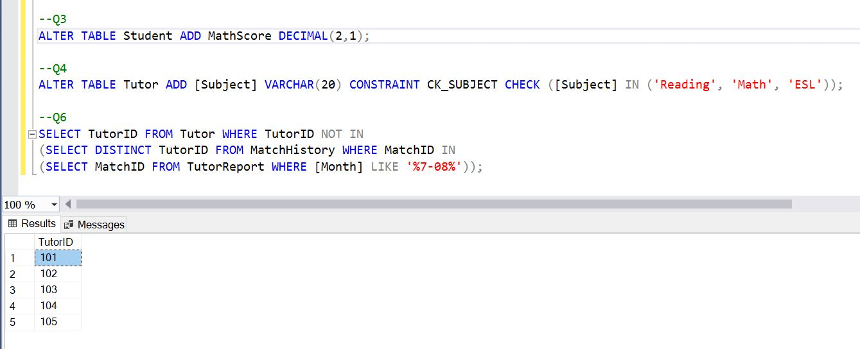

QUERIES:

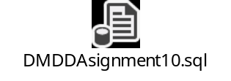

--Q1.
CREATE DATABASE AdultLiteracy;

CREATE TABLE Tutor(TutorID SMALLINT NOT NULL PRIMARY KEY, CertDate DATE, [Status] VARCHAR(15));

CREATE TABLE Student(StudentID SMALLINT NOT NULL PRIMARY KEY, [Read] DECIMAL(2,1));

CREATE TABLE MatchHistory(
MatchID SMALLINT NOT NULL PRIMARY KEY,
TutorID SMALLINT NOT NULL,
StudentID SMALLINT NOT NULL,
StartDate DATE,
EndDate DATE,
CONSTRAINT FK_TutorID FOREIGN KEY(TutorID) REFERENCES Tutor(TutorID),
CONSTRAINT FK_StudentID FOREIGN KEY(StudentID) REFERENCES Student(StudentId)
);

CREATE TABLE TutorReport(
MatchID SMALLINT NOT NULL,
[Month] DATE NOT NULL,
[Hours] SMALLINT,
Lessons SMALLINT,
CONSTRAINT PK_TutorReport PRIMARY KEY (MatchID, [Month])
);

--Q2
INSERT INTO Tutor (TutorID, CertDate, [Status]) VALUES (100, '1/5/2008', 'Active');
INSERT INTO Tutor (TutorID, CertDate, [Status]) VALUES (101, '1/5/2008', 'Temp Stop');
INSERT INTO Tutor (TutorID, CertDate, [Status]) VALUES (102, '1/5/2008', 'Dropped');
INSERT INTO Tutor (TutorID, CertDate, [Status]) VALUES (103, '5/22/2008', 'Active');
INSERT INTO Tutor (TutorID, CertDate, [Status]) VALUES (104, '5/22/2008', 'Active');
INSERT INTO Tutor (TutorID, CertDate, [Status]) VALUES (105, '5/22/2008', 'Temp Stop');
INSERT INTO Tutor (TutorID, CertDate, [Status]) VALUES (106, '5/22/2008', 'Active');

INSERT INTO Student (StudentID,[Read]) VALUES (3000, 2.3);
INSERT INTO Student (StudentID,[Read]) VALUES (3001, 5.6);
INSERT INTO Student (StudentID,[Read]) VALUES (3002, 1.3);
INSERT INTO Student (StudentID,[Read]) VALUES (3003, 3.3);
INSERT INTO Student (StudentID,[Read]) VALUES (3004, 2.7);
INSERT INTO Student (StudentID,[Read]) VALUES (3005, 4.8);
INSERT INTO Student (StudentID,[Read]) VALUES (3006, 7.8);
INSERT INTO Student (StudentID,[Read]) VALUES (3007, 1.5);

INSERT INTO MatchHistory VALUES (1, 100, 3000, '1/10/2008', NULL);
INSERT INTO MatchHistory VALUES (2, 101, 3001, '1/15/2008', '5/15/2008');
INSERT INTO MatchHistory VALUES (3, 102, 3002, '2/10/2008', '3/01/2008');
INSERT INTO MatchHistory VALUES (4, 106, 3003, '5/28/2008', NULL);
INSERT INTO MatchHistory VALUES (5, 103, 3004, '6/01/2008', '6/15/2008');
INSERT INTO MatchHistory VALUES (6, 104, 3005, '6/01/2008', '6/28/2008');
INSERT INTO MatchHistory VALUES (7, 104, 3006, '6/01/2008', NULL);

INSERT INTO TutorReport VALUES (1, '6/08/2008', 8, 4);
INSERT INTO TutorReport VALUES (4, '6/08/2008', 8, 6);
INSERT INTO TutorReport VALUES (5, '6/08/2008', 4, 4);
INSERT INTO TutorReport VALUES (4, '7/08/2008', 10, 5);
INSERT INTO TutorReport VALUES (1, '7/08/2008', 4, 2);

--Q3
ALTER TABLE Student ADD MathScore DECIMAL(2,1);

--Q4
ALTER TABLE Tutor ADD [Subject] VARCHAR(20) CONSTRAINT CK_SUBJECT CHECK ([Subject] IN ('Reading', 'Math', 'ESL'));

--Q6
SELECT TutorID FROM Tutor WHERE TutorID NOT IN
(SELECT DISTINCT TutorID FROM MatchHistory WHERE MatchID IN
(SELECT MatchID FROM TutorReport WHERE [Month] LIKE '%7-08%'));

