SQL Procedures

Q1.
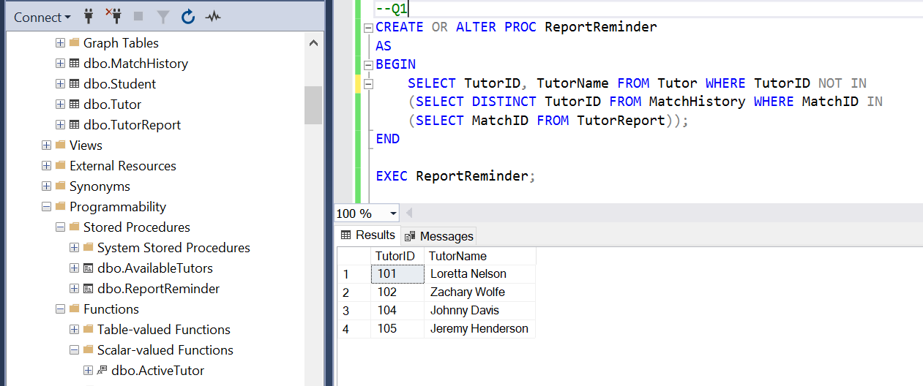

Q2.
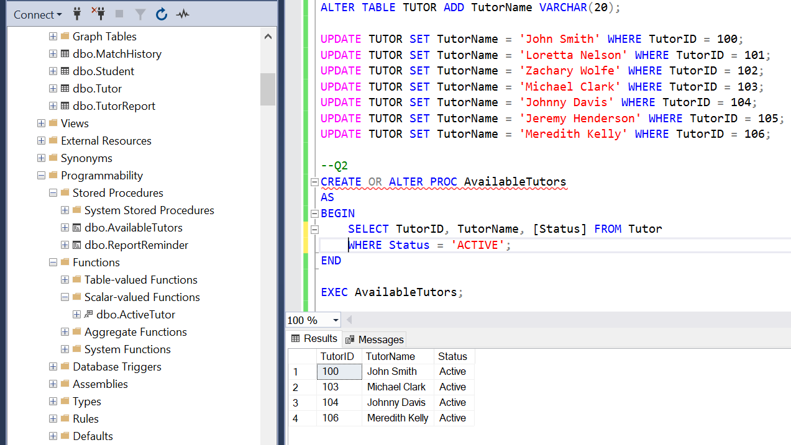

Q3.
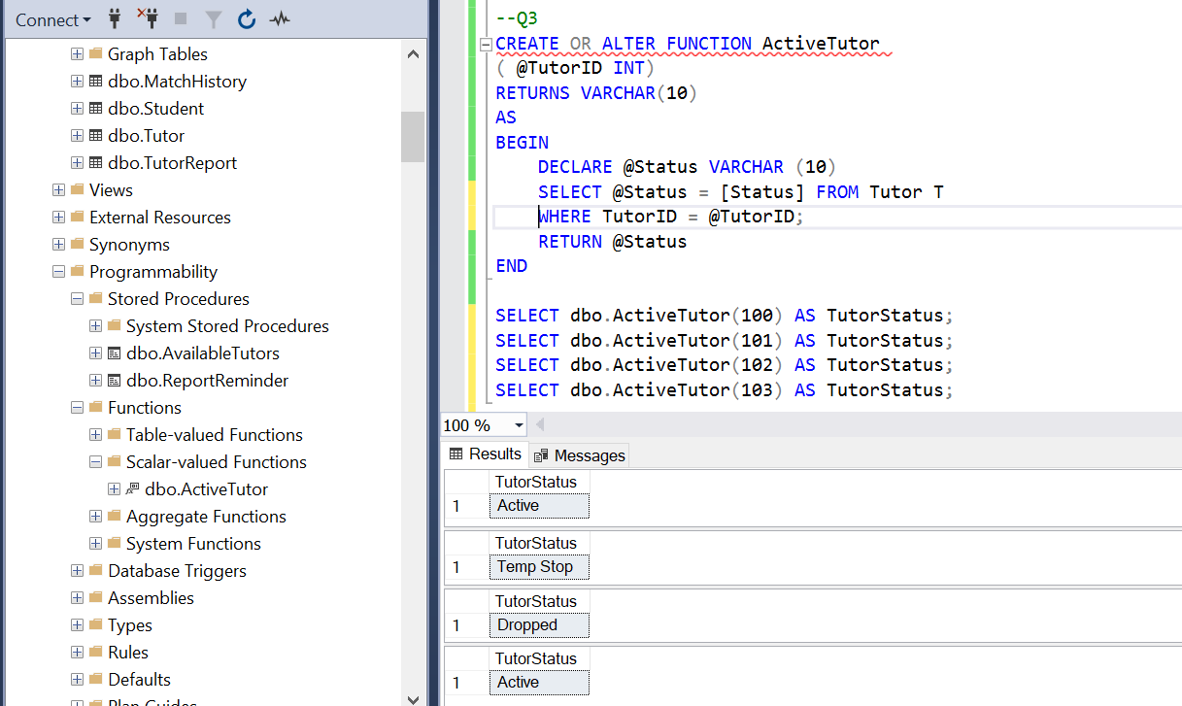

ALTERNATE APPROACH: (SHOWS STATUS AS EITHER ACTIVE OR DEACTIVE)
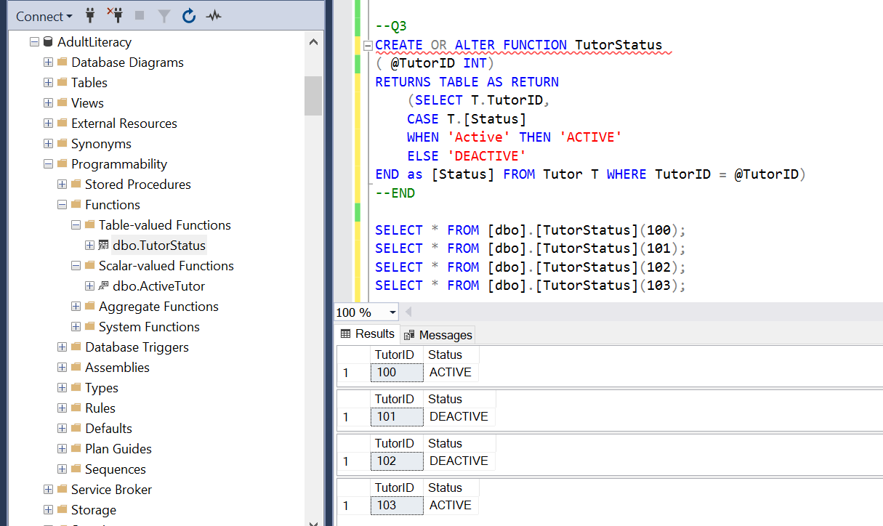

QUERIES:
--Q1
CREATE OR ALTER PROC ReportReminder
AS
BEGIN
SELECT TutorID, TutorName FROM Tutor WHERE TutorID NOT IN
(SELECT DISTINCT TutorID FROM MatchHistory WHERE MatchID IN
(SELECT MatchID FROM TutorReport));
END

EXEC ReportReminder;

ALTER TABLE TUTOR ADD TutorName VARCHAR(20);

UPDATE TUTOR SET TutorName = 'John Smith' WHERE TutorID = 100;
UPDATE TUTOR SET TutorName = 'Loretta Nelson' WHERE TutorID = 101;
UPDATE TUTOR SET TutorName = 'Zachary Wolfe' WHERE TutorID = 102;
UPDATE TUTOR SET TutorName = 'Michael Clark' WHERE TutorID = 103;
UPDATE TUTOR SET TutorName = 'Johnny Davis' WHERE TutorID = 104;
UPDATE TUTOR SET TutorName = 'Jeremy Henderson' WHERE TutorID = 105;
UPDATE TUTOR SET TutorName = 'Meredith Kelly' WHERE TutorID = 106;

--Q2
CREATE OR ALTER PROC AvailableTutors
AS
BEGIN
SELECT TutorID, TutorName, [Status] FROM Tutor
WHERE Status = 'ACTIVE';
END

EXEC AvailableTutors;

--Q3
CREATE OR ALTER FUNCTION ActiveTutor
( @TutorID INT)
RETURNS VARCHAR(10)
AS
BEGIN
DECLARE @Status VARCHAR (10)
SELECT @Status = [Status] FROM Tutor T
WHERE TutorID = @TutorID;
RETURN @Status
END

SELECT dbo.ActiveTutor(100) AS TutorStatus;
SELECT dbo.ActiveTutor(101) AS TutorStatus;
SELECT dbo.ActiveTutor(102) AS TutorStatus;
SELECT dbo.ActiveTutor(103) AS TutorStatus;

--ALTERNATE APPROACH
CREATE OR ALTER FUNCTION TutorStatus
( @TutorID INT)
RETURNS TABLE AS RETURN
(SELECT T.TutorID,
CASE T.[Status]
WHEN 'Active' THEN 'ACTIVE'
ELSE 'DEACTIVE'
END as [Status] FROM Tutor T WHERE TutorID = @TutorID)
--END

SELECT * FROM [dbo].[TutorStatus](100);
SELECT * FROM [dbo].[TutorStatus](101);
SELECT * FROM [dbo].[TutorStatus](102);
SELECT * FROM [dbo].[TutorStatus](103);

