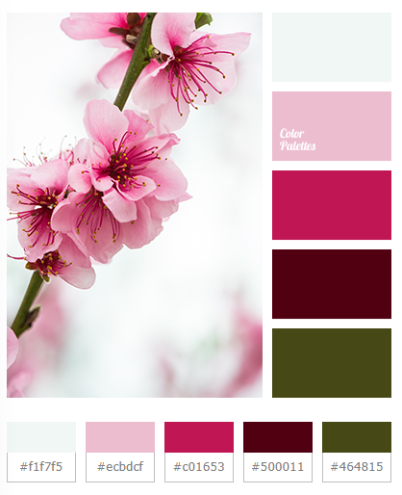

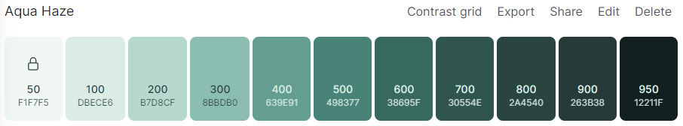

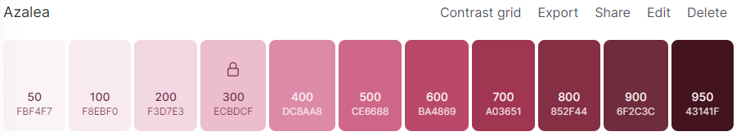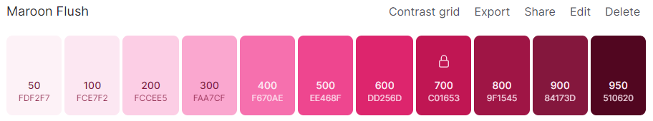

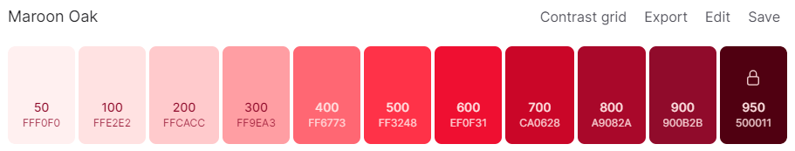

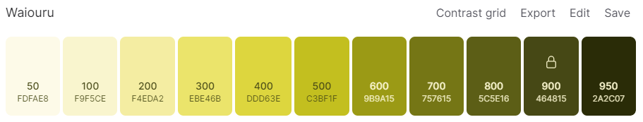

About me Section

I am Charm Relator. I am a Software Engineer with over a year of Web Development experience, currently studying Mobile Development. My goal is to have a good grasp of Software Development fundamentals so I can code regardless of programming language.

Ever since I was a kid, I liked asking questions.

I gained confidence that I could become a software engineer when I could complete my first task, whose scope was changed drastically. The path to completing it wasn’t easy, but I learned that learning how to read documentation, write pseudocode, and as well knowing when to ask for help