1. Creating a message : Post (localhost:8080/add/message)

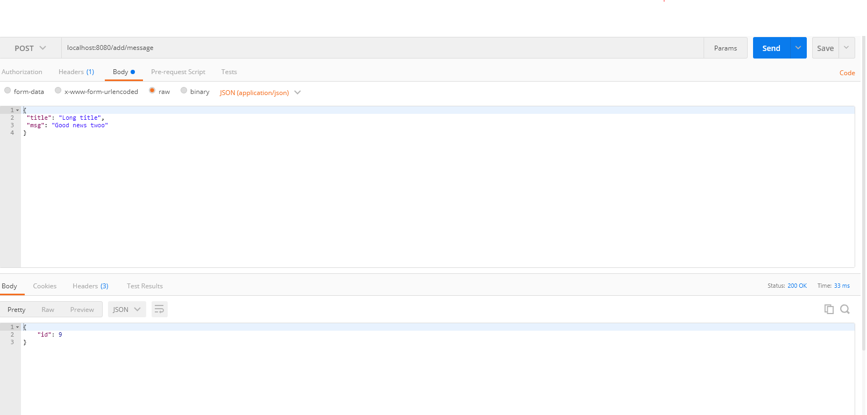

1. Modify Message – PUT(localhost:8080/modify/1)

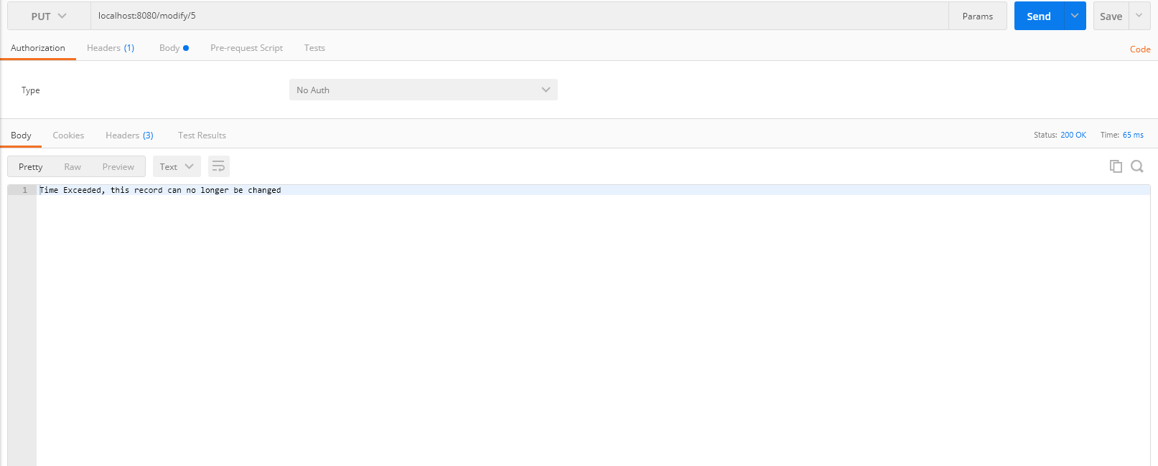

1. Get Message by ID – GET(localhost:8080/message/1)

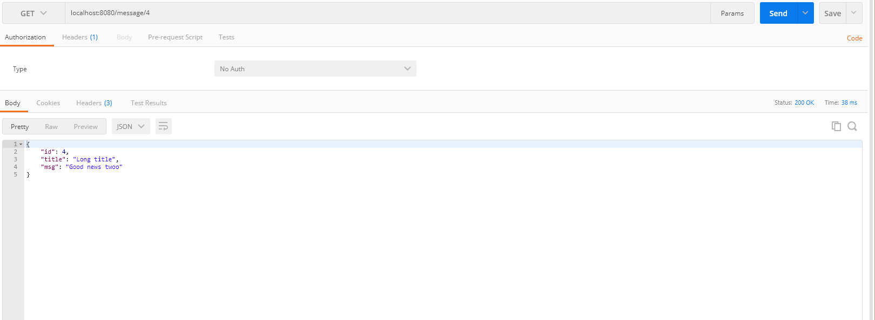

1. Get all Messgaes - GET(localhost:8080/messages)

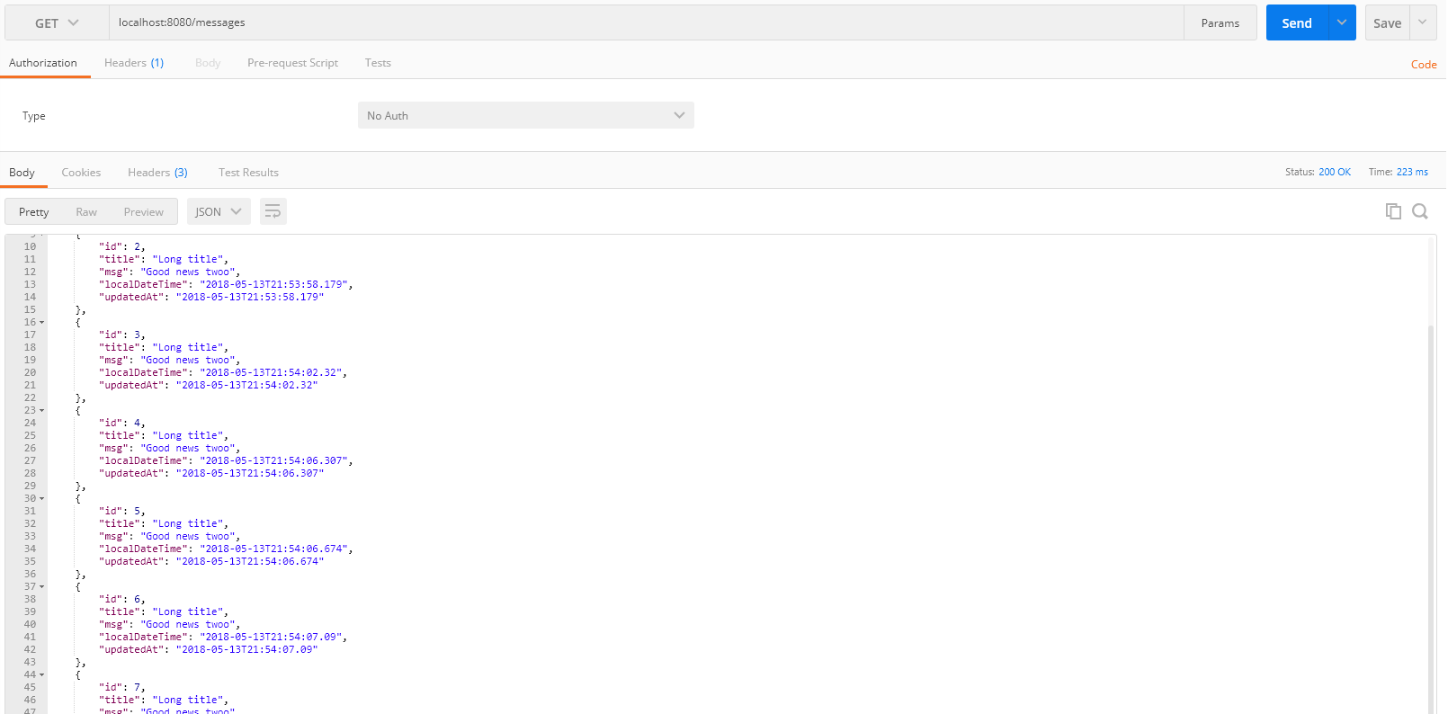

1. Get Last “N” Messages - GET (localhost:8080/lastmessages/3)

