LAB4 Multiple Linear Regression

Samuel Mweni

Stat 415/615 Regression, 2022

Table of Contents

1 Commercial Property (polynomial and interactions)

cpdata<-read.table("../homework7/CommercialProperty.txt", header=T)  
#cpdata  
head(cpdata, 3) # first 3 observations

## RentalRates Age Expense Vacancy Sfootage  
## 1 13.5 1 5.02 0.14 123000  
## 2 12.0 14 8.19 0.27 104079  
## 3 10.5 16 3.00 0.00 39998

tail(cpdata, 3) # last 3 observations

## RentalRates Age Expense Vacancy Sfootage  
## 79 15.00 15 11.97 0.14 254700  
## 80 15.25 11 11.27 0.03 434746  
## 81 14.50 14 12.68 0.03 201930

#1.1 Plot the data and comment. Also, get a numerical summary (mean,std.dev.) of all variables. Note that the mean of Age is 7.86.

par(mfrow=c(2,3))  
for (i in 1:5) hist(cpdata[, i])  
summary(cpdata)

## RentalRates Age Expense Vacancy   
## Min. :10.50 Min. : 0.000 Min. : 3.000 Min. :0.00000   
## 1st Qu.:14.00 1st Qu.: 2.000 1st Qu.: 8.130 1st Qu.:0.00000   
## Median :15.00 Median : 4.000 Median :10.360 Median :0.03000   
## Mean :15.14 Mean : 7.864 Mean : 9.688 Mean :0.08099   
## 3rd Qu.:16.50 3rd Qu.:15.000 3rd Qu.:11.620 3rd Qu.:0.09000   
## Max. :19.25 Max. :20.000 Max. :14.620 Max. :0.73000   
## Sfootage   
## Min. : 27000   
## 1st Qu.: 70000   
## Median :129614   
## Mean :160633   
## 3rd Qu.:236000   
## Max. :484290

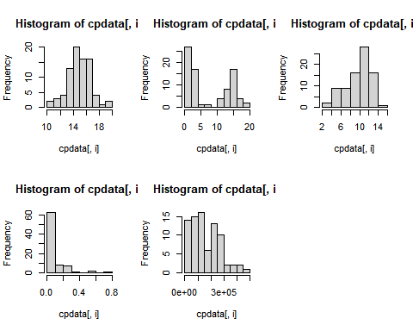

pairs(cpdata)

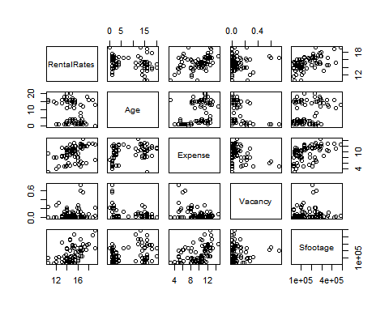

cor(cpdata)

## RentalRates Age Expense Vacancy Sfootage  
## RentalRates 1.00000000 -0.2502846 0.4137872 0.06652647 0.53526237  
## Age -0.25028456 1.0000000 0.3888264 -0.25266347 0.28858350  
## Expense 0.41378716 0.3888264 1.0000000 -0.37976174 0.44069713  
## Vacancy 0.06652647 -0.2526635 -0.3797617 1.00000000 0.08061073  
## Sfootage 0.53526237 0.2885835 0.4406971 0.08061073 1.00000000

#1.2 Follow the instruction in Problem 8.8 from the text, we will consider a regression model with predictors Age, Ageˆ2, Expense, and Square Footage.Fit the regression model.

cpdata$CentAge<-cpdata$Age-mean(cpdata$Age)  
cpreg1 <- lm(RentalRates~Age+I(Age^2)+Expense+Sfootage, data=cpdata)  
summary(cpreg1)

##   
## Call:  
## lm(formula = RentalRates ~ Age + I(Age^2) + Expense + Sfootage,   
## data = cpdata)  
##   
## Residuals:  
## Min 1Q Median 3Q Max   
## -2.89596 -0.62547 -0.08907 0.62793 2.68309   
##   
## Coefficients:  
## Estimate Std. Error t value Pr(>|t|)   
## (Intercept) 1.249e+01 4.805e-01 26.000 < 2e-16 ***  
## Age -4.043e-01 1.089e-01 -3.712 0.00039 ***  
## I(Age^2) 1.415e-02 5.821e-03 2.431 0.01743 *   
## Expense 3.140e-01 5.880e-02 5.340 9.33e-07 ***  
## Sfootage 8.046e-06 1.267e-06 6.351 1.42e-08 ***  
## ---  
## Signif. codes: 0 '***' 0.001 '**' 0.01 '*' 0.05 '.' 0.1 ' ' 1  
##   
## Residual standard error: 1.097 on 76 degrees of freedom  
## Multiple R-squared: 0.6131, Adjusted R-squared: 0.5927   
## F-statistic: 30.1 on 4 and 76 DF, p-value: 5.203e-15

#1.3 Add interaction terms to the previous model and examine their signifiance.

cpreg2<-lm(RentalRates~Age+I(Age^2)+Expense+Sfootage  
+ Age:Expense + Age:Sfootage, data=cpdata)  
summary(cpreg2)

##   
## Call:  
## lm(formula = RentalRates ~ Age + I(Age^2) + Expense + Sfootage +   
## Age:Expense + Age:Sfootage, data = cpdata)  
##   
## Residuals:  
## Min 1Q Median 3Q Max   
## -2.97236 -0.83548 -0.04637 0.68661 2.72955   
##   
## Coefficients:  
## Estimate Std. Error t value Pr(>|t|)   
## (Intercept) 1.296e+01 6.766e-01 19.151 < 2e-16 ***  
## Age -4.672e-01 1.211e-01 -3.856 0.000244 ***  
## I(Age^2) 1.052e-02 6.079e-03 1.731 0.087564 .   
## Expense 2.138e-01 8.127e-02 2.631 0.010357 *   
## Sfootage 1.013e-05 2.370e-06 4.274 5.65e-05 ***  
## Age:Expense 1.821e-02 9.962e-03 1.828 0.071539 .   
## Age:Sfootage -3.125e-07 2.220e-07 -1.408 0.163392   
## ---  
## Signif. codes: 0 '***' 0.001 '**' 0.01 '*' 0.05 '.' 0.1 ' ' 1  
##   
## Residual standard error: 1.085 on 74 degrees of freedom  
## Multiple R-squared: 0.6319, Adjusted R-squared: 0.602   
## F-statistic: 21.17 on 6 and 74 DF, p-value: 2.672e-14

# Using centered-variables.  
cpreg2b<-lm(RentalRates~CentAge+I(CentAge^2)+Expense+Sfootage  
+ CentAge:Expense + CentAge:Sfootage, data=cpdata)  
cpreg2b

##   
## Call:  
## lm(formula = RentalRates ~ CentAge + I(CentAge^2) + Expense +   
## Sfootage + CentAge:Expense + CentAge:Sfootage, data = cpdata)  
##   
## Coefficients:  
## (Intercept) CentAge I(CentAge^2) Expense   
## 9.935e+00 -3.016e-01 1.052e-02 3.570e-01   
## Sfootage CentAge:Expense CentAge:Sfootage   
## 7.670e-06 1.821e-02 -3.125e-07

anova(cpreg1, cpreg2)

## Analysis of Variance Table  
##   
## Model 1: RentalRates ~ Age + I(Age^2) + Expense + Sfootage  
## Model 2: RentalRates ~ Age + I(Age^2) + Expense + Sfootage + Age:Expense +   
## Age:Sfootage  
## Res.Df RSS Df Sum of Sq F Pr(>F)  
## 1 76 91.535   
## 2 74 87.086 2 4.4488 1.8901 0.1583

anova(cpreg1, cpreg2)

## Analysis of Variance Table  
##   
## Model 1: RentalRates ~ Age + I(Age^2) + Expense + Sfootage  
## Model 2: RentalRates ~ Age + I(Age^2) + Expense + Sfootage + Age:Expense +   
## Age:Sfootage  
## Res.Df RSS Df Sum of Sq F Pr(>F)  
## 1 76 91.535   
## 2 74 87.086 2 4.4488 1.8901 0.1583

# 2 Example 2. Qualitative/Categorical Predictors and Interactions

The data in file twins.txt and twins.sav are from a 1966 paper by Cyril Burt entitled “The genetic determination of differences in intelligence: A study of monozygotic twins reared apart”. The data consist of IQ scores for identical twins, one raised by foster parents, the other by the natural parents. We also know the social class of natural parents (high, middle or low). We are interested in predicting the IQ of the twin with foster parents from the IQ of the twin with the natural parents and the social class of natural parents.

twindata<-read.table("../homework7/twins.txt", header=T)  
head(twindata, 2)

## IQF IQN status  
## 1 82 82 h  
## 2 80 90 h

tail(twindata, 2)

## IQF IQN status  
## 26 107 106 l  
## 27 98 111 l

# Covert status to factor to simplify future code.  
twindata$status <- as.factor(twindata$status)

2.1 Plot the data

par(mfrow = c(1, 3))  
hist(twindata$IQF)  
hist(twindata$IQN)  
barplot(table(twindata$status))

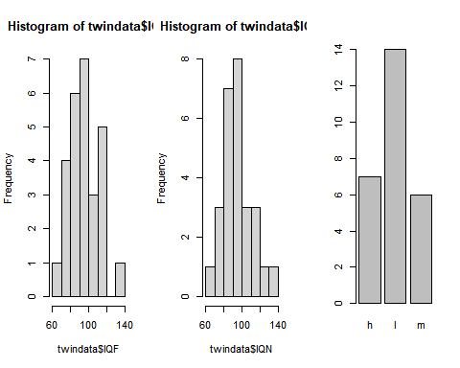

plot(IQF ~ IQN, col=status, pch=14+as.numeric(status), data=twindata)  
legend(70, 130, legend=c("High", "Low", "Median"), col=c(1:3), pch=14+c(1:3))

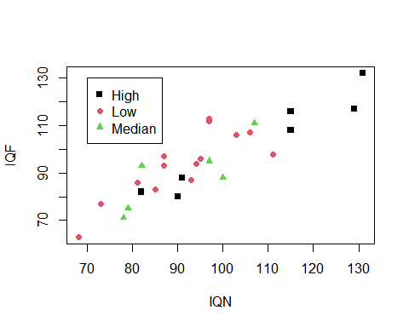 # 2.3 Fit regression models. Recall that we converted the categorical variable status into a factor variable earlier. Hence it can be used in the lm() function directly. If a categorical predictor is not converted into a factor, you must use as.factor(status) inside the lm() function.

twinreg<-lm(IQF~IQN+status, data=twindata)  
# twinreg<-lm(IQF~IQN+as.factor(status), data=twindata)  
summary(twinreg)

##   
## Call:  
## lm(formula = IQF ~ IQN + status, data = twindata)  
##   
## Residuals:  
## Min 1Q Median 3Q Max   
## -14.8235 -5.2366 -0.1111 4.4755 13.6978   
##   
## Coefficients:  
## Estimate Std. Error t value Pr(>|t|)   
## (Intercept) -0.6076 11.8551 -0.051 0.960   
## IQN 0.9658 0.1069 9.031 5.05e-09 ***  
## statusl 6.2264 3.9171 1.590 0.126   
## statusm 2.0353 4.5908 0.443 0.662   
## ---  
## Signif. codes: 0 '***' 0.001 '**' 0.01 '*' 0.05 '.' 0.1 ' ' 1  
##   
## Residual standard error: 7.571 on 23 degrees of freedom  
## Multiple R-squared: 0.8039, Adjusted R-squared: 0.7784   
## F-statistic: 31.44 on 3 and 23 DF, p-value: 2.604e-08

twinreg2<-lm(IQF~IQN+status+IQN:status, data=twindata)  
summary(twinreg2)

##   
## Call:  
## lm(formula = IQF ~ IQN + status + IQN:status, data = twindata)  
##   
## Residuals:  
## Min 1Q Median 3Q Max   
## -14.479 -5.248 -0.155 4.582 13.798   
##   
## Coefficients:  
## Estimate Std. Error t value Pr(>|t|)   
## (Intercept) -1.872044 17.808264 -0.105 0.917   
## IQN 0.977562 0.163192 5.990 6.04e-06 ***  
## statusl 9.076654 24.448704 0.371 0.714   
## statusm 2.688068 31.604178 0.085 0.933   
## IQN:statusl -0.029140 0.244580 -0.119 0.906   
## IQN:statusm -0.004995 0.329525 -0.015 0.988   
## ---  
## Signif. codes: 0 '***' 0.001 '**' 0.01 '*' 0.05 '.' 0.1 ' ' 1  
##   
## Residual standard error: 7.921 on 21 degrees of freedom  
## Multiple R-squared: 0.8041, Adjusted R-squared: 0.7574   
## F-statistic: 17.24 on 5 and 21 DF, p-value: 8.31e-07

twinreg2<-lm(IQF~IQN+status+IQN:status, data=twindata)  
summary(twinreg2)

##   
## Call:  
## lm(formula = IQF ~ IQN + status + IQN:status, data = twindata)  
##   
## Residuals:  
## Min 1Q Median 3Q Max   
## -14.479 -5.248 -0.155 4.582 13.798   
##   
## Coefficients:  
## Estimate Std. Error t value Pr(>|t|)   
## (Intercept) -1.872044 17.808264 -0.105 0.917   
## IQN 0.977562 0.163192 5.990 6.04e-06 ***  
## statusl 9.076654 24.448704 0.371 0.714   
## statusm 2.688068 31.604178 0.085 0.933   
## IQN:statusl -0.029140 0.244580 -0.119 0.906   
## IQN:statusm -0.004995 0.329525 -0.015 0.988   
## ---  
## Signif. codes: 0 '***' 0.001 '**' 0.01 '*' 0.05 '.' 0.1 ' ' 1  
##   
## Residual standard error: 7.921 on 21 degrees of freedom  
## Multiple R-squared: 0.8041, Adjusted R-squared: 0.7574   
## F-statistic: 17.24 on 5 and 21 DF, p-value: 8.31e-07

anova(twinreg, twinreg2)

## Analysis of Variance Table  
##   
## Model 1: IQF ~ IQN + status  
## Model 2: IQF ~ IQN + status + IQN:status  
## Res.Df RSS Df Sum of Sq F Pr(>F)  
## 1 23 1318.4   
## 2 21 1317.5 2 0.93181 0.0074 0.9926

twindata$baseH<-relevel(twindata$status, ref="h")  
twindata$baseM<-relevel(twindata$status, ref="m")  
twindata$baseL<-relevel(twindata$status, ref="l")  
as.factor(twindata$status)

## [1] h h h h h h h m m m m m m l l l l l l l l l l l l l l  
## Levels: h l m

twindata$baseH

## [1] h h h h h h h m m m m m m l l l l l l l l l l l l l l  
## Levels: h l m

twindata$baseM

## [1] h h h h h h h m m m m m m l l l l l l l l l l l l l l  
## Levels: m h l

twindata$baseL

## [1] h h h h h h h m m m m m m l l l l l l l l l l l l l l  
## Levels: l h m

twinreg.baseH <- lm(IQF~IQN+baseH, data=twindata)  
twinreg.baseM <- lm(IQF~IQN+baseM, data=twindata)  
twinreg.baseL <- lm(IQF~IQN+baseL, data=twindata)

#2.4 Interpret the regression coefficients in the context of the problem. the regression suggest that the child that was natured by a natural parent had a high IQ score compared to the other child.