**THAVISHALA CHARPITHA SREE**

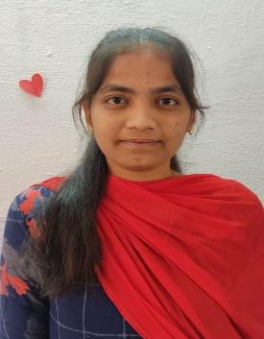Contact No: +919014500279

Email ID: charpithasreethavishala@gmail.com

9-117,

Chinthala peta Village,

Dhone mandal-518222,

kurnool District, Andhra Pradesh**.**

**CAREER OBJECTIVE**

To enhance my knowledge**,** skills and experience by getting involved in a challenging work environment and utilise them for personal and organisation growth to the best of my ability.

**ACADEMIC QUALIFICATION**

|  |  |  |  |  |  |  |  |
| --- | --- | --- | --- | --- | --- | --- | --- |
| **QUALIFICATION** | |  | | --- | | **INSTITUTE NAME** | | |  | | --- | | **YEAR OF** | | **PASSING** | | |  | | --- | | **PERCENTAGE** | |
| |  |  |  |  | | --- | --- | --- | --- | | Bachelor ofTechnology | | | | | in ComputerScience | | |  | | and Engineering | |  | | (pursuing) |  | | Annamacharya Institute of Technology and Sciences,Rajampet | |  | | --- | | 2024 | |  | | 9.99.99   |  | | --- | | 8.96  (till now) | |  | | |
| Intermediate | Sri Chaitanya Junior College,  Pasupala road,Kurnool-518002 | 2020 | 9.73 |
| S.S.C | Sri Sudha High School,Dhone-518222 | 2018 | 9.8 |

# TECHNICAL QUALIFICATIONS

**.** C

. PYTHON

. OBJECT ORIENTED JAVA

. SQL

# CERTIFICATE

Certification on Level-1.1E-commerce & Tech Quiz of the Flipkart Grid 5.0-software development track organised by the Flipkart.

Certification on 30 days masterclass on **Database Management System.**

Certification on participating in internship on “**Data Analytics**” Organised by SmartBridge.

**SKILLS**

. Hard Working

. Quick Learner

. Forthright

. Leadership

**PERSONAL DETAILS**

Name : THAVISHALA CHARPITHA SREE

Date of Birth : 06-03-2003

Gender : FEMALE

Father’s Name : Mr. Thavishala Vikramarka Reddy

|  |  |  |
| --- | --- | --- |
| Mother’s name | : Mrs. Thavishala Lalithamma |  |
| Languages known | : English,Telugu,Hindi |  |

Marital Status : Unmarried

Permanent Address : 9-117,Chinthala Peta Village,

Dhone Mandal-518222,

Kurnool District,Andhra Pradesh,India.

Hobbies : Listening Music,Dancing,Playing Games

## DECLARATION

I solemnly declare that all the above information is correct to the best of my knowledge and belief.

**Date:**29-08-2023

**Place:** Dhone

# (THAVISHALA CHARPITHA SREE)