DEPARTMENT OF COMPUTER STUDIES

**(Applications Development and Emerging Technologies)**

**TECHNICAL-SUMMATIVE ASSESSMENT**

**2**

**PHP ARRAYS AND PRE-DEFINED FUNCTIONS**

|  |  |
| --- | --- |
| **Student Name / Group Name:** |  |
| **Members (if Group):** | |  |  | | --- | --- | | **Name** | **Role** | |  |  | |  |  | |  |  | |
| **Section:** |  |
| **Professor:** |  |

1. **PROGRAM OUTCOME/S (PO) ADDRESSED BY THE LABORATORY EXERCISE**

* Design, implement and evaluate computer-based systems or applications to meet desired needs and requirements.

1. **COURSE LEARNING OUTCOME/S (CLO) ADDRESSED BY THE LABORATORY EXERCISE**

* Understand and apply best practices and standards in the development of website.

1. **INTENDED LEARNING OUTCOME/S (ILO) OF THE LABORATORY EXERCISE**

At the end of this exercise, students must be able to:

* To know the different approach of using arrays in PHP.
* To use PHP lazy function foreach to iterate through array elements.
* To implement one dimensional and multi-dimensional in the program.
* To know use variables that is globally declared and locally declared.
* To know how to include separate PHP code in the main page for code enhancement.
* To be familiar with the use of common predefined function such as define, include, and require.
* To use different available mathematical function for manipulating numbers.

1. **BACKGROUND INFORMATION**

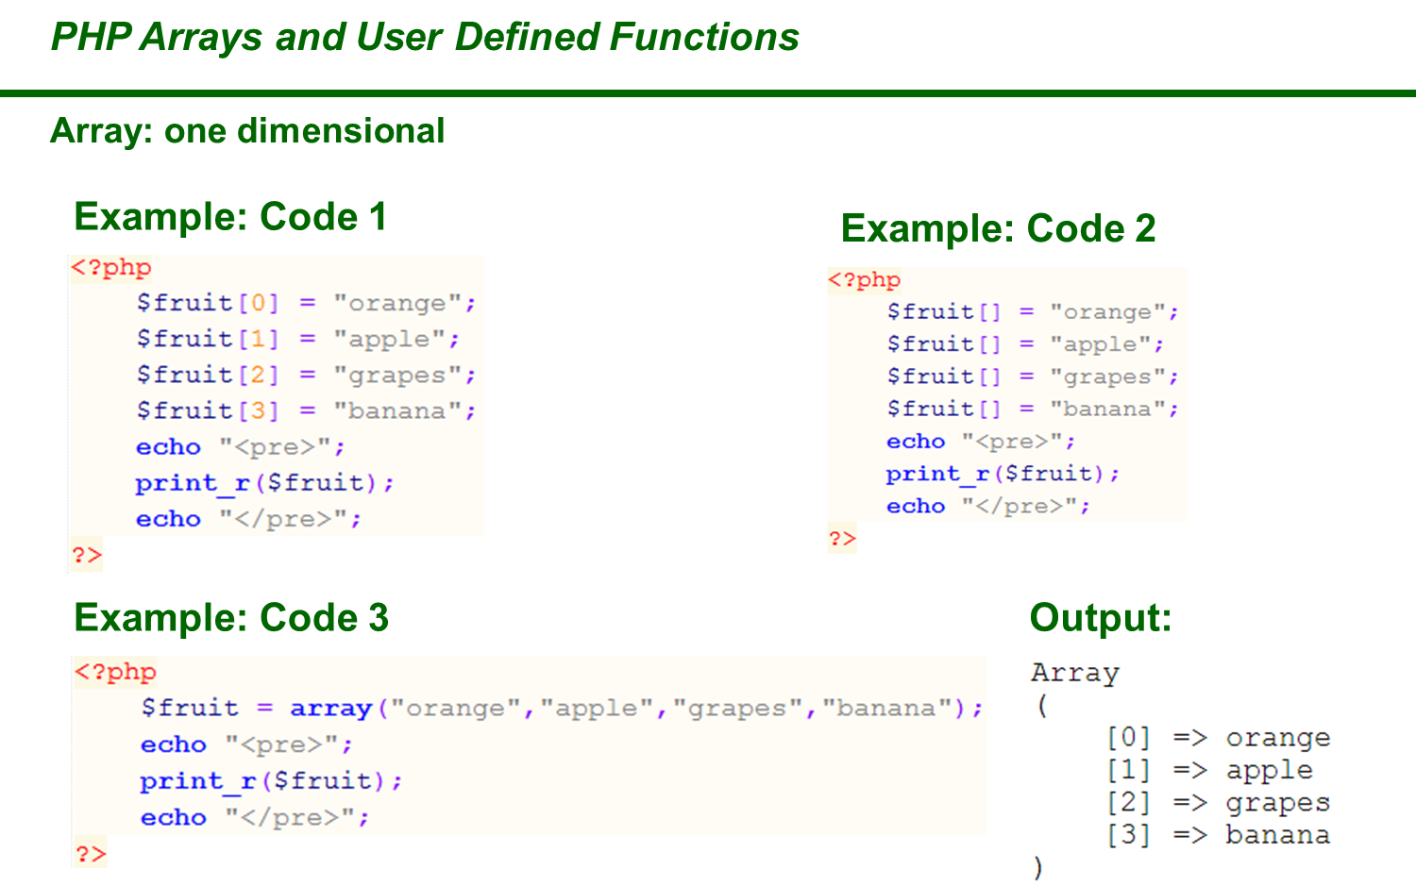

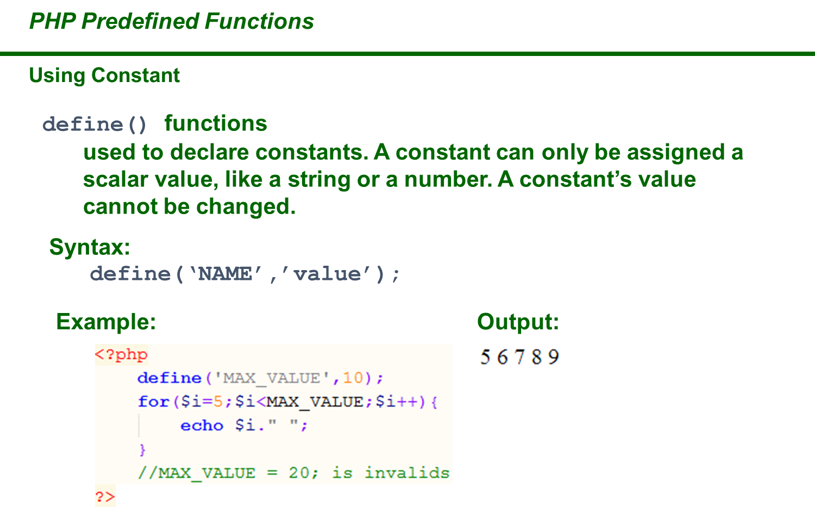

1. **GRADING SYSTEM / RUBRIC (please see separate sheet)**
2. **LABORATORY ACTIVITY**
3. **USING ARRAYS**, create a program using PHP that will display the number of days available for a specific month in a calendar view. Assuming that every month the 1st day starts every Monday. Also, the cell of your birthday must be RED. Please see sample output below:

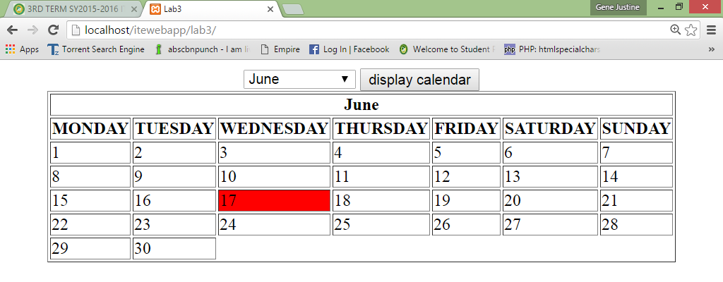

1. **Using ARRAYS**, create a fruit directory that will show the image, name, description and facts about the fruit (create at least 10 fruits sort in alphabetical order). Implement a HTML and CSS code for the structure and design of the webpage. Please see the sample output below.

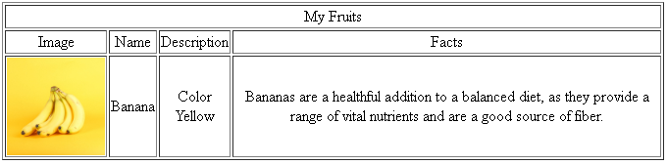

1. **USING USER DEFINED FUNCTION.** Create a formula for each volume of shapes (Cube, Right Rectangular Prism, Prism or Cylinder, Pyramid or Cone and Sphere) then display the result. Please see the sample below:

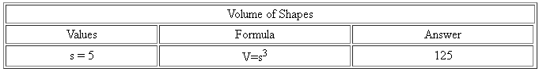

1. Convert your Student Resume into a web based form, used include() and require() functions to connect all pages

Include and create the following pages:

* Career Objective page
* Personal information page
* Educational Attainment page
* Skills page
* Affiliation page
* Work Experience Page

Please see the sample below:

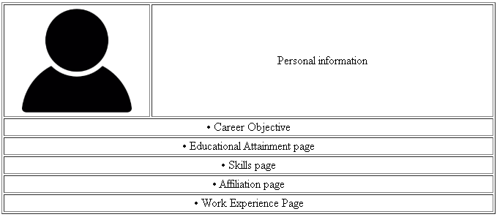

1. Creation of String Function in PHP
2. For the final output, apply all the necessary PHP string functions to produce the required result as stated in the next page. Use the variable ***$string*** as the main parameter for the functions. Use HTML table. Do not process if the string is empty. Use ***var_dump( )*** for item no. 16 and 17.

***Sample code for Item no 2:***

**echo '<tr><td>2.</td><td>Number of characters</td>';**

**echo '<td>*', *strlen($string)*, '*</td></tr>';**

1. For test data, enter the text  **an online guide to html form <input> tag**  (with one leading and trailing space). Compare the result below and make sure the output is the same.

String Functions

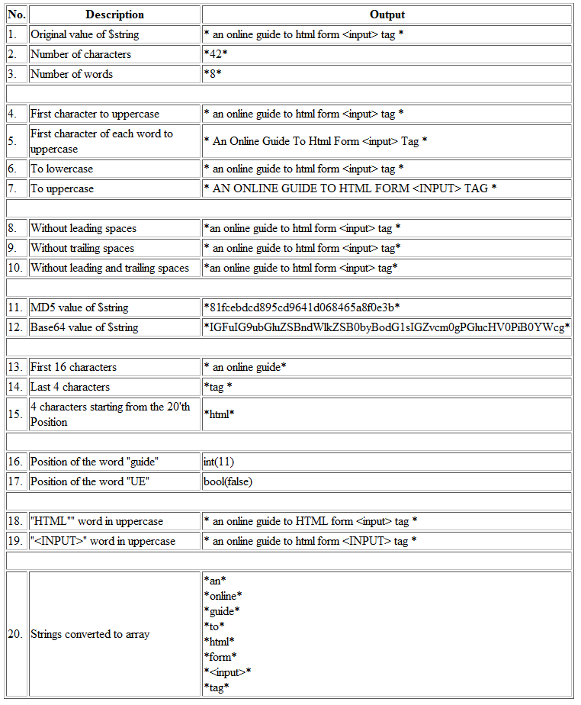

***Snip and paste your source codes here. Snip it directly from the IDE so that colors of the codes are preserved for readability. Include additional pages if necessary.***

1. **QUESTION AND ANSWER**
2. What is Array?
3. What is function in PHP?
4. Differentiate the one-dimensional array to multi-dimensional array
5. Describe the difference between Global Variable to Local Variable
6. What is the difference between function without parameter and a function with parameter?
7. What are the different common predefined functions? Describe each and give example
8. Is it useful to use an include or require function on a webpage? Why?
9. What is the importance of a function?
10. What is the importance of a string function?

**VIII. REFERENCES**

1. <https://www.w3schools.com/css/>
2. <https://www.w3schools.com/html/>
3. <https://www.w3schools.com/php/php_variables.asp>
4. <https://www.w3schools.com/php/php_arrays.asp>
5. <https://www.w3schools.com/php/php_arrays_indexed.asp>
6. <https://www.w3schools.com/php/php_arrays_associative.asp>
7. <https://www.w3schools.com/php/php_arrays_multidimensional.asp>
8. <https://www.w3schools.com/php/php_arrays_sort.asp>
9. <https://www.w3schools.com/php/php_functions.asp>
10. <https://www.w3schools.com/php/php_constants.asp>
11. <https://www.w3schools.com/php/php_includes.asp>
12. <https://www.w3schools.com/php/php_string.asp>

**Note: The following rubrics/metrics will be used to grade students’ output.**

|  |  |  |  |  |
| --- | --- | --- | --- | --- |
| **Program (100 pts.)** | **(Excellent)** | **(Good)** | **(Fair)** | **(Poor)** |
| **Program execution (20pts)** | Program executes correctly with no syntax or runtime errors **(18-20pts)** | Program executes with less than 3 errors **(15-17pts)** | Program executes with more than 3 errors **(12-14pts)** | Program does not execute **(10-11pts)** |
| **Correct output**  **(20pts)** | Program displays correct output with no errors **(18-20pts)** | Output has minor errors **(15-17pts)** | Output has multiple errors **(12-14pts)** | Output is incorrect **(10-11pts)** |
| **Design of output**  **(10pts)** | Program displays more than expected **(10pts)** | Program displays minimally expected output **(8-9pts)** | Program does not display the required output (**6-7pts)** | Output is poorly designed **(5pts)** |
| **Design of logic**  **(20pts)** | Program is logically well designed **(18-20pts)** | Program has slight logic errors that do no significantly affect the results **(15-17pts)** | Program has significant logic errors **(3-5pts)** | Program is incorrect **(10-11pts)** |
| **Standards**  **(20pts)** | Program code is stylistically well designed **(18-20pts)** | Few inappropriate design choices (i.e. poor variable names, improper indentation) **(15-17pts)** | Several inappropriate design choices (i.e. poor variable names, improper indentation) **(12-14pts)** | Program is poorly written **(10-11pts)** |
| **Delivery**  **(10pts)** | The program was delivered on time. **(10pts)** | The program was delivered a day after the deadline. **(8-9pts)** | The program was delivered two days after the deadline. **(6-7pts)** | The program was delivered more than two days after the deadline. **(5pts)** |