**Lesson 01 Demo 03**

**Updating and Deleting S3 bucket using CloudFormation**

**Objective:** To perform updates and deletions on AWS CloudFormation stacks related to S3 buckets

**Tools required:** AWS Management Console

**Prerequisites:** None

Steps to be followed:

1. Update the CloudFormation stack
2. Delete operation on the S3 CloudFormation Stack

**Step 1:** **Update the CloudFormation stack**

1. Select the desired CloudFormation stack and click on the **Update** option to initiate a stack update with new values

**Note:** If you haven't created a CloudFormation stack yet, please refer to previous demos to understand the process.

1. Click **Edit template in designer** and **View in Designer**. Now, click the **Next** button.

1. Click **Validate template**

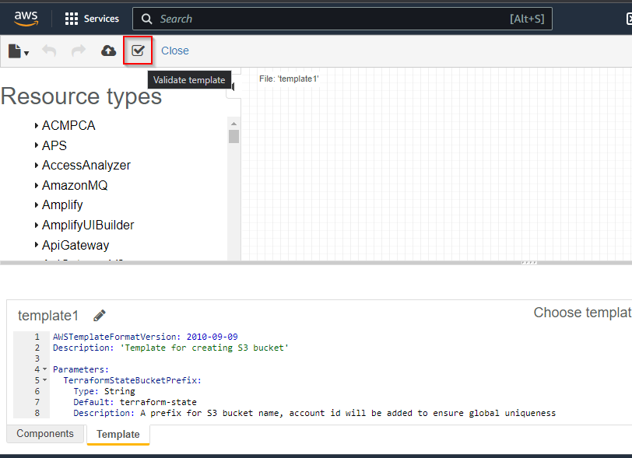

You can modify the CloudFormation template, if necessary, to adjust its functionality or proceed with the existing template.

1. Click **Next**

1. Enter the parameter name as **terraform-state-01** and click the **Next** button

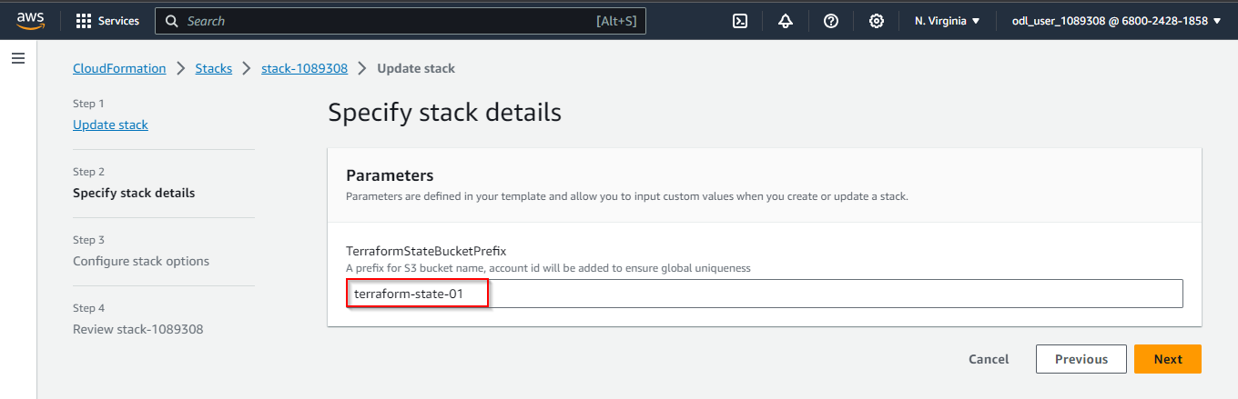

1. Click the **Submit** button

The update rollback process has been completed.

1. Navigate to the S3 Bucket service and click on **Buckets** to list all the new buckets

**Step 2:** **Delete operation on the S3 CloudFormation Stack**

1. Click on **CreateS3Bucket** and then **Delete**

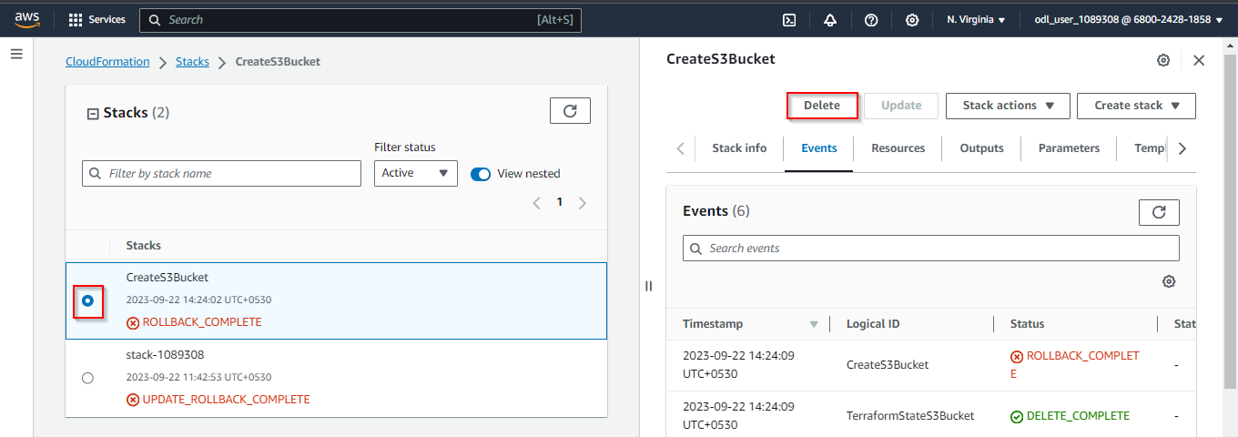

1. Click **Delete**

Once the delete operation has been completed, navigate to the S3 bucket to verify if the S3 bucket has been removed along with the CloudFormation stack.

By following these steps, you have successfully updated and deleted S3 buckets using AWS CloudFormation.