**Lesson 01 Demo 02**

**Executing crictl Commands**

**Objective:** To execute crictl commands for performing container runtime operations

**Tools required:** kubeadm, kubectl, kubelet, and containerd

**Prerequisites:** A Kubernetes cluster (refer to Demo 01 from Lesson 01 for setting up a cluster)

Steps to be followed:

1. Configure the container runtime environment
2. Perform container runtime operations

**Step 1: Configure the container runtime environment**

1. Execute the following commands to get root access, configure the runtime endpoint, and configure the image endpoint for containerd:

**sudo su**

**crictl config \   
--set runtime-endpoint=unix:///run/containerd/containerd.sock \**

**--set image-endpoint=unix:///run/containerd/containerd.sock**

**crictl version**

|  |
| --- |
| **Note**: Here, the command **crictl config** is used to configure the environment for using the container runtime endpoint and image endpoint provided by the containerd. |

**Step 2: Perform container runtime operations**

1. List and view the information of the pod in the container runtime environment using the following command:  
   **crictl pods**  
     
   A computer screen shot of text

   Description automatically generated
2. Retrieve images to view available container images in the runtime environment using the following command:  
   **crictl images**  
     
   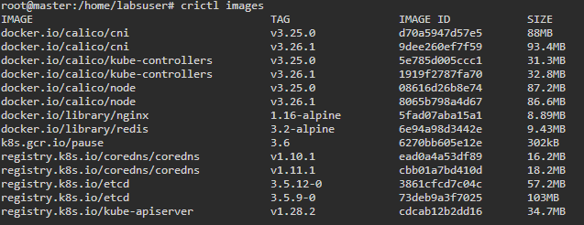
3. Obtain a simplified list of **IMAGE** **ID** for the available container images in the runtime environment using the following command:  
   **crictl images –q**

1. List and view active containers in the runtime environment using the following command:  
   **crictl ps**  
     
   A screenshot of a computer program

   Description automatically generated

|  |
| --- |
| **Note:** Copy any container ID from the list of containers, as shown in the above screenshot |

1. Retrieve all the active and inactive containers in the runtime environment using the following command:  
   **crictl ps -a**  
     
   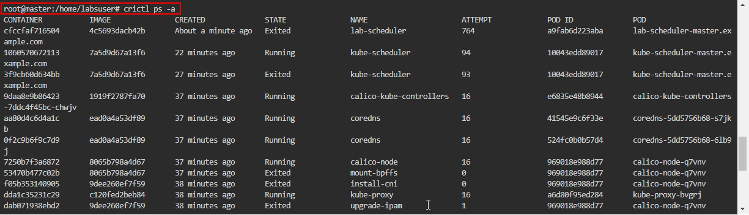
2. Access and view container logs for a specific container using the following command:  
   **crictl logs <container-ID>**  
     
   A computer screen shot of a program

   Description automatically generated

|  |
| --- |
| **Note:** Replace the <**container-ID**> with the ID of the container that you copied in the  step1.5 |

1. Retrieve the latest log entry for a specific container using the following command:  
   **crictl logs --tail=1 <container-ID>**

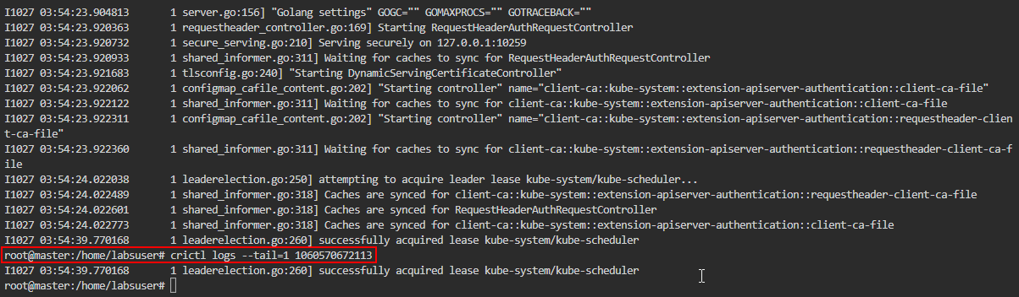

|  |
| --- |
| **Note:** Replace the <**container-ID**> with the ID of the container that you copied in the  step1.5 |

By following these steps, you have successfully executed crictl commands for performing container runtime operations. This can be used to retrieve information on pods, container images, and logs, demonstrating effective management of container operations.