WEEK 3
USING STATIC CONFIGURATION FOR ALL ROUTERS
ROUTER 1
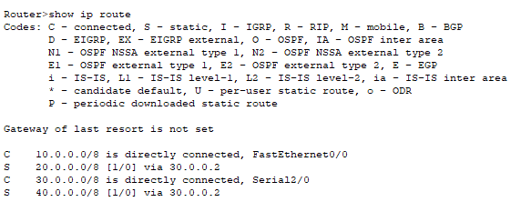
ROUTER 2
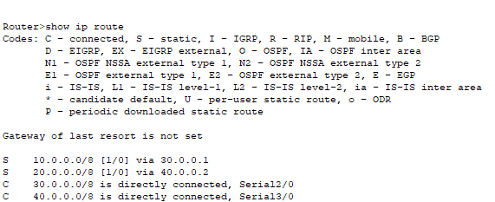
ROUTER 3
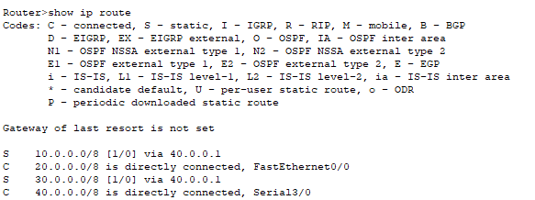

PING COMMANDS FROM PC 1 TO ALL OTHER NETWORKS
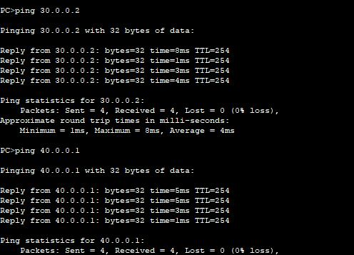
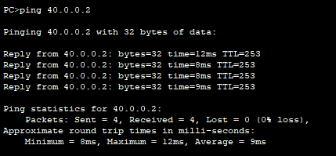
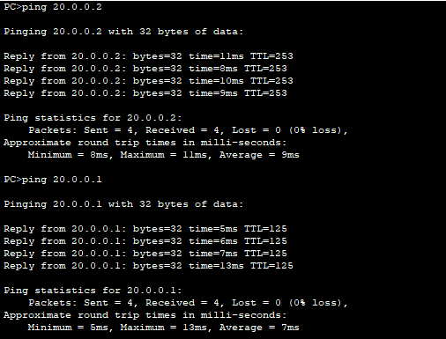
USING DEFAULT CONFIGURATION FOR ROUTER 0 AND 2
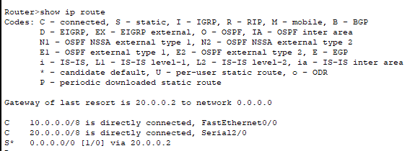
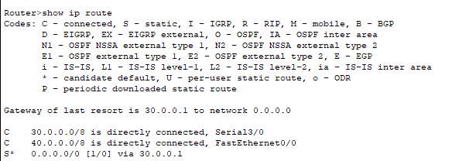

USING STATIC CONFIGURATION FOR ROUTER 1
