WEEK 7
Knapsack problem using Dynamic programming
#include <stdio.h>
#include <stdbool.h>

int max(int a, int b) {
return (a > b) ? a : b;
}

int knapsack(int W, int weights[], int values[], int n) {
int dp[n + 1][W + 1];

for (int i = 0; i <= n; i++) {
for (int w = 0; w <= W; w++) {
if (i == 0 || w == 0)
dp[i][w] = 0;
else if (weights[i - 1] <= w)
dp[i][w] = max(values[i - 1] + dp[i - 1][w - weights[i - 1]], dp[i - 1][w]);
else
dp[i][w] = dp[i - 1][w];
}
}

// Backtrack to find the selected items
int selected[n];
int i = n, w = W, count = 0;

while (i > 0 && w > 0) {
if (dp[i][w] != dp[i - 1][w]) {
selected[count++] = i;
w -= weights[i - 1];
i--;
} else {
i--;
}
}

printf("Selected objects: ");
for (int j = count - 1; j >= 0; j--)
printf("%d ", selected[j]);
printf("\n");
for (int i = 0; i <= n; i++) {
for (int w = 0; w <= W; w++) {
printf("%d ",dp[i][w]);
}
printf("\n");
}

return dp[n][W];
}

int main() {
int n, W;
printf("Enter the number of items: ");
scanf("%d", &n);

int weights[n], values[n];
printf("Enter the weights: ");
for (int i = 0; i < n; i++)
scanf("%d", &weights[i]);

printf("Enter the values: ");
for (int i = 0; i < n; i++)
scanf("%d", &values[i]);

printf("Enter the maximum weight capacity of the knapsack: ");
scanf("%d", &W);

int result = knapsack(W, weights, values, n);
printf("The maximum value that can be obtained from the knapsack is: %d\n", result);

return 0;
}
Output
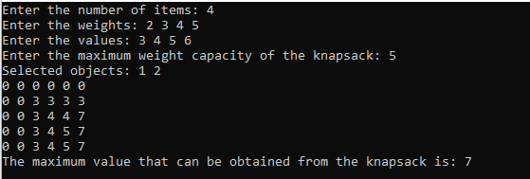

Minimum Spanning Tree using Prim’s Algorithm
#include<stdio.h>
#include<conio.h>

int cost[10][10],vt[10],et[10][10],vis[10],j,n;
int sum=0;
int x=1;
int e=0;
void prims();

void main()
{
int i;
printf("enter the number of vertices\n");
scanf("%d",&n);
printf("enter the cost adjacency matrix\n");
for(i=1;i<=n;i++)
{
for(j=1;j<=n;j++)
{
scanf("%d",&cost[i][j]);
}
vis[i]=0;
}
prims();
printf("edges of spanning tree\n");
for(i=1;i<=e;i++)
{
printf("%d,%d\t",et[i][0],et[i][1]);
}
printf("weight=%d\n",sum);
}

void prims()
{
int s,min,m,k,u,v;
vt[x]=1;
vis[x]=1;
for(s=1;s<n;s++)
{
j=x;
min=999;
while(j>0)
{
k=vt[j];
for(m=2;m<=n;m++)
{
if(vis[m]==0)
{
if(cost[k][m]<min)
{
min=cost[k][m];
u=k;
v=m;
}
}
}
j--;
}
vt[++x]=v;
et[s][0]=u;
et[s][1]=v;
e++;
vis[v]=1;
sum=sum+min;
}
}
Output
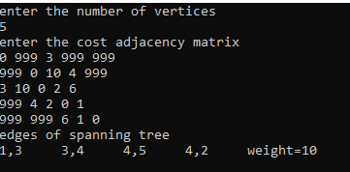

Minimum Spanning Tree using Kruskal’s Algorithm
#include<stdio.h>
#include<conio.h>

int find(int v,int parent[10])
{
while(parent[v]!=v)
{
v=parent[v];
}
return v;
}

void union1(int i,int j,int parent[10])
{
if(i<j)
parent[j]=i;
else
parent[i]=j;
}

void kruskal(int n,int a[10][10])
{
int count,k,min,sum,i,j,t[10][10],u,v,parent[10];
count=0;
k=0;
sum=0;
for(i=0;i<n;i++)
parent[i]=i;
while(count!=n-1)
{
min=999;
for(i=0;i<n;i++)
{
for(j=0;j<n;j++)
{

if(a[i][j]<min && a[i][j]!=0)
{
min=a[i][j];
u=i;
v=j;
}
}
}
i=find(u,parent);
j=find(v,parent);
if(i!=j)
{
union1(i,j,parent);
t[k][0]=u;
t[k][1]=v;
k++;
count++;
sum=sum+a[u][v];
}
a[u][v]=a[v][u]=999;
}
if(count==n-1)
{
printf("spanning tree\n");
for(i=0;i<n-1;i++)
{
printf("%d %d\n",t[i][0],t[i][1]);
}
printf("cost of spanning tree=%d\n",sum);
}
else
printf("spanning tree does not exist\n");
}

void main()
{
int n,i,j,a[10][10];
clrscr();
printf("enter the number of nodes\n");
scanf("%d",&n);
printf("enter the adjacency matrix\n");
for(i=0;i<n;i++)
for(j=0;j<n;j++)
scanf("%d",&a[i][j]);
kruskal(n,a);

}
Output
