WEEK 1
PROG 1 DFS
#include<stdio.h>
int a[20][20],reach[20],n;
void dfs(int v)
{
int i;
reach[v]=1;
for(i=1;i<=n;i++)
if(a[v][i] && !reach[i])
{
printf("\n %d->%d",v,i);
dfs(i);
}
}
void main()
{
int i,j,count=0;
//clrscr();
printf("\n Enter number of vertices:");
scanf("%d",&n);
for(i=1;i<=n;i++)
{
reach[i]=0;
for(j=1;j<=n;j++)
a[i][j]=0;
}
printf("\n Enter the adjacency matrix:\n");
for(i=1;i<=n;i++)
for(j=1;j<=n;j++)
scanf("%d",&a[i][j]);
dfs(1);
printf("\n");
for(i=1;i<=n;i++)
{
if(reach[i])
count++;
}
if(count==n)
printf("\n Graph is connected");
else
printf("\n Graph is not connected");

}
OUTPUT
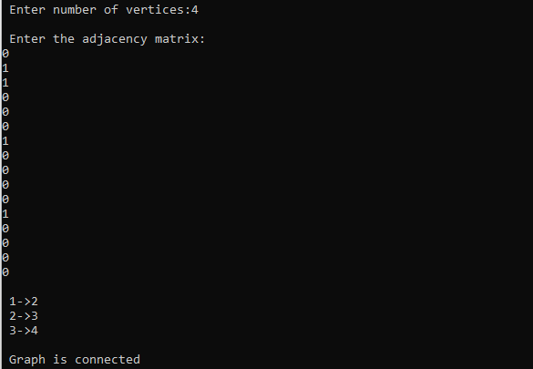
PROG 2-BFS
#include<stdio.h>

int a[20][20],q[20],visited[20],n,i,j,f=0,r=-1;
void bfs(int v)
{
for(i=1;i<=n;i++)
if(a[v][i] && !visited[i])
q[++r]=i;
if(f<=r)
{
visited[q[f]]=1;
bfs(q[f++]);
}
}
void main()
{
int v;
printf("\n Enter the number of vertices:");
scanf("%d",&n);
for(i=1;i<=n;i++)
{
q[i]=0;
visited[i]=0;
}
printf("\n Enter graph data in matrix form:\n");
for(i=1;i<=n;i++)
for(j=1;j<=n;j++)
scanf("%d",&a[i][j]);
printf("\n Enter the starting vertex:");
scanf("%d",&v);
bfs(v);
printf("\n The node which are reachable are:\n");
for(i=1;i<=n;i++)
if(visited[i])
printf("%d\t",i);
}
OUTPUT
