WEEK 4
// Merge sort
#include <stdio.h>
#include<time.h>
#define max 1000000

int a[max];
int b[max];

void merging(int low, int mid, int high) {
int l1, l2, i;

for(l1 = low, l2 = mid + 1, i = low; l1 <= mid && l2 <= high; i++) {
if(a[l1] <= a[l2])
b[i] = a[l1++];
else
b[i] = a[l2++];
}

while(l1 <= mid)
b[i++] = a[l1++];

while(l2 <= high)
b[i++] = a[l2++];

for(i = low; i <= high; i++)
a[i] = b[i];
}

void sort(int low, int high) {
int mid;

if(low < high) {
mid = (low + high) / 2;
sort(low, mid);
sort(mid+1, high);
merging(low, mid, high);
} else {
return;
}
}

int main() {
int i,n;
double time;
clock_t start, end;

printf("Enter the number of elements\n");
scanf("%d",&n);

for(i=0; i<n; i++){
a[i] = rand();
}
start = clock();
sort(0, n-1);
end = clock();

printf("\nList after sorting\n");

for(i = 0; i <n; i++)
printf("%d ", a[i]);

// end = clock();

//printf("Start time %f",(double)start/CLOCKS_PER_SEC);
// printf("Time taken to sort: %f",(double)end/CLOCKS_PER_SEC);
time = (double)(end-start)/CLOCKS_PER_SEC;
printf("\nTime taken to sort: %f",time);
return 0;
}
OUTPUT
For n=5
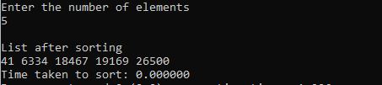
For n=50000
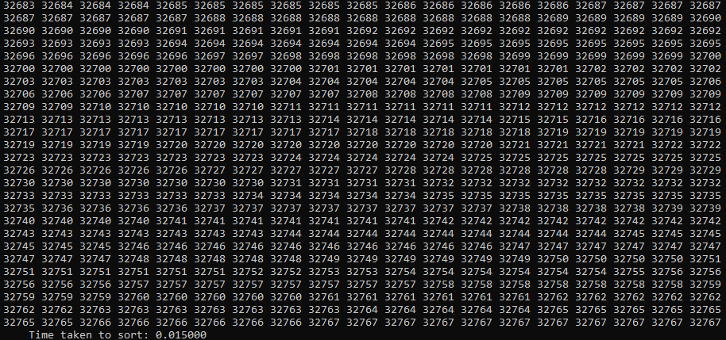

For n=100000
