**PROJECT REPORT**

**On**

**Lendor-Share & Rent Anything App**

Submitted to Rajasthan Technical University

in partial fulfillment of the requirement for the award of the degree of

**B.TECH.**

**in**

**COMPUTER ENGINEERING**

**Submitted By**

**Prashita Jain (Registration No)**

**Charu (PIET15CE027)**

**Harshita Sharma (PIET15CE040)**

**Under the Guidance of**

**Mrs. Rekha Jain**

at



**POORNIMA INSTITUTE OF ENGINEERING & TECHNOLOGY, JAIPUR**

**Rajasthan Technical University, KOTA**

**APRIL, 2018**

**CERTIFICATE**

This is to be certified that the project entitled “ Lendor-share & rent anything app ” has been submitted for the Bachelor of Computer Science and Engineering, Poornima Institute Of Engineering & Technology, Jaipur during the academic year 2018-2019 is a bona fide piece of project work carried out by “ **Prashita Jain, Charu& Harshita Sharma**” towards the partial fulfillment for the award of the Degree (B.Tech.) under the guidance of “**Mrs. Rekha Jain**” and supervision and no part of thereof has been submitted by them for any degree or diploma.

Project Guide Project Coordinator Mr. Deepak Moud

Mrs. Rekha Jain Prof. (Dr.) Praveen Gupta (H.O.D CSE)

(Assistant Professor) (Professor)

**CANDIDATE’S DECLARATION**

We, **Prashita Jain(PIET15CE076), Charu (PIET15CE027) & Harshita Sharma (PIET15CE040 )** B.Tech (Semester- VIII) of “**Poornima Institute Of Engineering & Technology, Jaipur”** hereby declare that the Project Report entitled **“Lendor-Share & rent anything app ”** is an original work and data provided in the study is authentic to the best of our knowledge.This report has not been submitted to any other Institute for the award of any other degree.

|  |  |  |
| --- | --- | --- |
| **Prashita jain** | **Charu** | **harshita sharma** |
| **(PIET15CE076)** | **(PIET15CE027)** | **(PIET15CE040)** |

|  |  |
| --- | --- |
| **Place: Jaipur** |  |
| **Date: 23rd October 2018** |  |

**ACKNOWLEDGEMENT**

It is our pleasure to be indebted to various people, who directly or indirectly contributed in the development of this work and who influenced our thinking, behavior and acts during the course of study.

We express our sincere gratitude to ***Dr. O. P. Sharma,*** Director, PIET for providing us an opportunity to undergo this Major Project as the part of the curriculum.

We are thankful to ***Mr. Deepak Moud, HOD, CS*** for his support, cooperation, and motivation provided to us during the training for constant inspiration, presence and blessings.

We are thankful to ***Mrs. Rekha Jain*** for his support, cooperation, and motivation provided to us during the training for constant inspiration, presence and blessings.

We also extend our sincere appreciation to ***Prof. (Dr.) Praveen Gupta*** who provided his valuable suggestions and precious time in accomplishing our Project report.

Lastly, we would like to thank the almighty and our parents for their moral support and friends with whom we shared our day-to-day experience and received lots of suggestions that improved our quality of work.

|  |  |  |
| --- | --- | --- |
| **Prashita jain** | **Charu** | **harshita sharma** |
| **(PIET15CE076)** | **(PIET15CE027)** | **(PIET15CE040)** |

**TABLE OF CONTENTS**

|  |  |  |
| --- | --- | --- |
| **CHAPTER NO.** | **TOPICS** | **PAGE NO.** |
|  | TITLE PAGE | I |
|  | CERTIFICATE | II |
|  | CANDIDATE’S DECLARATION | III |
|  | ACKNOWLEDGEMENT | IV |
|  | TABLE OF CONTENTS | V |
|  | TABLE OF FIGURE | VI |
|  | ABSTRACT | VII |
| 1 | **INTRODUCTION TO PROJECT** | 1 |
|  |  |  |
|  | Project Aim and Objective  Problem Statement  Background of the Project (Literature Survey)  Software Requirements  Hardware Requirements |  |
| 2 | **PRODUCT BACKLOG** |  |
|  | 1. PRODUCT Backlog 2. Sprint Backlog-1 3. Sprint Backlog-2 4. Sprint Backlog-3 5. Sprint Backlog-4 |  |
|  |  |  |
| 3 | **TECHNOLOGY APPLIED AND PROJECT MANAGEMENT** |  |
|  | Brief Description of All technology Apply in the Project.  Project management  Agile  Relevance to Society  Ethics  Life Long Learning  Project Finance  Environment and Sustainability |  |
|  |  |  |
|  |  |  |
| 4 | **PROJECT IMPLEMENTATION** |  |
|  | Sprint Backlog-1  Sprint Backlog-2  Sprint Backlog-3  Sprint Backlog-4 |  |
|  |  |  |
| 5 | **CONCLUSION** |  |
|  | Results  Conclusion  Future Scope |  |
| 6 | ANNEXURES |  |
|  | References |  |
|  | APPENDIX/ANNEXURES |  |
|  | Research Paper ( if Presented and approved for publication) |  |
|  | CV |  |
|  |  |  |

**LIST OF FIGURES**

|  |  |  |
| --- | --- | --- |
| **S. NO.** | **FIGURE** | **PAGE NO.** |
| 1. |  | 13 |
| 2. |  |  |
| 3. |  |  |
| 4. |  |  |
| 5. |  |  |
| 6. |  |  |
| 7. |  |  |
| 8. |  |  |

**LIST OF TABLES**

**ABSTRACT**

The Lendor App is a mobile application with the vision of a world that fully embraces the sharing economy. The lend items app is created for item owners who are willing to open up their library of things to those who need it at a small fraction of the cost.This has a wide list of items like Rental Camera Accessories, Renting Tool & Equipments, Costumes and Clothes For Rent, Lend Out Home Stuff, Free Lend Baby Stuffs, Sharing Rental Furniture, Rental Books & Comic, Music Instrument on Rent, and more. The application gives consumers a choice before making a purchase.

**KEYWORDS:**

Angular, Firebase, Ionic

**CHAPTER 1**

**INTRODUCTION TO PROJECT**

**Project Aim and Objective**

The Lender App provides rental, order & communication management all packed in the comfort of your mobile device. Through this Rental Store App, you can now search for a library of products over many categories for short term use while also listing your stuff like Lend Party & Event Stuff, Rent or Lend Stuff, Renting Car Accessories, etc. on the platform to earn some cash!

The Lender App is a mobile application with the vision of a world that fully embraces the sharing economy. The lend items app is created for item owners who are willing to open up their library of things to those who need it at a small fraction of the cost. This has a wide list of items like Rental Camera Accessories, Renting Tool & Equipment’s, Costumes and Clothes for Rent, Lend Out Home Stuff, Free Lend Baby Stuffs, Sharing Rental Furniture, Rental Books & Comic, Music Instrument on Rent, and more. The application gives consumers a choice before making a purchase.

While also complimenting traditional rental businesses, this Mobile Rental App i.e. The Lendor App provides rental, order & communication management all packed in the comfort of your mobile device. Through this Rental Store App, you can now search for a library of products over 24 categories for short term use while also listing your stuff like Lend Party & Event Stuff, Rent or Lend Stuff, Renting Car Accessories, etc. on the platform to earn some cash!

**Problem Statement**

As the stuff that you own continuously consumes money, space, and/or resources, whether you actually use it or not. It’s not always ideal to buy and own something (and this includes property). Often you buy an item to ensure access to it. But sufficient access can be achieved without all the downsides of ownership, such as the purchase cost, burden of full responsibility, and underutilization, where the item sits around collecting dust. Collective consumption, where there are many users who share access, reduces the downsides of ownership and is also more eco-friendly. This is where the Lender App comes in, as it connects suppliers of rental assets with consumers who wish to borrow those assets.

**Background of the Project**

The Lendor App is a proximity based, peer to peer mobile app for Library of Things.  
  
This platform is created for item owners who are willing to open up their Library of Things to those who need it at a small fraction of its cost while giving consumers a conscious choice before making any purchase. This encourages collaborative consumption which has tremendous positive effects to the environment, the economy and society as a whole.  
  
The Lendor App provides rental, order, communication management all packed in the comfort of your mobile device. You can now search for a library of products over 24 categories for short term use while also listing your stuff on the platform to recover its cost!  
  
The value proposition to our consumers is to  
- Share the item to their neighbour to recover some cost of the items  
- Choose not to buy and rent it from their neighbour  
  
**Rental**  
Lendor provides item rental management for all its users through a calendar booking system for users to manage their calendar, similar to travel booking applications. It also has a discount mechanism to help item owners encourage long term rentals.

**Order**  
Upon ordering an order is generated while the item's status is tracked. It will be used by users to track the status and conditions of the item which acts as an e-contract between 2 parties.  
  
**Securing your item**  
Lender currently provides 3 layers of securities for users. Firstly, all users are phone verified and non-anonymous. In Singapore, a SIM card is registered to and an ID card which can be tracked and therefore all user interactions are legally binding. Next, there is a refundable deposit which item owners have the prerogative to collect to give them a piece of mind. Lastly, Lender app has a robust reviews and ratings system that in the long run will help identify the good users from the bad ones. Item owners have free will to choose who they want to lend the item to.  
  
**Communication management**  
Lender is a community driven app and strongly believes that communication between users is key to forming a vibrant sharing culture. The chat messaging service in Lendor works just like any other chat messaging app and users are free to liase with each other directly.

**About the project**

As the stuff that you own continuously consumes money, space, and/or resources, whether you actually use it or not. It’s not always ideal to buy and own something (and this includes property). Often you buy an item to ensure access to it. But sufficient access can be achieved without all the downsides of ownership, such as the purchase cost, burden of full responsibility, and underutilisation, where the item sits around collecting dust. Collective consumption, where there are many users who share access, reduces the downsides of ownership and is also more eco-friendly. This is where the Lendor App comes in, as it connects suppliers of rental assets with consumers who wish to borrow those assets. Here’s why you should try them.

**What is Lendor?**

The Lendor App is a mobile library of things. It has a well-designed and user-friendly app interface. It looks similar to Carousell, which most Singaporeans are quite familiar with. The Lendor App provides rental, order & communication management, making it more convenient for searches, inquiries, chat/messages and arranging for meetups.

**How to Use Lender?**

The process can be summarised into 4 steps. Some of their notable features include geo-location, allowing you to rent based on proximity; a peer ratings & reviews feature; and a calendar feature to check or set availability of listed items. Transactions also include a legally-binding e-contract with timestamps on status updates. Other features, which are still pending as of this article, include insurance service to cover lost, stolen, or damaged items.

**Why You Should Use Lender?**

Of course, the #1 reason to use Lender for people who own underutilized stuff is the potential for extra income. On the other side of the table, people who want to use stuff sparingly (think ski equipment, wedding decor, karaoke machines, and cosplay costumes) have access to these things without having to make a big purchase for an item that would sit idly by after just a few uses. So for them, it’s a cost savings. But here’s some additional reasons why you might want to try Lender:

* Some Items Are FOC to Rent – Lender has an option for people to lend stuff out of goodwill (though you might still have to pay a refundable deposit). I’ve seen a few of these listings, and I myself had been doing some of this through Renttycoons.
* Try Things Out Before You Buy – If you’re in the market for say an electric scooter, but you’re not sure which is best suited for your needs, why not rent to try them out?
* Learn New Skills – Have you ever wanted to learn how to play the guitar or the drums? I recently sold a barely used guitar for someone whose child had a fleeting interest in playing. Does this sound familiar?
* Freelance – For some, the barrier to freelancing certain gigs was the upfront capital required. For example, if you ever wondered whether you had what it takes to be a paid photographer but didn’t want to spend $1500 on photography equipment as this would negate your earnings for months, why not rent the equipment and use it only when you book gigs.
* Host Unique Parties/Meetups – It’s a bit disconcerting that nearly all meetups involve just sitting around and eating. Why not throw a board gaming/casino party, a kid’s bouncy castle party, or football meetup. Yes, board games, gaming consoles, bouncy castles, and football goals are among Lendor’s rental listings.
* Lastly, because Lender, they are giving users the ability to use their platform for FREE for the next 6-12 months. After that, they will take a small percentage of transactions that have been performed through their platform. However, as a user, you are able to circumvent this fee if you arrange to transact outside of the app, but you assume risk by doing so.

**Functionality:**

LENDORS-

1. Snap, List and rent out any items you own and start making money instantly
2. Set your own optional refundable deposit amounts, weekly and monthly discounts to encourage longer rentals and therefore getting more value for your item
3. Choose who to rent / lend your item to depending on his/her accumulated ratings
4. Get acknowledged for your good service through ratings and review and hence raising your credibility
5. Track the status of your item through our one-touch order tracking with time stamp.
6. Lend out items for free out of good will sharing your stuff with your community.
7. Personalize your Profile page and share your products & services with your friends and community to discourage unnecessary purchase through a sharing economy

LENDEES-

1. Easy browsing through an extensive catalog of items for rent and loan, closest to you tracked via GPS to reduce the time taken in item exchanges
2. From Luxury items, to Tools and Equipment, Video games, the app offers a wide variety of items in your region which you can conveniently loan and rent from.
3. Save money by renting stuff instead of buying instead of hoarding and cluttering your home with low usage items
4. Private Chat feature within the app allows you to contact item owners to enquire for about the product or ask for more images before you make an offer
5. Sort items by Nearest, Recent, Popularity and by price
6. Track and timestamp all item status and its condition to protect yourself from future disputes
7. Build your reputation through our Robust rating system each time you complete a transaction while vetting through reliable and trustworthy item owners.

## ****How Lendor Works ?****

For example, the Lendor (owner of the item) has a DSLR camera he bought a year ago but does not use it frequently so he puts it up on the app and rents it out for $10 a day.

The Lendee (user who wants to rent), requires a camera for his photography project and rents this DSLR camera instead of buying a new one for a hundred times more than he can afford.

The Lendee can use the app to block out the dates of the rental – like Airbnb.

The transaction process is simple and secure; after settling on a location and price, an e-contract is generated that records each activity that goes on between both parties.

There are no listing fees, commissions, or extra charges for the first six months.

What Lendor hopes to achieve is that the Lendor can recover some costs of the item by lending it to someone who needs it – and not totally profiting off a low-income student, like the above example.

Lendors can also loan their items out of goodwill too.

## Why utilizing rental stuff is better than buying it?

## For example - Let’s say you are going for a vacation for a few weeks. Your travel destination is very far and you have to fly in order to reach there. Once you land, you need a vehicle to visit different places. So what are you going to do in this case, buy a car? This option is absurd. You should rent one. When you do so, you get a brand new model without a ton of mileage on it. You can also [rent a car](http://www.lendor.co/) that you can never imagine buying. In addition to this, if you have an extended family going along, you have the option of renting an extra large SUV car.

## Not just this there is a long list of items that you can rent like rental sports equipment, hire a rental car, rent travel essentials and more. It depends on your necessity.

Renting is beneficial over purchasing. Here are the top scenarios where renting is beneficial

**Expansion**

When you are planning to grow your business or expanding a process, [rental products](https://play.google.com/store/apps/details?id=sg.lendor&hl=en#details-reviews) are affordable. Unlike purchasing that would take a few weeks or maybe a month to fulfill your desires because of the complexity involved, a rental product is installed with the urgent need in order to meet the growing demands of the marketplace.

**Short Term projects**

If you are involved in a short-term project, opting for permanent purchase is waste of money. Renting gives you the flexibility required for the provisional time period. As soon as the productivity increases the profitability also enhances due to your efforts.

**Budget constraints**

When you don’t have a capital to invest or are in an urgent need, renting becomes the best choice. This affordable solution allows you to own a new equipment without worrying about the funds involved. Rental products are newer and efficient to give you higher productivity.

## There are many events in your life when you seek a need for appliances that can help you to serve your purpose. For such events and purpose you ask from your friend's colleagues to lend their devices, and if not the arrangement made then, you have to purchase them. But, from now you need not have to as there is a [Home Appliances Rental App](https://play.google.com/store/apps/details?id=sg.lendor) that acts as the best platform to meet the needs of Lendor and Lendees. And this is all possible just by following few simple steps that are given below:

You just have to take the snap of your products that you want to lend / rent on the app such as lend wedding essential on App, renting computer on an app and many more.

* Depending upon your choice you can set you are own optional of refundable deposit amounts.
* Moreover, you can also seek free renting and lending services on the app for six months to seek the benefits that to free of cost.
* You can [Lend Wedding Essential on App](https://lendorapp.blogspot.com/) to different customers from time to time to earn maximum profit.
* You can also rent Home Appliances that you can consider in your day to day life to carry out frugal ways for significant savings.

**Easiest Way to Share Stuff with Anyone**

Lendor believes in getting people to work together to make the orld a more efficient place for everyone. So, we are making it quick and easy for people to share their belongings. Our aim is to provide a platform where all goods- from the everyday to the abstract – can be borrowed easily. Because we know that sharing is the future, we know that having experiences is more important than owning stuff. And we think that borrowing specialized items should be quick, reliable and convenient.

The Lendor team strongly promotes the sharing culture and we believe if everyone were to share their own library of things at zero dollars, life will be simpler. So for now, before everyone become saints, our app allows you to rent things out of good will! Here are some listings we have right now by kind souls who genuinely just wants to give back to the society:

* Doing up your house, and clearly drilling a couple of holes shouldn’t burn a hole in your pocket. This Makita Cordless Driller is now renting out of goodwill, pay nothing to use it on Lendor.
* Healthcare items is a category where you may list what you or your family have just used for that one unfortunate accident. By lending it out of goodwill, you may greatly reduce the financial stress another family is facing.

**Why use this app?**

**RENTING > BUYING**

Why pay full price for an expensive item you'll only need a couple of times? Not only is renting easier on your wallet — it’s easier on the environment as well due to the sharing and re-using aspect of renting goods.

**FASTER & EASIER**

The *old way*of renting online entails scouring through various websites, calling businesses to find prices, having to go to places that may not be local, and filling out forms. We eliminate *all*of that.

**SAFE & SECURE**

We thoroughly screen and ID verify all members in order to eliminate fraud and ensure a quality experience.

Our item guarantee has you covered in the event that anything happens to your items.

**Features:**

1. **Security charge system**

You may set your own security charge for your items which a renter must pay partially or fully in the event of a lost, stolen or damaged item

1. **Secure payments**

To initiate the rental period, the lender must enter the renter's unique "pickup code" into their smartphone. When the rental period is complete, a "return code" must be entered into each smartphone in order for any monetary transactions to occur

1. **Identity verification**

During signup, all users must verify their email address and phone number. All users must also provide a picture of a government issued photo ID, and snap a live selfie to be used as their profile picture. Furthermore, we don't allow the use of prepaid credit cards.

1. **No tolerance policy**

It promptly and permanently bans any users who attempt to lie, cheat, or steal. We encourage all members to immediately report suspicious or fraudulent activity.

1. **Star-rating system**

After a rental takes place, both the lender and renter must rate each other on a scale of one to five stars. Ratings are visible on user profiles.

**Software Requirements:**

**MongoDB** – MongoDb has been the solution for building databases with no base idea of a software design. It allows easy trial & error since defining schemas to design the database is not needed. This helps to build your idea to store & manage data with ease. Also, since MongoDb supports data transfer through JSON format, data transfer from the web application is easy and economical. JSON also allows easy client server data transmission. Also, MongoDb lets you make use of just one language for the entire web application rather than fragmenting between multiple programming languages.

**Angular JS** – Angular JS front end development is an inordinate JavaScript framework that has some very gripping features for web developers and designers. The data binding feature of Angular JS lets you focus on the application rather than its code. The dependency injection feature in angular JS allows easy web application development and testing. Angular JS templating system and the logic layers are dramatically clean, thus providing easier inclusion of Java Script.

**Node.js** – Node.js is widely famous for building scalable real time applications and fast web applications. Node.js can compile the JavaScript code to native machine code before code execution. This feature is very useful in building server side JavaScript web applications. Robust back end based applications serve to accommodate high critical functionalities using Node.js. The most admired feature of Node.js is that it can use JavaScript as both the front end and back end language.

**Express** – The Express framework powered by Ruby has been used to build robust features in web application development. It’s cookie handling ability has proved to be favourable in crafting web pages in web based applications. Also, they aid in empowering the simple REST routes, handling automated HTTP header and supplementing Connect middleware to plug in for synchronous functions within web applications in order to manage requests and responses in web pages.

**IONIC Framework:**

Ionic’s open source Framework and developer-friendly tools and services power apps for some of the world’s best-known brands - from highly successful consumer apps like Sworkit, Untappd and Dow Jones MarketWatch, to mission-critical apps supporting Nationwide, Amtrak, and NASA.

The open source Ionic Framework features a rich library of front-end building blocks and UI components that make it easy to design beautiful, high-performance mobile and Progressive Web Apps (or PWAs) using web technologies like HTML, CSS, and JavaScript.

The more recent releases, known as Ionic 3 or simply "Ionic", are built on Angular. Ionic provides tools and services for developing hybrid mobile apps using Web technologies like CSS, HTML5, and Sass. Apps can be built with these Web technologies and then distributed through native app stores to be installed on devices by leveraging Cordova.

Ionic uses Cordova plugins to gain access to host operating systems features such as Camera, GPS, Flashlight, etc. Users can build their apps, and they can then be customized for Android, iOS, Windows, or modern browsers. Ionic allows you to build and deploy your apps by wrapping around the build tool Cordova with a simplified 'ionic' command line too.

**Firebase Realtime Database**

The Firebase Realtime Database is a cloud-hosted database. Data is stored as JSON and synchronized in realtime to every connected client. When you build cross-platform apps with our iOS, Android, and JavaScript SDKs, all of your clients share one Realtime Database instance and automatically receive updates with the newest data.

**CHAPTER 2**

**PRODUCT BACKLOG**

1. **PRODUCT Backlog**

In the simplest definition the Scrum Product Backlog is simply a list of all things that needs to be done within the project. It replaces the traditional requirements specification artifacts. These items can have a technical nature or can be user-centric e.g. in the form of user stories. The owner of the Scrum Product Backlog is the Scrum Product Owner. The Scrum Master, the Scrum Team and other Stakeholders contribute it to have a broad and complete To-Do list.Working with a Scrum Product Backlog does not mean that the Scrum Team is not allowed to create and use other artifacts. Examples for additional artifacts could be a summary of the various user roles, workflow descriptions, user interface guidelines, storyboards, or user interface prototypes. However, these artifacts do not replace the Scrum Product Backlog but complement and detail its content.

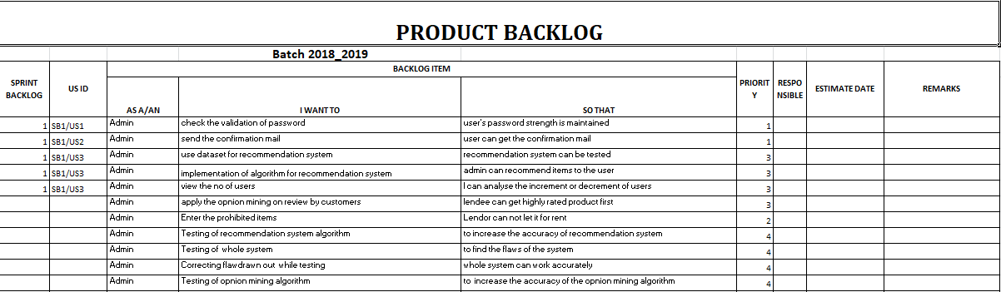

**Fig 1. Product Backlog**

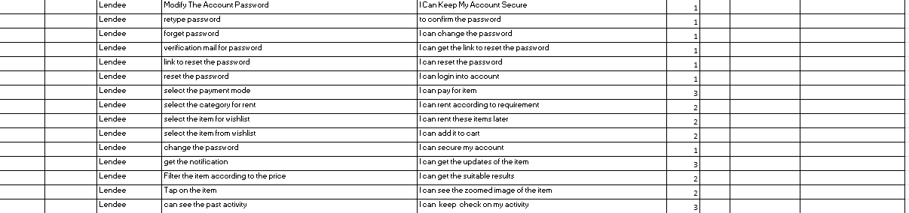

**Fig 1.a Product Backlog**

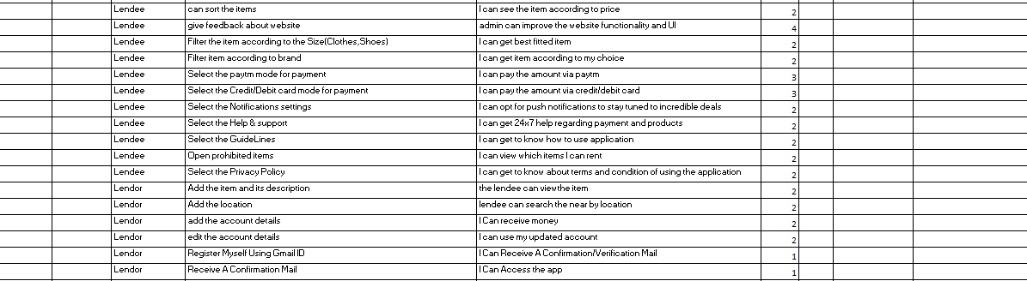

**Fig 1.b Product Backlog**

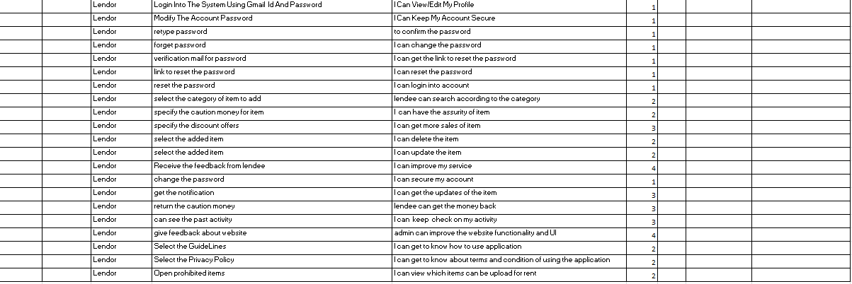

**Fig 1.c Product Backlog**

1. **Sprint Backlog-1**

The sprint backlog is a list of tasks identified by the Scrum team to be completed during the [Scrum](https://www.mountaingoatsoftware.com/agile/scrum)s print. During the sprint planning meeting, the team selects some number of product backlog items, usually in the form of user stories, and identifies the tasks necessary to complete each user story. Most teams also estimate how many hours each task will take someone on the team to complete.

It's critical that the team selects the items and size of the sprint backlog. Because they are the people committing to completing the tasks, they must be the people to choose what they are committing to during the Scrum sprint.

The sprint backlog is commonly maintained as a spreadsheet, but it is also possible to use your defect tracking system or any of a number of software products designed specifically for Scrum or agile. An example of a sprint backlog in a spreadsheet looks like this:

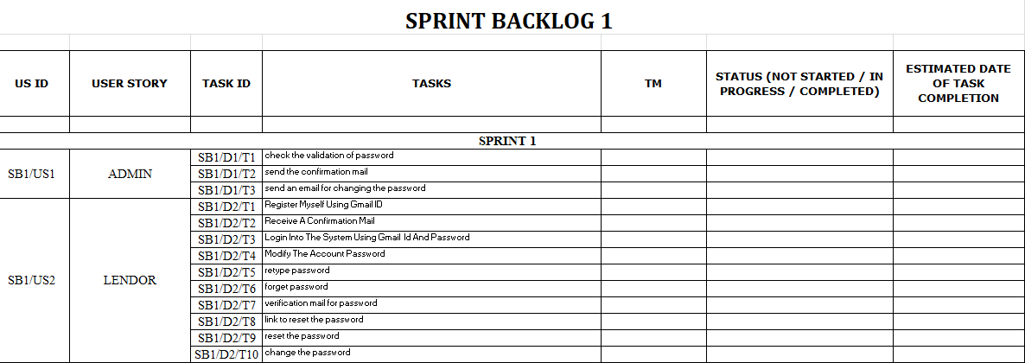

**Fig 2. Sprint Backlog1**

 **Fig 2.a Sprint Backlog1**

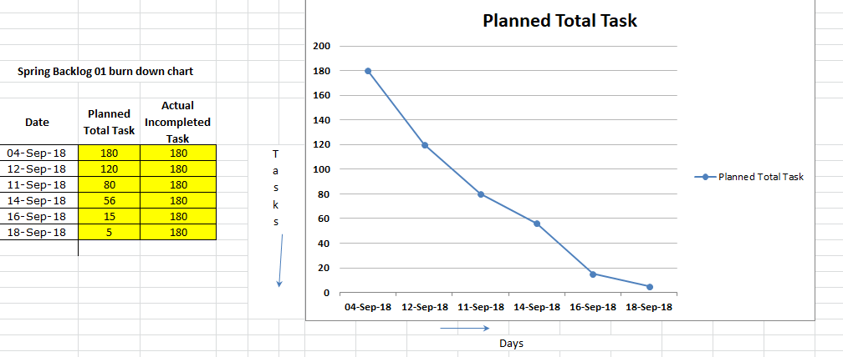

**Fig 2.b Graph**

**2.Sprint Backlog-2**

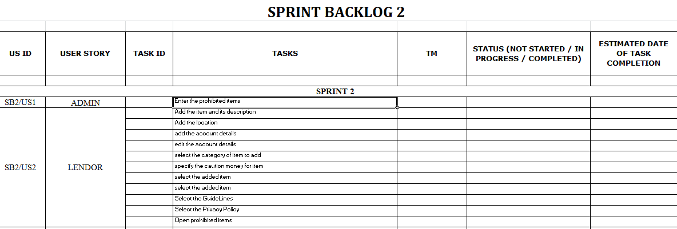

**Fig 3.a Sprint Backlog**

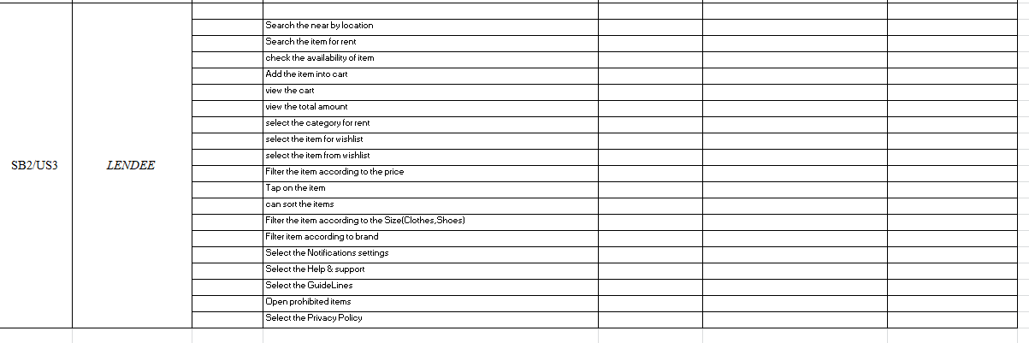

**Fig 3.b Sprint Backlog**

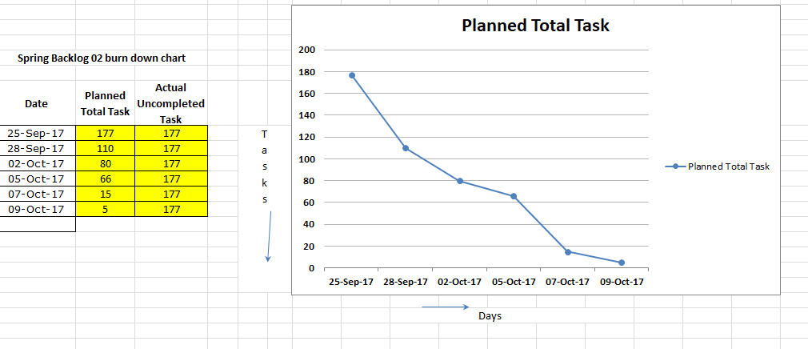

**Fig 3.b Graph**

1. **Sprint Backlog-3**

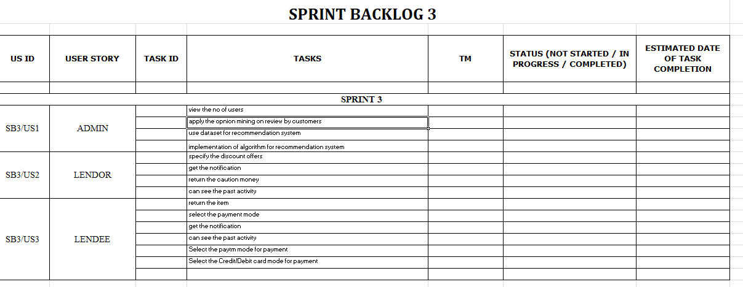

**Fig 4.a Sprint Backlog**

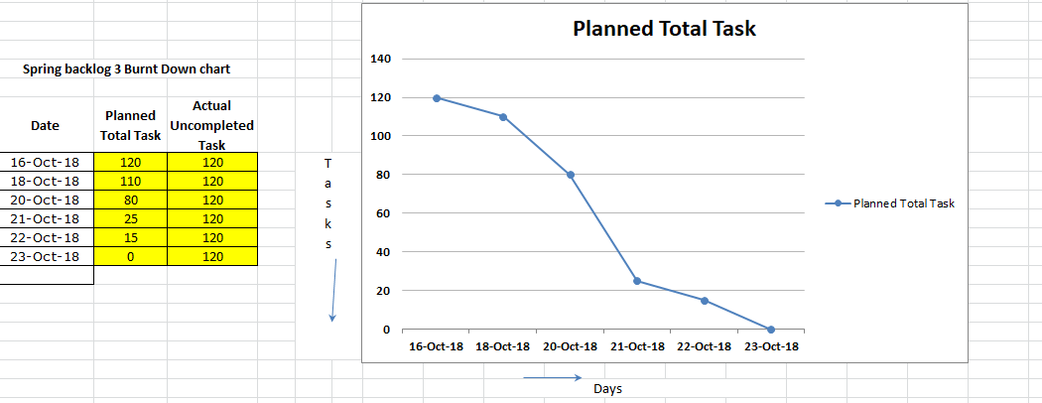

**Fig 4.b Graph**

1. **Sprint Backlog-4**

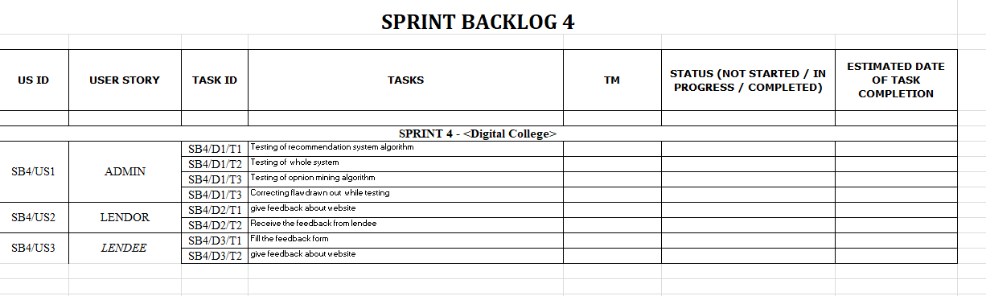

**Fig 5.a Sprint Backlog**

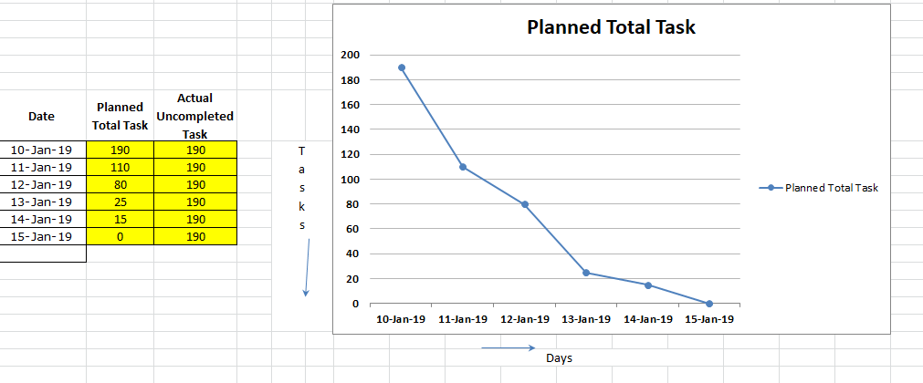

**Fig 5.b Graph**

**CHAPTER 3**

**TECHNOLOGY APPLIED AND PROJECT MANAGEMENT**

**Project management :**

Project management is the application of processes, methods, knowledge, skills and experience to achieve the project objectives. General. A project is a unique, transient endeavor, undertaken to achieve planned objectives, which could be defined in terms of outputs, outcomes or benefits.

Project management is the practise of initiating, planning, executing, controlling, and closing the [work](https://en.wikipedia.org/wiki/Work_(project_management)) of a [team](https://en.wikipedia.org/wiki/Project_team) to achieve specific goals and meet specific success criteria at the specified time. A [project](https://en.wikipedia.org/wiki/Project) is a temporary endeavor designed to produce a unique product, service or result with a defined beginning and end undertaken to meet unique goals and objectives, typically to bring about beneficial change or added value. The temporary nature of projects stands in contrast with [business as usual](https://en.wikipedia.org/wiki/Business_operations), which are repetitive, permanent, or semi-permanent functional activities to produce products or services. In practice, the [management](https://en.wikipedia.org/wiki/Management) of such distinct production approaches requires the development of distinct technical skills and management strategies.

**Software project management**

Software project management is the art and science of planning and leading software projects. It is a sub-discipline of [project management](https://en.wikipedia.org/wiki/Project_management) in which [software](https://en.wikipedia.org/wiki/Software) projects are planned, implemented, monitored and controlled.

The job pattern of an IT company engaged in software development can be seen split in two parts:

* Software Creation
* Software Project Management

A project is well-defined task, which is a collection of several operations done in order to achieve a goal (for example, software development and delivery). A Project can be characterized as:

* Every project may have a unique and distinct goal.
* Project is not routine activity or day-to-day operations.
* Project comes with a start time and end time.
* Project ends when its goal is achieved hence it is a temporary phase in the lifetime of an organization.
* Project needs adequate resources in terms of time, manpower, finance, material and knowledge-bank.

**Software Project**

A Software Project is the complete procedure of software development from requirement gathering to testing and maintenance, carried out according to the execution methodologies, in a specified period of time to achieve intended software product.

**Need of software project management**

Software is said to be an intangible product. Software development is a kind of all new stream in world business and there’s very little experience in building software products. Most software products are tailor made to fit client’s requirements. The most important is that the underlying technology changes and advances so frequently and rapidly that experience of one product may not be applied to the other one. All such business and environmental constraints bring risk in software development hence it is essential to manage software projects efficiently.

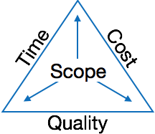

The image above shows triple constraints for software projects. It is an essential part of software organization to deliver quality product, keeping the cost within client’s budget constrain and deliver the project as per scheduled. There are several factors, both internal and external, which may impact this triple constrain triangle. Any of three factor can severely impact the other two.

Therefore, software project management is essential to incorporate user requirements along with budget and time constraints.

**Software Project Manager**

A software project manager is a person who undertakes the responsibility of executing the software project. Software project manager is thoroughly aware of all the phases of SDLC that the software would go through. Project manager may never directly involve in producing the end product but he controls and manages the activities involved in production.

A project manager closely monitors the development process, prepares and executes various plans, arranges necessary and adequate resources, maintains communication among all team members in order to address issues of cost, budget, resources, time, quality and customer satisfaction.

Let us see few responsibilities that a project manager shoulders -

**Managing People**

* Act as project leader
* Liaison with stakeholders
* Managing human resources
* Setting up reporting hierarchy etc.

**Managing Project**

* Defining and setting up project scope
* Managing project management activities
* Monitoring progress and performance
* Risk analysis at every phase
* Take necessary step to avoid or come out of problems
* Act as project spokesperson

**Software Management Activities**

Software project management comprises of a number of activities, which contains planning of project, deciding scope of software product, estimation of cost in various terms, scheduling of tasks and events, and resource management. Project management activities may include:

* **Project Planning**
* **Scope Management**
* **Project Estimation**

**Project Planning**

Software project planning is task, which is performed before the production of software actually starts. It is there for the software production but involves no concrete activity that has any direction connection with software production; rather it is a set of multiple processes, which facilitates software production. Project planning may include the following:

**Scope Management**

It defines the scope of project; this includes all the activities, process need to be done in order to make a deliverable software product. Scope management is essential because it creates boundaries of the project by clearly defining what would be done in the project and what would not be done. This makes project to contain limited and quantifiable tasks, which can easily be documented and in turn avoids cost and time overrun.

During Project Scope management, it is necessary to -

* Define the scope
* Decide its verification and control
* Divide the project into various smaller parts for ease of management.
* Verify the scope
* Control the scope by incorporating changes to the scope

**Project Estimation**

For an effective management accurate estimation of various measures is a must. With correct estimation managers can manage and control the project more efficiently and effectively.

Project estimation may involve the following:

* **Software size estimation**

Software size may be estimated either in terms of KLOC (Kilo Line of Code) or by calculating number of function points in the software. Lines of code depend upon coding practices and Function points vary according to the user or software requirement.

* **Effort estimation**

The managers estimate efforts in terms of personnel requirement and man-hour required to produce the software. For effort estimation software size should be known. This can either be derived by managers’ experience, organization’s historical data or software size can be converted into efforts by using some standard formulae.

* **Time estimation**

Once size and efforts are estimated, the time required to produce the software can be estimated. An effort required is segregated into sub categories as per the requirement specifications and interdependency of various components of software. Software tasks are divided into smaller tasks, activities or events by Work Breakthrough Structure (WBS). The tasks are scheduled on day-to-day basis or in calendar months.

The sum of time required to complete all tasks in hours or days is the total time invested to complete the project.

* **Cost estimation**

This might be considered as the most difficult of all because it depends on more elements than any of the previous ones. For estimating project cost, it is required to consider -

* + Size of software
  + Software quality
  + Hardware
  + Additional software or tools, licenses etc.
  + Skilled personnel with task-specific skills
  + Travel involved
  + Communication
  + Training and support

**Project Estimation Techniques**

We discussed various parameters involving project estimation such as size, effort, time and cost.Project manager can estimate the listed factors using two broadly recognized techniques

**Decomposition Technique**

This technique assumes the software as a product of various compositions.

There are two main models -

* **Line of Code** Estimation is done on behalf of number of line of codes in the software product.
* **Function Points** Estimation is done on behalf of number of function points in the software product.

**Empirical Estimation Technique**

This technique uses empirically derived formulae to make estimation.These formulae are based on LOC or FPs.

* **Putnam Model**

This model is made by Lawrence H. Putnam, which is based on Norden’s frequency distribution (Rayleigh curve). Putnam model maps time and efforts required with software size.

* **COCOMO**

COCOMO stands for COnstructiveCOstMOdel, developed by Barry W. Boehm. It divides the software product into three categories of software: organic, semi-detached and embedded.

**Project Scheduling**

Project Scheduling in a project refers to roadmap of all activities to be done with specified order and within time slot allotted to each activity. Project managers tend to define various tasks, and project milestones and they arrange them keeping various factors in mind. They look for tasks lie in critical path in the schedule, which are necessary to complete in specific manner and strictly within the time allocated. Arrangement of tasks which lies out of critical path are less likely to impact over all schedule of the project.

For scheduling a project, it is necessary to -

* Break down the project tasks into smaller, manageable form
* Find out various tasks and correlate them
* Estimate time frame required for each task
* Divide time into work-units
* Assign adequate number of work-units for each task
* Calculate total time required for the project from start to finish

**Resource management**

All elements used to develop a software product may be assumed as resource for that project. This may include human resource, productive tools and software libraries.

The resources are available in limited quantity and stay in the organization as a pool of assets. The shortage of resources hampers the development of project and it can lag behind the schedule. Allocating extra resources increases development cost in the end. It is therefore necessary to estimate and allocate adequate resources for the project.

Resource management includes -

* Defining proper organization project by creating a project team and allocating responsibilities to each team member
* Determining resources required at a particular stage and their availability
* Manage Resources by generating resource request when they are required and de-allocating them when they are no more needed.

**Project Risk Management**

Risk management involves all activities pertaining to identification, analysing and making provision for predictable and non-predictable risks in the project. Risk may include the following:

* Experienced staff leaving the project and new staff coming in.
* Change in organizational management.
* Requirement change or misinterpreting requirement.
* Under-estimation of required time and resources.
* Technological changes, environmental changes, business competition.

**Risk Management Process**

There are following activities involved in risk management process:

* **Identification -** Make note of all possible risks, which may occur in the project.
* **Categorize -** Categorize known risks into high, medium and low risk intensity as per their possible impact on the project.
* **Manage -** Analyze the probability of occurrence of risks at various phases. Make plan to avoid or face risks. Attempt to minimize their side-effects.
* **Monitor -** Closely monitor the potential risks and their early symptoms. Also monitor the effects of steps taken to mitigate or avoid them.

**Project Execution & Monitoring**

In this phase, the tasks described in project plans are executed according to their schedules.

Execution needs monitoring in order to check whether everything is going according to the plan. Monitoring is observing to check the probability of risk and taking measures to address the risk or report the status of various tasks.

These measures include -

* **Activity Monitoring -** All activities scheduled within some task can be monitored on day-to-day basis. When all activities in a task are completed, it is considered as complete.
* **Status Reports -** The reports contain status of activities and tasks completed within a given time frame, generally a week. Status can be marked as finished, pending or work-in-progress etc.
* **Milestones Checklist -** Every project is divided into multiple phases where major tasks are performed (milestones) based on the phases of SDLC. This milestone checklist is prepared once every few weeks and reports the status of milestones.

**Project Communication Management**

Effective communication plays vital role in the success of a project. It bridges gaps between client and the organization, among the team members as well as other stake holders in the project such as hardware suppliers.

Communication can be oral or written. Communication management process may have the following steps:

* **Planning** - This step includes the identifications of all the stakeholders in the project and the mode of communication among them. It also considers if any additional communication facilities are required.
* **Sharing** - After determining various aspects of planning, manager focuses on sharing correct information with the correct person on correct time. This keeps every one involved the project up to date with project progress and its status.
* **Feedback** - Project managers use various measures and feedback mechanism and create status and performance reports. This mechanism ensures that input from various stakeholders is coming to the project manager as their feedback.
* **Closure** - At the end of each major event, end of a phase of SDLC or end of the project itself, administrative closure is formally announced to update every stakeholder by sending email, by distributing a hardcopy of document or by other mean of effective communication.

After closure, the team moves to next phase or project.

**Configuration Management**

Configuration management is a process of tracking and controlling the changes in software in terms of the requirements, design, functions and development of the product.

IEEE defines it as “the process of identifying and defining the items in the system, controlling the change of these items throughout their life cycle, recording and reporting the status of items and change requests, and verifying the completeness and correctness of items”.

Generally, once the SRS is finalized there is less chance of requirement of changes from user. If they occur, the changes are addressed only with prior approval of higher management, as there is a possibility of cost and time overrun.

**Project management Tools:**

Project management required tools to manage the work , time and resources. At present many of the software are available for project management. Some of the popular software tools are as follows.

### 01. [Trello](http://send.getapp.com/aff_c?offer_id=677&aff_id=1371)

Trello is an project management tool, instead this app is a free visual way to to glance at the entire project with a single view. With Trello you can organise cards, these cards can be your thoughts, conversations and to-do lists and be placed on a board for everyone to collaborate on.

### 02. [Basecamp](http://send.getapp.com/aff_c?offer_id=637&aff_id=1371)

Basecamp is the granddaddy of project management apps. Basecamp is considered the leading project management tool around. It boost a simple and easy to use interface to collaborate with your team and client. It allows you to create multiple projects and setup discussions, write to-do lists, manage files, create and share documents, and organise dates for scheduling.

### 03. [Teamwork Projects](http://send.getapp.com/aff_c?offer_id=947&aff_id=1371)

Teamwork Projects is the ultimate productivity tool to manage projects with your team. Teamwork allows you to keep all your projects, tasks and files all in one place and easily collaborate with a team. Teamwork helps you to visualise the entire project through a marked calendar and gantt chart and setup reporting. Teamwork supports file management with Google Drive, Box.com and Dropbox. As well as integration with leading apps such as third party accounting software and customer support apps.

### 04. [Resource Guru](https://resourceguruapp.com/)

Billed as the "simple way to schedule people, equipment and other resources", Resource Guru is a streamlined resource scheduling and leave management tool that’s designed to keep your projects on track. You can plan your team's workloads, receive daily booking reminders, report on KPIs, and more. Apple, Saatchi & Saatchi and Deloitte are among some of the cloud-based team calendar’s heavyweight customers.

### 05. [ActiveCollab](http://send.getapp.com/aff_c?offer_id=949&aff_id=1371)

ActiveCollab recently released its new version 5.0. The new revamped app is now more powerful and focused project management tool. It offers team collaborating features, task management, time tracking and importing expenses. One of the biggest asset of ActiveCollab is it offers invoicing features. You are able to track payments and expenses and have invoices paid directly within ActiveCollab with PayPal, and other credit card payments.

### 06. [Zoho Projects](http://send.appdoubler.com/aff_c?offer_id=101&aff_id=1371)

Zoho offers a wide range of business software including Projects. Zoho Projects is an proficient tool to project plan and project coordinator from start to finish. It boost all the features you need for project management with some advance features including reporting, integration with Google Apps and Dropbox, bug tracking, setup Wiki Pages to build a repository of information, forums and more.

### 07. [Jira](http://send.getapp.com/aff_c?offer_id=281&aff_id=1371)

Jira is specifically targeted for software development teams. Jira offers abilities to raise issues and bugs. Jira makes it real easy to track bugs and see which issues are still outstanding and how much time was spent on each task. Jira offer other products including Confluence a document collaboration tool, and HipChat a team chat and video and file sharing platform and other products.

### 08. [Asana](http://send.getapp.com/aff_c?offer_id=587&aff_id=1371)

Asana is the easiest way for teams to track their work so everyone knows who's doing what, by when. With tasks, projects, conversations and dashboards, Asana keeps your work organized, and teammates accountable so you can move work forward faster. Asana also lets you keep track of your work wherever you are with mobile apps for both iOS and Android.

### 09. [Podio](http://send.getapp.com/aff_c?offer_id=951&aff_id=1371)

Podio is a ever growing tool to organise and communication tool for any business. Podio allows you to personalise this platform to fit your business needs. Besides being able to communicate with a team, setup task management, use as a file storage system, like a traditional project management app, Podio can be an internal intranet for all your colleagues and departments to interact.

### 10. [Freedcamp](https://freedcamp.com/)

Whatever your project may be, either setting up an event, a web project or organising a wedding, Freedcamp helps you organise and plan effectively. Freedcamp has an organised dashboard to view the entire project at a glance. You can easily setup tasks, use sticky notes to visually setup tasks and organise them into the calendar. Freedcamp provides advance add-ons for high level business use including CRM, invoicing, issue tracking and setting up wiki pages.

### 11. [Wrike](http://send.getapp.com/aff_c?offer_id=239&aff_id=1371)

Wrike is advance application to help you work smarter. By making sure you are always staying on track and ensure you have the adequate resources to finish on time and on budget.Setting up tasks, engage your team and integrate with your business tools including Google Apps, Microsoft Excel, Dropbox and many more is so easy with Wrike.

**PO and Their Relevance to project**

**PO1: Engineering knowledge:**Apply the knowledge of mathematics, science, engineering fundamentals and an engineering specialization to the solution of complex engineering problems.

In this project creation process engineering knowledge of the software engineering and Electronics engineering have been applied. we have used software engineering , HTML,xml, java , android , java script , php , j2ee, data base , oracle , my sql , mango and other programming language and database to the project. We have applied all above engineering subjects in our projects.

**PO2: Problem analysis:**Identify, formulate, review research literature, and analyze complex engineering problems reaching substantiated conclusions using first principles of mathematics, natural sciences, and engineering sciences.

In our projects we have identified an problem , once verified by the client we have worked to identify the solution using all of our theoretical and practical knowledge.

**PO3: Design/development of solutions:** Design solutions for complex engineering problems and design system components or processes that meet the specified needs with appropriate consideration for the public health and safety, and the cultural, societal, and environmental considerations.

**PO4: Conduct investigations of complex problems:** Use research-based knowledge and research methods including design of experiments, analysis and interpretation of data, and synthesis of the information to provide valid conclusions.

**PO5: Modern tool usage:**Create, select, and apply appropriate techniques, resources, and modern engineering and IT tools including prediction and modeling to complex engineering activities with an understanding of the limitations.

In the project development we have applied Integrated Development Environment IDE for the rapid development of the code, used web server for the software development.

**PO6: The engineer and society**: Apply reasoning informed by the contextual knowledge to assess societal, health, safety, legal and cultural issues and the consequent responsibilities relevant to the professional engineering practice.

In 1961 , the Conference of Engineering Societies of Western Europe and the United States of America defined "professional engineer" as follows.

A professional engineer is competent by virtue of his/her fundamental education and training to apply the scientific method and outlook to the analysis and solution of engineering problems. He/she is able to assume personal responsibility for the development and application of engineering science and knowledge, notably in research, design, construction, manufacturing, superintending, managing and in the education of the engineer. His/her work is predominantly intellectual and varied and not of a routine mental or physical character. It requires the exercise of original thought and judgement and the ability to supervise the technical and administrative work of others. His/her education will have been such as to make him/her capable of closely and continuously following progress in his/her branch of engineering science by consulting newly published works on a worldwide basis, assimilating such information and applying it independently. He/she is thus placed in a position to make contributions to the development of engineering science or its applications. His/her education and training will have been such that he/she will have acquired a broad and general appreciation of the engineering sciences as well as thorough insight into the special features of his/her own branch. In due time he/she will be able to give authoritative technical advice and to assume responsibility for the direction of important tasks in his/her branch.

**PO7: Environment and sustainability:** Understand the impact of the professional engineering solutions in and environmental contexts, and demonstrate the knowledge of, and need for sustainable development.

Sustainability is the ability to continue a defined behavior indefinitely. Sometimes environmental, social and economic are termed to be the three pillars of sustainability.

**PO8: Ethics**: Apply ethical principles and commit to professional ethics and responsibilities and norms of the engineering practice

The ethics of engineers and the fundamental principles for Engineers are as follows.

Engineers uphold and advance the integrity, honor and dignity of the engineering profession by:

I. using their knowledge and skill for the enhancement of human welfare;

II.being honest and impartial, and servicing with fidelity the public, their employers and clients;

III. Striving to increase the competence and prestige of the engineering profession; and

IV. Supporting the professional and technical societies of their disciplines.   
  
  
**PO9. Individual and team work**: Function effectively as an individual and as a member or leader in diverse teams, and in multidisciplinary settings.  
  
  
To work successful in team a team member must have following capabilities.

**1. The Ability to Listen**

it is important to listen to one another's ideas. Too often in a business setting, you have a group of people simply waiting for their turn to speak, not paying one iota of attention to the persons on their left or right. So it is a good teamwork skill to have the ability to listen

**2. Check Your Ego**

This isn't saying abandon your ego all together, because that isn't healthy. But leaving your ego at the door temporarily is a very important team work skill. The reason this is so essential is because there is always someone better than you at something, no matter how brilliant you are.

**3. Critique**

By critique, I mean constructive criticism. Be able to give others constructive criticism and be able to listen to others critique your ideas and work. There shouldn't be any offense taken to constructive criticism. You all want to succeed, and this is a vital step in doing so.

**4. Delegation**

The mentality must be applied to teamwork. Delegate roles to those who do them best.

**5. Show Respect**

If you and another person happen to be paired up and can't stand each other, you can still put that aside for a couple of hours, treat each other civilly, and complete the tasks at hand. You may even overcome the dislike toward one another.

**6. Be Helpful**

This is simple.If one of your teammates does not understand an idea, discussion, or task that is being completed, take the necessary time to explain it to them and work with them. There are no weak links when everyone helps one another. Some take longer to learn than others, but that doesn't mean that they are of less intelligence. If in a meeting someone asks a question because they don't understand, don't frown at them. Just answer the questions patiently and concisely.

**7. Question One Another**

If someone brings up a topic of discussion and a solution to this topic, question them. Respectfully question, don't badger. Rather, ask them how it will work, why it will work over the long-run, and how everyone else can implement the idea.

**8. Participation**

Have the entire team encourage shy people to engage in the topics of discussion. Don't demand it, but make them realize that you really want to hear their ideas.

**9. Rational Debate**

Bad ideas are bad for teams. Spirited, friendly, rational debate is where facts come forward, ideas are born, and quality rises to the top.

**10. Set The Right Environment**

Try to make the space in which your team is assembled as comfortable, relaxing, and inviting as possible. You do not want your team to be tense and with frayed nerves.

**PO 10: Communication:**Communicate effectively on complex engineering activities with the engineering community and with society at large, such as, being able to comprehend and write effective reports and design documentation, make effective presentations, and give and receive clear instructions.

**PO11: Project management and finance:**Demonstrate knowledge and understanding of the engineering management principles and apply these to one’s own work, as a member and leader in a team, to manage projects and in multidisciplinary environments.

Project management is the application of processes, methods, knowledge, skills and experience to achieve the project objectives. In general project is a unique, transient endeavour, undertaken to achieve planned objectives, which could be defined in terms of outputs, outcomes or benefits.

**PO12: Life-long learning**: Recognize the need for and have the preparation and ability to engage in independent and lifelong learning in the broadest context of technological change.

Life Long Learning means is the provision or use of both formal and informal learning opportunities throughout people's lives in order to foster the continuous development and improvement of the knowledge and skills needed for employment and personal fulfillment

**CHAPTER 4**

**PROJECT IMPLEMENTATION**

( Each Spring Backlog of 13-17 Pages total Chapter Size 50-70 pages)

1. Sprint Backlog-1  
     
   ( ***Project Design , Algo ,Database Design , ERD , Project Code ( Sample code only Limited to Max of 2-3 Page if needed , Project Screen Shots*** )
2. Sprint Backlog-2

( ***Project Design , Algo ,Database Design , ERD , Project Code ( Sample code only Limited to Max of 2-3 Page if needed , Project Screen Shots***

1. Sprint Backlog-3

( ***Project Design , Algo ,Database Design , ERD , Project Code ( Sample code only Limited to Max of 2-3 Page if needed , Project Screen Shots*** )

1. Sprint Backlog-4  
     
   ( ***Project Design , Algo ,Database Design , ERD , Project Code ( Sample code only Limited to Max of 2-3 Page if needed , Project Screen Shots*** )

**CHAPTER 5**

**CONCLUSION**

( 3 to 5 page)

Results

Conclusion

Future Scope

**ANNEXURES**

References

Research Paper ( if Presented and approved for publication)

DST Document presented for grants.

CV

**Instructions**

For Chapter Heading

Font: Times New Roman

Font Size: 14, Bold

Alignment: Center

Line Spacing 1.5

For Paragraph Heading

Font: Times New Roman

Font Size: 12, Bold

Alignment: Left

Line Spacing 1.5

For paragraph

Font: Times New Roman

Font Size: 12

Line Spacing 1.5

Alignment: Justify

Line Spacing 1.5