**Steps to setup API Environment**

**Step1:** Install env-cmd package manager by running below command

**Yourpath/npm install env-cmd**

Then now it will add env-cmd in your package.json file under **dependences** object like below



Step2: Create .env-cmdrc.json file at where package.json file located.

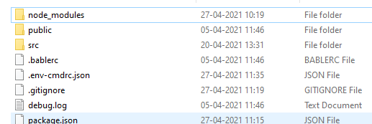

Key naming Structure should be start with REACT_APP_

**Ex:** 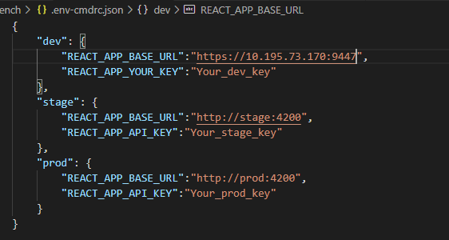

Step 3: Goto package.js file make start and build commands structure under **scripts** object like below

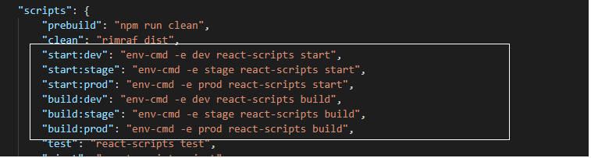

Step 4: Run below commands to start application based on your environment and build application

Yourpath/**npm run start:dev**

Yourpath/**npm run start:stage**

Yourpath/**npm run start:prod**

Yourpath/**npm run build:dev**

Yourpath/**npm run build:stage**

Yourpath/**npm run build:prod**

Usage in code

Where ever you require use key from process.env like below

${process.env.REACT_APP_BASE_URL}

Example:

