1. What does Command Prompt looks like?

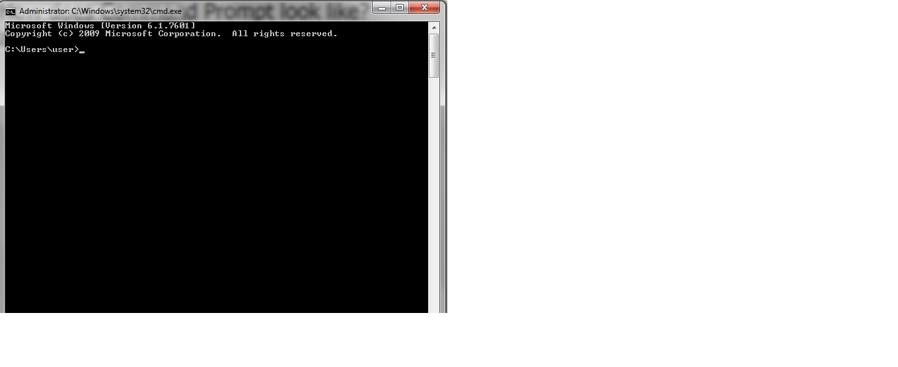

1. ---> cmd ---> Enter
2. What is Command Prompt?
3. Interpreter Application for command lines.
4. cmd.exe is the basic command line interpreter.
5. Command Lines

The basic opening page will show you where you currently are which in my case is the user.

1. How to change the directory?

cd ---> change directory

Ex. From initial opening page to desktop.

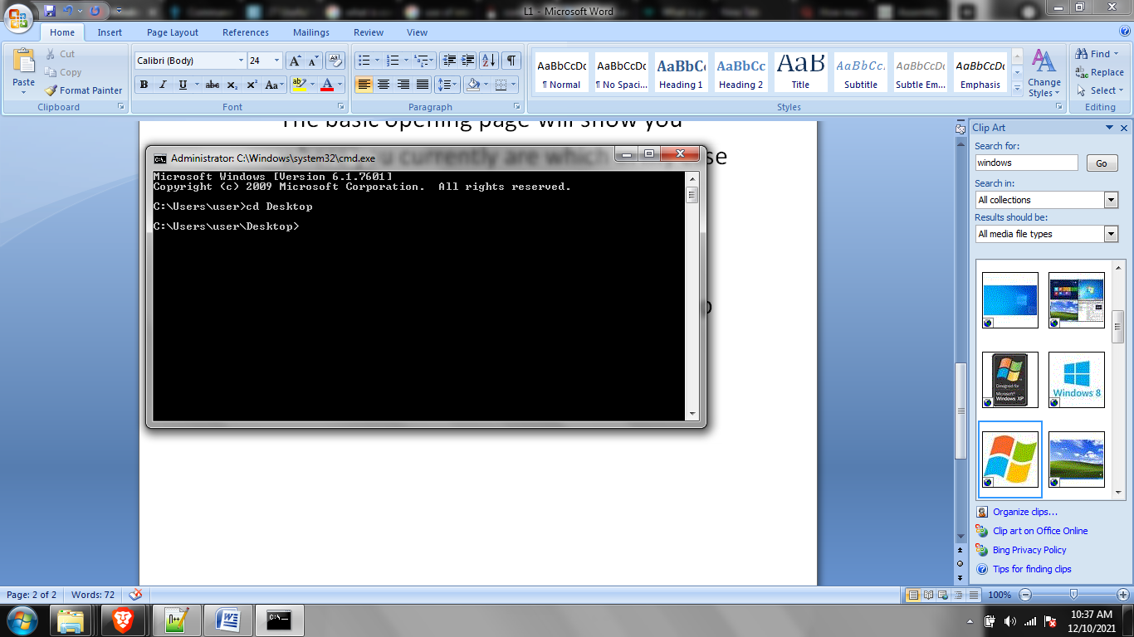

1. cd .. ----> takes you to the parent directory.

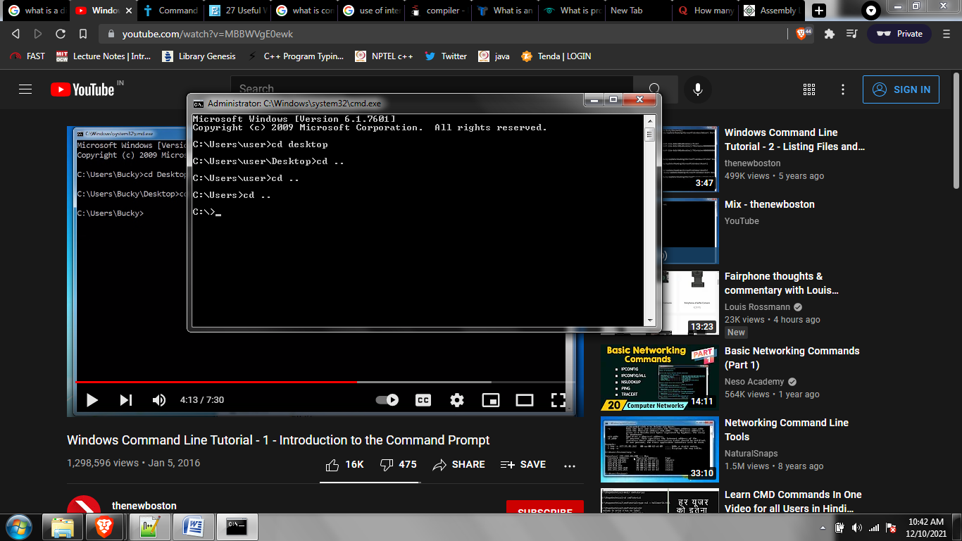

1. Backslash \

Allows you to jump into multiple directories through a single command line.

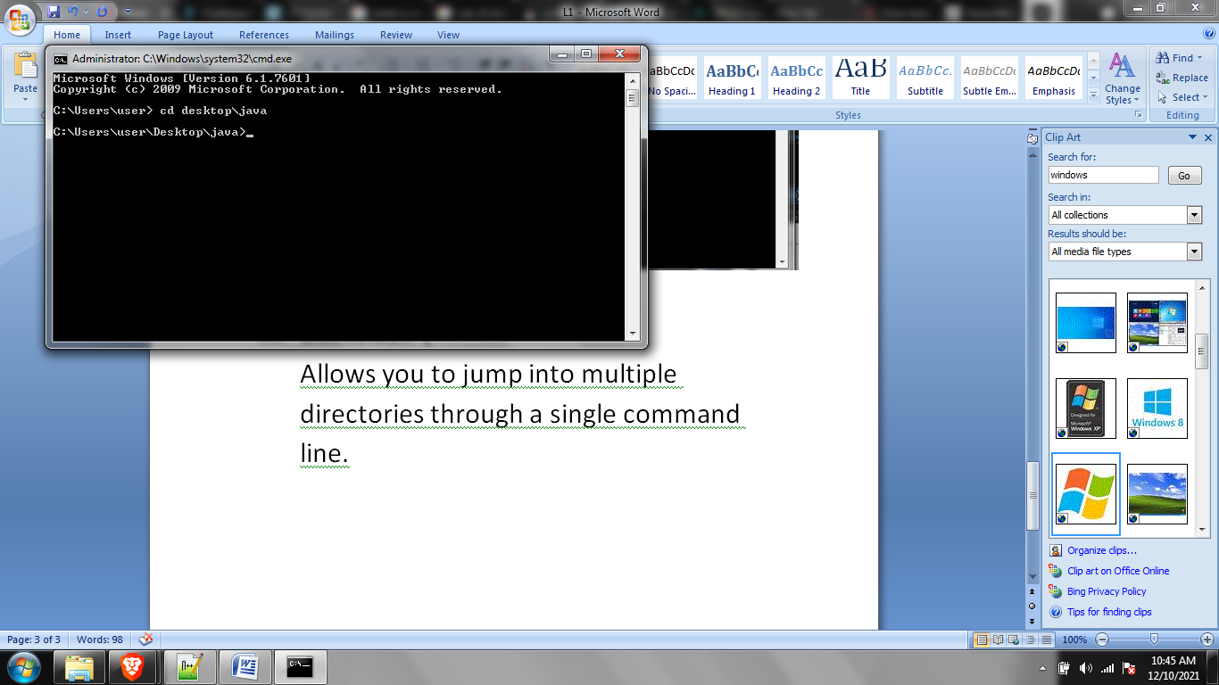

1. Forwadslash /

Allows you to move upwards multiple directories.

