Listing all the directories.

1. You can either move to the directory whose list you want to check.

Ex . I want to check what’s in the user directory.

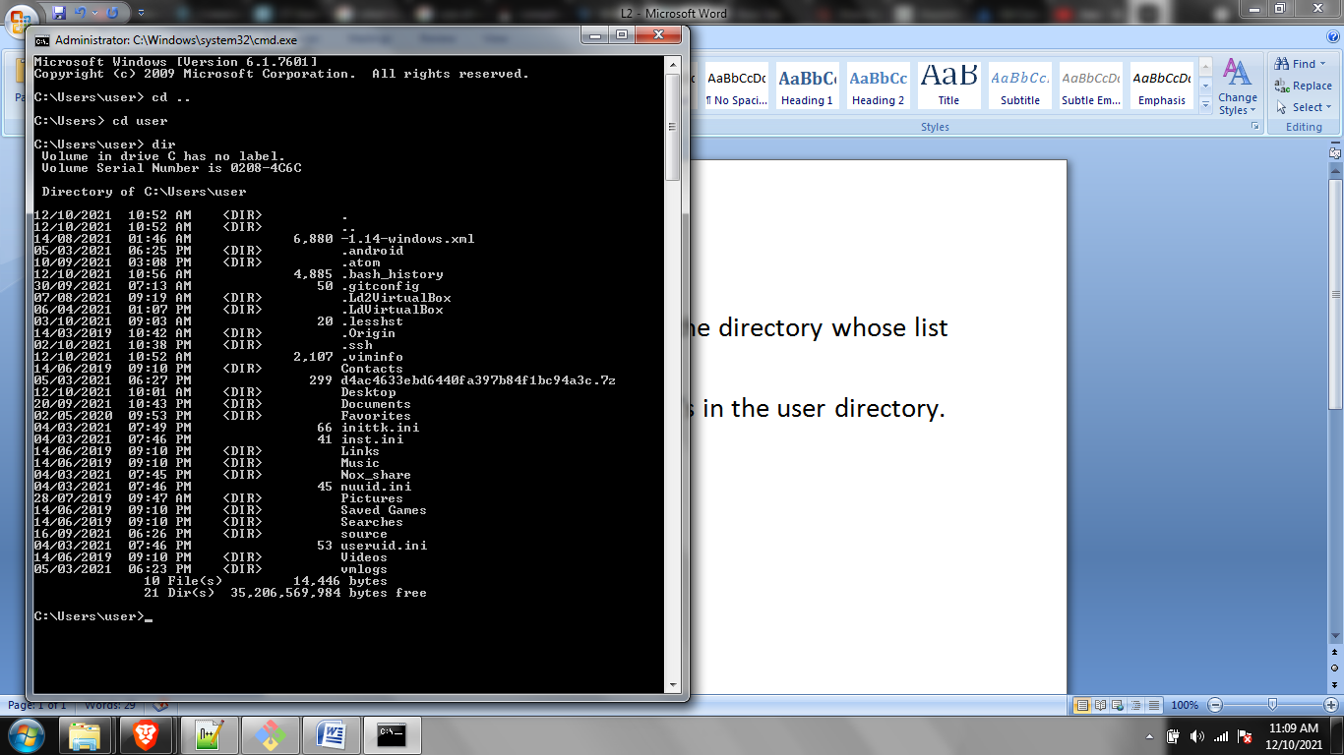

1. You can also access the list from anywhere without moving the specific directory.

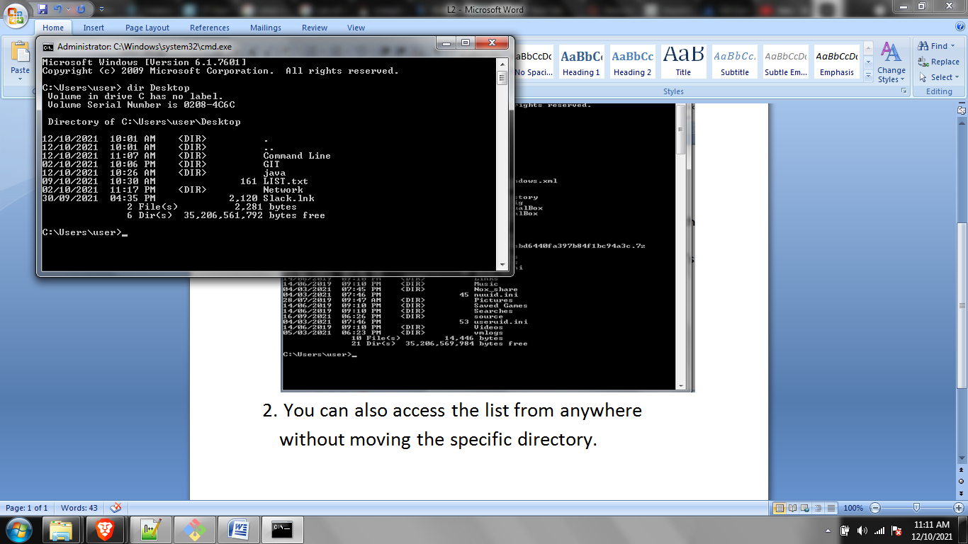

/a can also be used to see hidden files.

