Cls : clear screen

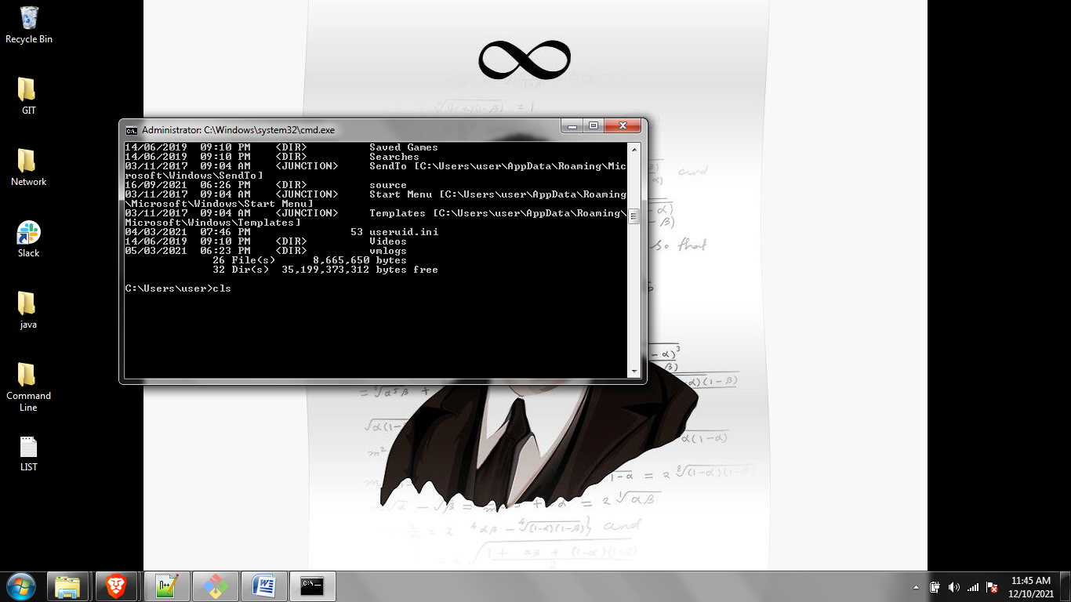

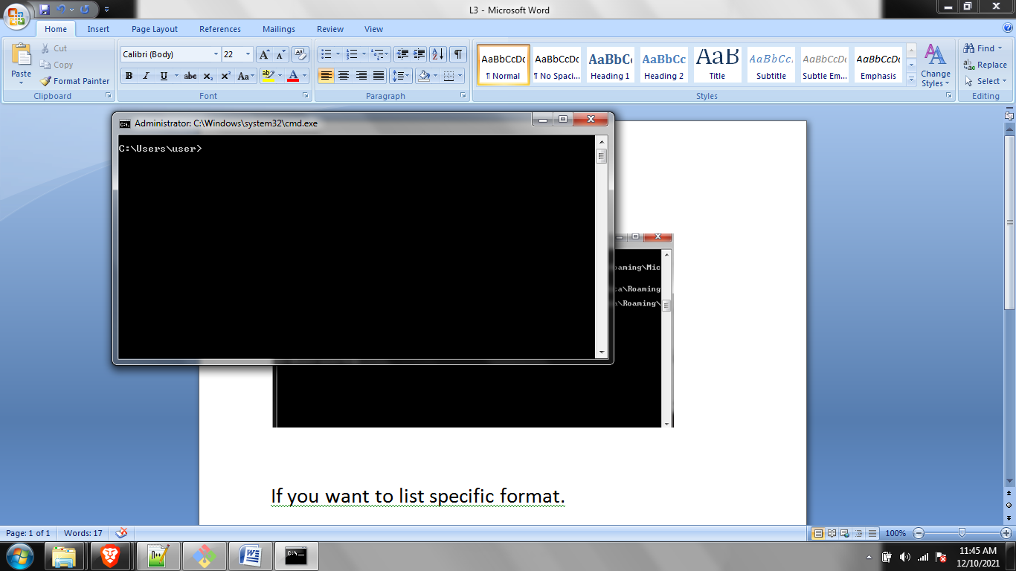

If you want to list specific format.

\*.type

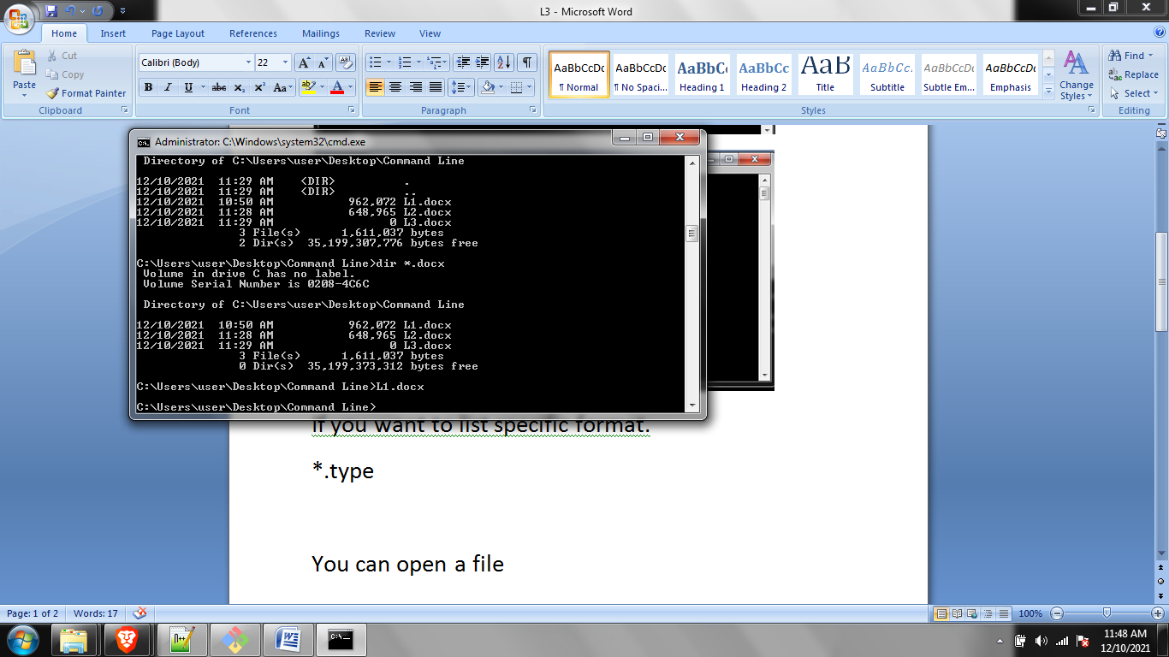

You can open a file

Simply enter after the name appears and the specific file will open. In the above case L1.docx opens.

/?

Will open all the flags for a specific command.