1. How to create/make a new directory?

mkdir <name>

I will make a new dir named empty in Command-Line on Desktop.

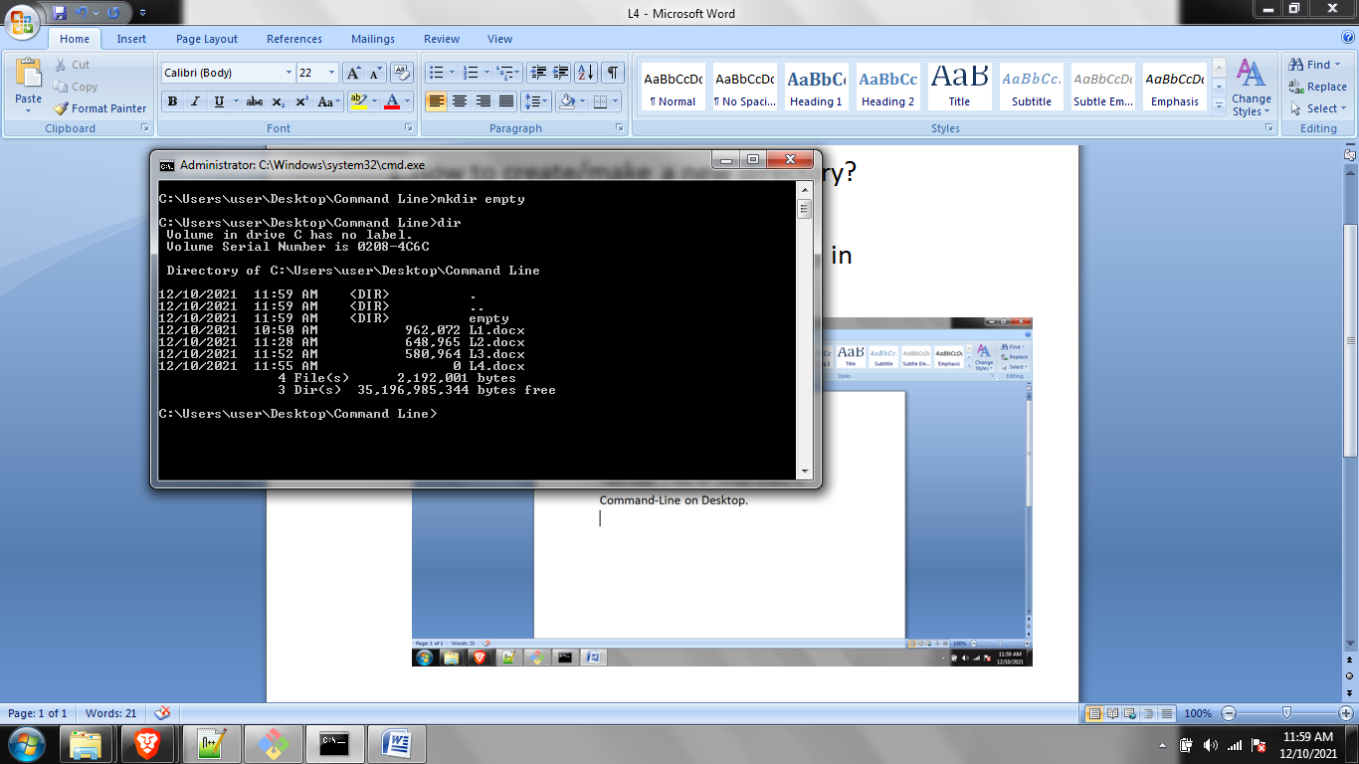

1. How to remove a directory?

Rmdir <name>

I will remove the empty directory.

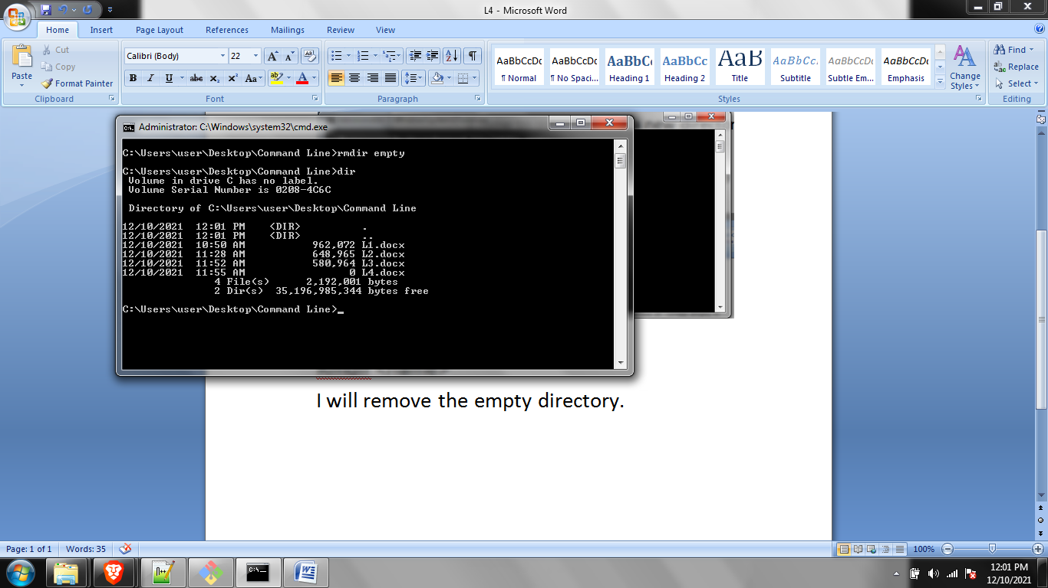

Now, If the directory is not empty the above command won’t work. It will show something like empty is not empty.

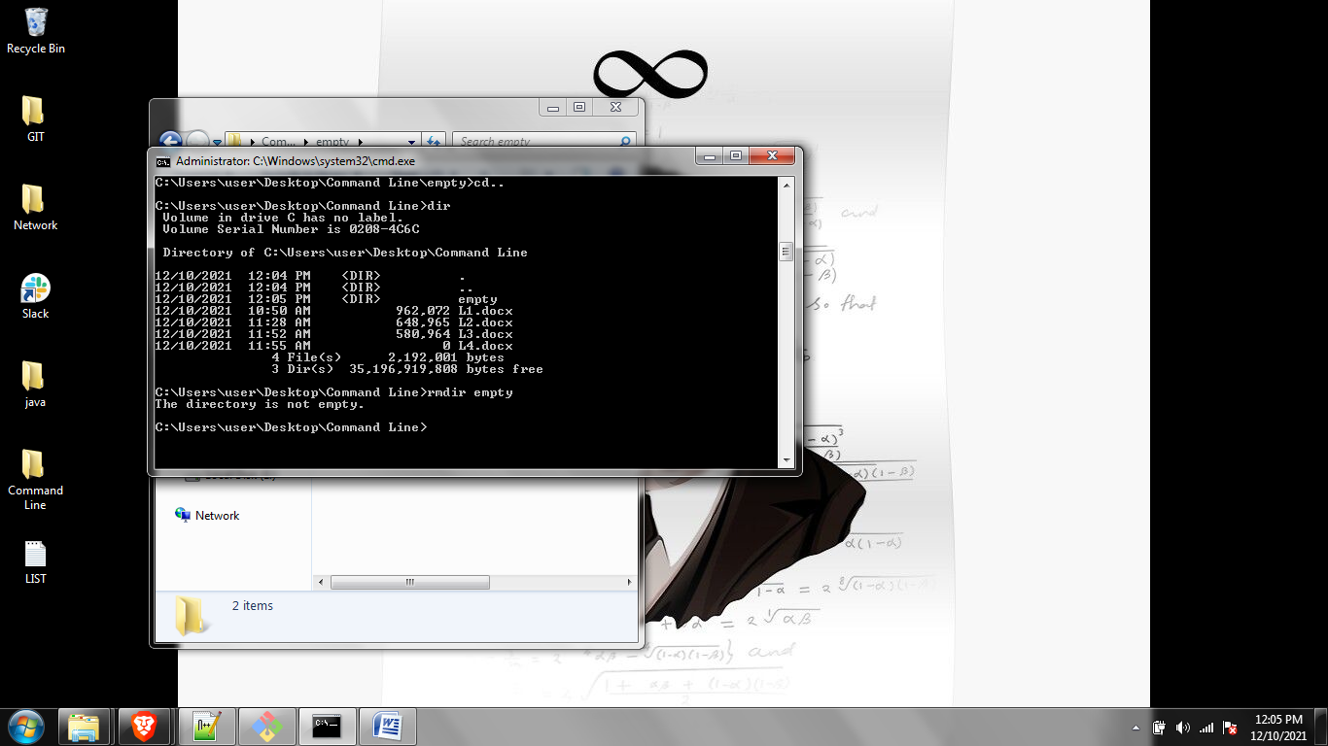

How to delete such files.

Use rmdir /s <name>

It will ask your y/n and then delete

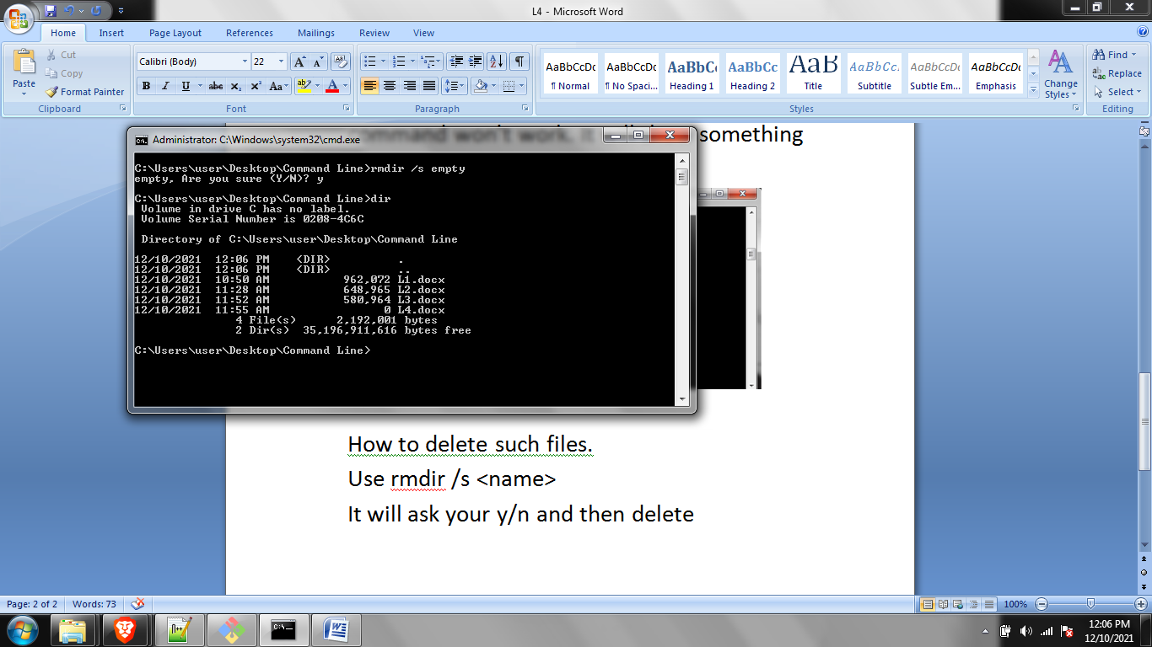

Home and end is a quick way to jump to the ends of a text

Also Ctrl+ left/right arrow allows you to jump words.