How to change directory through absolute path.

Till now, I know how to change dir relative to where I currently am.

I will do 2 things.

1. Change path to C:\Windows

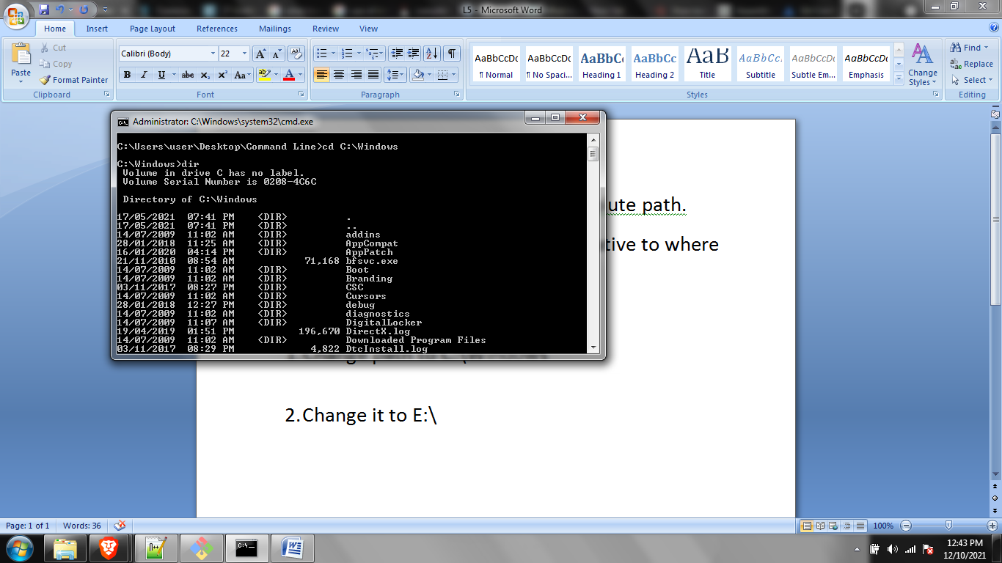

1. Change it to E:\

It can’t change drives.

Can only limit to C:

If you want to run exe files. It will run them in the cmd prompt



PATH

Write path command to get path info

