Drives and Changing Colors

To change drives. Get to the c dir and just enter the name of the drive with:

Ex c:\>E:

Changes from c to e

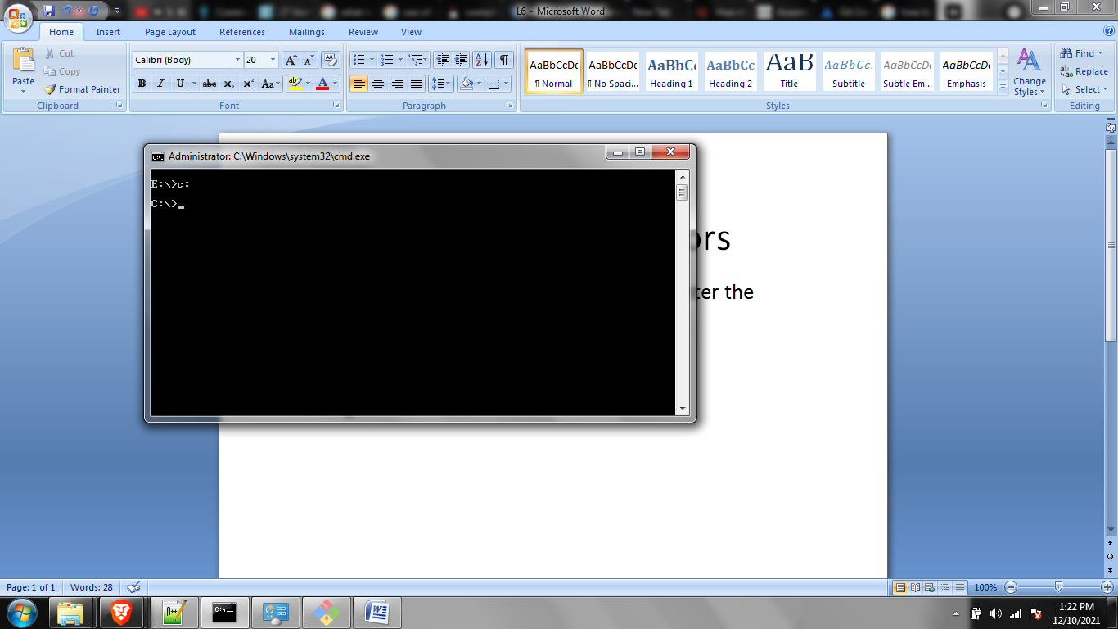

Color

Color 0B

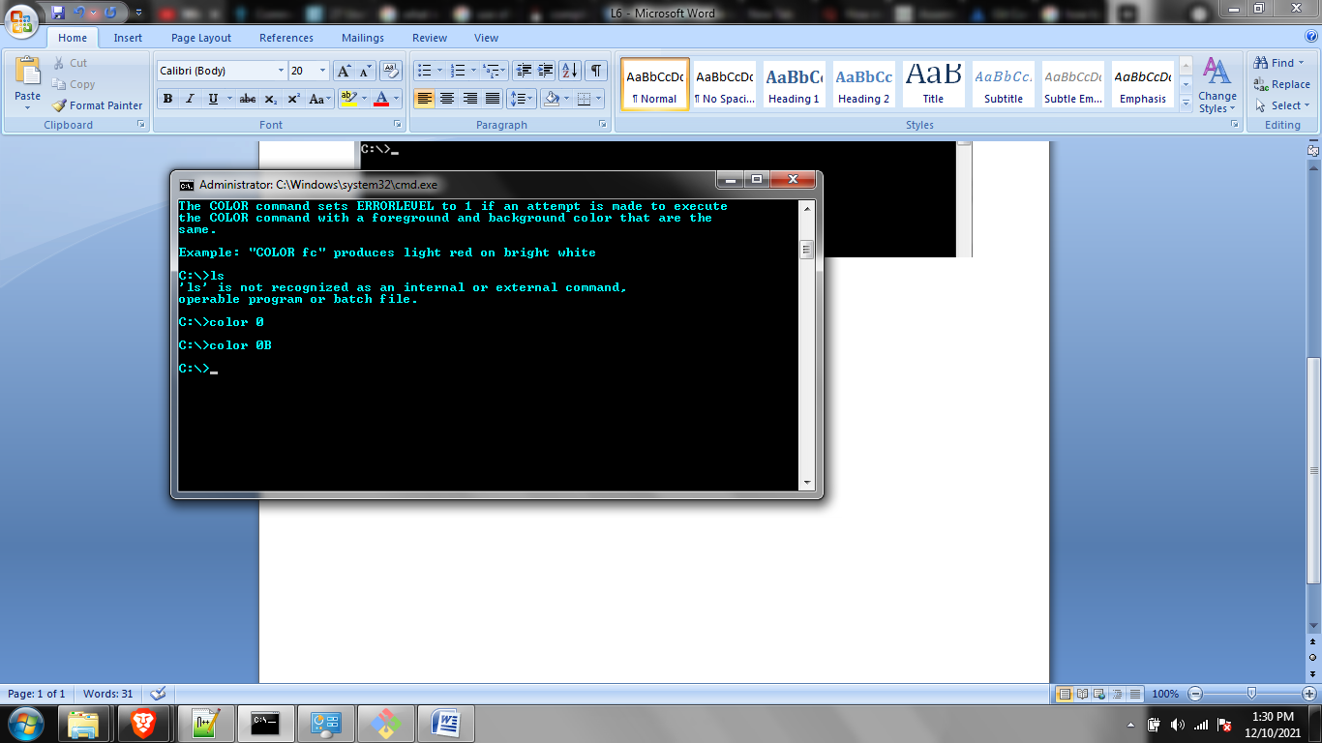

Just type color to reset

First digit ---- background color

Last digit ---- text color