How to delete a file

del <name>

You can also read a text file from it.

Type <name>

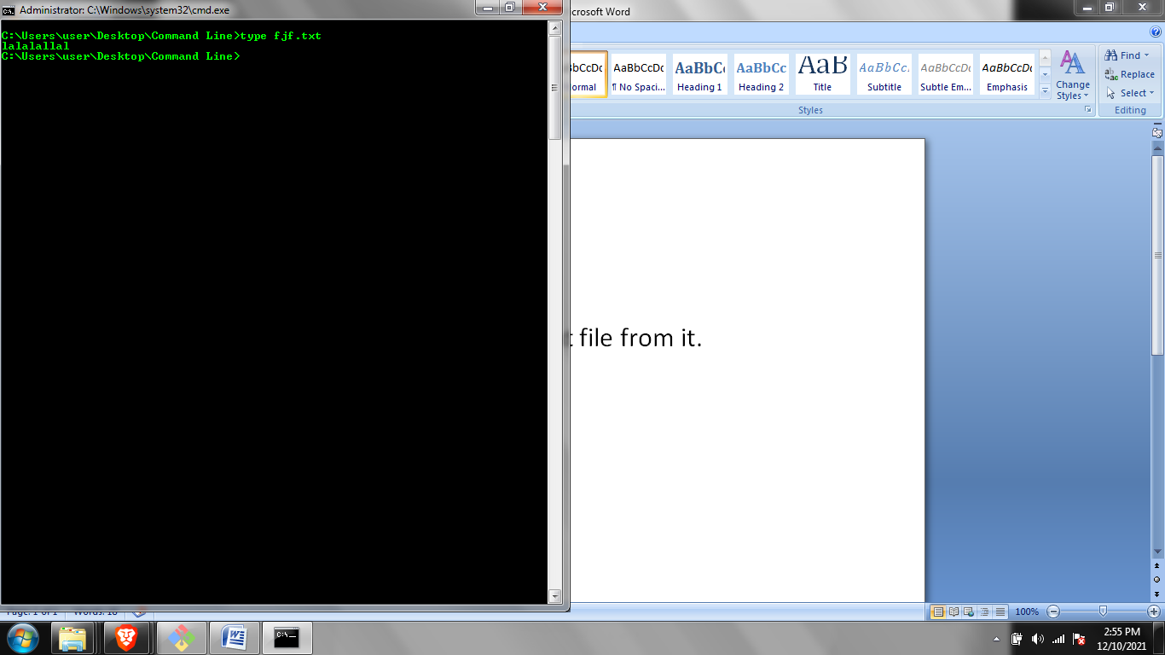

Overwriting files(.txt) >

echo <text> > <name>

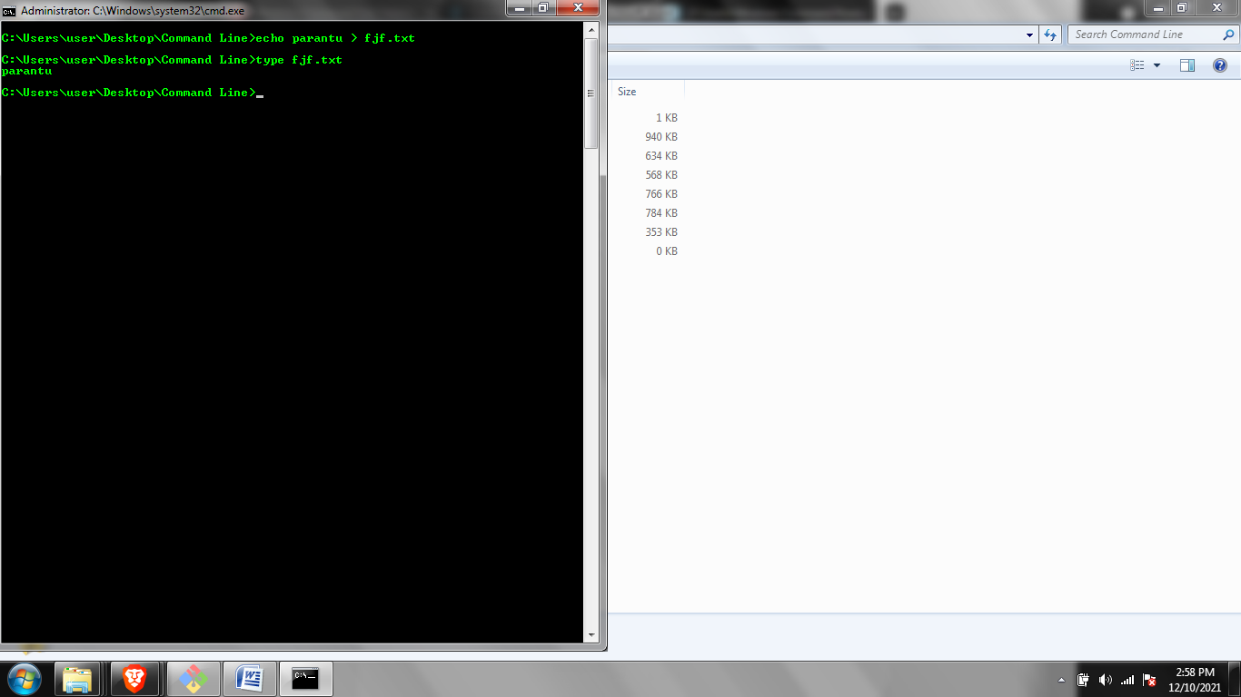

Adding text >>

Echo ---- >> ----

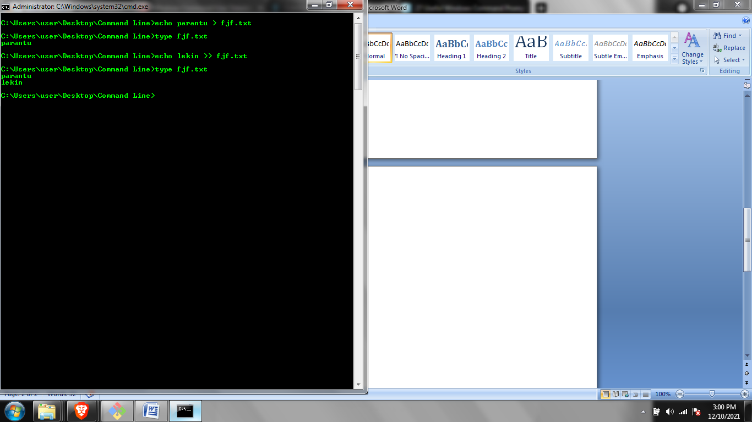

You can also save dir to a new txt file

Dir > porky.txt

