* COPYING AND MOVING FILES

For this I will make a dir test on desktop

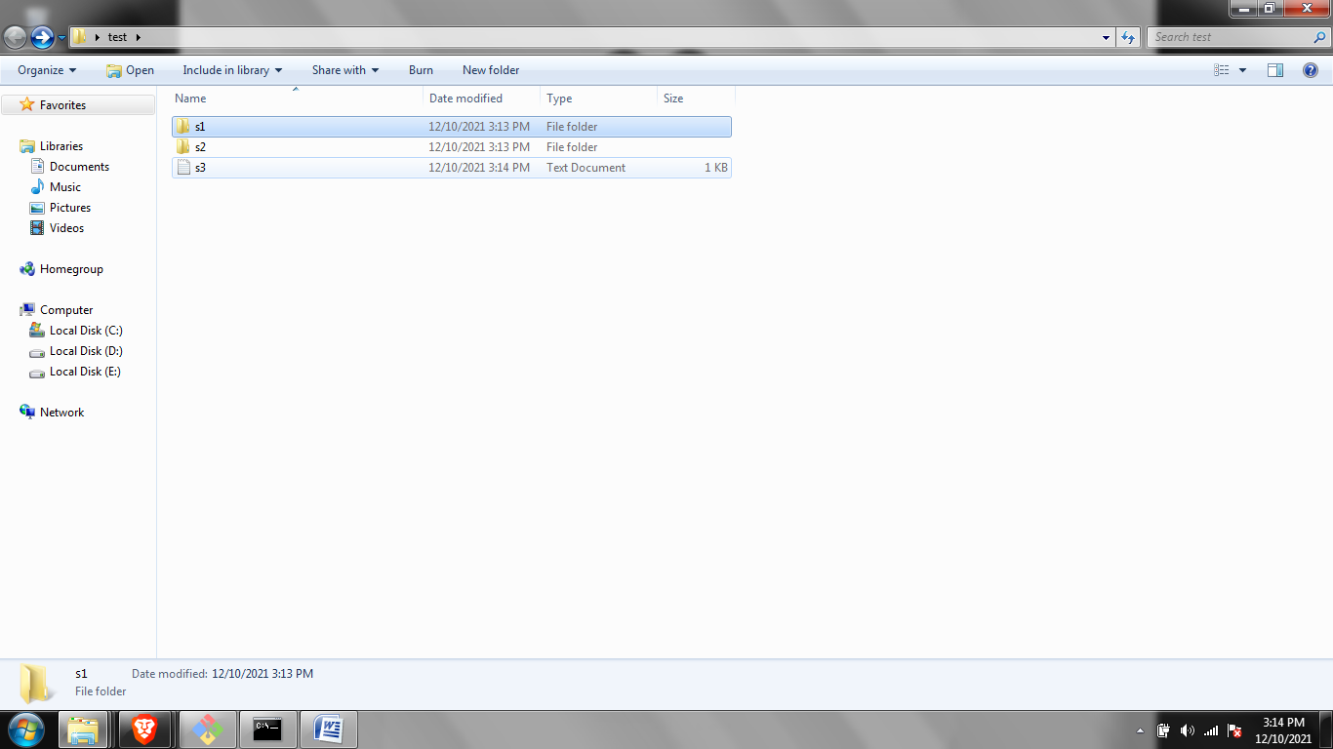

Now we learn how to copy.

For this I will copy s3.txt to s1 dir

copy s1.txt s1

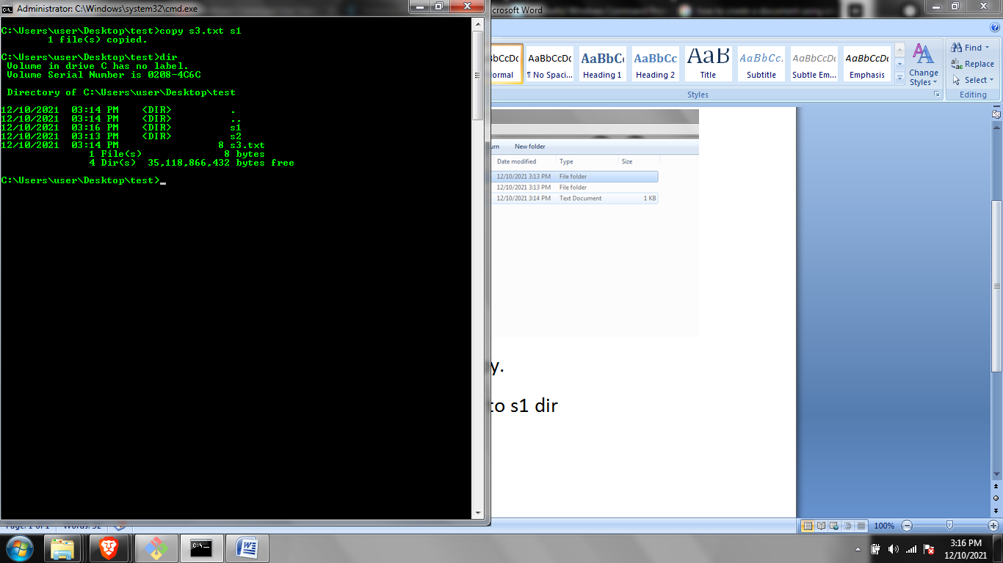

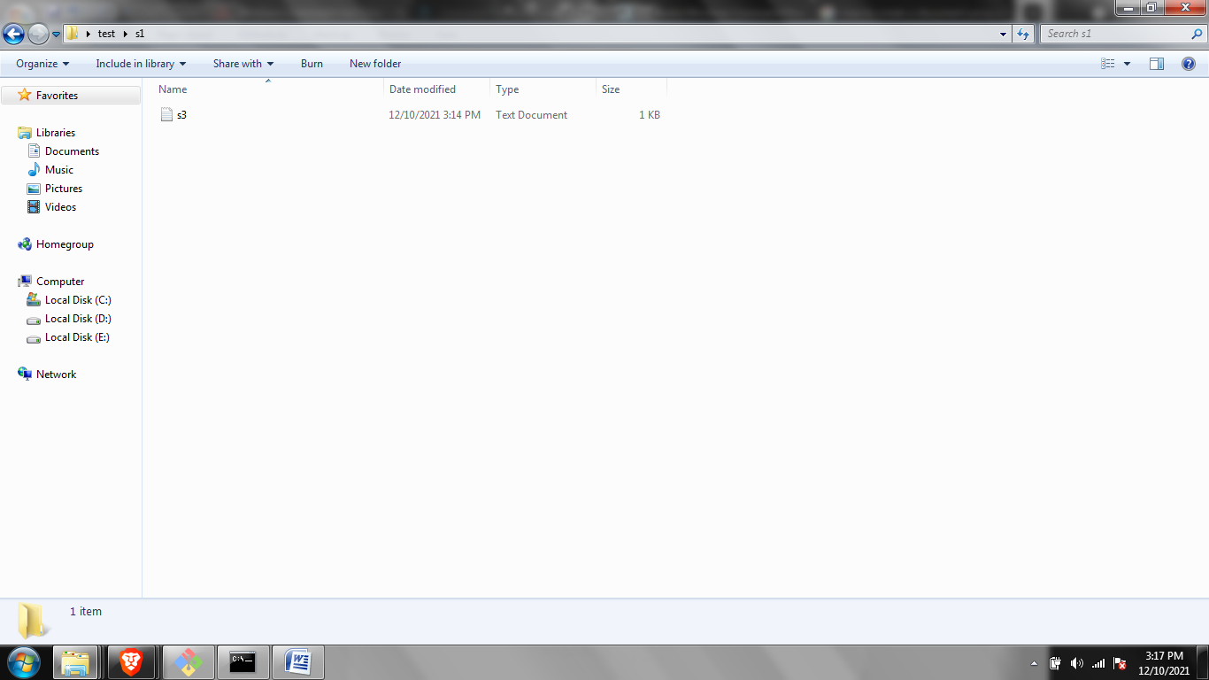

Copied!!

* You can also copy a complete file into another

Xcopy

I will copy s1 to s2

* Now we move

Move

I will move s3.txt to s2

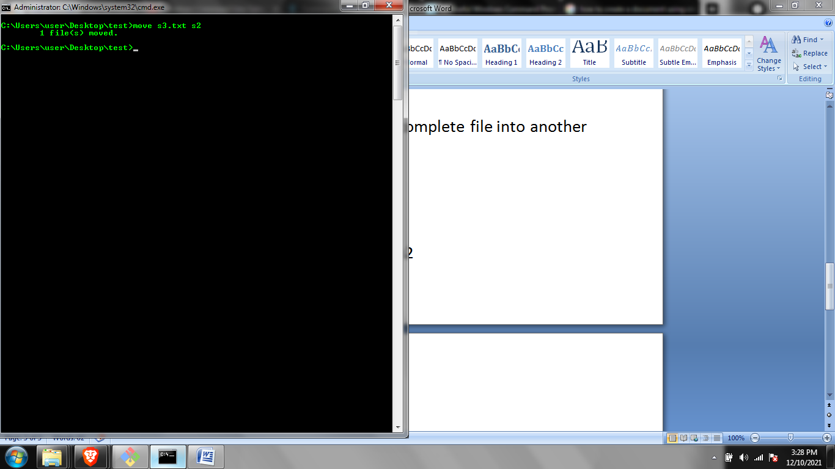

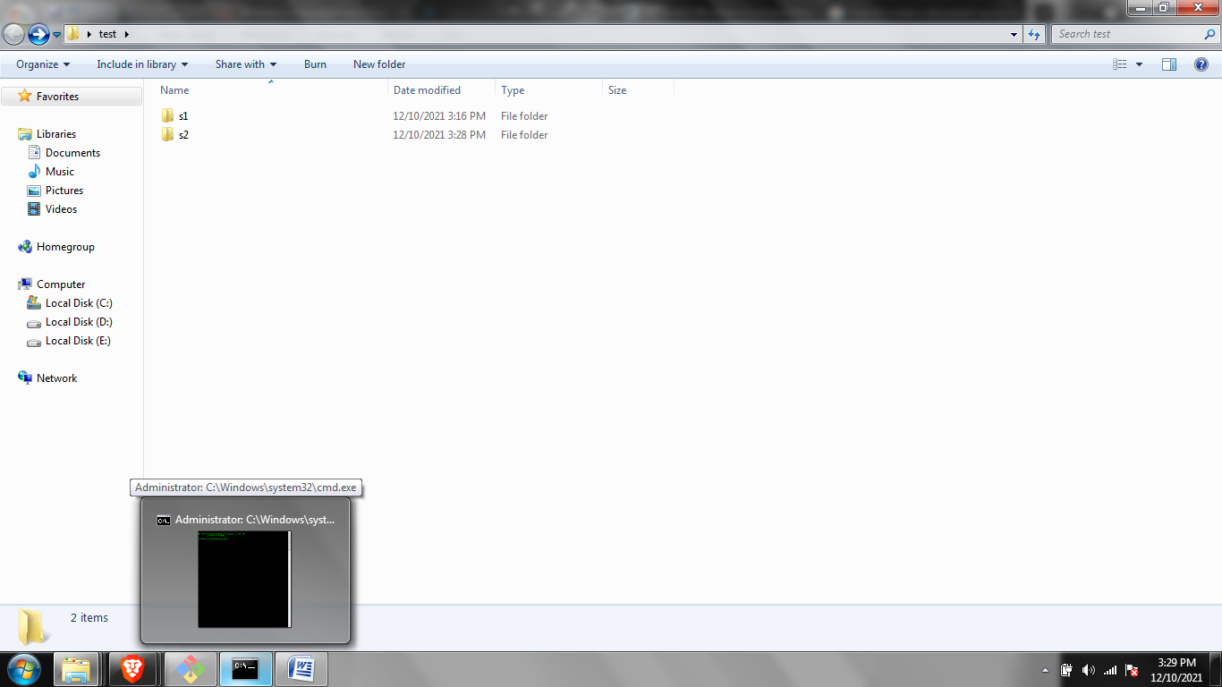

Moved!!

\*How to rename

I will rename s1 to sample

