PICO-2W PDX
Digital Modes Transceiver
Step-1 User & Operations Manual
Station: VU2UPX · Grid: MK69KE · Pico 2W (RP2350)
Firmware: PICO2W_PDX_Step1 · Manual version 1.4.0 · 2026-09-22

1. Purpose of Step-1
Step-1 is the first milestone of the PICO-2W PDX project: a standalone digital-modes beacon platform on the Raspberry Pi Pico 2W with Si5351, OLED, optional TFT TX log, WiFi/NTP, web UI (Beacon On/Off), and FT8/WSPR beacons.

1.1 Hardware
Photo of the assembled unit (placeholder until replaced).
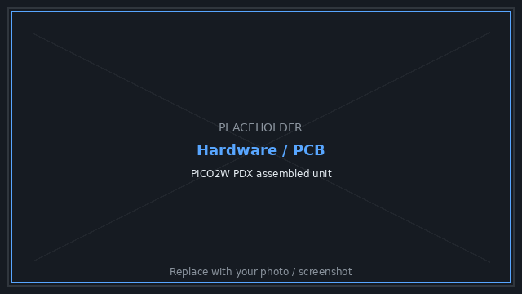
Figure 1 — Hardware / PCB [placeholder]

2. Web interface
Open the STA IP shown on the OLED, or http://192.168.4.1 in AP/config portal mode. Screenshots below are rendered from the firmware web page markup.

2.1 Main page (Beacon OFF)
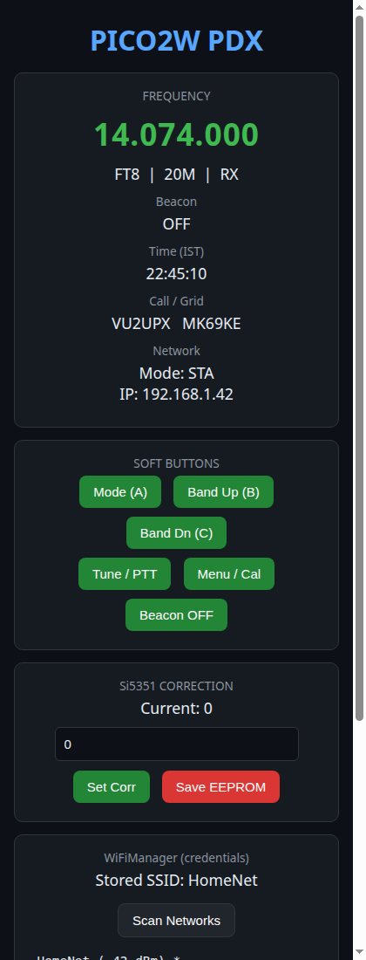
Figure 2 — Web UI (Beacon OFF)

2.2 Main page (Beacon ON)
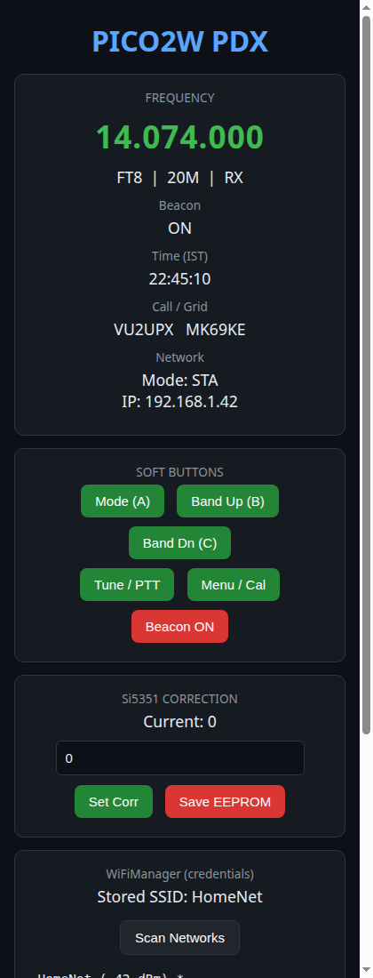
Figure 3 — Web UI (Beacon ON)

2.3 Soft buttons
Button | Action
Mode (A) | Cycle FT8 → FT4 → JS8 → WSPR
Band Up / Dn | Change HF band
Tune / PTT | Toggle carrier TX / RX
Menu / Cal | Enter menu / calibration
Beacon ON/OFF | Enable/disable beacon scheduler (default OFF)

3. Displays

3.1 OLED (primary)
Line | Content
1 | Mode + IST time
2 | Dial frequency
3 | RX/TX, band, BCN/--- or TX progress
4 | STA or AP IP

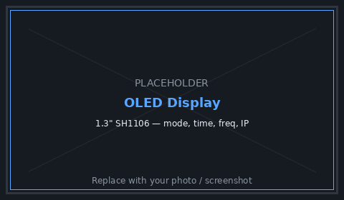
Figure 4 — OLED display [placeholder]

3.2 TFT TX log
Format: MODE BAND DD-MM-YYYY HH:MM:SS (IST). Header shows BEACON ON/OFF.
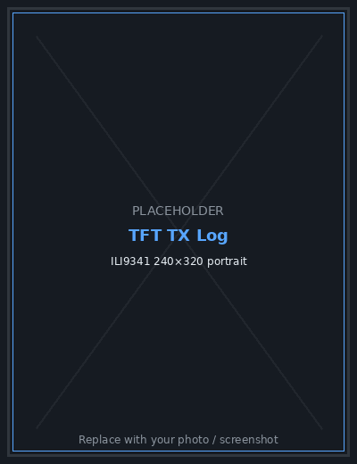
Figure 5 — TFT TX log [placeholder]

4. Front-panel controls
Control | Short | Long
Switch A | Mode cycle | Save EEPROM & exit menu/cal
Switch B | Band up | Cancel menu/cal
Switch C | Band down | Cancel menu/cal
Encoder SW | — | Enter CAL / menu
Encoder | Adjust corr in CAL | —

5. FT8 and WSPR beacons
Only when Beacon is ON and mode is FT8 or WSPR. Never concurrent.
Mode | Timing | Notes
FT8 | Once per FT8_TX_EVERY_MIN at UTC ~:00 | 79 symbols, Costas
WSPR | Even UTC minutes; every WSPR_TX_EVERY_MIN | Type 1 call+grid+dBm

6. Configuration (config.h)
Define | Purpose
MY_CALLSIGN / MY_GRID4 | Station identity
WSPR_DBM / WSPR_TX_EVERY_MIN | Power and WSPR interval
FT8_TX_EVERY_MIN | FT8 interval
DISPLAY_OPTION | 1 = TFT log
WIFI_AP_SSID / PASS | Config portal

7. Getting started
1. Install libraries; configure TFT_eSPI if needed.
2. Upload with Pico 2W + Pico SDK USB stack.
3. Connect WiFi; confirm IST on OLED.
4. Calibrate Si5351 (Section 8).
5. Select mode; Beacon ON; confirm TFT log.

8. Si5351 calibration procedure
CAL mode outputs 10.000 MHz on CLK1. RX_EN and Tx/Rx relay off; CLK0/CLK2 disabled.
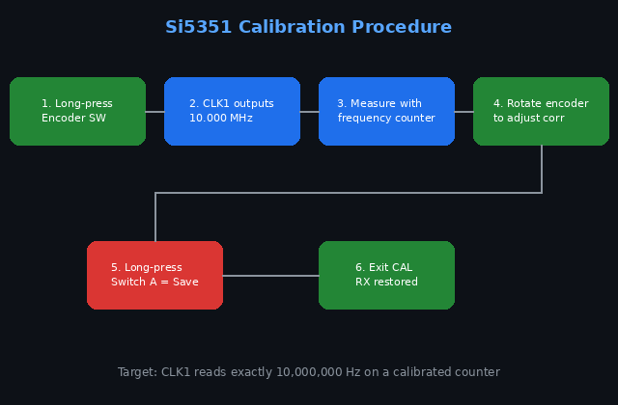
Figure 6 — Calibration procedure flow
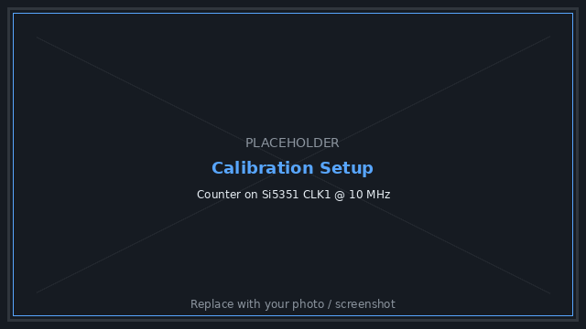
Figure 7 — Calibration bench setup [placeholder]

8.1 Step-by-step
1. Beacon OFF. Long-press encoder → CAL (OLED: 10MHz CLK1).
2. Measure CLK1; rotate encoder until counter reads 10,000,000 Hz.
3. Long-press Switch A to save and exit. B or C cancels.
4. Optional: set correction on web UI → Save EEPROM.

9. RF / antenna
Use a dummy load or legal antenna. Match WSPR_DBM to real power.
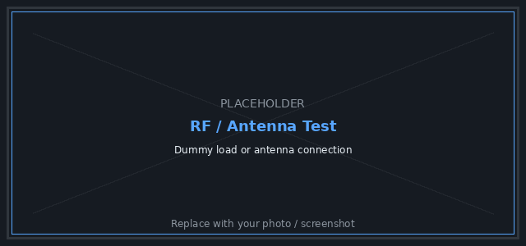
Figure 8 — Antenna / dummy load [placeholder]

10. Operating notes
- Keep Beacon OFF while calibrating.
- WSPR TX ~111 s — monitor PA temperature.
- FT8 free-text may decode as free text in WSJT-X.

11. Known limits
- No DC RX path yet
- No USB Audio for WSJT-X
- No standard FT8 CQ packing yet
- No Si4732/PCF8574 automation

12. Manual versioning
This document is produced by the automated builder in manual_build/. Version is read from VERSION; figures from figures/manifest.json.
Command | Effect
./bump_version.sh patch | 1.4.0 → 1.4.1 and rebuild
./bump_version.sh minor | 1.4.0 → 1.5.0 and rebuild
./bump_version.sh major | 1.4.0 → 2.0.0 and rebuild
python3 build_manual.py | Rebuild current VERSION only
python3 build_manual.py --check | Verify all figures exist

13. Document control
Field | Value
Manual version | 1.4.0
Build date | 2026-09-22
Station | VU2UPX · MK69KE
Firmware | PICO2W_PDX_Step1
Figures total | 8
Screenshots | 2
Placeholders | 5

— End of Step-1 User & Operations Manual v1.4.0 —

