**TITLE: SMART WATER MANAGEMENT**

**1.INTRODUCTION:**

Smart water management refers to the use of advanced technologies and data-driven approaches to efficiently and sustainably manage water resources. This innovative approach leverages sensors, IoT devices, data analytics, and automation to improve the management of water distribution, wastewater treatment, irrigation, and more, ultimately contributing to the conservation of this precious resource.

**2.PROBLEM STATEMENT:**

This problem statement encapsulates the need for a smart water management system to tackle issues related to water conservation,infrastructure efficiency, and water quality, all of which can be addressed through the application of advanced technologies and data-driven approaches.

**3.OBJECTIVES:**

### 3.1 **Reduce wasting water**

  3.2 Improved water qualiity

3.3 Improves the efficiency of water system

3.4 Implement leakage control

3.5 Practice consumption monitoring

**4.METHODOLOGY**

**4.1 Sensor Deployment:**

Install a network of IoT sensors at key points in the water infrastructure. These sensors can measure various parameters like water flow, quality, pressure, and temperature.

**4.2 Remote Monitoring and Control:**

Enable remote monitoring and control of water infrastructure to make real-time adjustments as needed, such as valve control or pump regulation.

**4.3** **Selection of Smart Water Parameters:**

The criteria used for selecting the smart water management parameter are Flow Rate,Water Quality,Water Pressure,Leak Detection ,Asset Health

**4.4 Data Collection and Transmission:**

The sensors collect data and transmit it over a secure network to a central data repository. Data can be transmitted using wired or wireless protocols.

**5.IMPLEMENTATION:**

**5.1Equipment and resources:**

Water Level Monitoring,Equipment Used,Water level indicator,Float Valve,Water Level Monitoring and Controlling,Equipment Used,Water level controllers,Float Switch,Flow Measurement,Equipment Used,Flow Meter (Paddle Type)

**5.2 Project Timeline:**

Planning and data collection done in 1 to 2 months.Sensor deployment to instal IOT sensor in 2 to 4 months.Data processing to setup data storage and analysis done in 2 to 3 months.

**5.3 Stakeholder Collaboration:**

Working with local and national water authorities to ensure compliance with regulations and access to resources.Collaborate with universities for research, data analysis, and technology development.

**6.DATA COLLECTION ANALYSIS:**

**6.1 Data Management System:**

Store the collected data in a central repository, typically a cloud-based platform or local server.It utilized to improve the efficiency, sustainability, and quality of water distribution and management.

**6.2 Data Validation and Quality Control:**

Regularly calibrate IoT sensors to maintain accuracy.It provides reliable, accurate, and trustworthy data, which is essential for making informed decisions and optimizing water distribution and quality.

**6.3 Data Analysis and Interpretation:**

Exploratory Data Analysis (EDA) used to Visualize data through graphs and charts to identify patterns and anomalies.

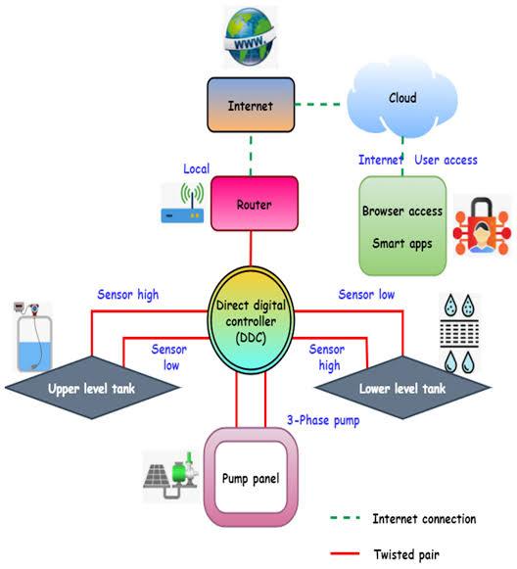**7.BLOCK DIAGRAM:**

**8.RESULTS AND FINDINDS:**

**8.1 Water Management Trends and Patterns:**

Data analysis can reveal inefficiencies in water distribution, allowing for optimizations that reduce water wastage and energy consumption.It contributes to more efficient, sustainable, and reliable water distribution while minimizing waste and environmental impact.

**8.2 Identification of Pollution Sources:**

Deploy water quality sensors at various points in the water system to detect abnormal levels of contaminants or pollutants.Use Geographic Information Systems (GIS) to map pollution sources and potential pathways of contamination.

**8.3 Health and Environmental Impacts:**

Long-term exposure to polluted water may result in chronic health problems, including gastrointestinal disorders, skin conditions, and developmental issues in children.Pollution can lead to a loss of biodiversity, impacting not only aquatic species but also those that rely on them for food.

**9.RECOMMENDATION:**

**9.1 Water Quality Improvement Measures:**

Implement best practices and technologies to minimize pollutants entering water bodies.Require regular reporting of data from both public and private entities.

**9.2 Community Outreach and Awareness:**

There is a pressing need for an intelligent and automated smart water management system that can optimize water distribution, detect leakages, predict consumption patterns, and enable informed decision-making for efficient and sustainable water usage.

**10. CONCLUSION:**

By employing advanced technologies, real-time monitoring, predictive analytics, and community involvement, we can optimize water usage, detect leaks, reduce wastage, and ensure equitable distribution. This not only conserves this precious resource.

**11.REFERENCE:**

[1] Z. Zude, L. Quan, A. Qingsong, & X. Cheng, “Intelligent monitoring And diagnosis for modern mechanical equipment based on the Integration of embedded technology and FBGS technology”. Pp 1499–1511. 12 Nov. 2011.

[2] J.M.P. Martinez, R.B. Llavori, M.J.A. Cabo, and T.B. Pedersen, “Integrating Data Warehouses with Web Data: A Survey,” IEEE Trans. Knowledge and Data Eng., preprint, 21 Dec. 2007, Doi:10.1109/TKDE.2007.190746.