1. To compute the histogram of the original image and perform histogram
Shaping. (Assignment 2 Question 1)
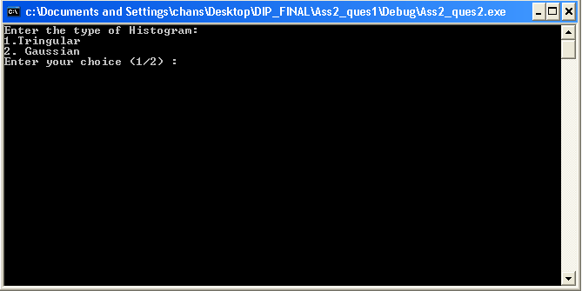

- Triangular
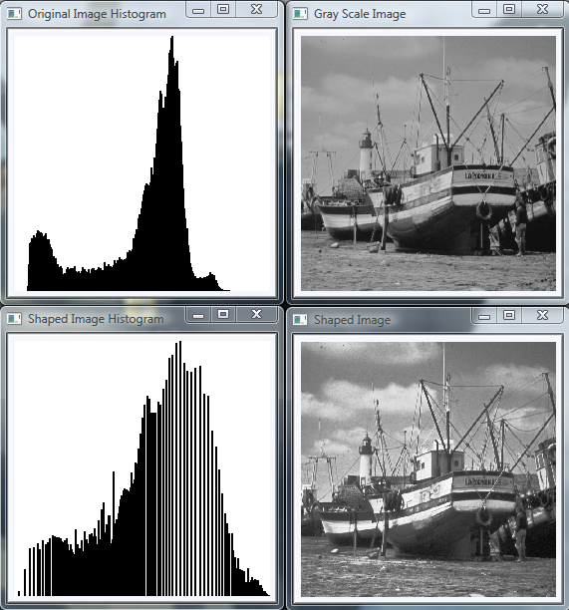

- Gaussian

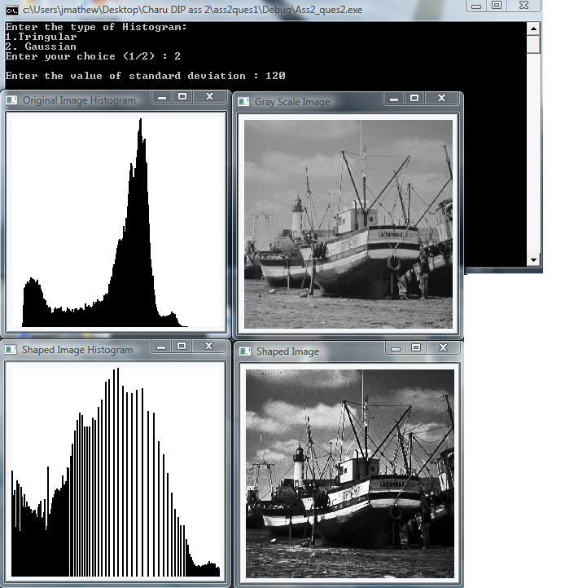

2. To generate a toeplitz stripe image of the size 48x48 with a square of
32x32 in the center of the image and perform a rotation of 45 degrees using bilinear interpolation.
Results are as follows:
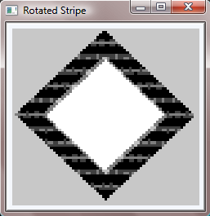
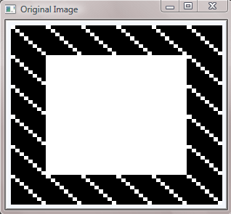

b. To compute the DFT of rotated toeplitz stripe and display the magnitude and phase plots. Generate a mask for the parts in the Fourier transform that came from the diagonals in the rotated image. Mask out the frequencies in the Fourier domain and take an inverse transform.
Results are as follows:
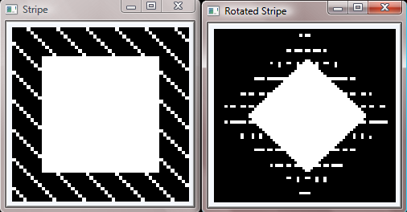
Below are the centered frequency plot and the same after log compression and full contrast stretch, but first the rotated image is padded.
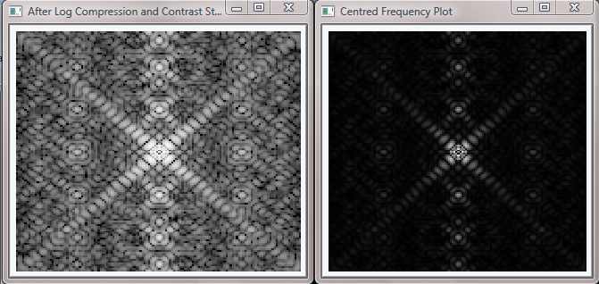
Below is the phase plot after log compression and full contrast stretch.
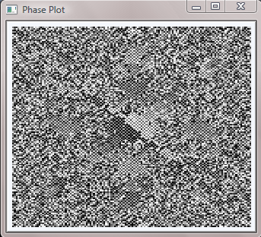

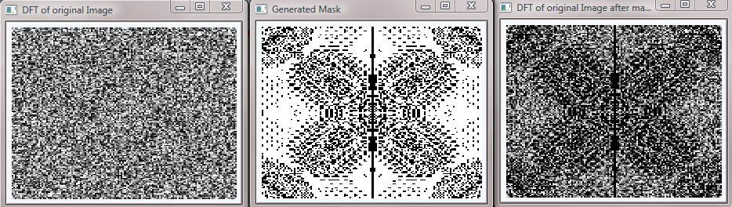
Below is the DFT of the original image, generated mask and DFT of image after masking (no centered plots).

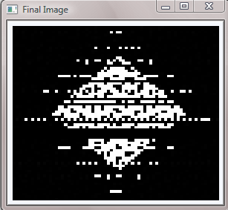
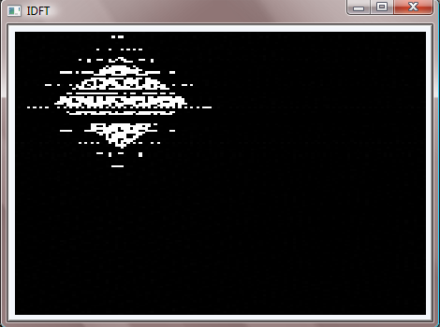
Result: after masking and performing IDFT Unpadded

3. Cartesian to log Polar
This function is used to translate a Cartesian image to a log-polar image. For visualization, log operation is ignored.

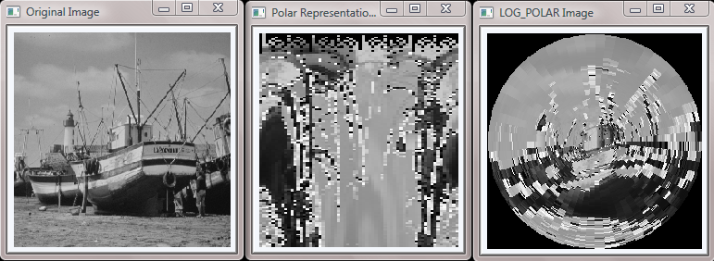

4. Cartesian to Cortical
This function is used to simulate the further magnification of the foveal region from retina to cortex. This part lets the user to choose the center from the image by clicking the original image and the results pop up on its own.

Below is the original image and the console window indicating the point selected.

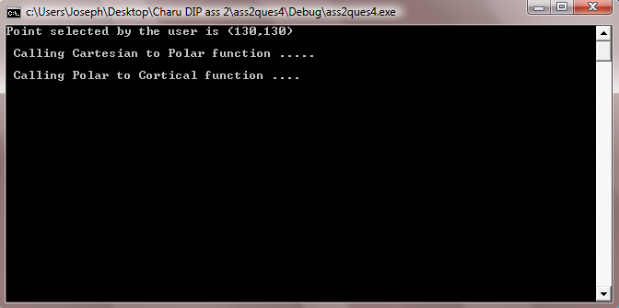
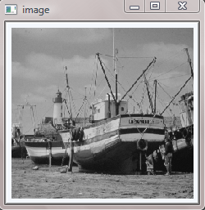

Below we have the polar representation and also the polar image (log has been removed for visualization)
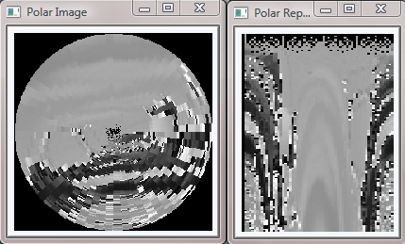

Below is the cortical representation along with the cortical image. It is according to the center selected by the user.

