Digital Image Processing (COSC 6380)
Assignment 1
Name: CHARU HANS
PeopleSoft#: 0816182

Environment used: Microsoft visual studio 2008
1 To Binarize the Image (Question 1)
In this code we are assuming that the input image has the bimodal histogram and we are trying to find the optimal threshold value to binarize the input grayscale image.
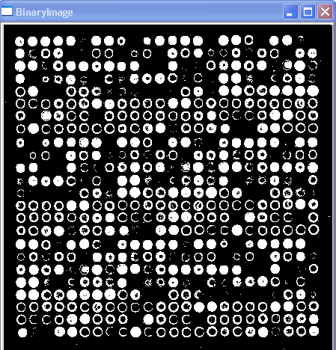
The following is the result of this particular code with the given image

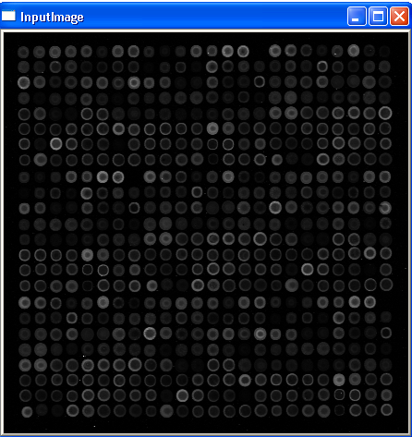


Window named ‘Input Image’ shows the grayscale image that is our input
Window named ‘Binary Image’ shows the binary image that is the result of the code.
2. Laying Grid on Image (Question 2)
We are summing number of pixels with value 255 for each row and column in an image. We are putting the sum in two arrays ‘rows’ and ‘cols’. We are setting values of arrays to zero, for which number of pixels is less than 18.
Then we compute first and last coordinate of an image, and lay a rectangle using them.
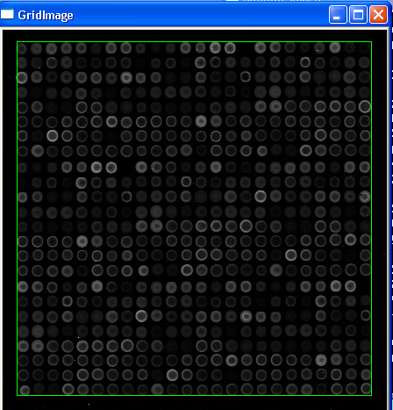
After that for laying next line we find the zero value of Arrays.
for(int i = r1; i < r2; i++)
{
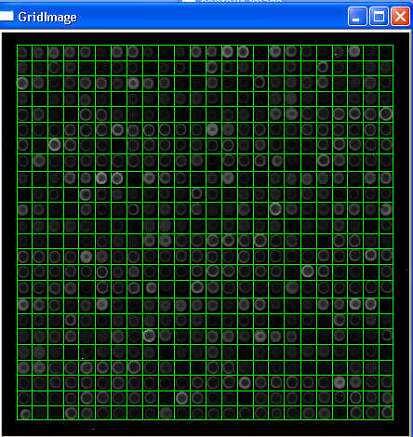
if(rows[i] == 0)
{
do
{
i = i + 1;
}while(rows[i] == 0);
tCols = tCols + 1;
cvLine(image1, cvPoint(i-1,c1), cvPoint(i-1,c2), cvScalar(0,255,0), 1);
}
}
tRows = 1;
for(int i = c1; i < c2; i++)
{

if(cols[i] == 0)
{
do
{
i = i + 1;

}while(cols[i] == 0);
tRows = tRows + 1;
cvLine(image1, cvPoint(r1,i-1), cvPoint(r2,i-1), cvScalar(0,255,0), 1);
}

3. Perform smoothing operation (Question 3)
In this part we are trying to do the smoothing operation on the image using 3x3 or 5x5 window. We are doing this to eliminate small regions (if any) and fill holes in the larger regions (again, if any). In this code I am asking for user’s choice for type of operation .
1 for open-close 3x3 window,
2 for close-open3x3 window
3 for open-close 5x5 window,
4 for close-open 5x5 window
The output is as follows for choices 1, 2, 3, 4:

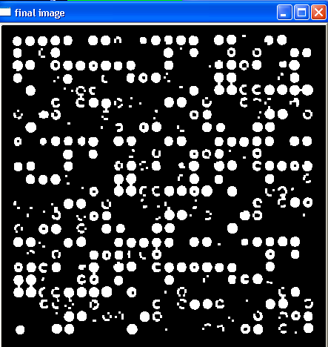

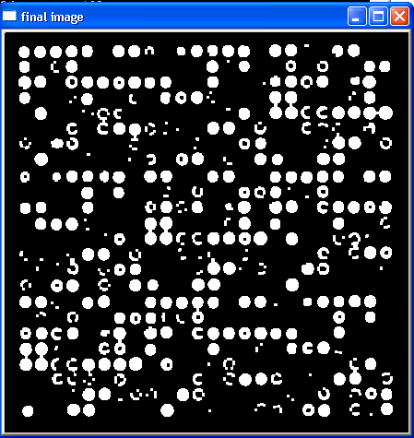

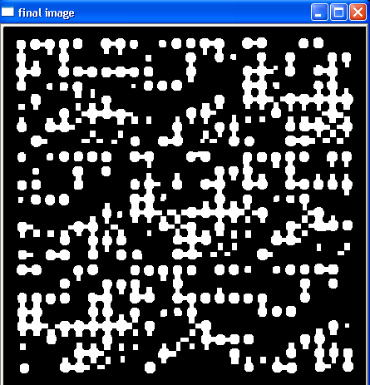

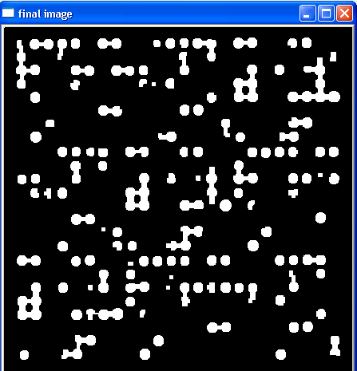

4. Blob-coloring (Question 4)
In this code we are doing blob coloring on the Smoothed Image obtain by morphological operation (I am using the result of question 3 for 3x3 close-open).
In this I am using 3x3 open-close window
We are doing 4-connected or 8-connected blob coloring.
Basic idea for 4-connected blob coloring is as follows:
Here we have that each cell (in red) is connected with 4 cells (in black). So the value of the red cell will be affected by the values of the black cells around it.
Since we are scanning the image in the top-down left-right manner we would only be considering the following cells

So in our case it would be like a 2-connected, our algorithm for 4-connected blob coloring is same as 2-connected.
Cell in red has co-ordinates (i,j) while the cell above has co-ordinates (i-1,j) and the one before has co-ordinates (i,j-1)
Different cases that we would be coming across in 4-connected blob coloring is as follows
Case 1: Case2: Case 3:

In case 1 the value at (i,j)= 255 while other cells have value =0, so this cell is assigned a new region number.
In case 2 the value at (i,j)= 255 while the one before it is also the same but the one above has value = 20, so this cell is assigned the same region number as the cell before it.
In case 3 the value at (i,j)= 255 while the one above it is also the same but the one before has value = 20, so this cell is assigned the same region number as the cell above it

Case 4

Case 4 is a particular case where all three cells have value = 255 but it has two separate cases
Sub case ‘a’: If both the cells above and below have the same region number then the cell (i,j) is given the same region number
Sub case ‘b’: If the cells above and below do not have the same region number then the cell (i,j) is given the smaller region number and we make both the region numbers equivalent.

Similar, is the idea for 8-connected blob coloring is as follows:
Following is the result of the 4-connected blob coloring on the binary image:
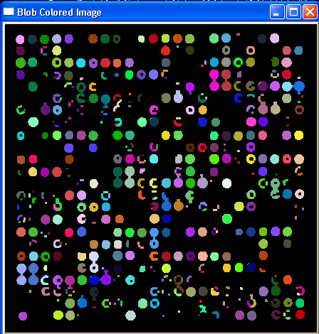
Following is the result of the 8-connected blob coloring on the binary image :
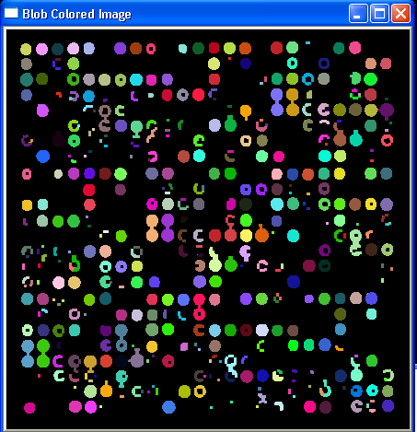
5. Contour-Image (Question 5)
In this part we are using 3x3 window pixel by pixel on dilated image, whenever the window has all the values 255, it implies I am inside the circle. So, I set that pixel 0.
