EXPERIMENT 6 - TIME SERIES ANALYSIS OF WEBSITE TRAFFIC

AIM:
To analyze website traffic time series data to identify trends, seasonality and anomalies. The manual requires website_traffic.csv but does not include the actual CSV/output. This completedversion creates a reproducible sample daily dataset and applies the same methodology specified in the manual.
CODE:
import pandas as pd import numpy as np
import matplotlib.pyplot as plt
from statsmodels.tsa.seasonal import seasonal_decompose

np.random.seed(42)
dates = pd.date_range("2026-01-01", periods=90, freq="D") trend = np.linspace(1000,1450,90)
seasonal = 120*np.sin(2*np.pi*np.arange(90)/7) noise = np.random.normal(0,35,90)
data = pd.DataFrame({ "Date":dates,
"Page_Views":trend+seasonal+noise,
"Unique_Visitors":trend*0.55+seasonal*0.35+np.random.normal(0,20,90),
"Bounce_Rate":55+4*np.sin(2*np.pi*np.arange(90)/7)+np.random.normal(0,1.5,90)
})
data.loc[60,"Page_Views"] += 650 data.set_index("Date", inplace=True) data.interpolate(inplace=True)
decomposition = seasonal_decompose(data["Page_Views"], model="additive", period=7) decomposition.plot()
plt.show()

data["Page_Views_MA"] = data["Page_Views"].rolling(window=30).mean() data[["Page_Views","Page_Views_MA"]].plot()
plt.title("Page Views with Moving Average") plt.show()
data["Page_Views_Z"] = (data["Page_Views"]-data["Page_Views"].mean())/data["Page_Views"].std() anomalies = data[data["Page_Views_Z"].abs()>3] plt.plot(data.index,data["Page_Views"],label="Page Views") plt.scatter(anomalies.index,anomalies["Page_Views"],color="red",label="Anomalies")
plt.legend() plt.show()
print("Number of anomalies:",len(anomalies)) print(anomalies[["Page_Views","Page_Views_Z"]])

OUTPUT:
Number of anomalies: 1

Page_Views 2026-03-02 1884.533639

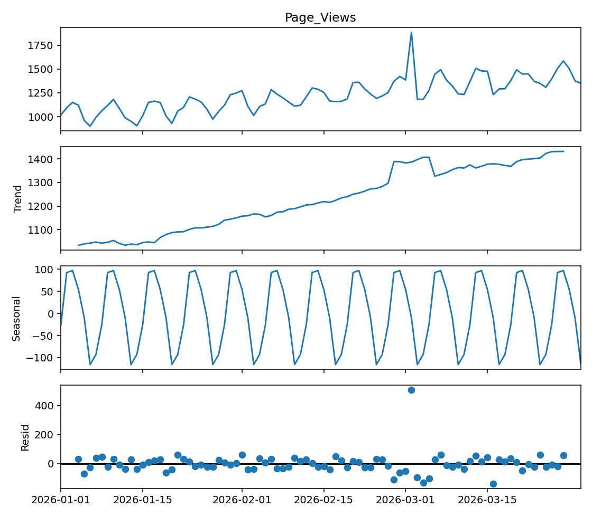
Page_Views_Z 3.786145

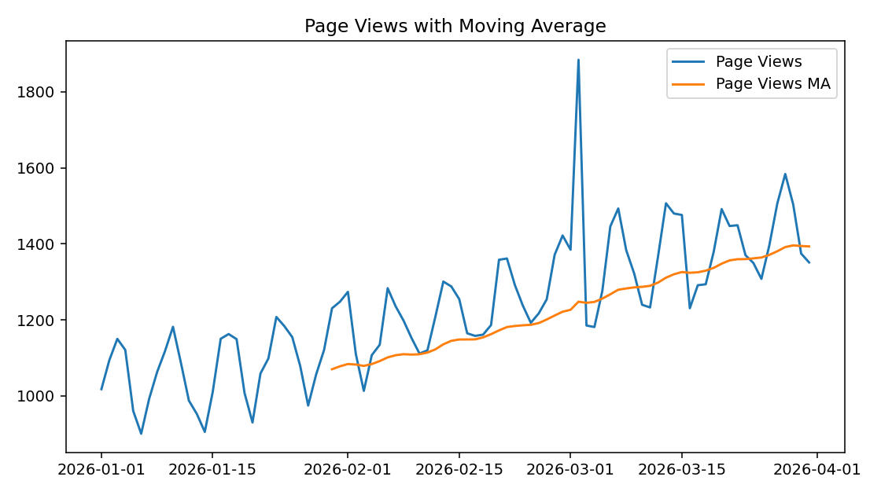

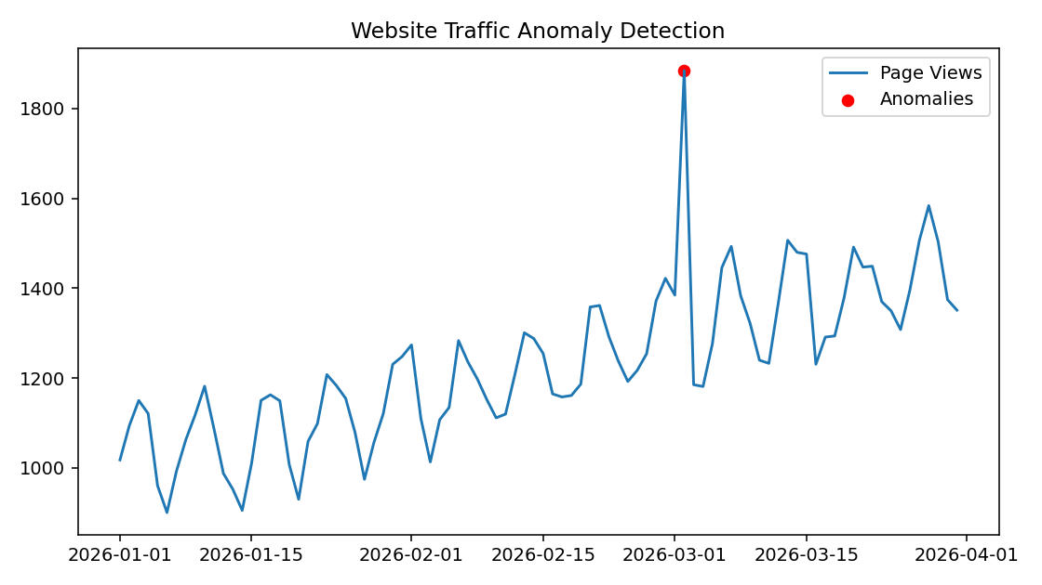

Result
The website traffic time series was analyzed successfully using decomposition, moving averages and Z- score anomaly detection.

