MATPLOTLIB LIBRARY USE CASES IN DATA SCIENCE THROUGH VISUALIZATION

AIM
To understand the use cases of the Matplotlib (and Seaborn) library in data science by visualizing the Iris dataset.

PROGRAM
import pandas as pd
import numpy as np
import seaborn as sns
import matplotlib.pyplot as plt

data = pd.read_csv('Iris_Dataset.csv')
print(data)
data.info()
print(data.describe())
print(data.value_counts('variety'))

sns.countplot(x='variety', data=data)
plt.title('Count of each variety')
plt.show()

dummies = pd.get_dummies(data.variety)
FinalDataset = pd.concat([dummies, data.iloc[:, [0, 1, 2, 3]]], axis=1)
print(FinalDataset.head())

sns.scatterplot(x='SepalLengthCm', y='SepalWidthCm', hue='variety', data=data)
plt.show()

sns.scatterplot(x='PetalLengthCm', y='PetalWidthCm', hue='variety', data=data)
plt.show()

sns.pairplot(data.drop(columns='Id'), hue='variety', height=2)
plt.show()

for column in ['PetalLengthCm', 'PetalWidthCm', 'SepalLengthCm', 'SepalWidthCm']:
g = sns.FacetGrid(data, hue='variety', height=4)
g.map(sns.histplot, column).add_legend()
plt.show()

OUTPUT
Id SepalLengthCm SepalWidthCm PetalLengthCm PetalWidthCm \
0 1 5.1 3.5 1.4 0.2
1 2 4.9 3.0 1.4 0.2
2 3 4.7 3.2 1.3 0.2
3 4 4.6 3.1 1.5 0.2
4 5 5.0 3.6 1.4 0.2
.. ... ... ... ... ...
145 146 6.7 3.0 5.2 2.3
146 147 6.3 2.5 5.0 1.9
147 148 6.5 3.0 5.2 2.0
148 149 6.2 3.4 5.4 2.3
149 150 5.9 3.0 5.1 1.8

variety
0 Iris-setosa
1 Iris-setosa
2 Iris-setosa
3 Iris-setosa
4 Iris-setosa
.. ...
145 Iris-virginica
146 Iris-virginica
147 Iris-virginica
148 Iris-virginica
149 Iris-virginica

[150 rows x 6 columns]
<class 'pandas.DataFrame'>
RangeIndex: 150 entries, 0 to 149
Data columns (total 6 columns):
# Column Non-Null Count Dtype
--- ------ -------------- -----
0 Id 150 non-null int64
1 SepalLengthCm 150 non-null float64
2 SepalWidthCm 150 non-null float64
3 PetalLengthCm 150 non-null float64
4 PetalWidthCm 150 non-null float64
5 variety 150 non-null str
dtypes: float64(4), int64(1), str(1)
memory usage: 7.2 KB
Id SepalLengthCm SepalWidthCm PetalLengthCm PetalWidthCm
count 150.000000 150.000000 150.000000 150.000000 150.000000
mean 75.500000 5.843333 3.057333 3.758000 1.199333
std 43.445368 0.828066 0.435866 1.765298 0.762238
min 1.000000 4.300000 2.000000 1.000000 0.100000
25% 38.250000 5.100000 2.800000 1.600000 0.300000
50% 75.500000 5.800000 3.000000 4.350000 1.300000
75% 112.750000 6.400000 3.300000 5.100000 1.800000
max 150.000000 7.900000 4.400000 6.900000 2.500000
variety
Iris-setosa 50
Iris-versicolor 50
Iris-virginica 50
Name: count, dtype: int64

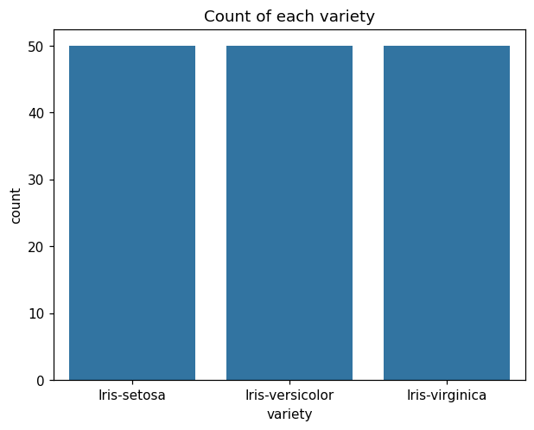
Iris-setosa Iris-versicolor Iris-virginica Id SepalLengthCm \
0 True False False 1 5.1
1 True False False 2 4.9
2 True False False 3 4.7
3 True False False 4 4.6
4 True False False 5 5.0

SepalWidthCm PetalLengthCm
0 3.5 1.4
1 3.0 1.4
2 3.2 1.3
3 3.1 1.5
4 3.6 1.4

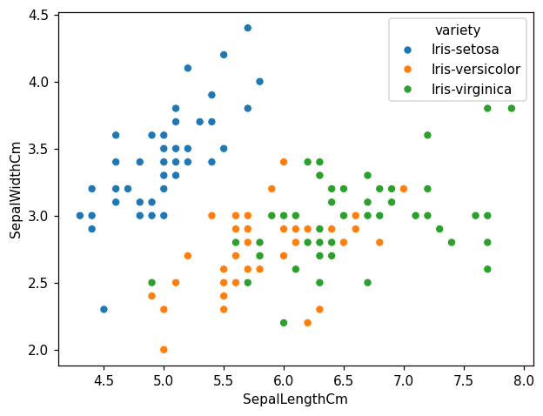
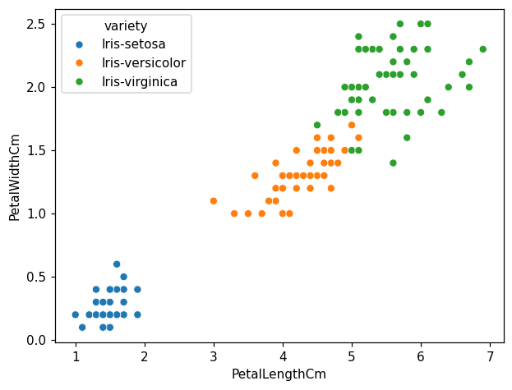
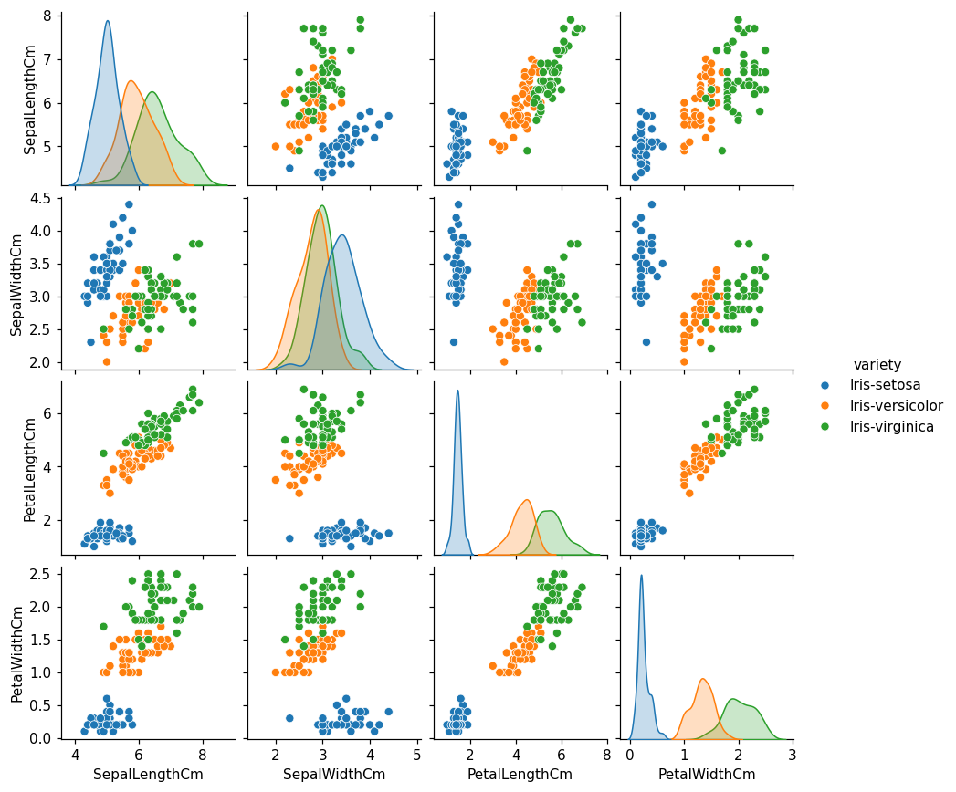
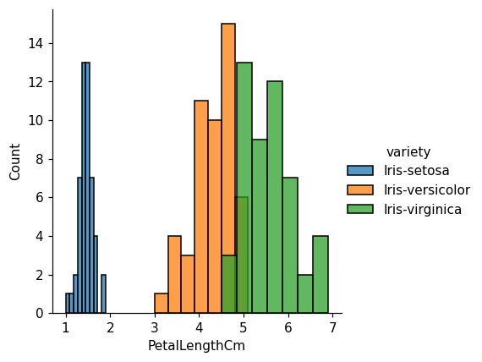
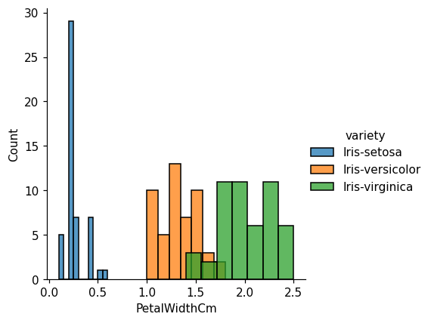
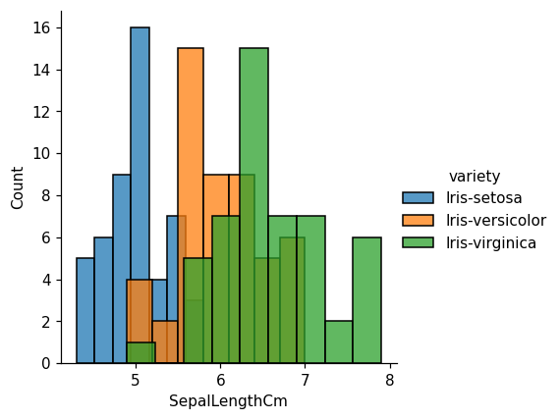
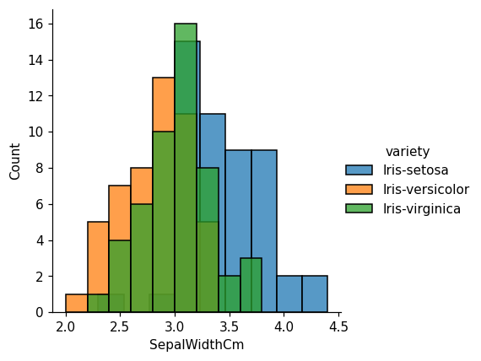

RESULT
Thus the Iris dataset was explored and visualized with Matplotlib and Seaborn. The plots show that Iris-setosa is clearly separable from the other two varieties using petal length and petal width.

