DETECTING OUTLIERS IN A DATA SET

AIM
To understand the procedure to identify and remove outliers in a given data set using the Inter-Quartile Range (IQR) method.

PROGRAM
import numpy as np
import seaborn as sns
import matplotlib.pyplot as plt

# array = np.random.randint(1, 100, 16) # 16 random numbers between 1 and 99
array = np.array([27, 50, 44, 6, 58, 61, 23, 86, 67, 20, 75, 7, 79, 61, 90, 54])
print("Array :", array)
print("Mean :", array.mean())
print("25th percentile :", np.percentile(array, 25))
print("50th percentile :", np.percentile(array, 50))
print("75th percentile :", np.percentile(array, 75))
print("100th percentile:", np.percentile(array, 100))

# Outlier detection using the IQR method
def outDetection(array):
Q1, Q3 = np.percentile(array, [25, 75])
IQR = Q3 - Q1
lr = Q1 - (1.5 * IQR)
ur = Q3 + (1.5 * IQR)
return lr, ur

lr, ur = outDetection(array)
print("\nLower range, Upper range:", lr, ur)

sns.histplot(array, kde=True)
plt.title('Distribution of the data')
plt.show()

new_array = array[(array > lr) & (array < ur)]
print("Outliers found :", array[(array < lr) | (array > ur)])
print("After removal :", new_array)

lr1, ur1 = outDetection(new_array)
print("Ranges after removal:", lr1, ur1)
final_array = new_array[(new_array > lr1) & (new_array < ur1)]
print("Final array :", final_array)

# Data set containing an extreme value
array2 = np.append(array, 250)
lr2, ur2 = outDetection(array2)
print("\nArray with extreme value:", array2)
print("Lower range, Upper range:", lr2, ur2)
print("Outliers found :", array2[(array2 < lr2) | (array2 > ur2)])
cleaned = array2[(array2 > lr2) & (array2 < ur2)]
print("After removal :", cleaned)

fig, ax = plt.subplots(1, 2, figsize=(9, 3))
sns.boxplot(x=array2, ax=ax[0])
ax[0].set_title('Before removing outlier')
sns.boxplot(x=cleaned, ax=ax[1])
ax[1].set_title('After removing outlier')
plt.tight_layout()
plt.show()

OUTPUT
Array : [27 50 44 6 58 61 23 86 67 20 75 7 79 61 90 54]
Mean : 50.5
25th percentile : 26.0
50th percentile : 56.0
75th percentile : 69.0
100th percentile: 90.0

Lower range, Upper range: -38.5 133.5

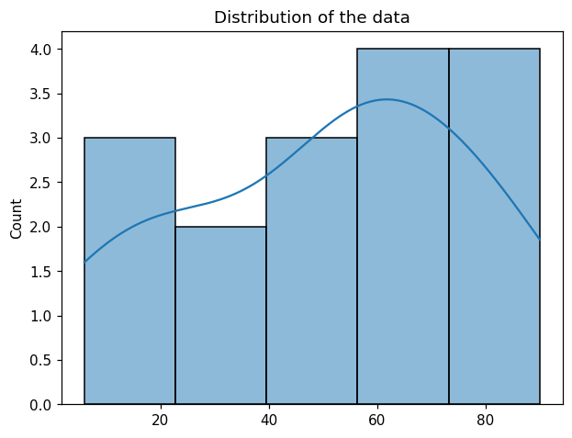
Outliers found : []
After removal : [27 50 44 6 58 61 23 86 67 20 75 7 79 61 90 54]
Ranges after removal: -38.5 133.5
Final array : [27 50 44 6 58 61 23 86 67 20 75 7 79 61 90 54]

Array with extreme value: [ 27 50 44 6 58 61 23 86 67 20 75 7 79 61 90 54 250]
Lower range, Upper range: -45.0 147.0
Outliers found : [250]
After removal : [27 50 44 6 58 61 23 86 67 20 75 7 79 61 90 54]

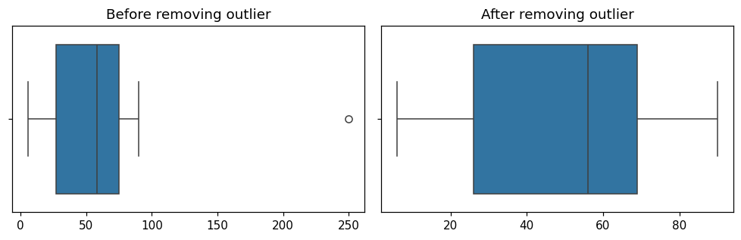

RESULT
Thus the outliers in the given data set were detected using the IQR method. The original data set has no outliers, and the extreme value 250 added to the second data set was detected and removed.

