EDA - QUANTITATIVE AND QUALITATIVE ANALYSIS

AIM
To understand the importance of Exploratory Data Analysis (EDA) by performing quantitative and qualitative analysis on the 'tips' data set.

PROGRAM
import seaborn as sns
import pandas as pd
import numpy as np
import matplotlib.pyplot as plt

tips = sns.load_dataset('tips')
print(tips.head())

# ---------- Quantitative analysis ----------
print(tips.describe())

sns.displot(tips.total_bill, kde=True)
plt.show()

sns.displot(tips.total_bill, kde=False)
plt.show()

sns.jointplot(x=tips.tip, y=tips.total_bill)
plt.show()

sns.jointplot(x=tips.tip, y=tips.total_bill, kind="reg")
plt.show()

sns.jointplot(x=tips.tip, y=tips.total_bill, kind="hex")
plt.show()

sns.pairplot(tips, height=2)
plt.show()

print(tips.time.value_counts())
sns.pairplot(tips, hue='time', height=2)
plt.show()

sns.pairplot(tips, hue='day', height=2)
plt.show()

sns.heatmap(tips.corr(numeric_only=True), annot=True)
plt.show()

sns.boxplot(y=tips.total_bill)
plt.show()

sns.boxplot(y=tips.tip)
plt.show()

# ---------- Qualitative analysis ----------
print(tips.day.value_counts())
print(tips.sex.value_counts())

sns.countplot(x='day', data=tips)
plt.show()

sns.countplot(x='sex', data=tips)
plt.show()

tips.sex.value_counts().plot(kind='pie', autopct='%1.1f%%')
plt.show()

tips.sex.value_counts().plot(kind='bar')
plt.show()

sns.countplot(x='day', data=tips[tips.time == 'Dinner'])
plt.title('Dinner count per day')
plt.show()

OUTPUT
total_bill tip sex smoker day time size
0 16.99 1.01 Female No Sun Dinner 2
1 10.34 1.66 Male No Sun Dinner 3
2 21.01 3.50 Male No Sun Dinner 3
3 23.68 3.31 Male No Sun Dinner 2
4 24.59 3.61 Female No Sun Dinner 4
total_bill tip size
count 244.000000 244.000000 244.000000
mean 19.785943 2.998279 2.569672
std 8.902412 1.383638 0.951100
min 3.070000 1.000000 1.000000
25% 13.347500 2.000000 2.000000
50% 17.795000 2.900000 2.000000
75% 24.127500 3.562500 3.000000
max 50.810000 10.000000 6.000000

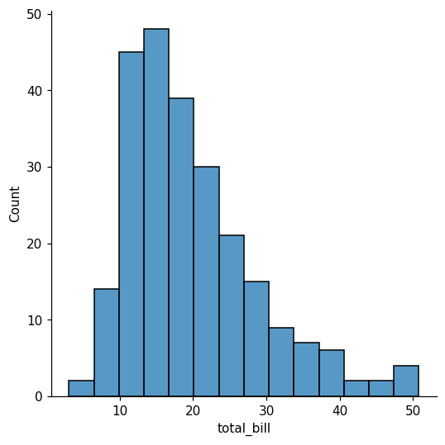
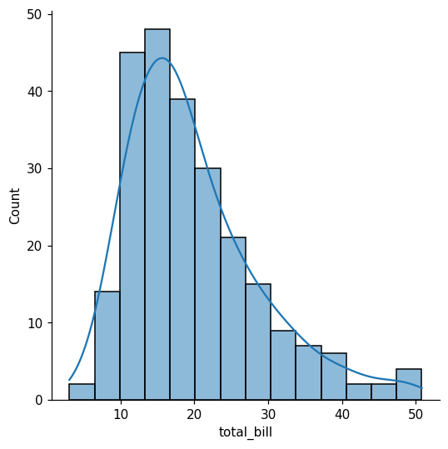

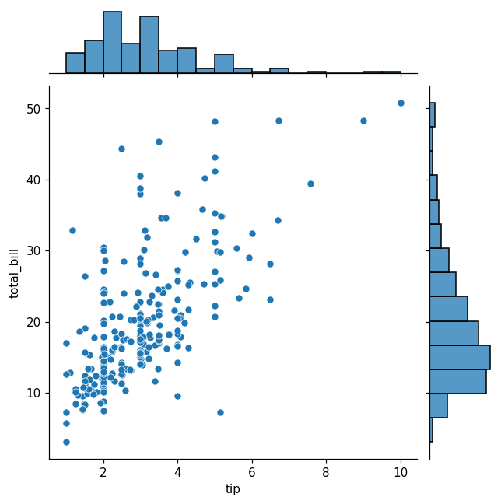
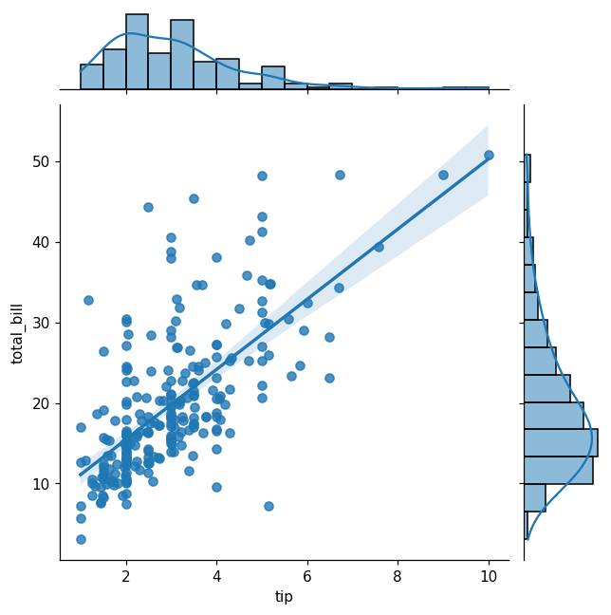
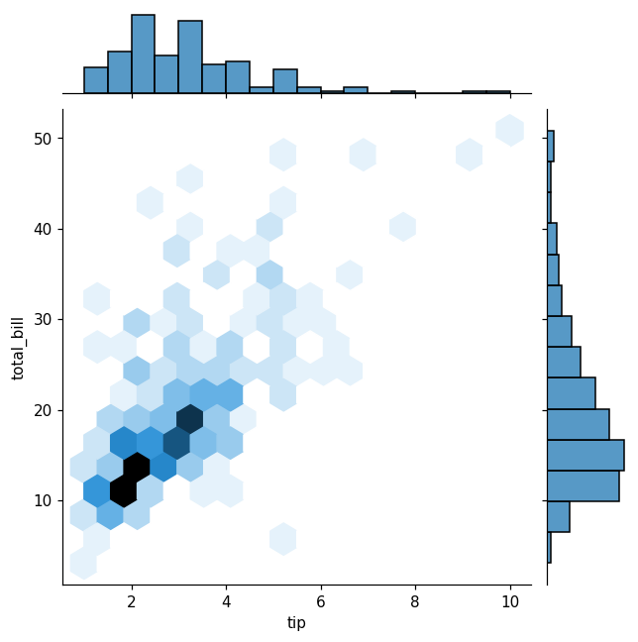
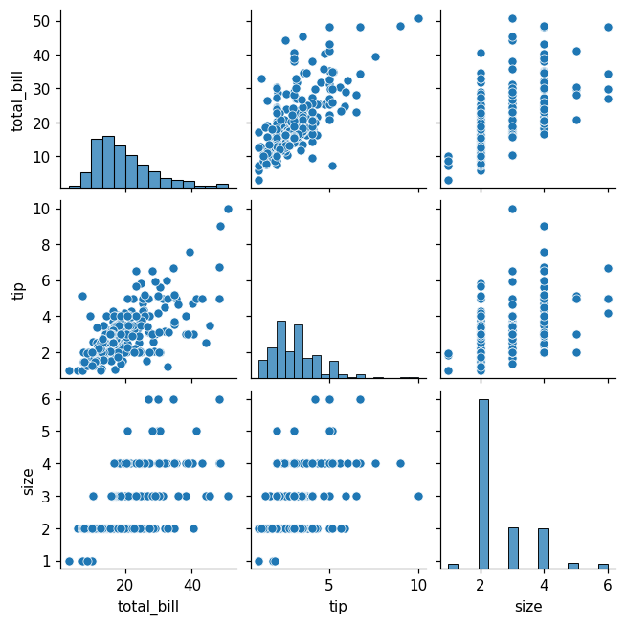
time
Dinner 176
Lunch 68
Name: count, dtype: int64

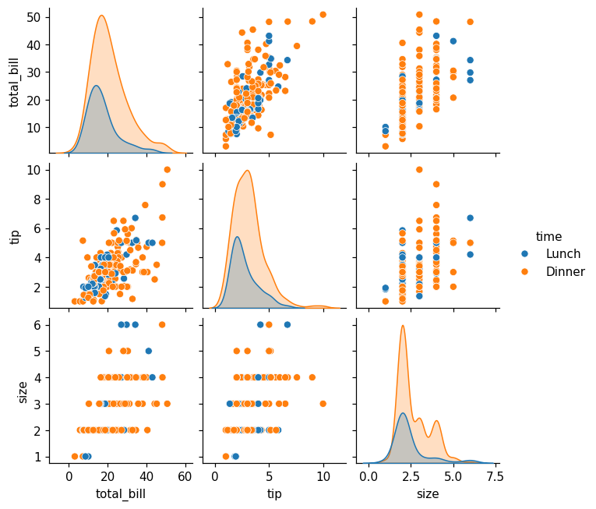
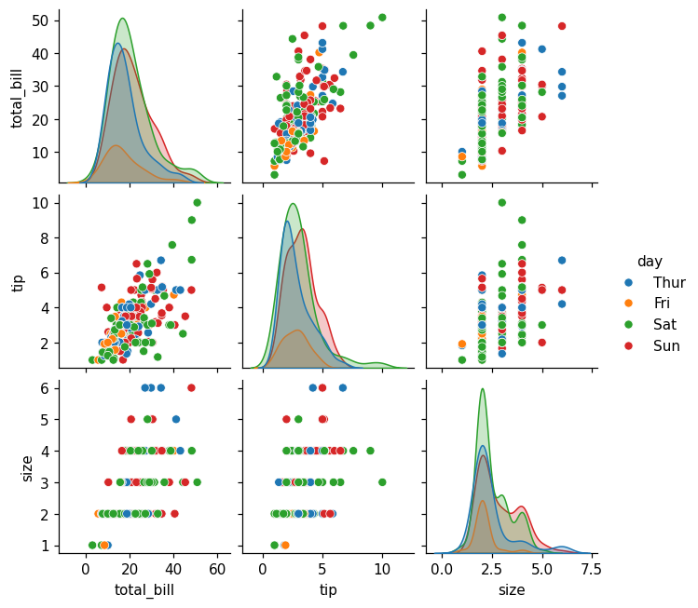
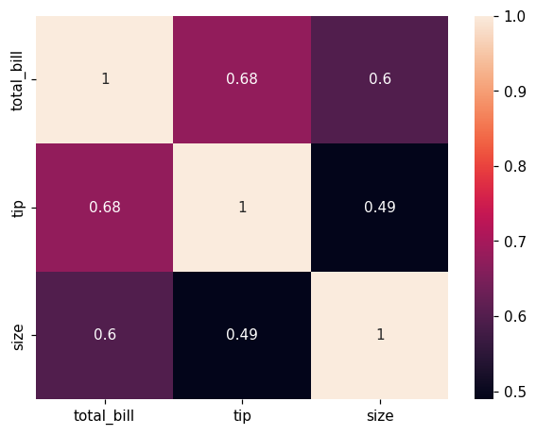
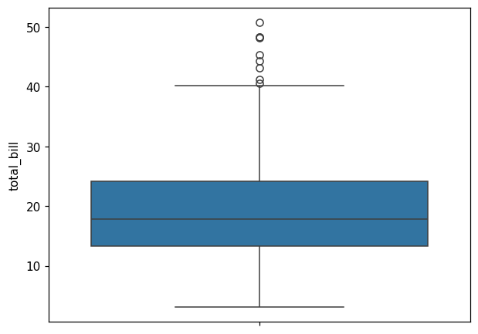
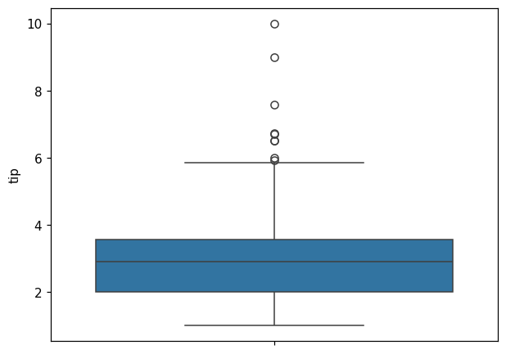
day
Sat 87
Sun 76
Thur 62
Fri 19
Name: count, dtype: int64
sex
Male 157
Female 87
Name: count, dtype: int64

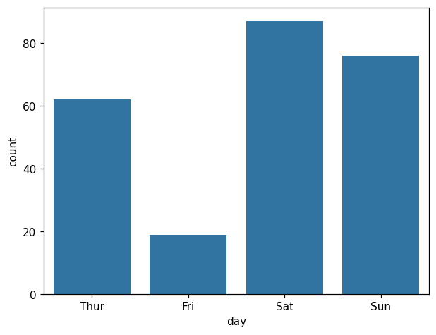
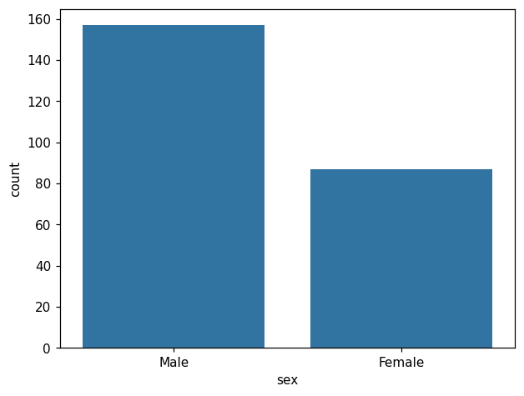
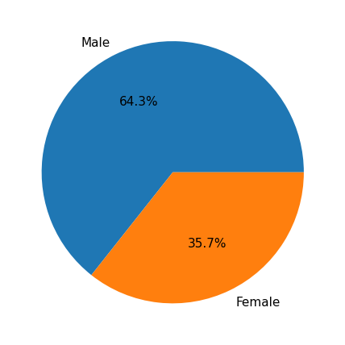
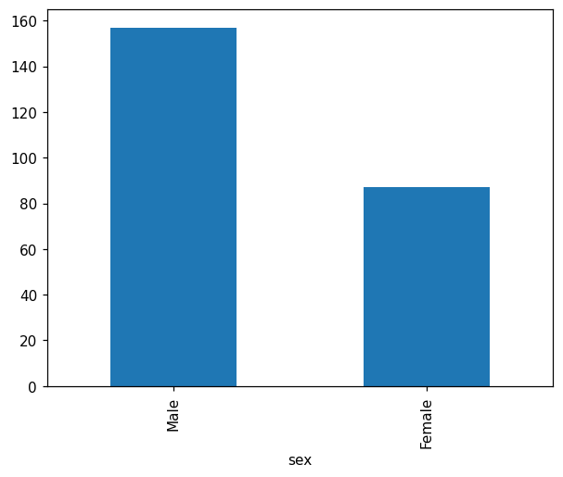
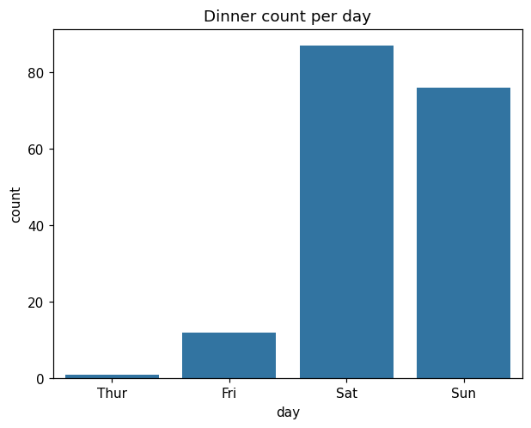

RESULT
Thus exploratory data analysis (quantitative and qualitative) was performed on the tips data set. The total bill and tip are positively correlated, the bill amounts are right-skewed with a few high-value outliers, and most of the records belong to dinner time.

