LINEAR REGRESSION

AIM
To understand Linear Regression by building a model that predicts the salary of an employee from the years of experience.

PROGRAM
import numpy as np
import pandas as pd
import matplotlib.pyplot as plt

df = pd.read_csv('Salary_data.csv')
print(df)
df.info()
df.dropna(inplace=True)
df.info()
print(df.describe())

features = df.iloc[:, [0]].values
label = df.iloc[:, [1]].values

from sklearn.model_selection import train_test_split
x_train, x_test, y_train, y_test = train_test_split(
features, label, test_size=0.2, random_state=23)

from sklearn.linear_model import LinearRegression
model = LinearRegression()
model.fit(x_train, y_train)

print("Training score :", model.score(x_train, y_train))
print("Testing score :", model.score(x_test, y_test))
print("Coefficient :", model.coef_)
print("Intercept :", model.intercept_)

# Visualizing the regression line
plt.scatter(x_train, y_train, color='blue', label='Training data')
plt.scatter(x_test, y_test, color='green', label='Testing data')
plt.plot(features, model.predict(features), color='red', label='Regression line')
plt.xlabel('Years of Experience')
plt.ylabel('Salary')
plt.title('Salary vs Experience')
plt.legend()
plt.show()

# Saving and loading the model
import pickle
pickle.dump(model, open('SalaryPred.model', 'wb'))
model = pickle.load(open('SalaryPred.model', 'rb'))

yr_of_exp = 5.0 # years of experience (input value)
yr_of_exp_NP = np.array([[yr_of_exp]])
Salary = model.predict(yr_of_exp_NP)
print("Estimated Salary for {} years of experience is {}".format(yr_of_exp, Salary))

OUTPUT
YearsExperience Salary
0 1.1 39343
1 1.3 46205
2 1.5 37731
3 2.0 43525
4 2.2 39891
5 2.9 56642
6 3.0 60150
7 3.2 54445
8 3.2 64445
9 3.7 57189
10 3.9 63218
11 4.0 55794
12 4.0 56957
13 4.1 57081
14 4.5 61111
15 4.9 67938
16 5.1 66029
17 5.3 83088
18 5.9 81363
19 6.0 93940
20 6.8 91738
21 7.1 98273
22 7.9 101302
23 8.2 113812
24 8.7 109431
25 9.0 105582
26 9.5 116969
27 9.6 112635
28 10.3 122391
29 10.5 121872
<class 'pandas.DataFrame'>
RangeIndex: 30 entries, 0 to 29
Data columns (total 2 columns):
# Column Non-Null Count Dtype
--- ------ -------------- -----
0 YearsExperience 30 non-null float64
1 Salary 30 non-null int64
dtypes: float64(1), int64(1)
memory usage: 612.0 bytes
<class 'pandas.DataFrame'>
RangeIndex: 30 entries, 0 to 29
Data columns (total 2 columns):
# Column Non-Null Count Dtype
--- ------ -------------- -----
0 YearsExperience 30 non-null float64
1 Salary 30 non-null int64
dtypes: float64(1), int64(1)
memory usage: 612.0 bytes
YearsExperience Salary
count 30.000000 30.000000
mean 5.313333 76003.000000
std 2.837888 27414.429785
min 1.100000 37731.000000
25% 3.200000 56720.750000
50% 4.700000 65237.000000
75% 7.700000 100544.750000
max 10.500000 122391.000000
Training score : 0.9603182547438908
Testing score : 0.9184170849214232
Coefficient : [[9281.30847068]]
Intercept : [27166.73682891]

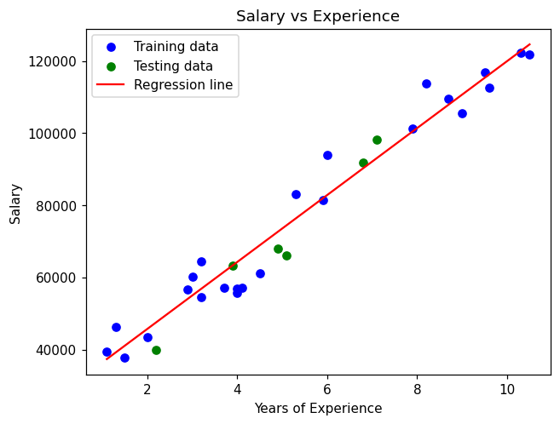
Estimated Salary for 5.0 years of experience is [[73573.27918232]]

RESULT
Thus a Linear Regression model was built to predict the salary from the years of experience. The model fits the data well (training score 0.96, testing score 0.92) and was used to predict the salary for a given experience.

