K-NEAREST NEIGHBOURS (KNN) ALGORITHM

AIM
To understand the KNN algorithm by classifying the species of the Iris flowers.

PROGRAM
import numpy as np
import pandas as pd
import matplotlib.pyplot as plt

df = pd.read_csv('Iris.csv')
df.info()
print(df.variety.value_counts())
print(df.head())

features = df.iloc[:, :-1].values
label = df.iloc[:, 4].values

from sklearn.model_selection import train_test_split
from sklearn.neighbors import KNeighborsClassifier
xtrain, xtest, ytrain, ytest = train_test_split(
features, label, test_size=.2, random_state=23)

model_KNN = KNeighborsClassifier(n_neighbors=5)
model_KNN.fit(xtrain, ytrain)

print("Training score :", model_KNN.score(xtrain, ytrain))
print("Testing score :", model_KNN.score(xtest, ytest))

from sklearn.metrics import confusion_matrix, classification_report
ypred = model_KNN.predict(xtest)
print("\nConfusion matrix:\n", confusion_matrix(ytest, ypred))
print("\nClassification report:\n", classification_report(ytest, ypred))

# Predicting a new sample
sample = np.array([[5.1, 3.5, 1.4, 0.2]])
print("Prediction for", sample[0], "->", model_KNN.predict(sample)[0])

# Effect of K on accuracy
scores = []
for k in range(1, 16):
knn = KNeighborsClassifier(n_neighbors=k).fit(xtrain, ytrain)
scores.append(knn.score(xtest, ytest))
plt.plot(range(1, 16), scores, marker='o')
plt.xlabel('K (number of neighbours)')
plt.ylabel('Testing accuracy')
plt.title('Accuracy for different values of K')
plt.show()

OUTPUT
<class 'pandas.DataFrame'>
RangeIndex: 150 entries, 0 to 149
Data columns (total 5 columns):
# Column Non-Null Count Dtype
--- ------ -------------- -----
0 sepal.length 150 non-null float64
1 sepal.width 150 non-null float64
2 petal.length 150 non-null float64
3 petal.width 150 non-null float64
4 variety 150 non-null str
dtypes: float64(4), str(1)
memory usage: 6.0 KB
variety
Setosa 50
Versicolor 50
Virginica 50
Name: count, dtype: int64
sepal.length sepal.width petal.length petal.width variety
0 5.1 3.5 1.4 0.2 Setosa
1 4.9 3.0 1.4 0.2 Setosa
2 4.7 3.2 1.3 0.2 Setosa
3 4.6 3.1 1.5 0.2 Setosa
4 5.0 3.6 1.4 0.2 Setosa
Training score : 0.9583333333333334
Testing score : 1.0

Confusion matrix:
[[12 0 0]
[ 0 8 0]
[ 0 0 10]]

Classification report:
precision recall f1-score support

Setosa 1.00 1.00 1.00 12
Versicolor 1.00 1.00 1.00 8
Virginica 1.00 1.00 1.00 10

accuracy 1.00 30
macro avg 1.00 1.00 1.00 30
weighted avg 1.00 1.00 1.00 30

Prediction for [5.1 3.5 1.4 0.2] -> Setosa

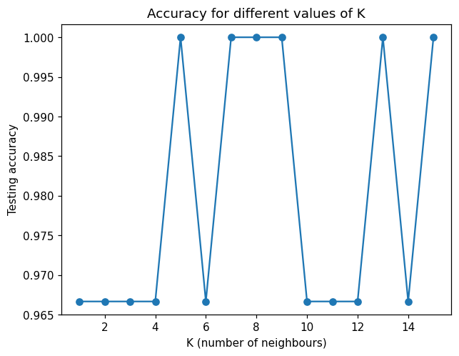

RESULT
Thus the KNN algorithm was implemented on the Iris data set and the species of the flowers were classified with high accuracy.

