LOGISTIC REGRESSION

AIM
To understand the Logistic Regression algorithm by classifying tumours as malignant or benign for a given data set.

PROGRAM
import numpy as np
import pandas as pd
import matplotlib.pyplot as plt
import seaborn as sns
from sklearn.datasets import load_breast_cancer
from sklearn.model_selection import train_test_split
from sklearn.preprocessing import StandardScaler
from sklearn.linear_model import LogisticRegression
from sklearn.metrics import accuracy_score, confusion_matrix, classification_report

# The sigmoid (logistic) function used by Logistic Regression
z = np.linspace(-8, 8, 200)
plt.plot(z, 1 / (1 + np.exp(-z)))
plt.axhline(0.5, color='red', linestyle='--')
plt.title('Sigmoid function')
plt.xlabel('z')
plt.ylabel('probability')
plt.show()

# Load the data set
data = load_breast_cancer(as_frame=True)
df = data.frame
print("Shape :", df.shape)
print(df.iloc[:, [0, 1, 2, 3, -1]].head())
print("Missing values :", df.isnull().sum().sum())
print(df['target'].value_counts())

features = df.drop('target', axis=1)
label = df['target']
x_train, x_test, y_train, y_test = train_test_split(
features, label, test_size=0.2, random_state=23)

# Feature scaling
sc = StandardScaler()
x_train = sc.fit_transform(x_train)
x_test = sc.transform(x_test)

# Training the model
model = LogisticRegression(max_iter=1000)
model.fit(x_train, y_train)

# Prediction and evaluation
y_pred = model.predict(x_test)
print("Training score :", model.score(x_train, y_train))
print("Testing accuracy:", accuracy_score(y_test, y_pred))
print("Probabilities of first 5 test records [malignant, benign]:")
print(model.predict_proba(x_test[:5]).round(4))
print("Predicted classes :", y_pred[:5])
print("Actual classes :", y_test.values[:5])

cm = confusion_matrix(y_test, y_pred)
print("\nConfusion matrix:\n", cm)
print("\nClassification report:")
print(classification_report(y_test, y_pred, target_names=data.target_names))

sns.heatmap(cm, annot=True, fmt='d', cmap='Blues',
xticklabels=data.target_names, yticklabels=data.target_names)
plt.xlabel('Predicted')
plt.ylabel('Actual')
plt.title('Confusion matrix')
plt.show()

OUTPUT
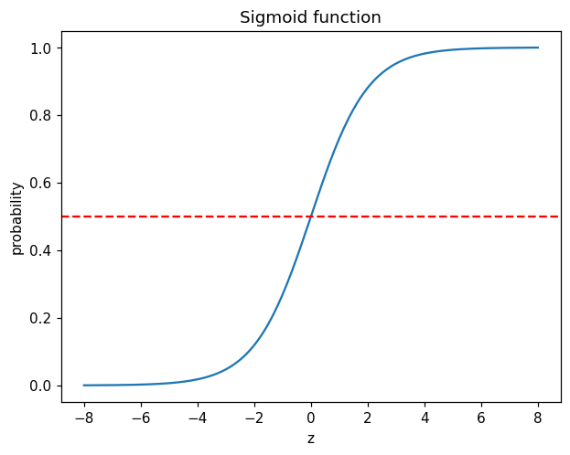
Shape : (569, 31)
mean radius mean texture mean perimeter mean area target
0 17.99 10.38 122.80 1001.0 0
1 20.57 17.77 132.90 1326.0 0
2 19.69 21.25 130.00 1203.0 0
3 11.42 20.38 77.58 386.1 0
4 20.29 14.34 135.10 1297.0 0
Missing values : 0
target
1 357
0 212
Name: count, dtype: int64
Training score : 0.989010989010989
Testing accuracy: 0.9824561403508771
Probabilities of first 5 test records [malignant, benign]:
[[0.0044 0.9956]
[0.5369 0.4631]
[1. 0. ]
[0.0336 0.9664]
[0.9983 0.0017]]
Predicted classes : [1 0 0 1 0]
Actual classes : [1 1 0 1 0]

Confusion matrix:
[[38 1]
[ 1 74]]

Classification report:
precision recall f1-score support

malignant 0.97 0.97 0.97 39
benign 0.99 0.99 0.99 75

accuracy 0.98 114
macro avg 0.98 0.98 0.98 114
weighted avg 0.98 0.98 0.98 114

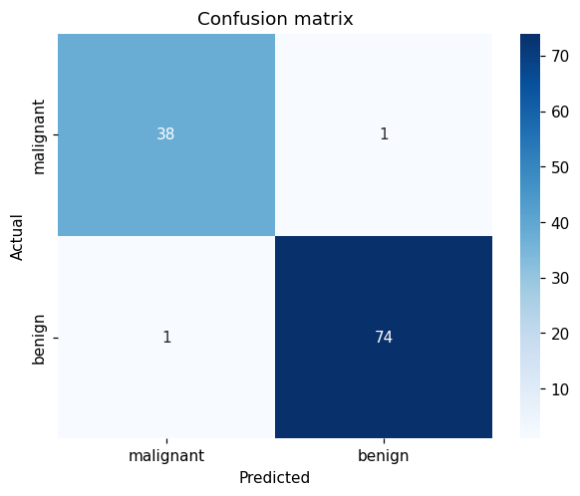

RESULT
Thus the Logistic Regression model was built and trained on the Breast Cancer data set and it classified the tumours with high accuracy on the test data.

